Practical No : 3 = Installation of linux(ubuntu)

Roll no = 4110

Aim
To understand and perform the step-by-step installation of the Ubuntu Linux operating system on a computer or virtual machine.

Step 1: Boot from the installation media
Insert the bootable USB drive (or mount the ISO in your virtual machine) and restart the computer. Enter the BIOS/UEFI boot menu (commonly F2, F10, F12, or Esc depending on the manufacturer) and select the USB drive / ISO as the boot device. The GRUB boot menu appears; select "Try or Install Ubuntu" and press Enter.
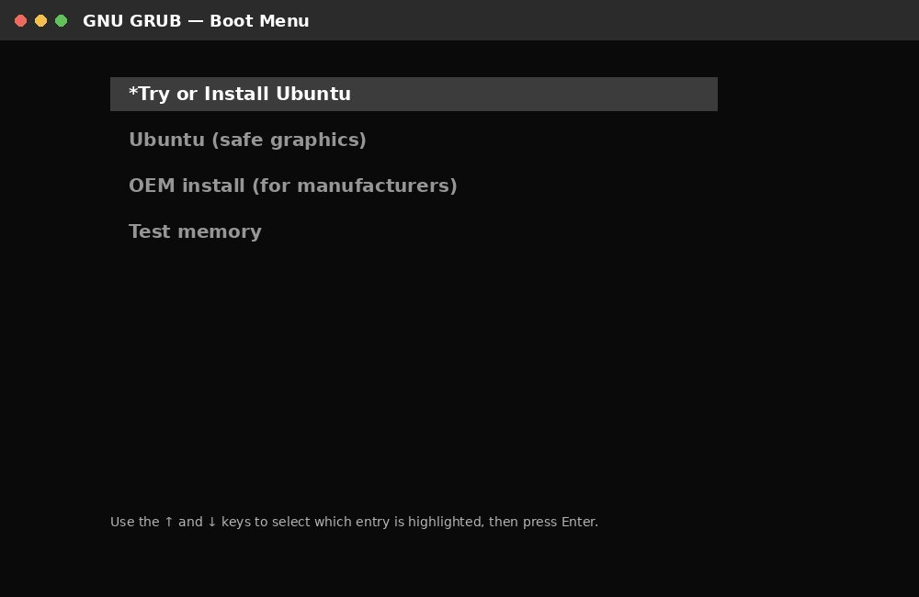
Fig 1: GRUB boot menu — select 'Try or Install Ubuntu'

Step 2: Select language
Once the installer loads, choose your preferred language from the list on the left. This sets the language for the installer and the installed system. Click Next / Continue.
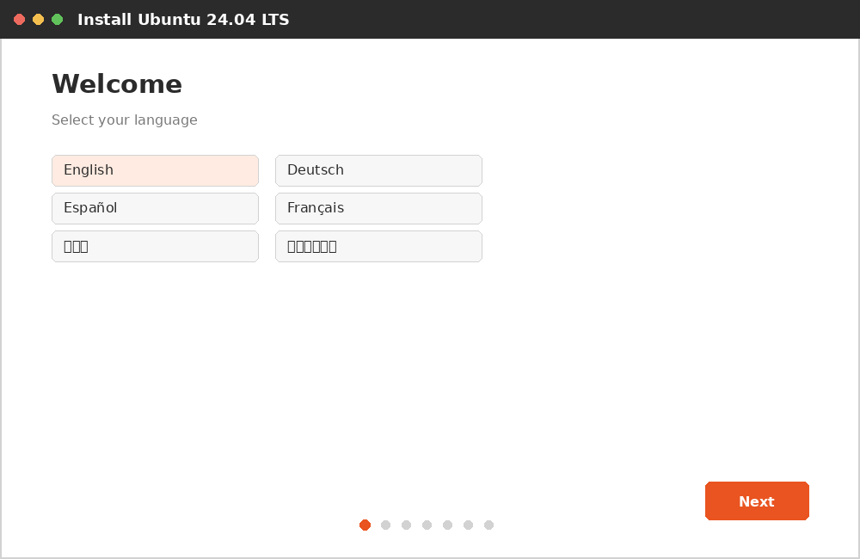
Fig 2: Welcome screen — language selection

Step 3: Choose keyboard layout
Select your keyboard layout and variant from the two list boxes. You can click inside the text box provided and type to auto-detect / test your keyboard. Click Next.
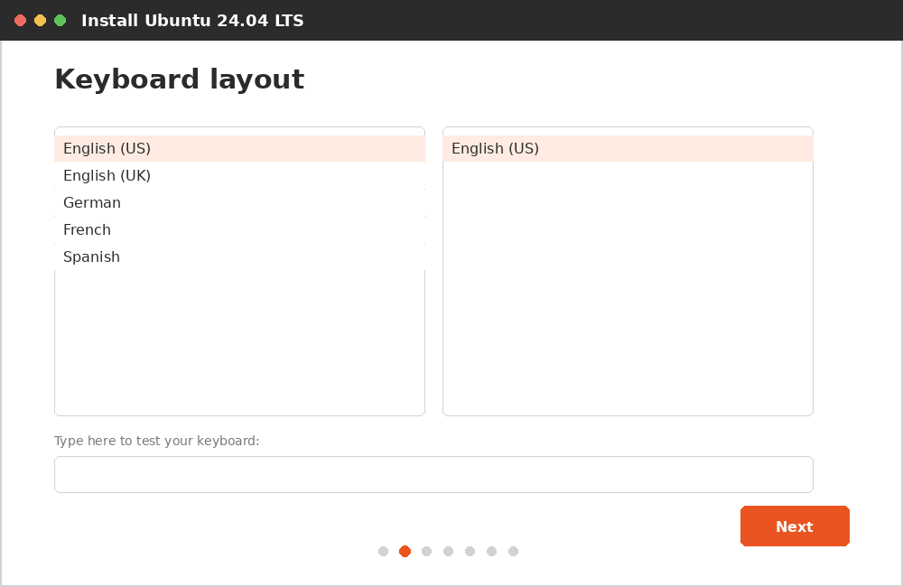
Fig 3: Keyboard layout selection

Step 4: Updates and other software
Choose between a Normal installation (includes web browser, utilities, office software, games, and media players) and a Minimal installation (only a web browser and basic utilities). Optionally, check the boxes to download updates while installing and to install third-party software for graphics and Wi-Fi hardware. Click Next.
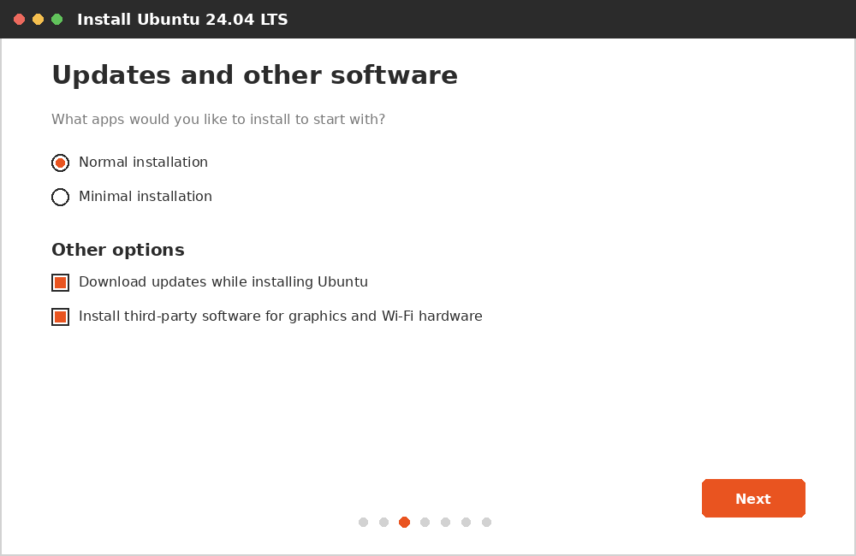
Fig 4: Updates and other software options

Step 5: Select installation type
Choose how Ubuntu should be installed:
- Erase disk and install Ubuntu — removes everything and installs Ubuntu as the only OS (used on a fresh virtual disk)
- Install Ubuntu alongside — sets up dual boot with an existing operating system such as Windows
- Something else — allows manual creation and formatting of partitions (advanced/custom setups)
For a practical carried out on a virtual machine, "Erase disk and install Ubuntu" is normally selected because the virtual disk is empty. Click Install Now, then confirm the changes.
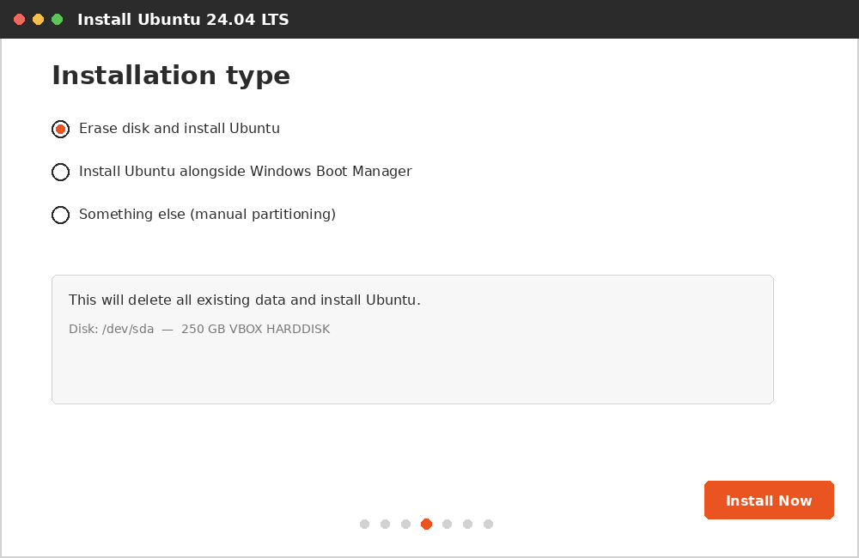
Fig 5: Installation type — disk partitioning options

Step 6: Select time zone
Click on your location on the map, or type your city/region, so that the system clock is set correctly. Click Next.
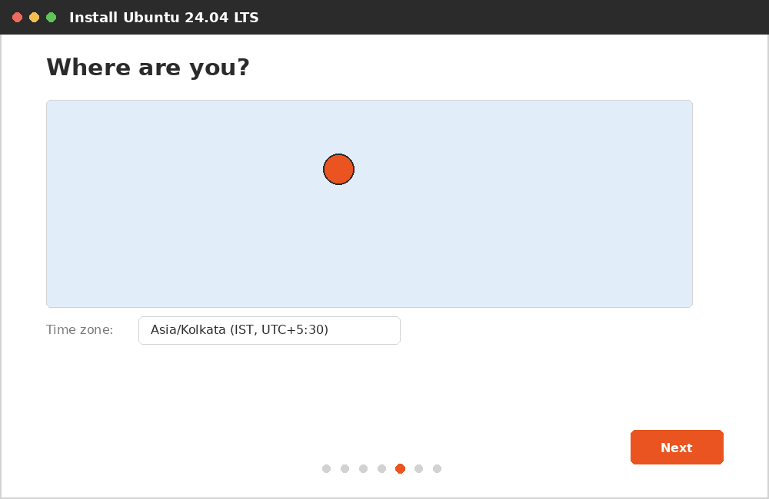
Fig 6: Time zone selection

Step 7: Create user account
Enter your name, choose a computer name, set a username, and create a password for the account. Optionally select whether a password is required to log in. Click Next / Continue to begin the installation.
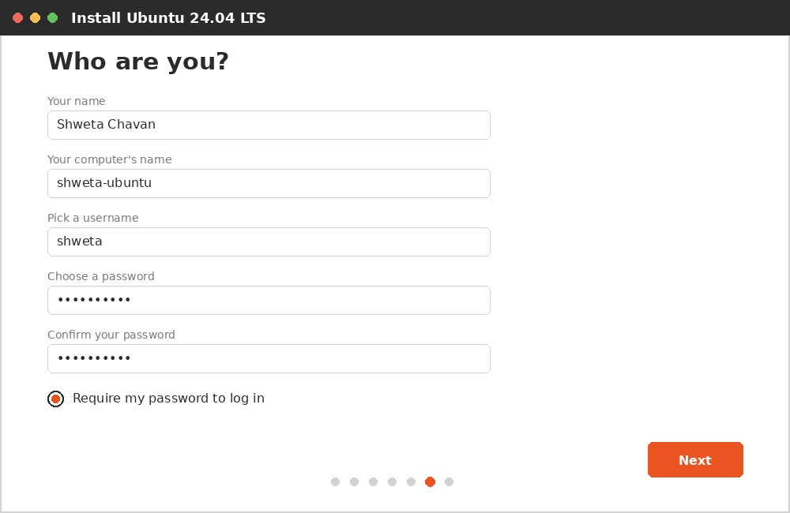
Fig 7: Creating the user account

Step 8: Installation progress
The installer copies files and sets up the system. This step shows a progress bar and a slideshow describing Ubuntu's features. This process typically takes 10–20 minutes depending on system speed.
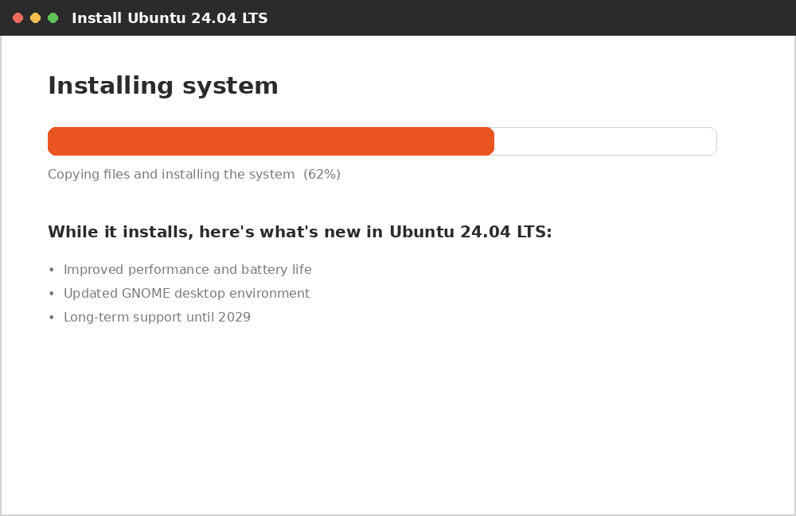
Fig 8: Installation in progress

Step 9: Restart the system
Once installation is complete, a message prompts you to restart the device. Remove the installation media (USB/ISO) when prompted, and press Enter to reboot into the newly installed Ubuntu system.
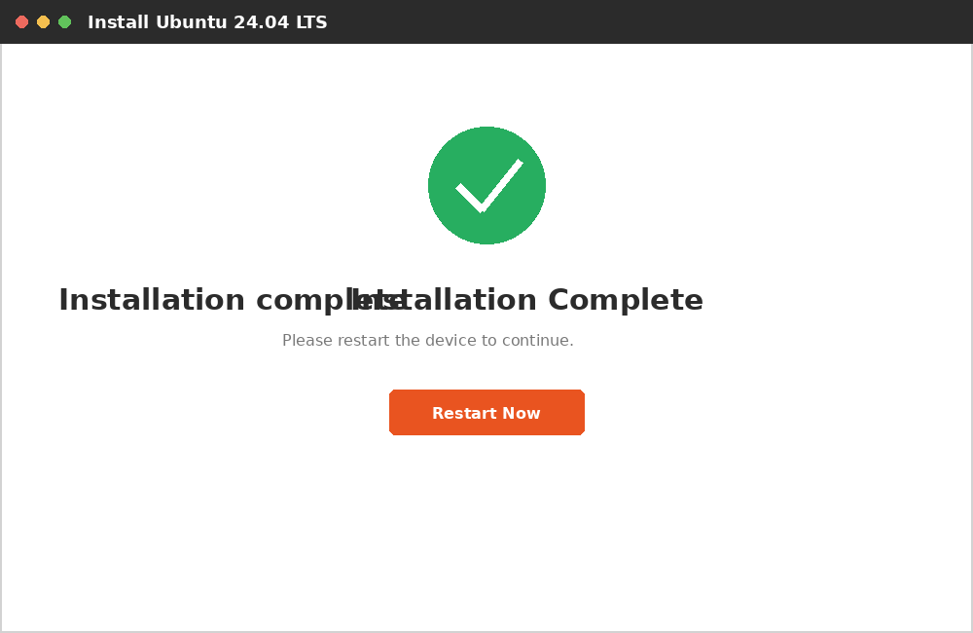
Fig 9: Installation complete — restart prompt

Step 10: First login
After rebooting, the Ubuntu login screen appears. Select your username, enter the password created in Step 7, and press Enter to log in to the Ubuntu desktop for the first time.
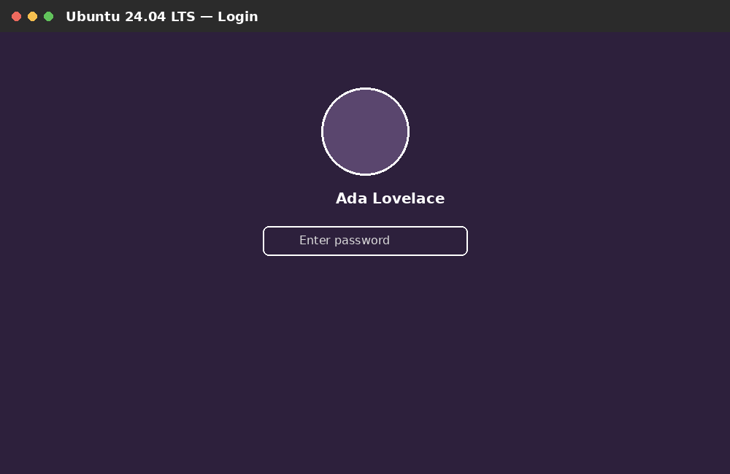
Fig 10: Ubuntu login screen

Result
Ubuntu Linux was successfully installed and configured on the system/virtual machine, and the desktop environment was accessed by logging in with the created user account.

