Experiment 4
Title : Creating Matrices and Some Simple Matrix Operations using Scilab
Roll No-4110

Aim
To create matrices in Scilab and perform basic matrix operations such as addition, subtraction, multiplication, transpose, determinant, inverse, and element-wise operations.

Screenshot Of Code

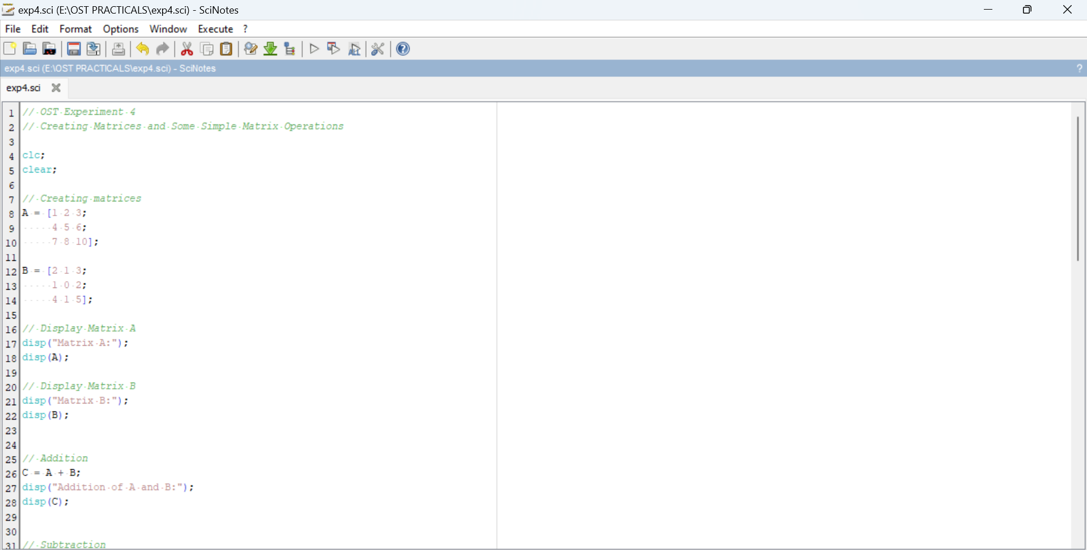

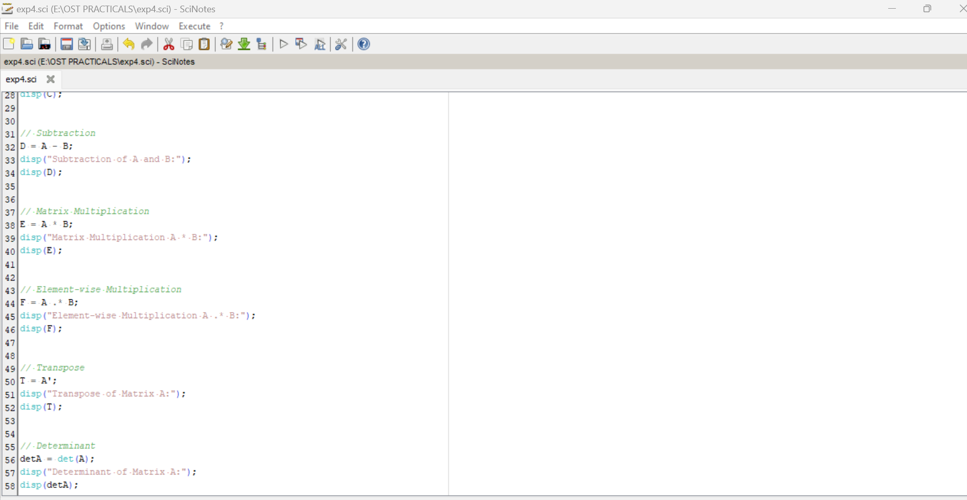

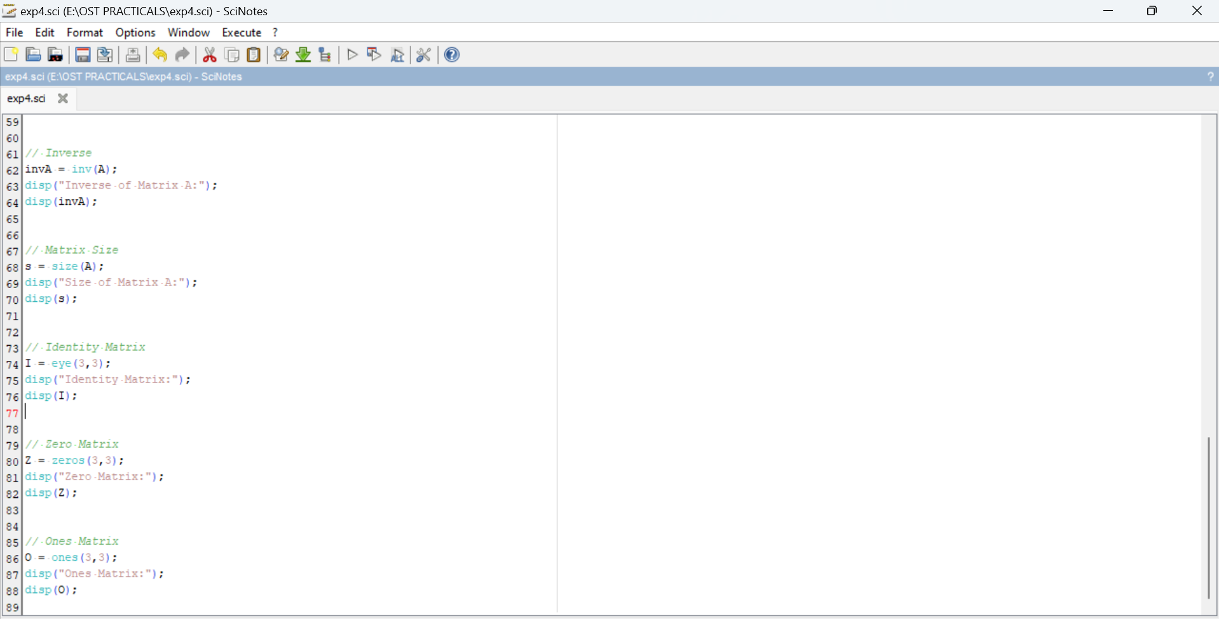

OUTPUT
