Name: Shweta Shahaji Chavan.
Roll no.:4110
Div: B
URN: 24032005
Batch: B5

Experiment 7
Title : Learn how to host a simple static website using GitHub Pages.

Aim
To learn how to host and publish a simple static website using GitHub Pages.


Theory
GitHub Pages is a free hosting service provided by GitHub for publishing static websites directly from a GitHub repository.
A static website generally contains:
  - HTML → Structure of the webpage
  - CSS → Styling and appearance
  - JavaScript → Client-side interactivity For example:
index.html style.css
images/
When GitHub Pages is enabled, GitHub publishes these files as a website.

Requirements
  - Computer/Laptop

  - Internet connection
  - GitHub account
  - Web browser
  - Basic knowledge of HTML

Procedure
Step 1: Create a GitHub Account
Open GitHub and sign in to your account.
If you already have an account, simply log in.

Step 2: Create a New Repository
- Click + → New repository.
- Enter repository name, for example: my-static-website
- Select Public.
- Select Add a README file if required.
- Click Create repository.
You will now have a repository such as:
https://github.com/username/my-static-website

Step 3: Create the HTML File
Create a file named:
index.html
Important: The main webpage should normally be named index.html. Example:
<!DOCTYPE html>

<html>
<head>
<title>My First Website</title>
</head>

<body>
<h1>Welcome to My Website</h1>

<p>This website is hosted using GitHub Pages.</p>

<h2>About Me</h2>
<p>I am a B.Tech Computer Science student.</p>

<h2>My Skills</h2>
<ul>
<li>Java</li>
<li>Python</li>
<li>HTML & CSS</li>
</ul>
</body>
</html>

Step 4: Upload the File to GitHub
Inside your repository:
- Click Add file.
- Select Create new file.

- Enter: index.html
- Paste the HTML code.
- Scroll down.
- Enter a commit message, for example: Added index.html
- Click Commit changes.
Your repository should now look approximately like: my-static-website
├── index.html
└── README.md

Enable GitHub Pages
Go to:
Repository → Settings → Pages Under Build and deployment: Source
Select:
Deploy from a branch Then select:
Branch: main Folder: / (root) Click Save.
GitHub will start deploying your website.

Access the Website
After deployment, GitHub will provide a website URL similar to: https://username.github.io/my-static-website/
Open the URL in a browser.
Your HTML page should now be publicly accessible. Expected Output

Welcome to My Website

This website is hosted using GitHub Pages.

About Me
I am a B.Tech Computer Science student.

My Skills
- Java
- Python
- HTML & CSS

Thus, matrices were successfully created in Scilab and basic matrix operations including addition, subtraction, matrix multiplication, element-wise multiplication, transpose,

determinant, inverse, identity matrix, zero matrix, ones matrix, and matrix size were performed successfully.

Add CSS to Make the Website Attractive
Students can create another file: style.css
Example:
body {
font-family: Arial, sans-serif; margin: 40px;
}
h1 {
text-align: center;
}
p {
font-size: 18px;
}

li {
margin: 8px;
}
Then connect it with index.html:
<head>
<title>My First Website</title>
<link rel="stylesheet" href="style.css">
</head>

Repository:
my-static-website
├── index.html
├── style.css
└── README.md
After committing the changes, GitHub Pages will automatically update the website.

Performed Work
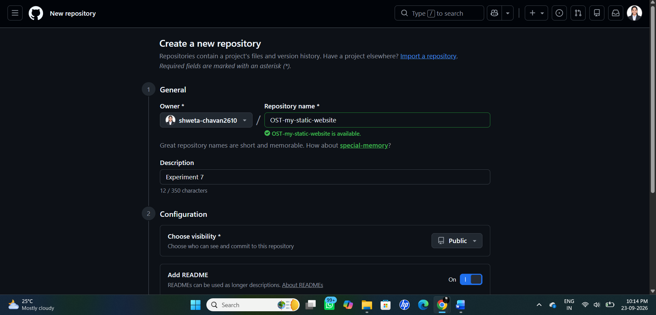
Fig: Creating a new GitHub repository for the static website.
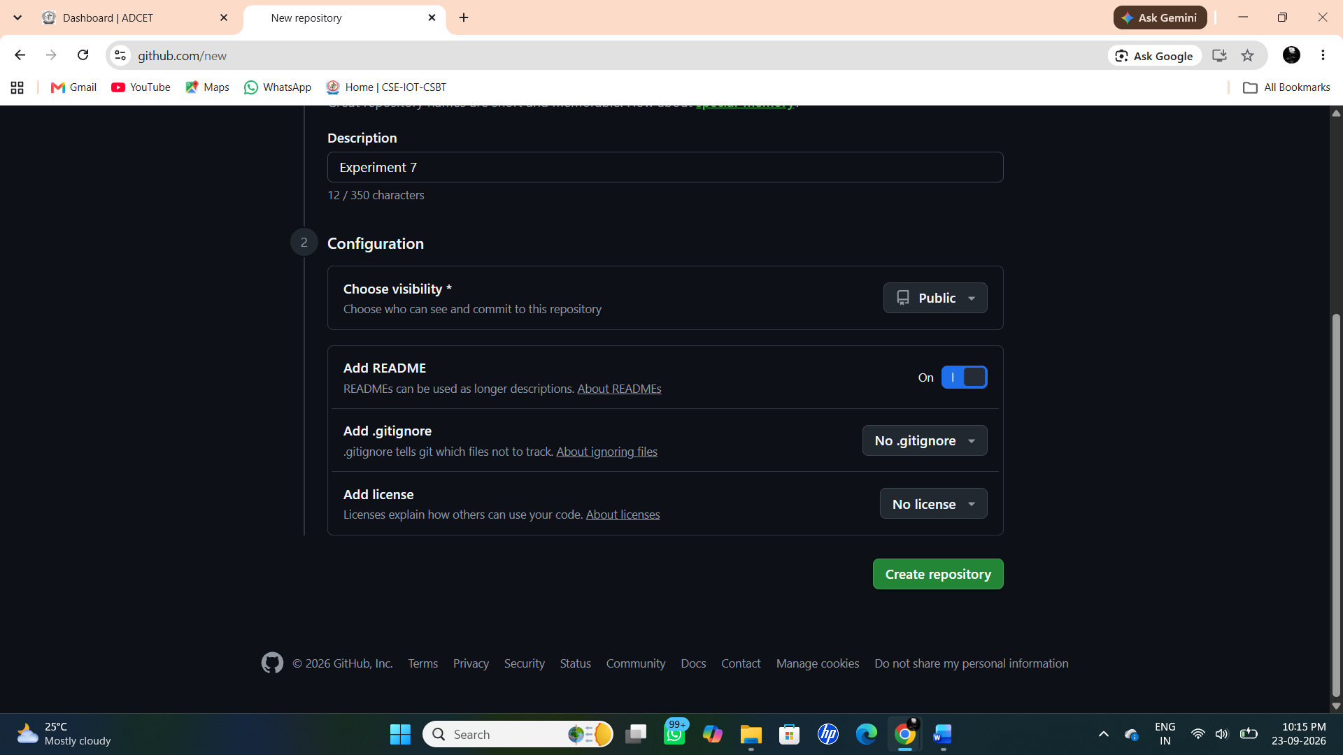

Fig: Repository configuration options (README, .gitignore, license)
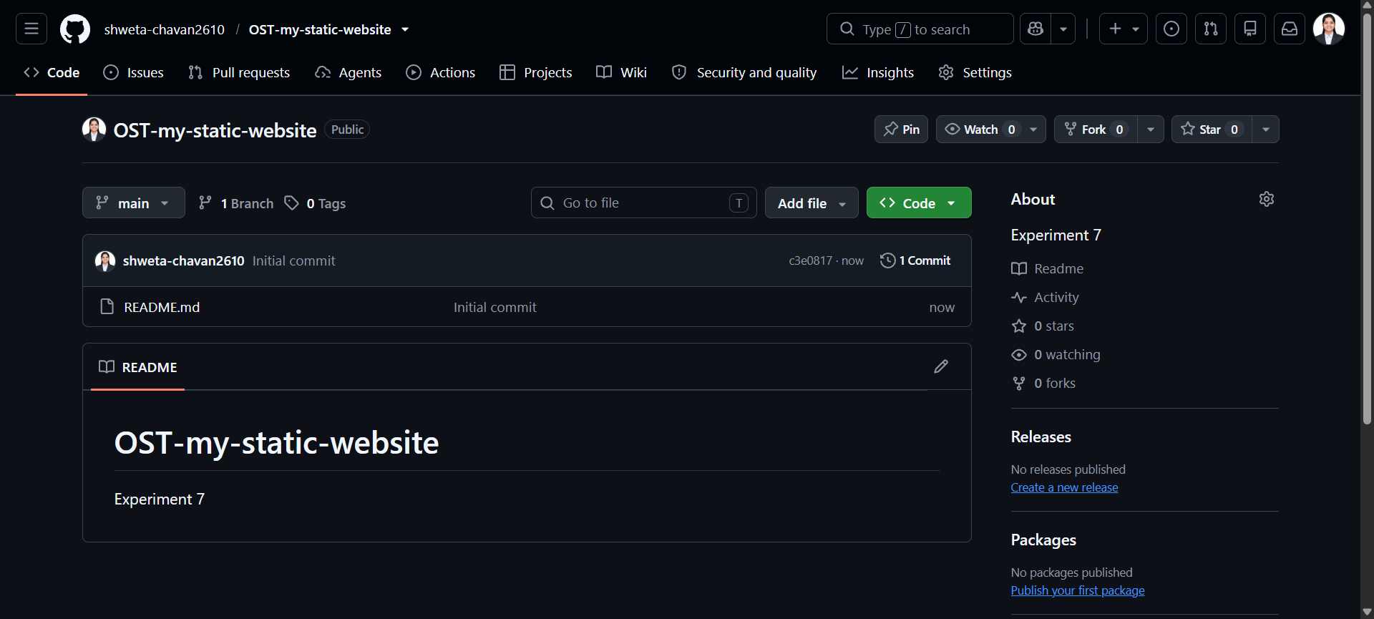
Fig: Newly created repository showing the README file.

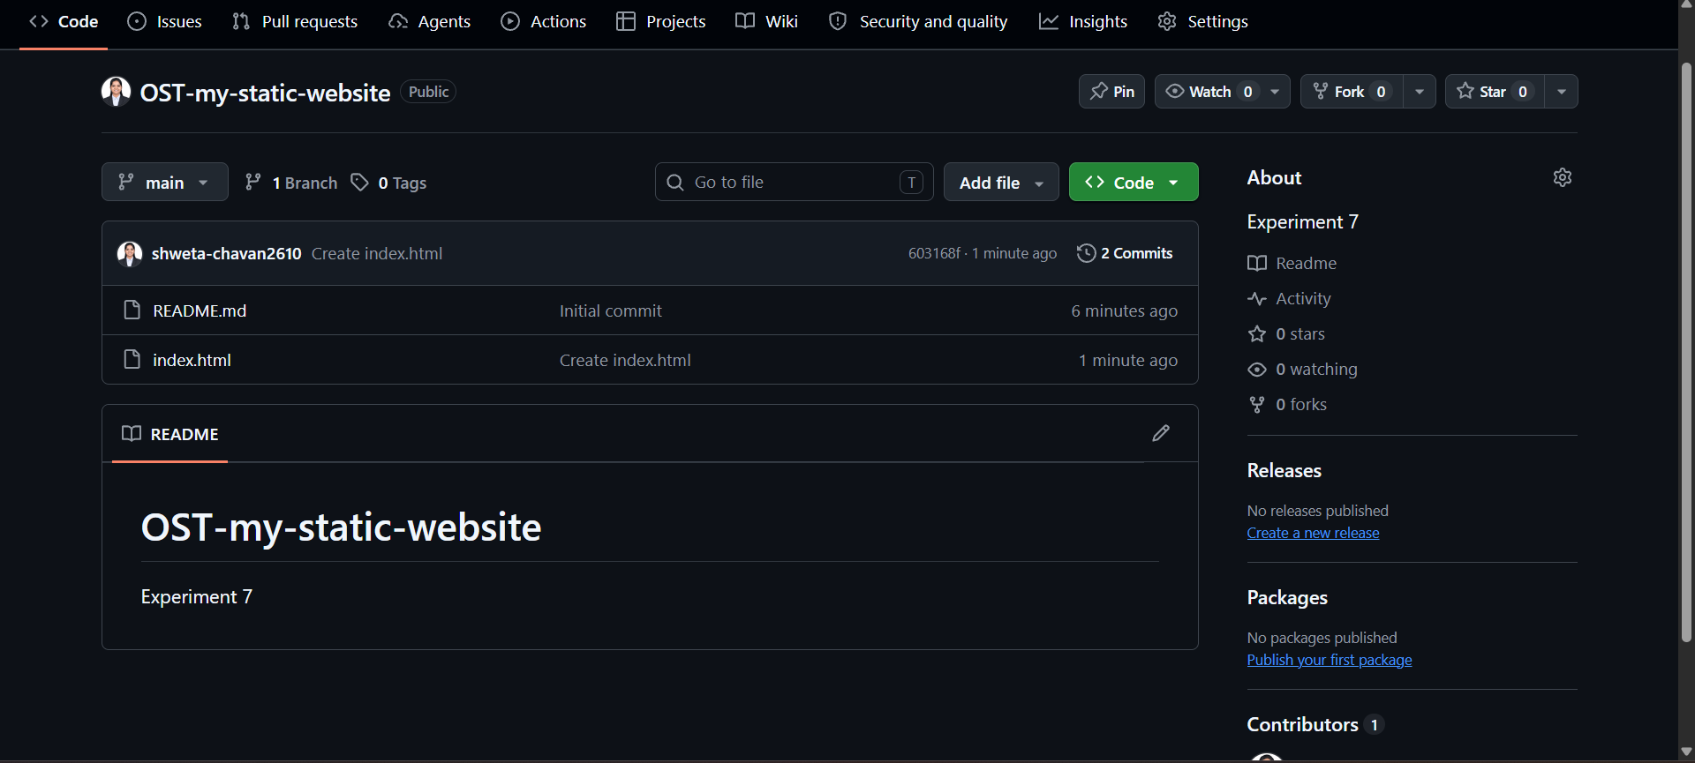
Fig: Repository view after committing index.html.

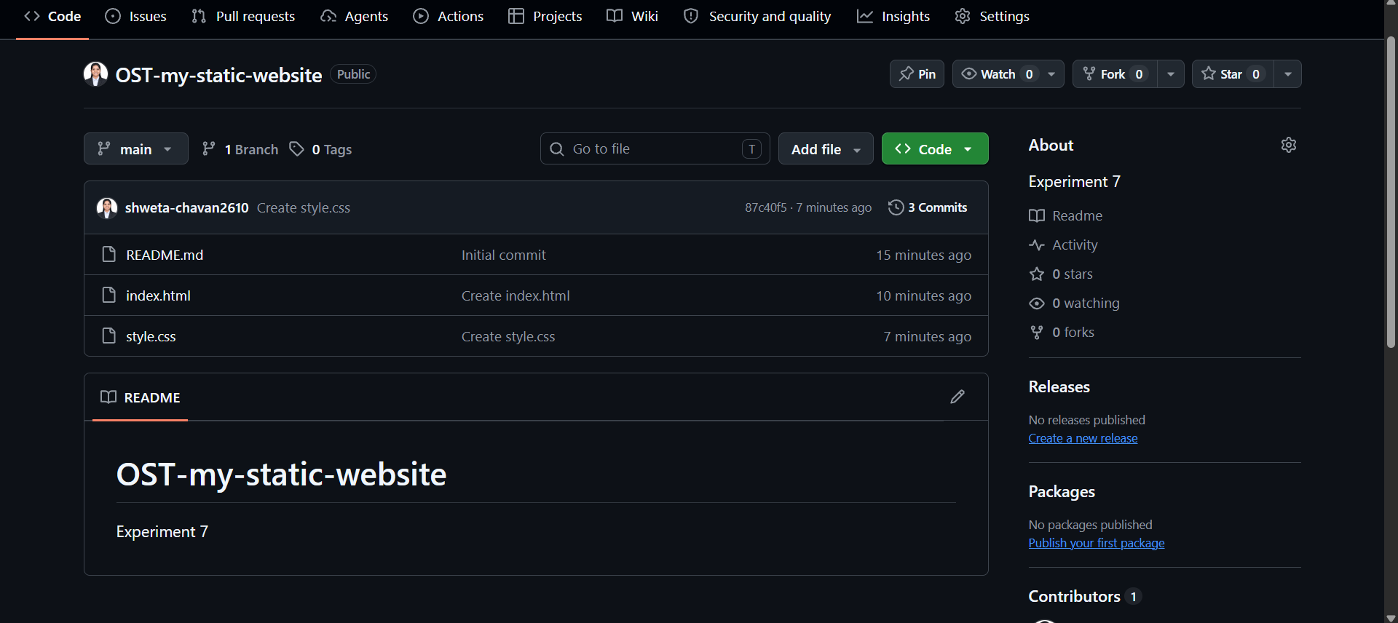

Fig: Repository view after committing style.css

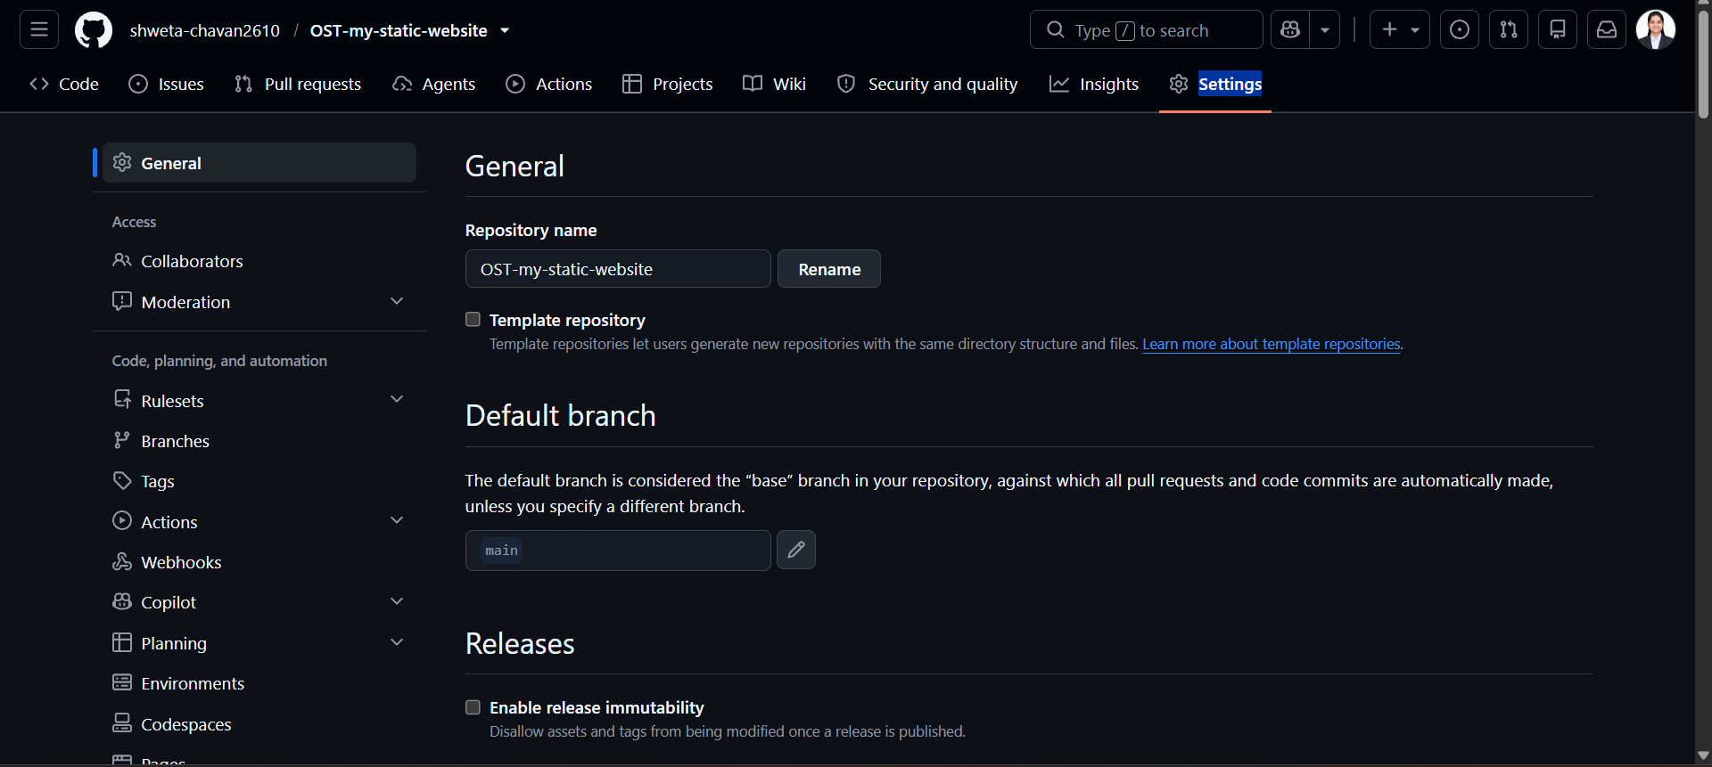

Fig: GitHub repository Settings — General page.

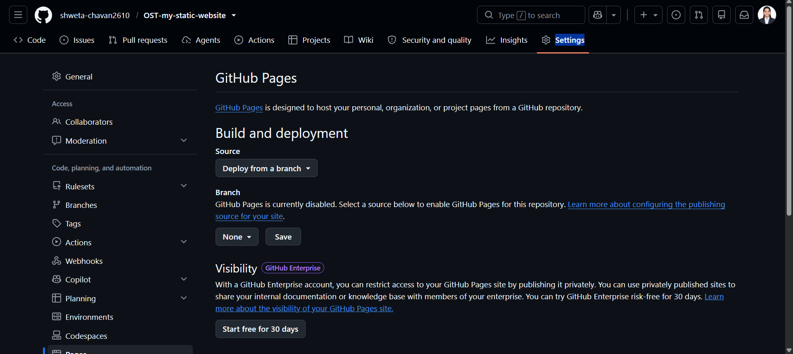
Fig GitHub Pages settings before enabling deployment.

