Experiment No. 8
Title: Create a simple open-source project and learn how to upload and share it on GitHub.
1. Aim
To create a simple open-source project, initialize a Git repository, upload the project to GitHub, and share the repository with others.
2. Learning Objectives
After completing this experiment, students will be able to:
- Understand the concept of an open-source project.
- Create a simple project with source files.
- Initialize and manage a Git repository.
- Create a repository on GitHub.
- Commit and push project files to GitHub.
- Create a .gitignore file.
- Add a README file and open-source license.
- Share a GitHub repository with other users.
3. Prerequisites
- Basic knowledge of files and folders.
- A GitHub account.
- Git installed on the computer.
- Internet connection.
- Basic knowledge of command prompt/terminal.

4. Theory
What is Open Source?
Open-source software is software whose source code is made available so that people can study, use, modify, and share it according to the project's license.
Examples:
- Linux
- Git
- Mozilla Firefox
- LibreOffice
- Python
- WordPress
What is Git?
Git is a distributed version-control system used to track changes in source code and collaborate with other developers.
What is GitHub?
GitHub is an online platform for hosting Git repositories. It allows developers to:
- Store projects online
- Track changes
- Collaborate with others
- Share source code
- Manage issues
- Review contributions
Git vs GitHub
Git | GitHub
Version-control software | Online platform
Works on local computer | Mainly cloud-based
Tracks file changes | Hosts Git repositories
Uses commands such as commit and branch | Provides repository sharing and collaboration
Can work without internet | Internet is generally required for remote GitHub operations

5. Problem Statement
Create a simple open-source project called:
Student Grade Calculator
The project should accept marks of a student, calculate the total and percentage, and display the grade.
For example:
Enter marks of 3 subjects:
Subject 1: 75
Subject 2: 82
Subject 3: 68

Total Marks = 225
Percentage = 75.00%
Grade = A

6. Software/Tools Required
Tool | Purpose
Git | Version control
GitHub | Online repository hosting
VS Code / Notepad / Eclipse | Writing source code
Command Prompt / Git Bash | Executing Git commands
Web Browser | Accessing GitHub

7. Procedure
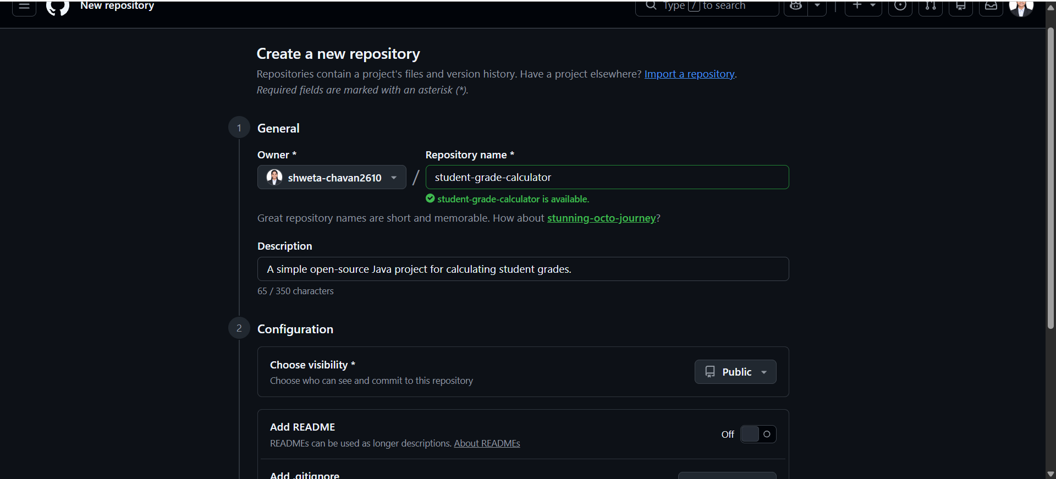
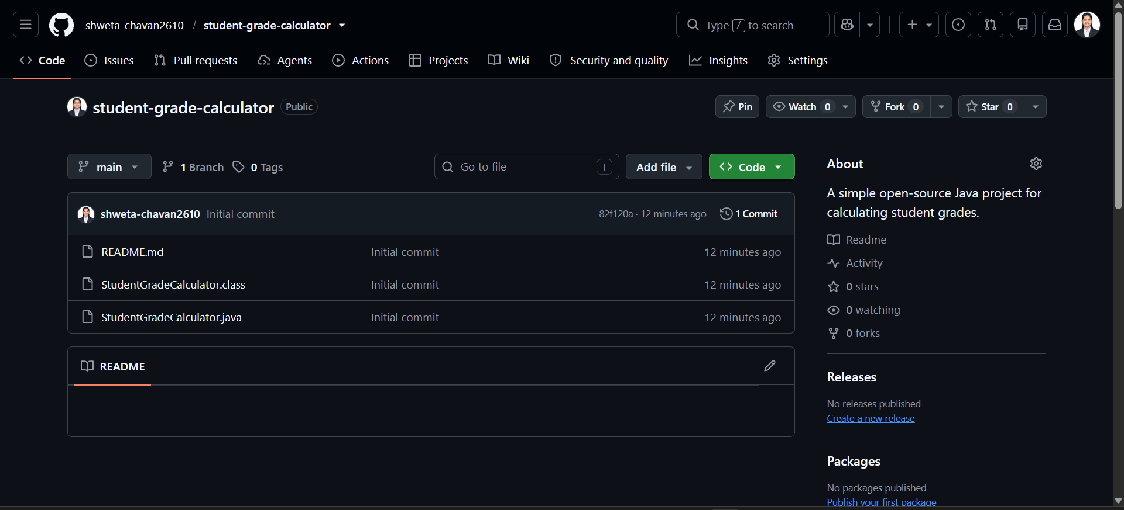
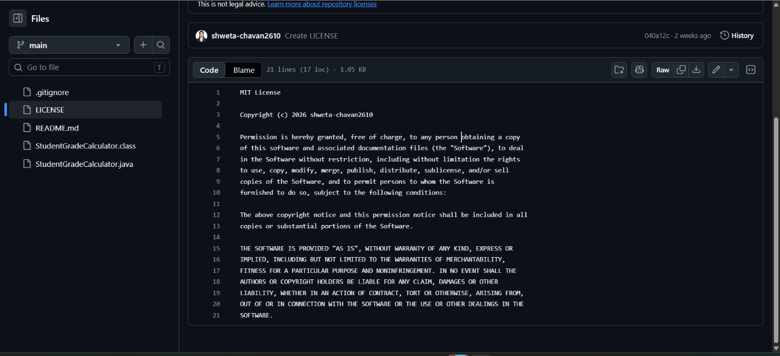
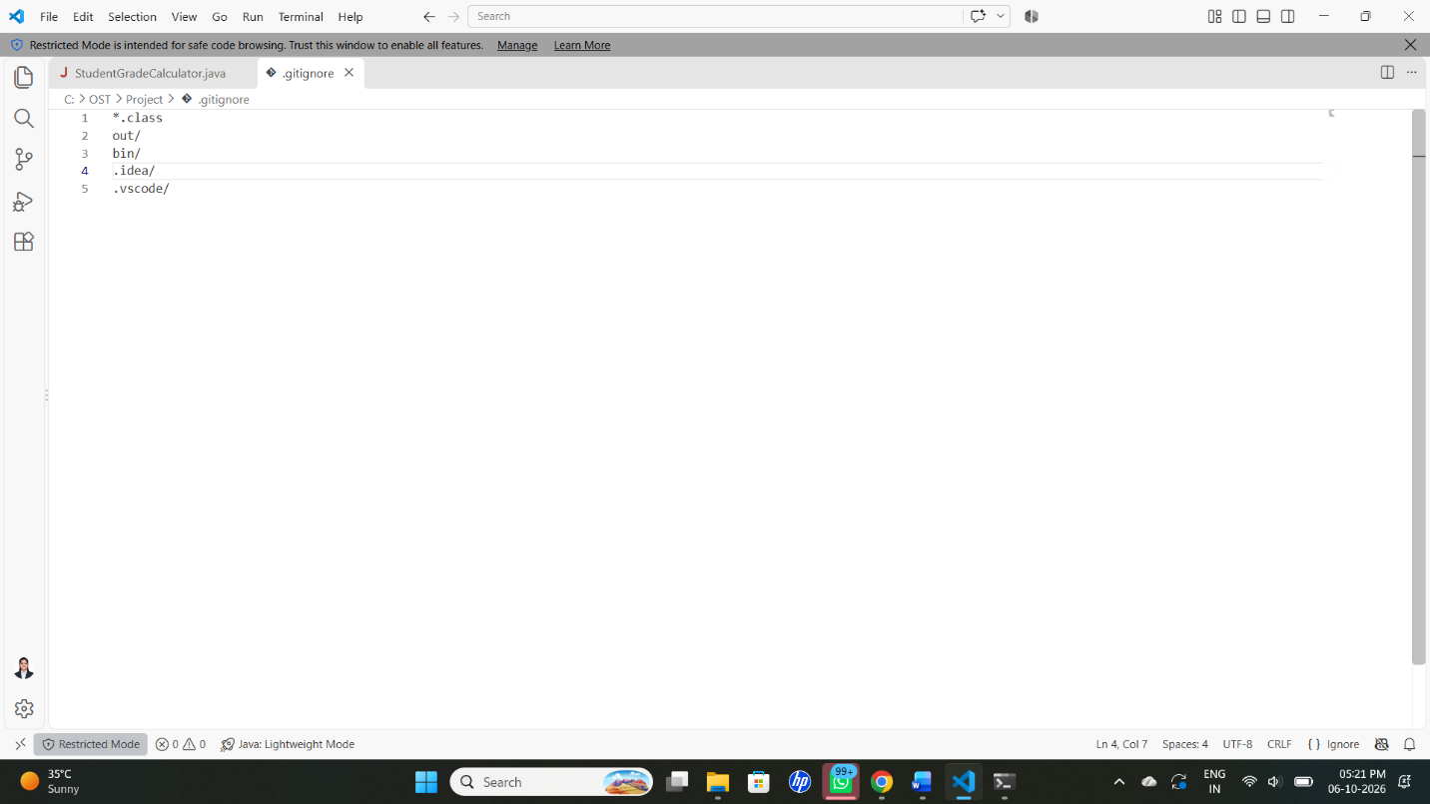
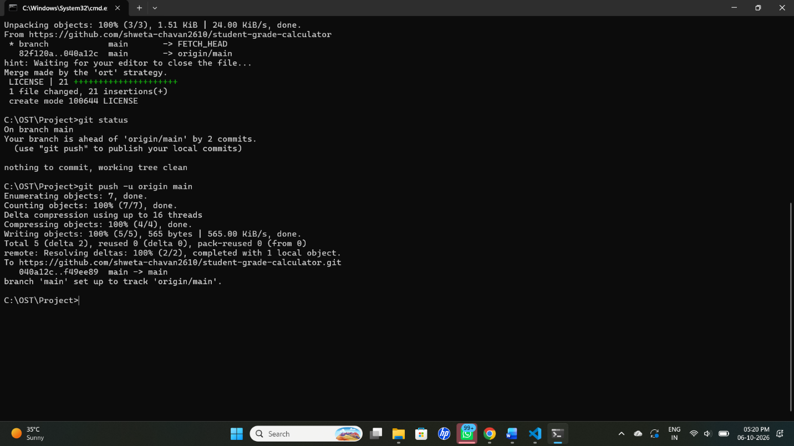
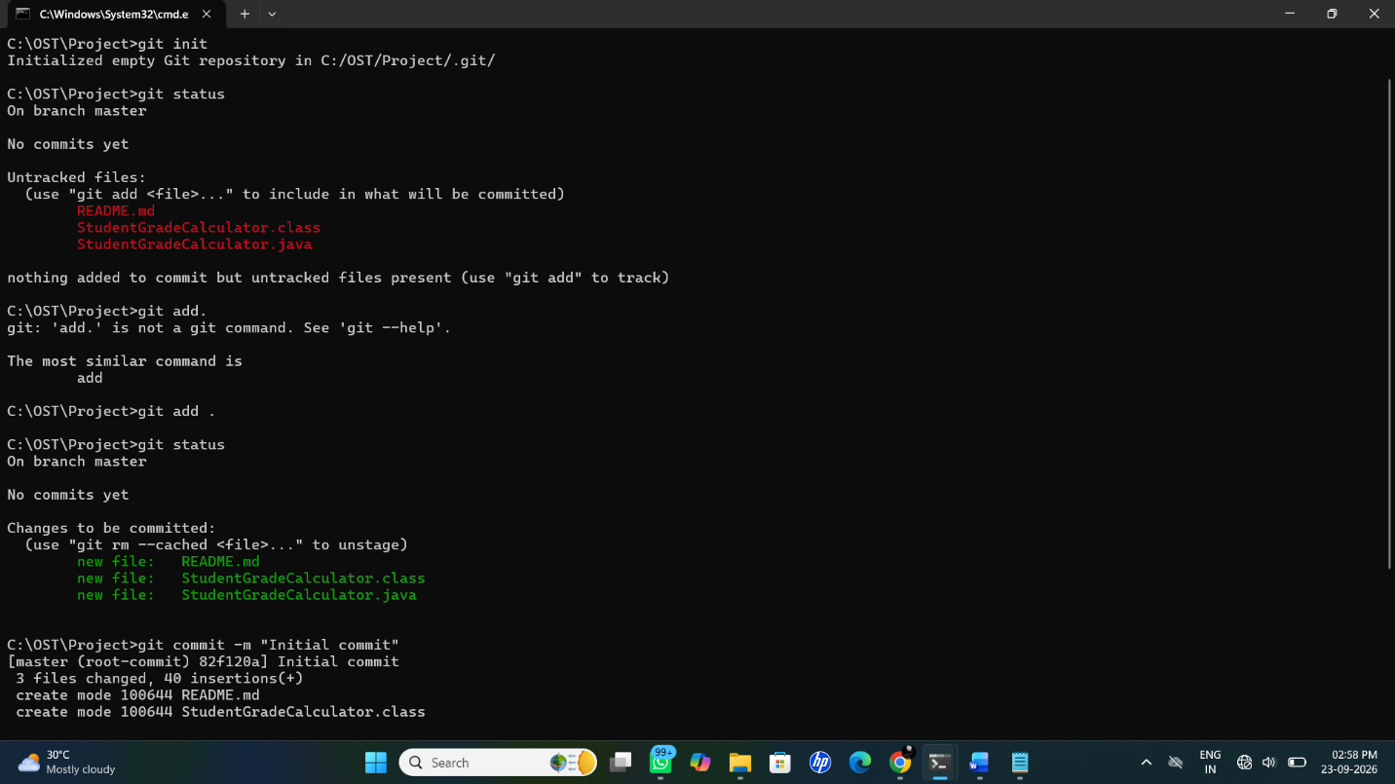

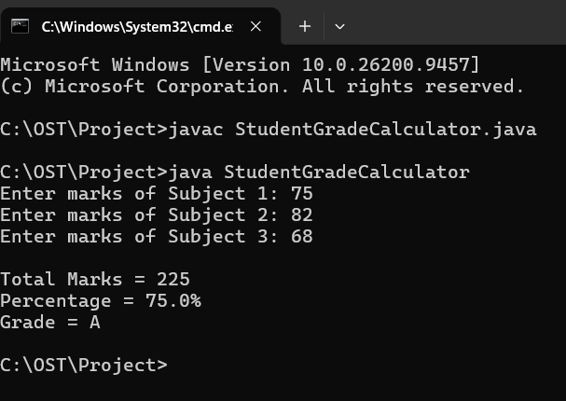

22. Result
Successfully created a simple open-source project, initialized a Git repository, created a GitHub repository, uploaded the project using Git commands, added project documentation and .gitignore, and shared the project through GitHub.

