The Weather Application
Overview:
This Weather App provides APIs to store and retrieve sensor-based weather data. It supports inserting sensor readings, fetching all records, retrieving data by sensor name, and querying sensor data based on conditions.

Tech Stack:
Backend: Java 17 – Spring Boot
Database: H2 in-memory
Tool: Maven, JUnit 5 + Mockito

API:
- Insert Sensor Data
  - Endpoint: POST / insertData
  - Description: Insert sensor data in database.
  - Request Body:
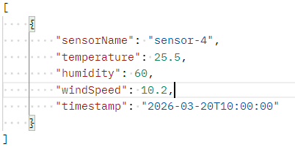
  - Optional Parameters: timestamp
  - Response:
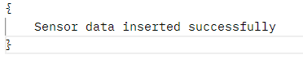

- Get All Sensor Data
  - Endpoint: GET / all
  - Description: Displays all sensor data.
  - Request Body: No parameters required.

  - Response:
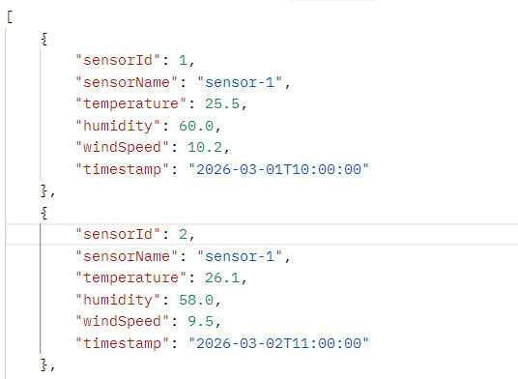

- Get Data by Sensor Name
  - Endpoint: GET /name/{sensorName}
  - Description: Sensor specific data is displayed based on sensor name.
  - Request: Path parameter – Name of the sensor
  - Response:
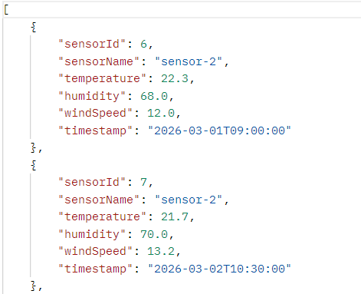

- Query Sensor Data
  - Endpoint: POST /querySensorData
  - Description: Filters multiple sensor data based on parameters.
  - Optional: Start time and End time is optional.
  - Request:
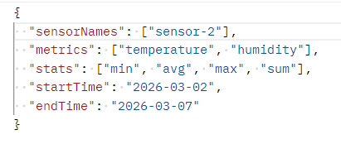
  - Response:
