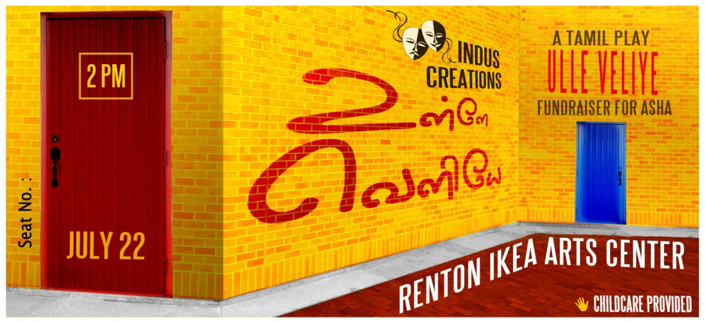
Hi #Name#,
We’re very excited about seeing you at Ulle Veliye!
Below are your seat numbers and coupons for any additional services that you have bought.
Please print out and bring this page with you.
Show: 2 P.M.
Seats
#Seat 1# | #Seat 2# | #Seat 3# | #Seat 4# | #Seat 5#
#Seat 6# | #Seat 7# | #Seat 8# | #Seat 9# | #Seat 10#
#Seat 11# | #Seat 12# | #Seat 13# | #Seat 14# | #Seat 15#

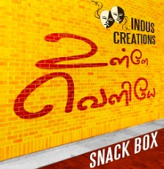 #Snacks#  #Childcare#
