1. Write the Test Scenarios for the following user story

a. As a new user

I want to create an account in LUMA shopping site

So that I can buy product using my registered account

* Verify that the user can navigate to the LUMA shopping site.
* Verify that the user can see the Create an Account link to create new account.
* Verify that the user can click on the Create an Account link.
* Verify that the user can enter the required details (first name, last name, email, password) in the registration form.
* Verify that error is thrown if mandatory fields are not filled during registration.
* Verify that error is thrown if email address is not correct.
* Validate that error is thrown if password does not fill the required parameters (Capital letter, lower letter, number etc)
* Validate that password and confirm password should be matching.
* Validate that password can not be copy and pasted into Confirm password.
* Validate that password strength is displayed when password is typed.
* Validate that color of password strength is changed as per the password typed.
* Validate that data of password strength is changed as per the password typed.
* Validate that password is not visible and displayed like dot characters.
* Validate that password is visible when eye icon is clicked.
* Validate that eye slash gets created on eye icon once it is clicked.
* Validate that Sign up for Newsletter is clickable.
* Validate that error is thrown if invalid length data is provided on text fields.
* Validate that data in password and confirm password automatically gets deleted when user tries to click form after providing wrong information.
* Verify that the user can submit the registration form.
* Verify that the user can receive a confirmation message after successful registration.
* Verify that the user can log in to their registered account.

b. As a registered user

I want to check different clothing options for men

So that I can compare the product and buy it

* Verify that the user can navigate to the LUMA shopping site.
* Verify that the user can see the Signin link to login.
* Verify that the user can click on the Signin link.
* Verify that the user can log in to their registered account by providing valid credentials.
* Verify that user is not able to login if invalid credentials are provided.
* Verify that user can request for password change by clicking on forgot password.
* Verify that the user can navigate to the "Men" section on the homepage.
* Validate that automatic dropdowns are displayed with mouse hover action.
* Validate that text changes to grey with mouse hover actions.
* Validate that all links are clickable for men section and user lands on appropriate page(if Men🡪Bottoms then user lands on men/buttoms page)
* Verify that the user can select a category of their choice.
* Verify that the user can view the different product options within the selected category.
* Verify that the user can filter the products based on their preferences (size, color, price, etc.).
* Verify that the user can add products to Add to Compare section.
* Validate that add to Compare section is updated on adding the products to compare section
* Validate that user can remove the product from Compare section.
* Validate that user can compare the items in compare section.
* Validate that user gets navigated to compare screen on clicked
* Validate that compared data is visible for the selected product on the screen
* Validate that user can add the product to cart from compare screen
* Validate that user can add the item to wishlist from compare screen.

2. Do some exploratory tests on Checkout functionality in the website link provided and find as

many bugs as you can

1. A short description (1-2 sentences) of the approach you took to your testing.

I created account on the website and then explored the UI and different sections available on the screen. I added the different products and played around before checkout and noticed the bugs and then added the address for checkout where also I found some issues. Finally, I placed the order and completed the flow.

1. A bulleted list of the scenarios you tried, even if they were successful.

* Validate that there is no delay in updating fixed rate and tax section is visible in order summary (Error)
* Validate that user can move the item from wish list to Cart.
* Validate that if no Discount is available then it should not be provided in Total Amount Section (Error)
* Validate that user is not able to check out if there are no items in cart.
* Validate that if incorrect discount code is applied, error should be displayed.
* Validate that total price should be reduced if discount code is correct.
* Validate that cancel button is provided if user wants to cancel the flow after checkout at payment and address page(Error)
* Validate that Shipping rate should get added to Total Amount Section(Error)
* Validate that Move to wishlist and Edit button should be provided for all the items in Shopping cart(Error)
* Validate that check box should be provided to delete multiple items from cart(Error)
* Validate that checkbox should be provided to checkout for specific products(Error)
* Validate that Total amount should not be 0 when there are items in shopping cart(Error)
* Validate that print receipt is visible on UI after placing the items for multiple addresses(Error)
* Validate that user cannot select multiple address by clicking check out for multiple address(Error)
* Validate that user can create account on the shopping website by providing mandatory fields.
* Validate that user is unable to create account on shopping website if mandatory fields are not provided.
* Validate the field level validations for new user account for mandatory fields.
* Validate that valid data is present on different sections on UI.
* Validate that Sort by is working properly on UI.
* Validate that values are getting filtered out when price filter is selected for the section(Error)
* Validate that user is not able to add the products to the cart if mandatory parameters (size, color)are not selected.
* Validate that user can move the items to wishlist.
* Validate that user is able to move the item to Add to Compare section.
* Validate that user should not be able to add Address having more than 255 characters (Error)
* Validate that field level validation (length and Datatype) should be provided to Pin code(Error)
* Validate that field level validation (length and datatype) should be provided to mobile number(Error)
* Validate that email should be sent to the registered email address if its written on UI after successfully placing the order(Error)
* Validate that total number of items should be updated once item is added/removed from cart
* Validate that estimated Delivery by information should be provided before/after placing the order (Error)
* Validate that information should be provided if items are returnable or not(Error)
* Validate that size chart should be provided so that user can select the correct size(Error)
* Validate that information should be provided if product is Out of Stock(Error)
* Validate that user is able to edit multiple fields other than quantity from shopping cart(Error)
* Validate that not more than 1 address is added for the same user while placing order
* Validate that user is able to view color changed on UI on selecting different colors(Error)
* Validate that user is able to change the password by clicking on forgot new password(error)

c. A quick description of any bugs you found. It’s OK to not have found any – we’re more

interested in your test ideas and approach than what you executed in the 30 minutes.

Defect: Price Filter is not working properly

Description: When user tries to filter the Bottom pants for Men and filters the price as Price$40.00 - $49.99 , pants should be visible in the selected category but pants are displayed as the value $57.00 and $51.00 that is not in the selected price category.

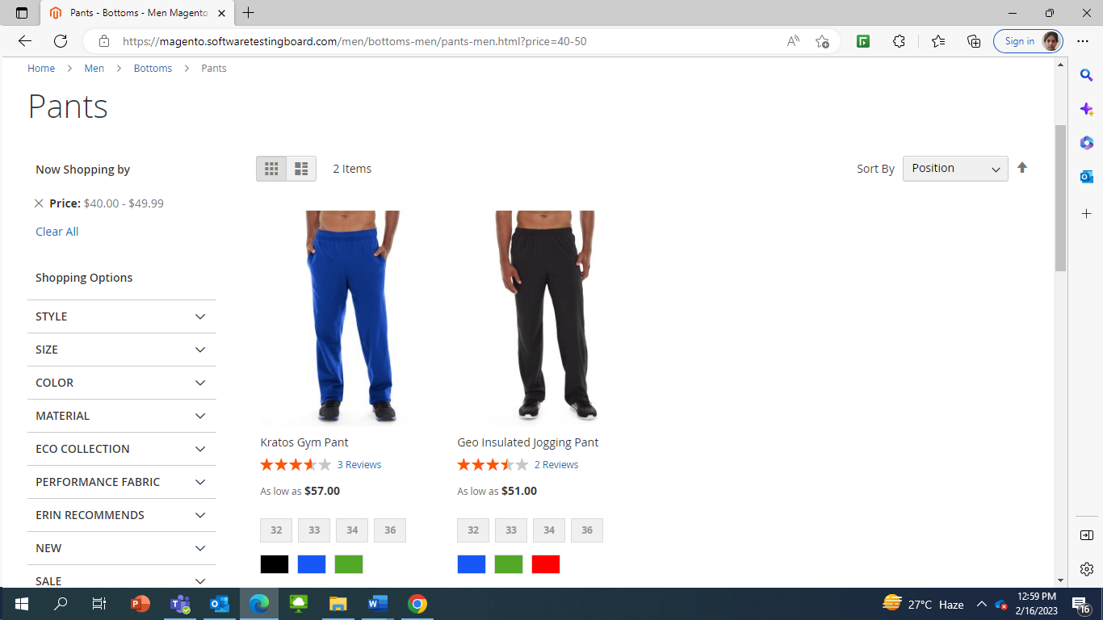

Defect: Text on the button from Add to Cart to Added is not every time visible once items are added to cart

Summary: When user provided the mandatory information for the product after clicking Add to Cart Button, then text changes to Adding… and then again back to Add to Cart which is misleading information. It should be changed to Added for all the products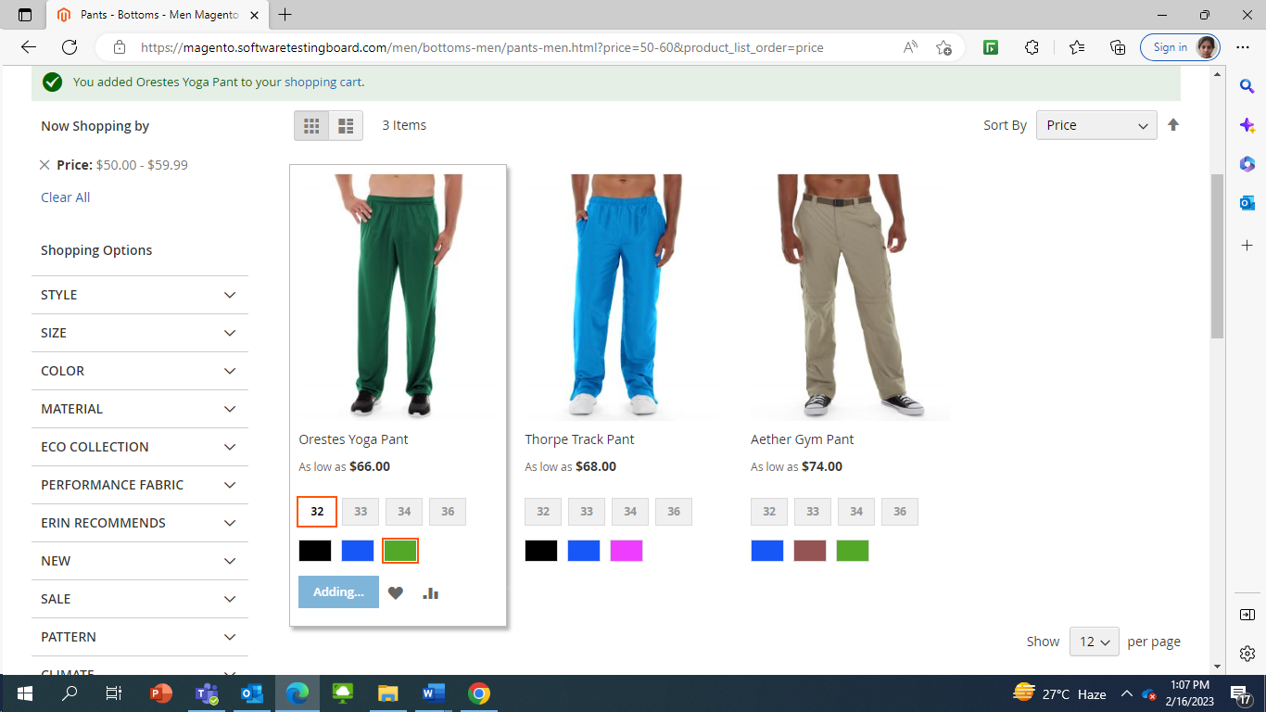

Defect: Delay in updating Fixed Rate and Tax section gets hidden in Total Amount when item is moved to Wish list from shopping Cart

Description: Total Amount should be updated as soon as the item is moved from shopping cart to wish list. It shows Tax as 0.00 and Fixed rate is not available when it is loading, and Tax section gets hidden once UI is completed loaded.

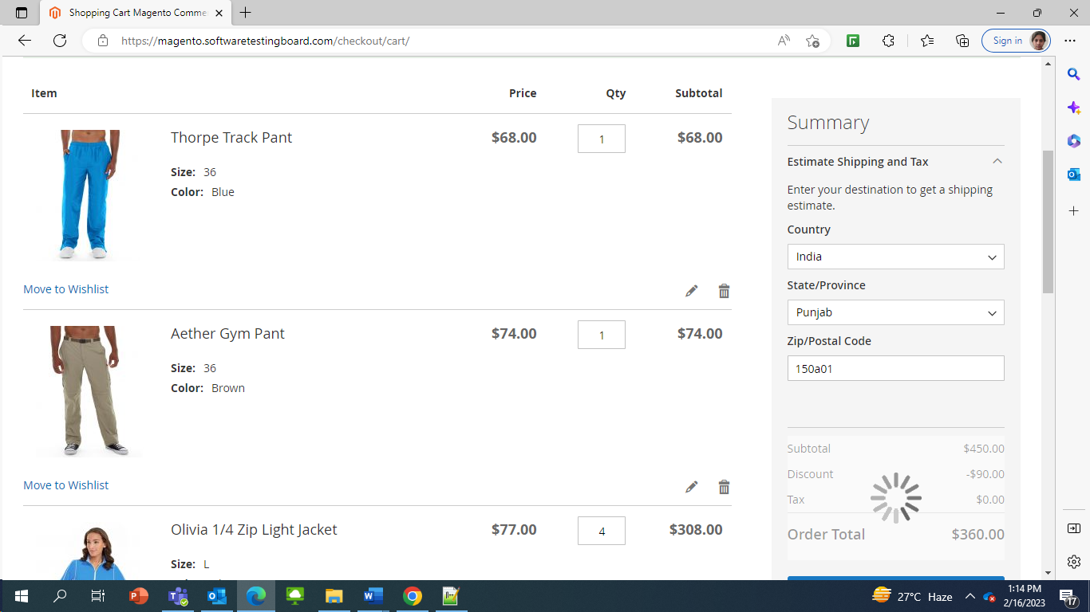

Defect: Discount is provided in Total Amount Section even if it is not available

Description: When user add items to the cart, discount is provided in the Total Amount Section even when there is no Discount Code applied and there is no off provided on individual items then also some Discount is provided. It is not clear from where discount is coming. Proper information should be provided if it’s a valid discount.

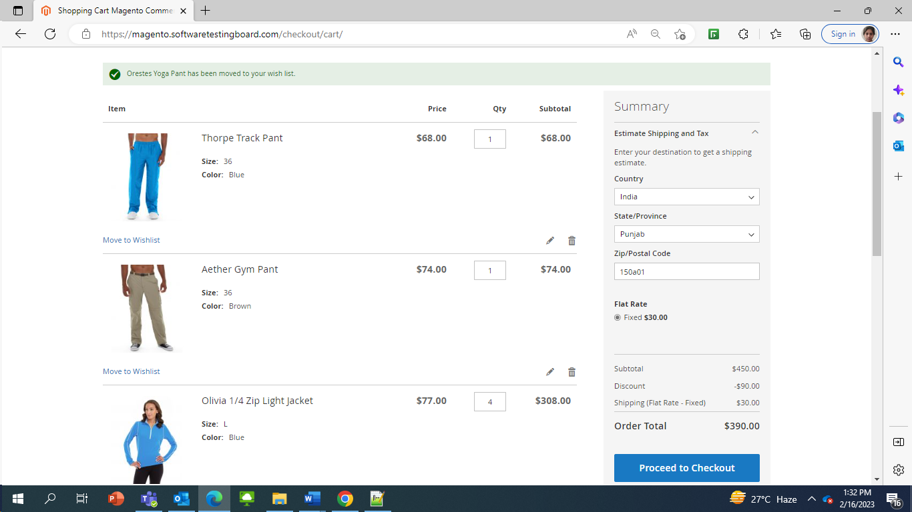

Defect: Shipping Rate is not added to Total Amount Section

Description: When some items are added to the cart, Shipping rate is added as $0 even though it has Fixed value of $70.

Defect: Move to wishlist and Edit is not present for all products on Shopping cart

Description: When Set of Sprite Yoga Straps product is added to the shopping cart, Move to wishlist and edit button is not present on Shopping cart Page but for other items, links are present.

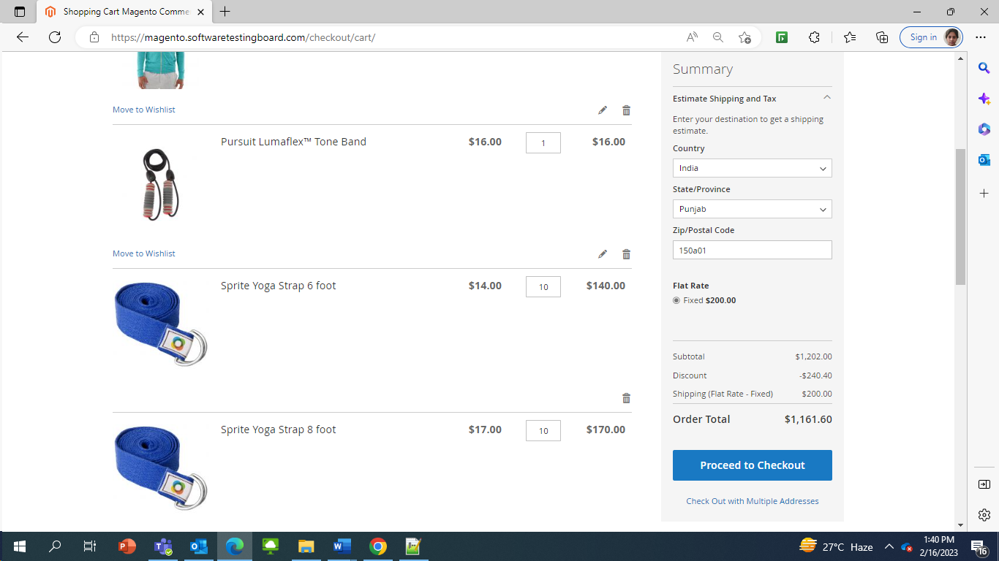

Defect: No other field is editable other than Quantity from Shopping Cart even after clicking on Update Shopping Cart

Description: User should be able to update multiple fields from Shopping cart Website other than quantity. Dropdown should be provided if size or color need to modify on shopping cart if last minute update had to be done.

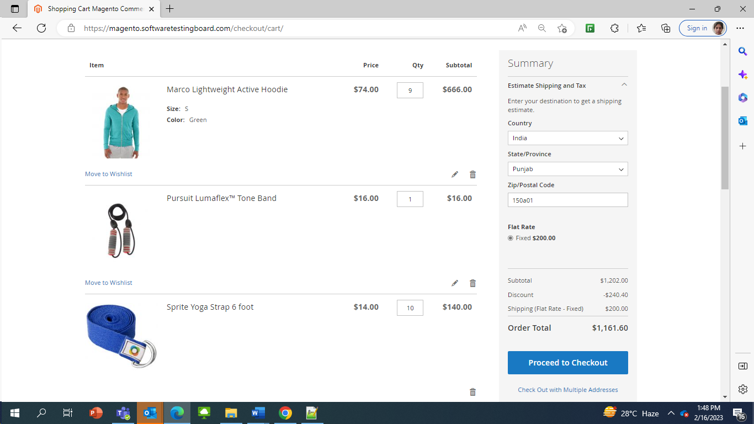

Defect: Order Total is $0 when items are available in cart

Description: User clicked on Check out Multiple Address after adding some items on shopping Cart but when I clicked Back Button, the value of Order total was coming as $0.00

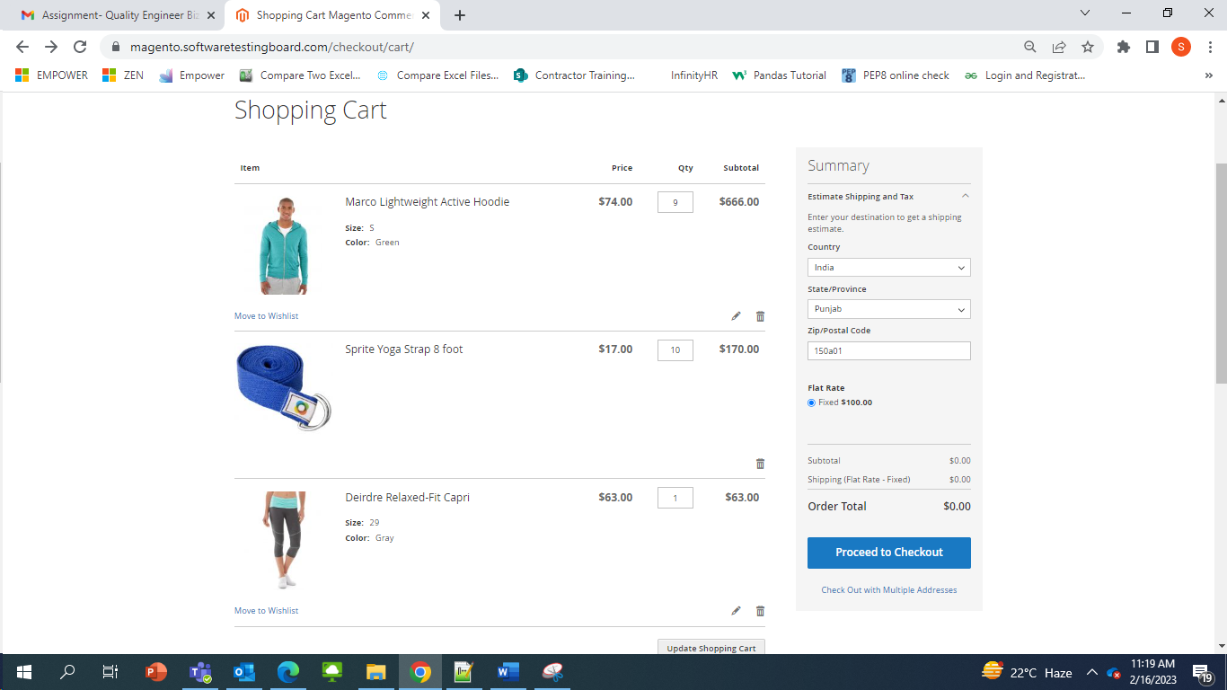

Defect: Address field validation

Description: User should not be able to add more than 255 characters in text field for Street Address. Pincode should not accept more than 6 characters and string values. Phone number should not accept String values.

Defect: More than 1 address should not be added for 1 user or some distinct value should be there

Description: User should not be able to add more than 1 address for same person having same name or some field should be asked such as Home/Office/Other Address to avoid confusion.

Defect: No email confirmation is provided on Registered email address after successfully placing the order

Description: Once user successfully places the order, information is provided on the UI as:

Your order number is: 000018647.

We'll email you an order confirmation with details and tracking info.

But no email is received on the registered email address for the order placed.

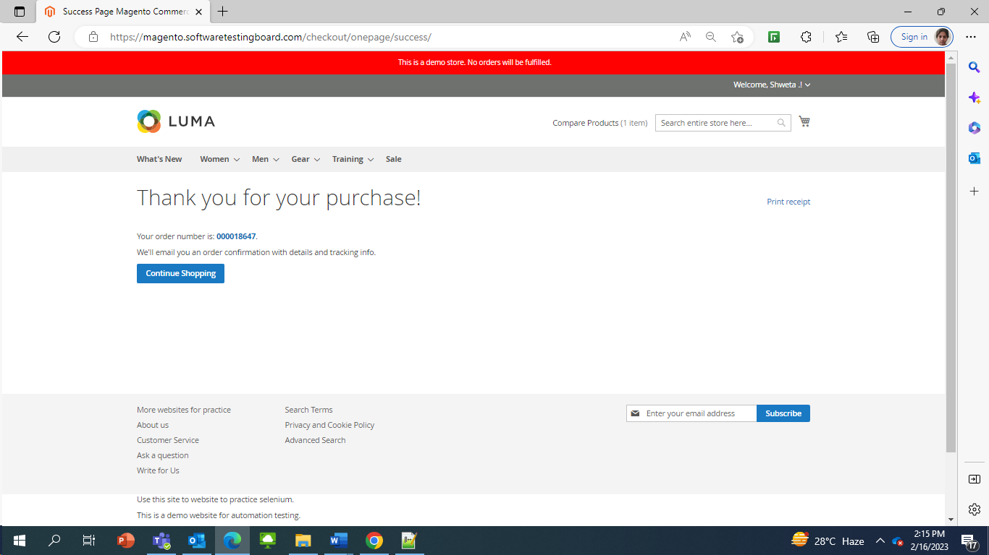

Defect: Color is not getting updated on UI

Description: User is not able to modify the color to Purple on UI for different tops if it is available.

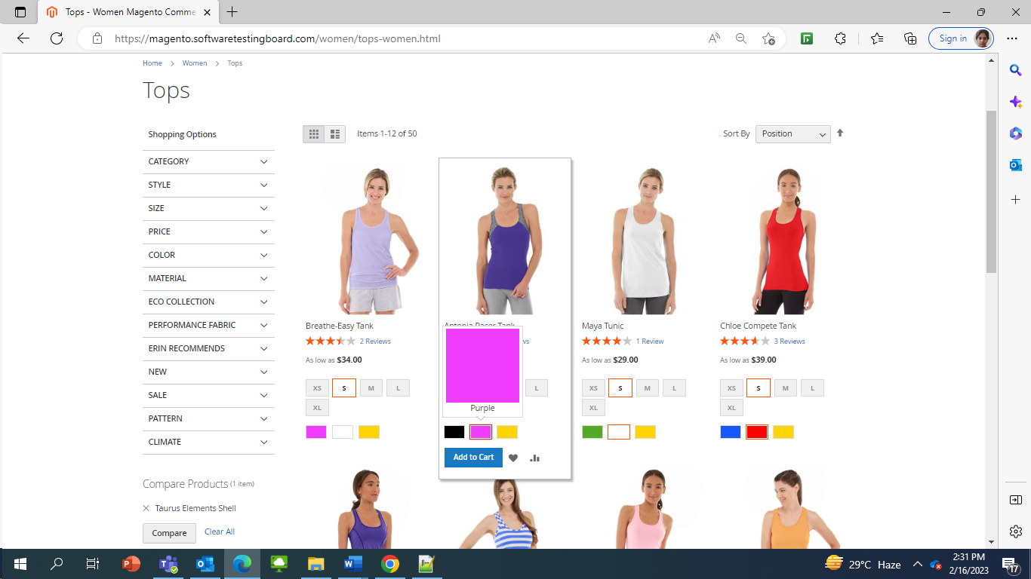

Defect: Print Receipt is not displayed when order is placed using Multiple Address

Description: When user places the order by selecting multiple address for different products, then after successfully placing the order, print receipt link is not visible on UI.

d. A list of further testing areas that you would want completed before you would be

comfortable shipping this feature to users. Consider the risks of the feature as you

understand it.

Registration and login functionality

Filter functionality

Sort By (Ascending and Descending order) for different sections

Address validations

Automatic Email Address validations

Payment validations

Additional information should be provided for Estimate Delivery Date before/after placing order, size chart should be made available on UI to enable user to select the correct size and information if item is returnable or not and if returnable, in how many days it should be returned.

3. Pick a bug from Task No. 2 that you think is most critical and write down how you would log it

in JIRA provided the following JIRA fields,

a. Summary

b. Description

c. Attachment

Summary: Discount is provided in Total Amount Section even if it is not available/applicable

Description: When user add items to the cart, discount is provided in the Total Amount Section even when there is no Discount Code applied and there is no discount/off provided on individual items added in the cart then also some Discount is provided in total order section. It is not clear from where discount is coming. Proper information should be provided if it’s a valid discount. Else it is a huge business loss.

Steps to Reproduce:

1. Login to website as new or registered user
2. Add products to shopping cart by providing mandatory fields
3. Go to Cart page to validate the total amount(Error)

