**ESE-3025**

**Homework 4**

**Submitted By:**

**Shweta(747925)**

The following commands are run in terminal after downloading mcuXpresso IDE from NXP.Its mode is changed and after that it is installed.

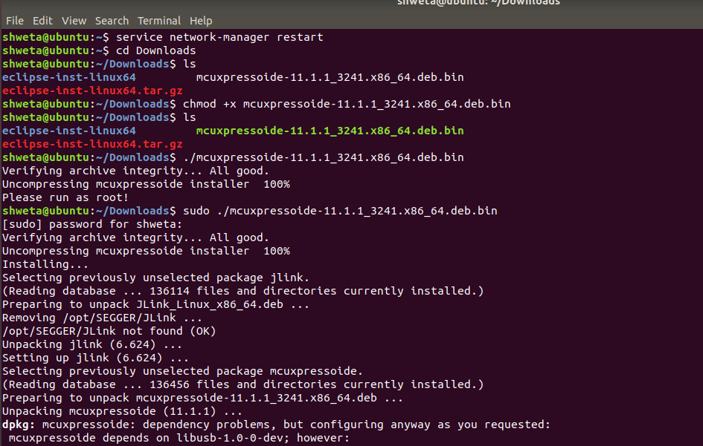

After that mcuXpresso IDE is launched.The screenshot is taken.

