ESE -3014

Lab 4

PCM

Submitted By:

Shweta (747925)

Amandeep(748434)

Sampling , Quantization and Encoding a signal. Script is written in Editor and after its execution in command window, screenshots of result are shown.

**Editor Window**

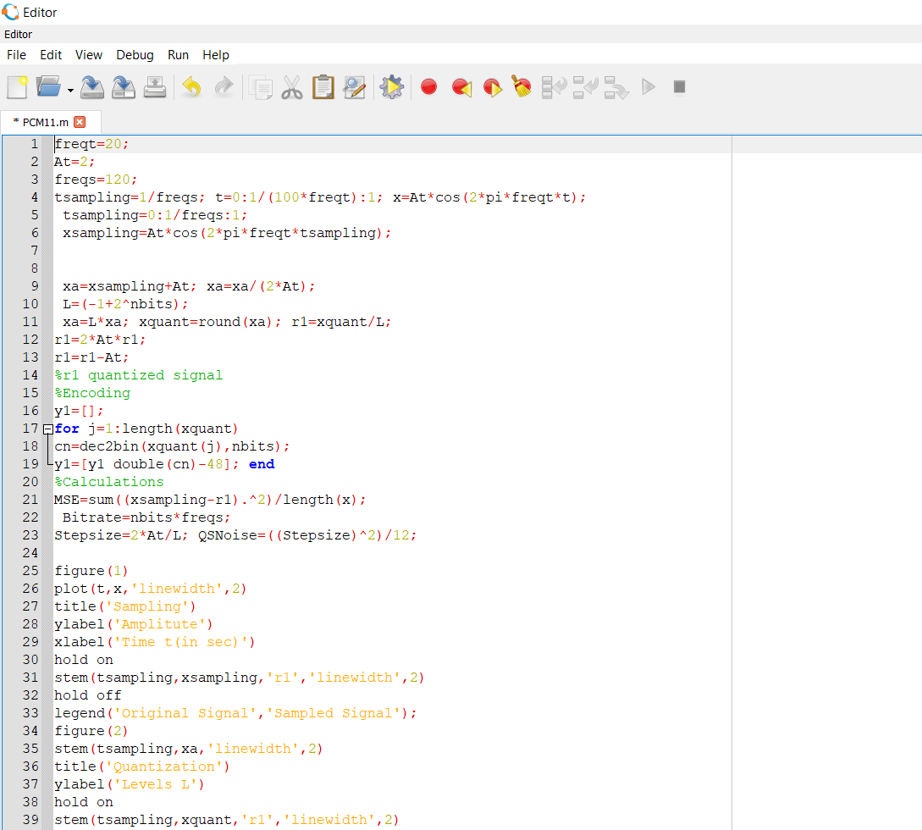

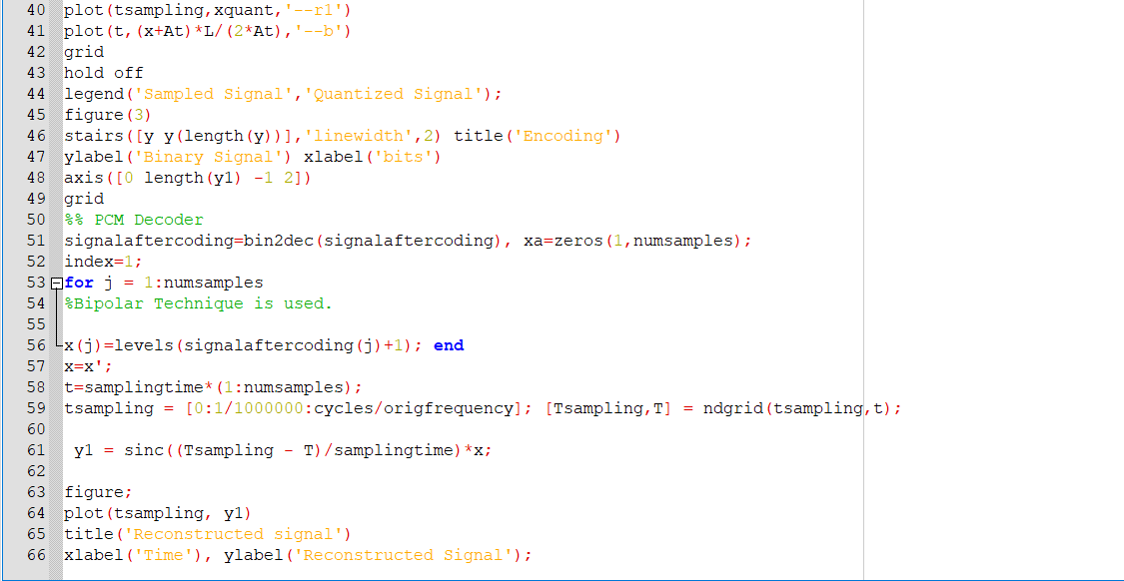

**Output**

