1. What is Emmet?

Emmet is a built-in feature of VS Code, so it doesn’t require any additional installation. By using shorthand and abbreviations, Emmet greatly improves and speeds up your HTML and CSS workflow, saving the stress of having to manually type out the code in full.

Emmet uses different abbreviations and short expressions depending on what’s passed, and then dynamically converts the abbreviations into the full code. Emmet is mostly used for HTML, XML, and CSS, but it can also be used with programming languages

1. Difference between a Library and Framework?

|  |  |  |
| --- | --- | --- |
| **Parameters** | **Library** | **Framework** |
| Definition | Libraries provide developers with predefined functions and classes to make their work easier and boost the development process. | Framework, on the other hand, is like the foundation upon which developers build applications for specific platforms. |
| Inversion of Control | By using a library, you can control the flow of the application and call the library. | In contrast, when you use a framework, the control is inverted, i.e., the framework controls the flow and calls your code. |
| Collection | Generally, libraries are a collection of helper modules, objects, classes, functions, message templates, pre-written code, etc. | Frameworks consist of a lot of APIs, compilers, toolsets, support programs, libraries, etc. |
| Code Modification | Codes in libraries are geared toward a particular program or to solve a specific development problem. Therefore, developers must modify library code to meet their needs. | Despite the fact that frameworks generate new codes for developers. These codes cannot be altered or modified later. Unlike libraries, frameworks do not allow users to modify their pre-written codes, so you don’t have to worry about deleting or changing them. |
| Scope | It is possible to call a library out of context. You may use the library wherever you see fit in your code. | On the other hand, you can only call and use what belongs to a Framework within the same Framework. |
| Function | In the program linking and binding process, they play an important role. | Using them, you can build and deploy applications in a standard way as the framework already provides code to perform common tasks and uses code provided by a developer for custom functionality. |
| Complexity | Having a library means understanding the functionality of each method, and it isn’t easy to create complex interactions since you need to call many methods to get the desired results. | Frameworks, on the other hand, embody the basic flow, and since plugins need to be added to code, it is easier to do the right modification. |
| Extensibility | Generally, libraries aren’t designed for extensibility; they are designed to accomplish a specific purpose. | Frameworks provide general functionality. Because of this, they are built to be extensible, which allows developers to incorporate app-specific features without modifying the framework’s source code. |
| Replaceable | It is easy to replace a library with another library. For instance, if you do not like the jQuery date picker library, you can use another date picker like a bootstrap date picker or pick date. | Frameworks are difficult to replace. If, for instance, you were using AngularJS to build your product, you cannot simply swap it out for another framework. It requires rewriting the entire codebase. |
| Performance | Less code is required to build libraries, which leads to faster loading times and better performance. | Developing a framework requires a lot of coding, which increases loading times and decreases performance. |
| Usage | The purpose of libraries is to perform a defined and specific task. Eg: Image manipulation, network protocols, math operations, etc. | Frameworks can be used for performing a wide range of tasks. Among these are Web application systems, plug-in managers, GUI systems, and so on. |
| Existing Projects | You can integrate libraries seamlessly into existing projects to add functionality. | Incorporating frameworks seamlessly into an existing project is impossible. Instead, frameworks should be used when starting a new project. |
| Benefits | Good code quality, reusability, and control, enhanced speed and performance of the program, etc. | Faster programming, support from the community, great support for MVC (Model View Controller) pattern, etc. |
| Examples | JQuery, React JS, etc. | Spring, NodeJS, AngularJS, Vue JS, etc. |

1. What is CDN? Why do we use it?

A CDN (content delivery network), also called a content distribution network, is a group of geographically distributed and interconnected servers. They provide [cached](https://www.techtarget.com/searchstorage/definition/cache) internet content from a network location closest to a user to speed up its delivery.

The primary goal of a CDN is to improve web performance by reducing the time needed to send content and rich media to users

4) Why is React known as React?

React is named React because of its ability to react to changes in data. When the data in a React component changes, React will automatically re-render the component so that it reflects the new data. This makes it easy to create performant user interfaces that always look up-to-date.

1. What is crossorigin in script tag?

* The crossorigin attribute sets the mode of the request to an HTTP CORS Request.
* Web pages often make requests to load resources on other servers. Here is where CORS comes in.
* A cross-origin request is a request for a resource (e.g. style sheets, iframes, images, fonts, or scripts) from another domain.
* CORS is used to manage cross-origin requests.
* CORS stands for Cross-Origin Resource Sharing, and is a mechanism that allows resources on a web page to be requested from another domain outside their own domain. It defines a way of how a browser and server can interact to determine whether it is safe to allow the cross-origin request. CORS allows servers to specify who can access the assets on the server, among many other things.

1. What is diference between React and ReactDOM

react package is required to create and use components and hooks, react-dom contains react-dom/client and  *react-Dom/server* to render you app in the browser's DOM or inside a string (or a stream) on the server.

1. What is difference between react.development.js and react.production.js files via CDN?

react.development.js provides us extra features like debugging, hmr(Hot module reloading) and lots of other stuffs that you might use while developing app with the help of bundlers like webpack, parcel, vite. This bundler bundles and minifies our code to be deployed on production

These minified files will be deployed on production which removes lots of unnecessary files which will not be used by our app for this we have react.production.js to make our much faster(as bundlers and lots of other files have done there work and are not required now).

7) What is async and defer? -

**defer attribute:** First it will download the script file and then wait of html parsing. After the end of html parsing, script will execute. In other words, It will guarantee all the scripts will execute after the html parsing.

Defer attribute is useful when script is using for DOM manipulations. Means script will apply on document html.

**async attribute:** It will download the script file and execute without wait the end of html parsing. In other words, It will not guarantee all the scripts will execute after the html parsing.

Async attribute is useful when script is not using for DOM manipulation. Some time you need script only for server side operations or for handling cache or cookie but not for DOM manipulations. Means script is not related to the used html.

[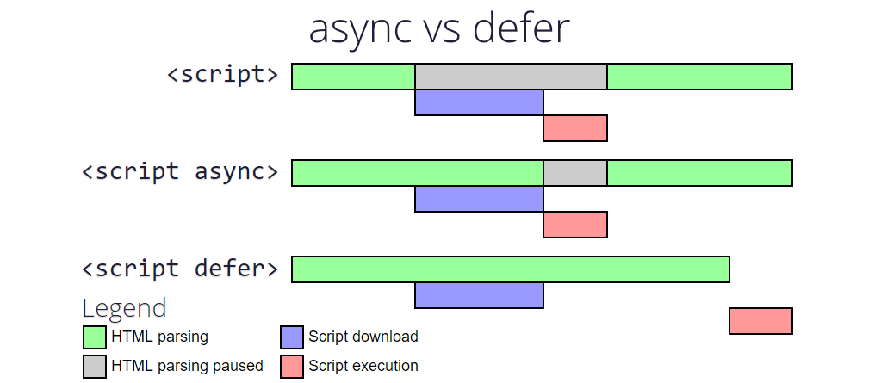](https://i.stack.imgur.com/pI1Wn.png)