Requirements Document
Quote App

Version | Description of Change | Author | Date
0.1 | First Draft | Shweta Herlekar | 5th June , 2018

CONTENTS
1 INTRODUCTION 4
1.1 Purpose 4
1.2 Scope 4
1.3 Background 4
1.4 References 4
1.5 Assumptions and Constraints 4
1.6 Document Overview 5
2 METHODOLOGY 5
3 FUNCTIONAL REQUIREMENTS 5
4.1 Context 5
4.2 User Requirements 5
4.3 Data Flow Diagrams 6
4.4 Logical Data Model/Data Dictionary 6
4.5 Functional Requirements 6
5 OTHER REQUIREMENTS 6
5.1 Interface Requirements 6
5.2 Data Conversion Requirements 7
5.3 Hardware/Software Requirements 7
5.4 Operational Requirements 7
APPENDIX A - GLOSSARY 11

INTRODUCTION
This quote app will provide you the daily dose of financial knowledge through pictorial quote.

Purpose
This document will provide the overall description of the requirements of this quote app The requirements of backend system that will process and push the quote to user device as well as the user interface requirements which actually provide the visual interface to this app with which user will interact.

Scope
The scope of this app will be defined by implementation of following objectives:
1.2.1 User authentication
1.2.2 Daily Notification of the quote
1.2.3 Visual interface to view the quotes
1.2.4 Visual interface to change the settings of app for example, date range, time etc.

Background
This app is created to provide user with financial awareness on daily basis by providing the quotes of some famous financial advisors. This document created to define the current scope, requirements of the system and the objectives to meet.

References
This documents refers to the document “QuoteOfTheDay.pdf” which will provide basic requirements for this app.

Assumptions and Constraints
[Provide a list of contractual or task level assumptions and/or constraints that are preconditions to preparation of the FRD. Assumptions are future situations beyond the control of the project, whose outcomes influence the success of a project.]
Following are the assumptions and constraints for this app:

Assumptions
- Availability of internet that will allow the app to connect with server to fetch the data.
- Availability of server to connect with.
- Availability of device that will support the software and hardware requirements of this app.

Constraints

- The delivery date of the first and basic version of this app would be 27th June, 2018.
- The intended users for this app will not be able to see the quotes in future
- Users will not be able to export any kind of data from this app.

METHODOLOGY
This app will basically show the quotes that are pushed from server on daily basis. Providing the user with availability of all the quotes pushed on his/her device with filtering option. The backed server will read and push the quote/s to the app. App not only provides the ability to view this quote but also the availability to download this quote. This app will enable the user to share this app with friends and family.

FUNCTIONAL REQUIREMENTS

Context
[Provide a context diagram of the system, with explanations as applicable. The context of a system refers to the connections and relationships between the system and its environment.]
Exhibit 2 - Generic Context Diagram
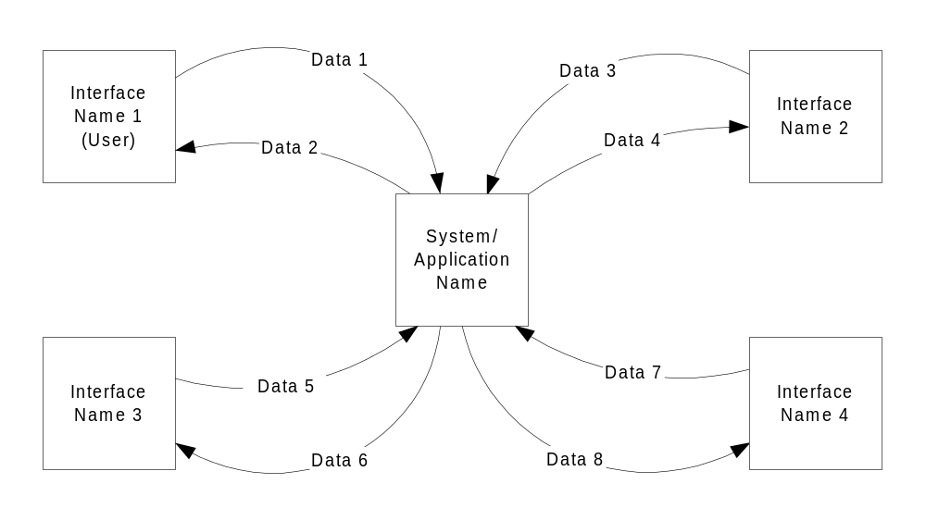

User Requirements

User must be able to authenticate himself with the Google login.
User must be able to view daily notification of the quote on the given time if any provided.
User must be able to view the older quote based on the date filtration.
User must be able to save the quote on his device.
User must be able to share this app with friends

Data Flow Diagrams
[Decompose the context level diagrams to determine the functional requirements. Data flow diagrams should be decomposed down to the functional primitive level. These diagrams are further decomposed during design.]

Logical Data Model/Data Dictionary
[Create the initial Logical Data Model. Describe data requirements by providing data entities, decomposition, and definitions in a data dictionary. The data requirements describe the business data needed by the application system. Data requirements do not describe the physical database and are not at the level of identifying field names.]

Functional Requirements

Section/ Requirement ID | Requirement Definition
 | App should allow user to login with Google credentials
FR1.0. | The system should push the quote to the app
FR2.0 | App should show the notification for the quote
 | App should provide the setting to change the time notification.
FR1.1.1 | App should provide user interface for this quote
FR1.1.2 | App should provide date range settings to filter the older quotes
 | App should provide user interface to show the older quotes based on the date filtration.
 | App should provide option to share the link of this app with friends on whatsapp.

OTHER REQUIREMENTS
Following are the non-behavioral requirements for this product:

Interface Requirements
Interface of this app should provide the quotes with the changing backgrounds.

Hardware Interfaces
This app can only be installed on the mobile device with android operating system

Software Interfaces
This app will support the android devices with API level 23(marshmallow) and higher.

Communications Interfaces
This app needs to have the connectivity with the server over the Internet to get the notifications and any other operations.

Data Conversion Requirements
Date exchanged between this app and server will not cover any data conversion requirements considering the sensitivity of this data.

Hardware/Software Requirements
Mobile device with android operating system with API level 23 or higher

Operational Requirements
Following are some of the operational requirements for this app:

Security and Privacy
A. App should not disclore user’s private data associated with user authentication with Google login.
B. Only the database administrator can alter the data associated with this app

Audit Trail
The number of quotes delivered on the user device within number of days.

System Availability
The app should be available all the time except the maintenance of the server.

General Performance
A. Response time for quotes should be few seconds
B. Expected rate of user activity will be minimum one.

Capacity
App should be able to support 100 user at a time with volume of 10 GB data in the database.

APPENDIX A - GLOSSARY
[Define terms, acronyms, and abbreviations used in the FRD.]

