PIZZA SALES SQL QUERIES

1. **KPI’s**
2. **Total Revenue** :

SELECT SUM(total_price) AS "Total Revenue" FROM pizza_sales;

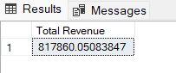

1. **Average Order Value :**

SELECT SUM(total_price) / COUNT(DISTINCT(order_id))AS "Average Value" FROM pizza_sales;

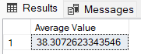

1. **Total Quantity :**

SELECT SUM(quantity) AS "Total Quantity" FROM pizza_sales;

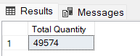

1. **Total Orders Placed:**

SELECT COUNT(DISTINCT(order_id)) AS "Total Orders Placed" FROM pizza_sales;

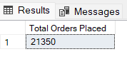

1. **Average Pizzas Per Order:**

SELECT SUM(quantity) / COUNT(DISTINCT(order_id)) AS "Average Pizzas Per Order" FROM pizza_sales;

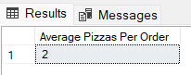

1. **Charts :**
2. **Daily trends for total orders :**

SELECT DATENAME(DW, order_date) AS "Order Day", SUM(DISTINCT(order_id)) AS "Total Orders"

FROM pizza_sales

GROUP BY DATENAME(DW, order_date);

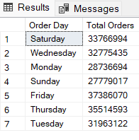

1. **Monthly trend for total orders :**

SELECT DATENAME(MONTH, order_date) AS "Month Name", SUM(DISTINCT(order_id)) AS "Total Orders"

FROM pizza_sales

GROUP BY DATENAME(MONTH, order_date);

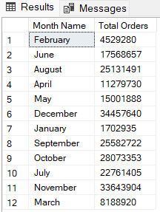

1. **Percentage of sales by pizza category :**

SELECT pizza_category, ROUND (SUM(total_price),2) AS “Total sales ”, ROUND(SUM(total_price)* 100 / (SELECT SUM(total_price) FROM pizza_sales), 2) AS "Sales Percentage"

FROM pizza_sales

GROUP BY pizza_category

ORDER BY pizza_category ;

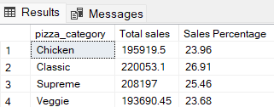

1. **Percentage of Sales by Pizza Size:**

SELECT pizza_size, ROUND(SUM(total_price),2) AS “Total Sales”,ROUND(SUM(total_price)* 100 / (SELECT SUM(total_price) FROM pizza_sales), 2) AS "Sales Percentage"

FROM pizza_sales

GROUP BY pizza_size

ORDER BY pizza_size;

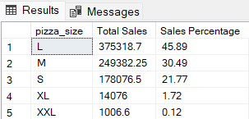

1. **Total Pizzas Sold by Pizza Category:**

SELECT pizza_category, SUM(quantity) AS "Total Pizza Sold"

FROM pizza_sales

GROUP BY pizza_category;

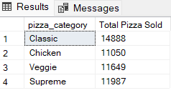

1. **Top 5 Best Sellers by Revenue, Total Quantity and Total Orders :**

**BY TOTAL QUANTITY:**

SELECT TOP 5 pizza_name, ROUND (SUM(total_price),2) AS "Total Revenue" FROM pizza_sales

GROUP BY pizza_name

ORDER BY "Total Revenue" DESC ;

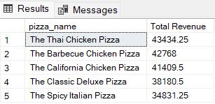

**BY TOTAL ORDERS :**

SELECT TOP 5 pizza_name, COUNT(DISTINCT order_id) AS "Total Orders" FROM pizza_sales

GROUP BY pizza_name

ORDER BY "Total Orders" DESC;

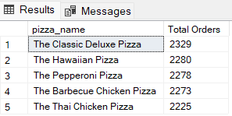

1. **Bottom 5 Best Sellers by Revenue, Total Quantity and Total Orders :**

**BY TOTAL QUANTITY:**

SELECT TOP 5 pizza_name, ROUND (SUM(quantity),2) AS "Total Quantity" FROM pizza_sales

GROUP BY pizza_name

ORDER BY "Total Quantity " ASC;

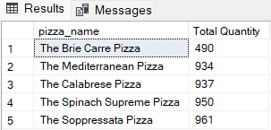

**BY TOTAL ORDERS :**

SELECT TOP 5 pizza_name, COUNT(DISTINCT order_id) AS "Total Orders" FROM pizza_sales

GROUP BY pizza_name

ORDER BY "Total Orders" ASC;

