ANDROID APPLICATION DEVELOPMENT LAB

MCA II A
Shweta Negi 25/SCA/MCAN/032
Submitted to: Urvashi Sangwan Ma’am
S.No. | Name of the Programs(Intermediate level) | Date
1 | Develop an application that shows names as a list and on selecting a name, it should show the details of the candidate on the next screen with a back button. If the screen is rotated to landscape mode width greater than height, then the screen should show list on left fragment and details on right fragment instead of second screen with back button, use fragment transactions and  rotation event listener.
2 | - Create a user registration application that stores the user details in a database table  - Create a database and a user table where the details of login names and password are stored. Insert some names and password. Initially now the login details entered by the user should be verified with the database and an appropriate dialogue should be shown to the user.
3 | Create an admin application for the user table, which shows all records as a list and the administration. Select any record for edit or modify. The result should be reflected in the table.
4 | Create an alarm that rings every Sunday at 8 AM, modify it to use a time, picker to set alarm time.
5 | Create an activity that uses a menu with three options for dialogue, a number, opening a website and to send an SMS.
6 | Basic music player app.

Program-2
- Create a user registration application that stores the user details in a database table
- Create a database and a user table where the details of login names and password are stored. Insert some names and password. Initially now the login details entered by the user should be verified with the database and an appropriate dialogue should be shown to the user.

activity_main.xml:
<?xml version="1.0" encoding="utf-8"?>
<manifest xmlns:android="http://schemas.android.com/apk/res/android" xmlns:tools="http://schemas.android.com/tools">
<application android:allowBackup="true"
android:dataExtractionRules="@xml/data_extraction_rules" android:fullBackupContent="@xml/backup_rules" android:icon="@mipmap/ic_launcher" android:label="@string/app_name" android:roundIcon="@mipmap/ic_launcher_round" android:supportsRtl="true"
android:theme="@style/Theme._2UserRegistrationAPPLICATIONSTOREUSERDETAILS INDATABASE">
<activity android:name=".MainActivity" android:exported="true">
<intent-filter>
<action android:name="android.intent.action.MAIN" />
<category android:name="android.intent.category.LAUNCHER" />
</intent-filter>
</activity>
</application>
</manifest>

MainActivity.java:
package com.example.a2userregistrationapplicationstoreuserdetailsindatabase;
import android.os.Bundle; import android.view.View; import android.widget.Button; import android.widget.EditText; import android.widget.Toast;

import androidx.appcompat.app.AlertDialog;
import androidx.appcompat.app.AppCompatActivity;

public class MainActivity extends AppCompatActivity {
EditText etUsername, etPassword; Button btnRegister, btnLogin; DatabaseHelper db;

@Override
protected void onCreate(Bundle savedInstanceState) { super.onCreate(savedInstanceState); setContentView(R.layout.activity_main);

db = new DatabaseHelper(this);
etUsername = findViewById(R.id.etUsername); etPassword = findViewById(R.id.etPassword); btnRegister = findViewById(R.id.btnRegister); btnLogin = findViewById(R.id.btnLogin);

btnRegister.setOnClickListener(new View.OnClickListener() { @Override
public void onClick(View v) {
String username = etUsername.getText().toString(); String password = etPassword.getText().toString();
if (username.isEmpty() || password.isEmpty()) { Toast.makeText(MainActivity.this, "Please fill all fields",
Toast.LENGTH_SHORT).show();
} else {
boolean success = db.insertUser(username, password); if (success) {
Toast.makeText(MainActivity.this, "Registration successful", Toast.LENGTH_SHORT).show();
} else {
Toast.makeText(MainActivity.this, "Registration failed", Toast.LENGTH_SHORT).show();
}
}
}
});
btnLogin.setOnClickListener(new View.OnClickListener() { @Override
public void onClick(View v) {
String username = etUsername.getText().toString(); String password = etPassword.getText().toString();

if (db.checkUser(username, password)) {
showDialog("Login Successful", "Welcome, " + username + "!");
} else {
showDialog("Login Failed", "Invalid username or password.");
}
}
});
}
private void showDialog(String title, String message) { AlertDialog.Builder builder = new AlertDialog.Builder(this); builder.setTitle(title)
.setMessage(message)
.setPositiveButton("OK", null)
.show();
}
}
Output-
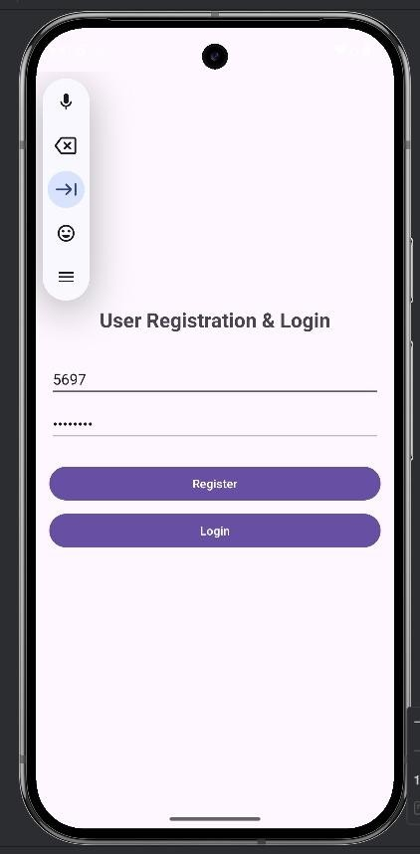

Program-3
Create an admin application for the user table, which shows all records as a list and the administration. Select any record for edit or modify. The result should be reflected in the table.

activity_main.xml:
<?xml version="1.0" encoding="utf-8"?>
<manifest xmlns:android="http://schemas.android.com/apk/res/android" xmlns:tools="http://schemas.android.com/tools">
<application android:allowBackup="true"
android:dataExtractionRules="@xml/data_extraction_rules" android:fullBackupContent="@xml/backup_rules" android:icon="@mipmap/ic_launcher" android:label="@string/app_name" android:roundIcon="@mipmap/ic_launcher_round" android:supportsRtl="true" android:theme="@style/Theme._3UserAdminManager">
<activity android:name=".MainActivity" android:exported="true">
<intent-filter>
<action android:name="android.intent.action.MAIN" />
<category android:name="android.intent.category.LAUNCHER" />
</intent-filter>
</activity>
<activity android:name=".EditUserActivity" />
</application>
</manifest>

MainActivity.java:
package com.example.a3useradminmanager;
import android.content.Intent; import android.os.Bundle; import android.view.View;
import android.widget.AdapterView; import android.widget.ListView;

import androidx.appcompat.app.AppCompatActivity; import java.util.List;

public class MainActivity extends AppCompatActivity { private ListView listViewUsers;
private DatabaseHelper databaseHelper; private UserAdapter userAdapter; private List<User> userList;

@Override
protected void onCreate(Bundle savedInstanceState) { super.onCreate(savedInstanceState); setContentView(R.layout.activity_main);

listViewUsers = findViewById(R.id.listViewUsers); databaseHelper = new DatabaseHelper(this);
refreshUserList();

listViewUsers.setOnItemClickListener(new AdapterView.OnItemClickListener() { @Override
public void onItemClick(AdapterView<?> parent, View view, int position, long id) { User selectedUser = userList.get(position);
Intent intent = new Intent(MainActivity.this, EditUserActivity.class); intent.putExtra("user", selectedUser);
startActivity(intent);
}
});
}
@Override
protected void onResume() { super.onResume(); refreshUserList();
}
private void refreshUserList() {
userList = databaseHelper.getAllUsers(); userAdapter = new UserAdapter(this, userList); listViewUsers.setAdapter(userAdapter);
}
}

Output-
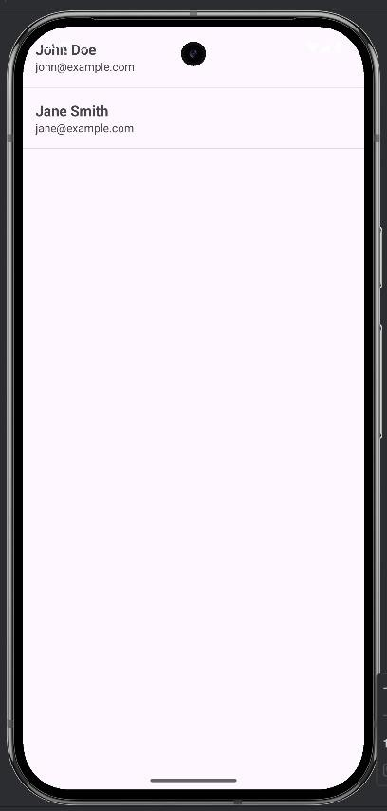

Program-4
Create an alarm that rings every Sunday at 8 AM, modify it to use a time, picker to set alarm time.

activity_main.xml:
<?xml version="1.0" encoding="utf-8"?>
<manifest xmlns:android="http://schemas.android.com/apk/res/android" xmlns:tools="http://schemas.android.com/tools">

<uses-permission android:name="android.permission.SCHEDULE_EXACT_ALARM" />
<uses-permission android:name="android.permission.POST_NOTIFICATIONS" />
<application android:allowBackup="true"
android:dataExtractionRules="@xml/data_extraction_rules" android:fullBackupContent="@xml/backup_rules" android:icon="@mipmap/ic_launcher" android:label="@string/app_name" android:roundIcon="@mipmap/ic_launcher_round" android:supportsRtl="true" android:theme="@style/Theme._4SundayAlarmApp">
<activity android:name=".MainActivity" android:exported="true">
<intent-filter>
<action android:name="android.intent.action.MAIN" />
<category android:name="android.intent.category.LAUNCHER" />
</intent-filter>
</activity>

<receiver android:name=".AlarmReceiver" android:exported="false" />
</application>

</manifest>

MainActivity.java:
package com.example.a4sundayalarmapp;
import android.Manifest;
import android.app.AlarmManager; import android.app.PendingIntent; import android.app.TimePickerDialog; import android.content.Context;

import android.content.Intent;
import android.content.pm.PackageManager; import android.os.Build;
import android.os.Bundle; import android.provider.Settings; import android.widget.Button;
import android.widget.TextView; import android.widget.Toast;
import androidx.activity.EdgeToEdge;
import androidx.activity.result.ActivityResultLauncher;
import androidx.activity.result.contract.ActivityResultContracts; import androidx.appcompat.app.AppCompatActivity;
import androidx.core.content.ContextCompat; import androidx.core.graphics.Insets;
import androidx.core.view.ViewCompat;
import androidx.core.view.WindowInsetsCompat;
import java.util.Calendar; import java.util.Locale;
public class MainActivity extends AppCompatActivity { private TextView tvAlarmTime;
private final ActivityResultLauncher<String> requestPermissionLauncher = registerForActivityResult(new ActivityResultContracts.RequestPermission(),
isGranted -> {
if (isGranted) { showTimePicker();
} else {
Toast.makeText(this, "Notification permission denied. You won't see the alarm notification.", Toast.LENGTH_LONG).show();
// Still show picker because the alarm itself doesn't require notification permission to be scheduled
showTimePicker();
}
});
@Override
protected void onCreate(Bundle savedInstanceState) { super.onCreate(savedInstanceState); EdgeToEdge.enable(this); setContentView(R.layout.activity_main);
ViewCompat.setOnApplyWindowInsetsListener(findViewById(R.id.main), (v, insets) -
> {
Insets systemBars = insets.getInsets(WindowInsetsCompat.Type.systemBars());

v.setPadding(systemBars.left, systemBars.top, systemBars.right, systemBars.bottom); return insets;
});

tvAlarmTime = findViewById(R.id.tvAlarmTime); Button btnSetAlarm = findViewById(R.id.btnSetAlarm);
btnSetAlarm.setOnClickListener(v -> checkPermissionsAndShowPicker());
}

private void checkPermissionsAndShowPicker() {
if (Build.VERSION.SDK_INT >= Build.VERSION_CODES.TIRAMISU) {
if (ContextCompat.checkSelfPermission(this, Manifest.permission.POST_NOTIFICATIONS) != PackageManager.PERMISSION_GRANTED) {

requestPermissionLauncher.launch(Manifest.permission.POST_NOTIFICATIONS);
} else {
showTimePicker();
}
} else {
showTimePicker();
}
}
private void showTimePicker() {
// Default to 8:00 AM as requested int hour = 8;
int minute = 0;
TimePickerDialog timePickerDialog = new TimePickerDialog(this, (view, hourOfDay, minute1) -> {
setSundayAlarm(hourOfDay, minute1); tvAlarmTime.setText(String.format(Locale.getDefault(), "Sunday Alarm set
for %02d:%02d", hourOfDay, minute1));
}, hour, minute, true);
timePickerDialog.show();
}
private void setSundayAlarm(int hour, int minute) { AlarmManager alarmManager = (AlarmManager)
getSystemService(Context.ALARM_SERVICE);

// For Android 12+, we need to check if we can schedule exact alarms if we were using setExact
// For setRepeating, it's generally inexact anyway, so this might not be strictly required

// unless we want it to be very precise. Let's keep the check for best practice. if (Build.VERSION.SDK_INT >= Build.VERSION_CODES.S) {
if (!alarmManager.canScheduleExactAlarms()) { Intent intent = new
Intent(Settings.ACTION_REQUEST_SCHEDULE_EXACT_ALARM); startActivity(intent);
// We'll proceed with scheduling, but it might be inexact until permission is granted.
}
}

Intent intent = new Intent(this, AlarmReceiver.class);
PendingIntent pendingIntent = PendingIntent.getBroadcast(this, 0, intent, PendingIntent.FLAG_UPDATE_CURRENT | PendingIntent.FLAG_IMMUTABLE);
Calendar calendar = Calendar.getInstance(); calendar.set(Calendar.DAY_OF_WEEK, Calendar.SUNDAY); calendar.set(Calendar.HOUR_OF_DAY, hour); calendar.set(Calendar.MINUTE, minute); calendar.set(Calendar.SECOND, 0);
calendar.set(Calendar.MILLISECOND, 0);
// If the calculated time is in the past, move it to next Sunday
if (calendar.getTimeInMillis() <= System.currentTimeMillis()) { calendar.add(Calendar.WEEK_OF_YEAR, 1);
}
// Schedule a repeating alarm every week (7 days) alarmManager.setRepeating(
AlarmManager.RTC_WAKEUP, calendar.getTimeInMillis(), AlarmManager.INTERVAL_DAY * 7, pendingIntent
);

Toast.makeText(this, "Alarm scheduled for every Sunday at " + String.format(Locale.getDefault(), "%02d:%02d", hour, minute), Toast.LENGTH_SHORT).show();
}
}

Output-
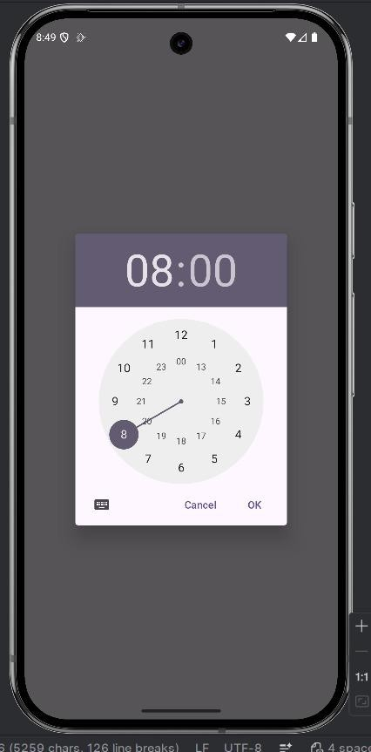

Program-5
Create an activity that uses a menu with three options for dialogue, a number, opening a website and to send an SMS.

activity_main.xml:
<?xml version="1.0" encoding="utf-8"?>
<manifest xmlns:android="http://schemas.android.com/apk/res/android" xmlns:tools="http://schemas.android.com/tools">
<!-- Permissions are not strictly required for ACTION_DIAL, ACTION_VIEW (browser), and ACTION_SENDTO (sms), as they delegate the action to system apps. -->
<application android:allowBackup="true"
android:dataExtractionRules="@xml/data_extraction_rules" android:fullBackupContent="@xml/backup_rules" android:icon="@mipmap/ic_launcher" android:label="@string/app_name" android:roundIcon="@mipmap/ic_launcher_round" android:supportsRtl="true" android:theme="@style/Theme._6ConnectHub">
<activity android:name=".MainActivity" android:exported="true">
<intent-filter>
<action android:name="android.intent.action.MAIN" />

<category android:name="android.intent.category.LAUNCHER" />
</intent-filter>
</activity>
</application>
</manifest>

MainActivity.java:
package com.example.a6connecthub;

import android.content.Intent; import android.net.Uri;
import android.os.Bundle; import android.view.Menu; import android.view.MenuItem; import android.widget.Toast;

import androidx.activity.EdgeToEdge; import androidx.annotation.NonNull;
import androidx.appcompat.app.AppCompatActivity; import androidx.appcompat.widget.Toolbar;
import androidx.core.graphics.Insets; import androidx.core.view.ViewCompat;
import androidx.core.view.WindowInsetsCompat; public class MainActivity extends AppCompatActivity {
@Override
protected void onCreate(Bundle savedInstanceState) { super.onCreate(savedInstanceState);
// Enable edge-to-edge display EdgeToEdge.enable(this); setContentView(R.layout.activity_main);
// Initialize Toolbar
Toolbar toolbar = findViewById(R.id.toolbar); setSupportActionBar(toolbar);

// Handle window insets for edge-to-edge ViewCompat.setOnApplyWindowInsetsListener(findViewById(R.id.main), (v, insets) -> {
Insets systemBars = insets.getInsets(WindowInsetsCompat.Type.systemBars()); v.setPadding(systemBars.left, systemBars.top, systemBars.right, systemBars.bottom); return insets;
});
}

// Inflate the menu resource (menu_main.xml) into the toolbar @Override
public boolean onCreateOptionsMenu(Menu menu) { getMenuInflater().inflate(R.menu.menu_main, menu); return true;
}

// Handle menu item clicks with Intents and Toasts @Override
public boolean onOptionsItemSelected(@NonNull MenuItem item) { int id = item.getItemId();
if (id == R.id.action_dial) {
// Requirement 3a: Dial Number (ACTION_DIAL doesn't require CALL_PHONE permission)

Toast.makeText(this, "Opening Dialer: 9876543210", Toast.LENGTH_SHORT).show(); Intent dialIntent = new Intent(Intent.ACTION_DIAL); dialIntent.setData(Uri.parse("tel:9876543210"));
startActivity(dialIntent); return true;
} else if (id == R.id.action_web) {
// Requirement 3b: Open Website
Toast.makeText(this, "Opening Browser: google.com", Toast.LENGTH_SHORT).show(); Intent webIntent = new Intent(Intent.ACTION_VIEW); webIntent.setData(Uri.parse("https://www.google.com"));
startActivity(webIntent); return true;

} else if (id == R.id.action_sms) {
// Requirement 3c: Send SMS
Toast.makeText(this, "Opening SMS app...", Toast.LENGTH_SHORT).show(); Intent smsIntent = new Intent(Intent.ACTION_SENDTO); smsIntent.setData(Uri.parse("smsto:9876543210")); smsIntent.putExtra("sms_body", "Hello from my app!"); startActivity(smsIntent);
return true;
}

return super.onOptionsItemSelected(item);
}
}

Output-
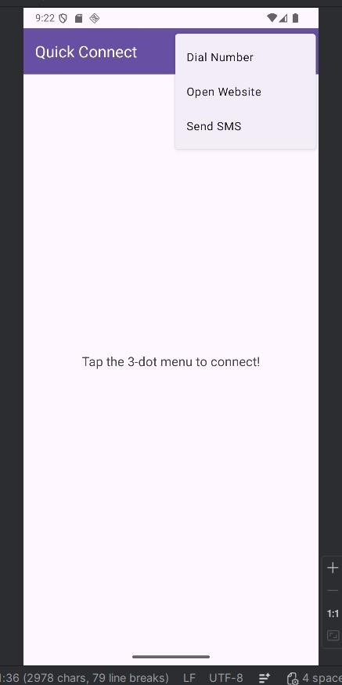

Program-6

Basic music player app.

activity_main.xml:
<LinearLayout xmlns:android="http://schemas.android.com/apk/res/android" android:orientation="vertical"
android:gravity="center" android:layout_width="match_parent" android:layout_height="match_parent">
<Button android:id="@+id/playBtn" android:text="Play"
android:layout_width="wrap_content" android:layout_height="wrap_content"/>
<Button android:id="@+id/pauseBtn" android:text="Pause"
android:layout_width="wrap_content" android:layout_height="wrap_content"/>

<Button android:id="@+id/stopBtn" android:text="Stop"
android:layout_width="wrap_content" android:layout_height="wrap_content"/>
</LinearLayout>

MainActivity.java:
package com.example.musicapp;

import android.media.MediaPlayer; import android.os.Bundle;
import android.view.View; import android.widget.Button;
import androidx.appcompat.app.AppCompatActivity; public class MainActivity extends AppCompatActivity {
Button play, pause, stop;

MediaPlayer mediaPlayer;
@Override
protected void onCreate(Bundle savedInstanceState) { super.onCreate(savedInstanceState); setContentView(R.layout.activity_main);
play = findViewById(R.id.playBtn); pause = findViewById(R.id.pauseBtn); stop = findViewById(R.id.stopBtn);
mediaPlayer = MediaPlayer.create(this, R.raw.song); play.setOnClickListener(v -> mediaPlayer.start()); pause.setOnClickListener(v -> mediaPlayer.pause()); stop.setOnClickListener(v -> {
mediaPlayer.stop();
mediaPlayer = MediaPlayer.create(this, R.raw.song);
});
}
}
Output-

