OUTPUT

Output for option 1
━━━━━━━━━━━━━━━━━━━━━━━━━━━━━━━━━━━━━━━━ 1.1/1.1 MB 29.3 MB/s eta 0:00:00Creating new Ultralytics Settings v0.0.6 file ✅
View Ultralytics Settings with 'yolo settings' or at '/root/.config/Ultralytics/settings.json'
Update Settings with 'yolo settings key=value', i.e. 'yolo settings runs_dir=path/to/dir'. For help see https://docs.ultralytics.com/quickstart/#ultralytics-settings.
==================================================
OBJECT DETECTION SYSTEM
==================================================

Loading YOLOv8 model...
Downloading https://github.com/ultralytics/assets/releases/download/v8.3.0/yolov8n.pt to 'yolov8n.pt': 100% ━━━━━━━━━━━━ 6.2MB 238.6MB/s 0.0s
Model loaded successfully!

==================================================
MAIN MENU
==================================================

Choose an option:
1. Use Demo Image
2. Upload Your Own Image

Enter your choice (1-2): 1

==================================================
DEMO IMAGE OPTION
==================================================

Downloading demo image...
Demo image downloaded: 'demo_image.jpg'

Running object detection on demo image...

0: 640x480 4 persons, 1 bus, 1 stop sign, 81.0ms
Speed: 14.3ms preprocess, 81.0ms inference, 8.3ms postprocess per image at shape (1, 3, 640, 480)

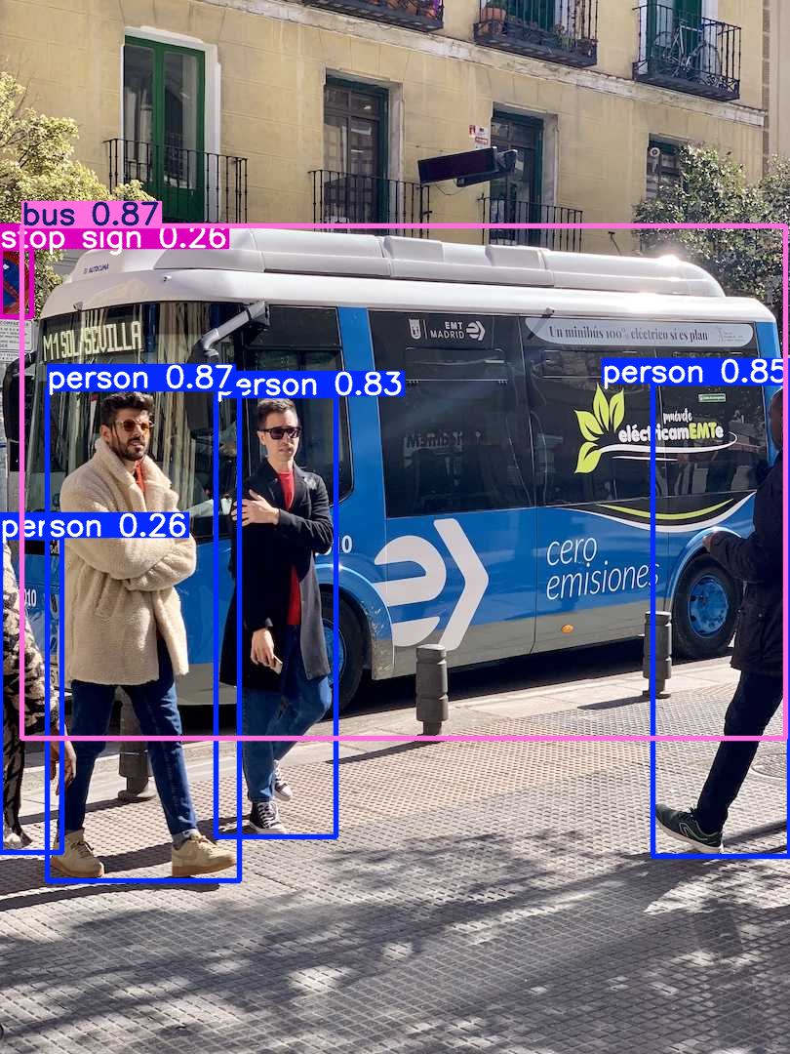
========================================
DETECTION RESULTS for 'demo_image.jpg'
========================================
Total objects detected: 6
----------------------------------------
Object Summary:
• bus: 1
• person: 4
• stop sign: 1

Detailed List:
1. bus (confidence: 0.87)
2. person (confidence: 0.87)
3. person (confidence: 0.85)
4. person (confidence: 0.83)
5. person (confidence: 0.26)
6. stop sign (confidence: 0.26)
========================================

==================================================
Program completed!

Output for option 2
==================================================
OBJECT DETECTION SYSTEM
==================================================

Loading YOLOv8 model...
Model loaded successfully!

==================================================
MAIN MENU
==================================================

Choose an option:
1. Use Demo Image
2. Upload Your Own Image

Enter your choice (1-2): 2

==================================================
UPLOAD YOUR OWN IMAGE
==================================================

Please upload an image file (jpg, jpeg, png):
· stock-photo-many-traffic-signals-at-a-junction-in-a-contemporary-modern-city-2270226437.jpg(image/jpeg) - 251119 bytes, last modified: 07/11/2025 - 100% done
Saving stock-photo-many-traffic-signals-at-a-junction-in-a-contemporary-modern-city-2270226437.jpg to stock-photo-many-traffic-signals-at-a-junction-in-a-contemporary-modern-city-2270226437.jpg

Uploaded file: 'stock-photo-many-traffic-signals-at-a-junction-in-a-contemporary-modern-city-2270226437.jpg'

0: 480x640 7 traffic lights, 2 stop signs, 55.5ms
Speed: 5.6ms preprocess, 55.5ms inference, 5.1ms postprocess per image at shape (1, 3, 480, 640)
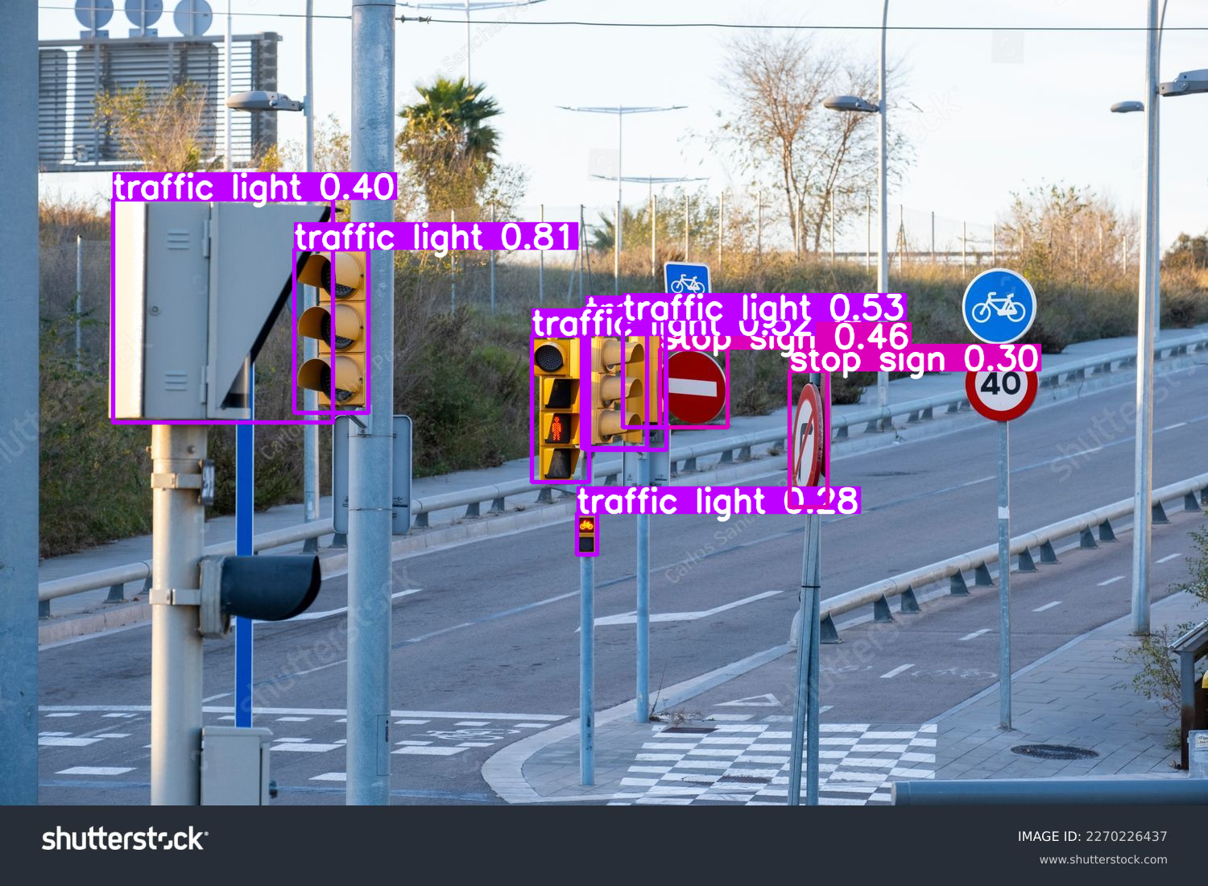
========================================
DETECTION RESULTS for 'stock-photo-many-traffic-signals-at-a-junction-in-a-contemporary-modern-city-2270226437.jpg'
========================================
Total objects detected: 9
----------------------------------------
Object Summary:
• traffic light: 7
• stop sign: 2

Detailed List:
1. traffic light (confidence: 0.81)
2. traffic light (confidence: 0.53)
3. traffic light (confidence: 0.52)
4. stop sign (confidence: 0.46)
5. traffic light (confidence: 0.40)
6. traffic light (confidence: 0.39)
7. stop sign (confidence: 0.30)
8. traffic light (confidence: 0.29)
9. traffic light (confidence: 0.28)
========================================

==================================================
Program completed!

