FairIBAN
IBAN Discrimination Reporter — User Journey Walkthrough
“IBAN discrimination is illegal in all 27 EU countries. We built the enforcement layer the EU forgot.”

Prepared 20 July 2026 · Hackathon MVP v0.1

About this walkthrough
This document walks through the complete FairIBAN user journey exactly as a reporter, visitor, or judge would experience it: filing a report of IBAN discrimination, receiving an instant, legally grounded complaint letter, and seeing the report appear on a public map and wall of shame. Each step below is captured live from the running application, with the relevant functional requirement (FR) from the product spec noted for traceability.
No account, login, or cookie consent is required anywhere in this flow — that is by design (FR-A1, FR-F1).

1. Landing page
Implements: Product overview
A visitor arrives at FairIBAN and immediately sees the one-line pitch and the core call to action. Two paths are offered from the very first screen: report an incident, or browse the public map — reflecting the two audiences the product serves (reporters and the general public/press).
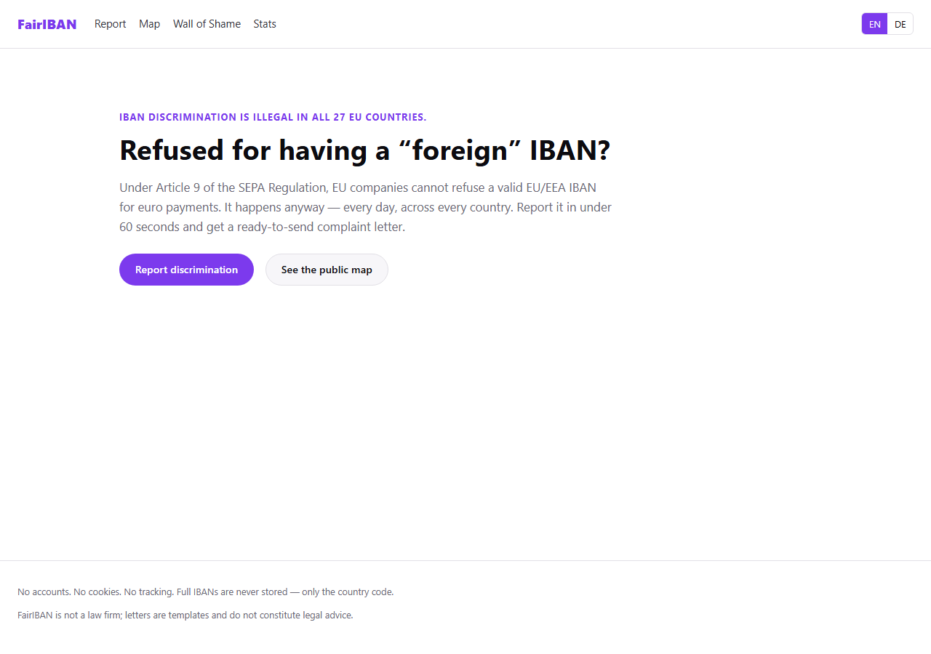

2. Report form
Implements: FR-A1, FR-A2
The reporter opens the report form with zero friction — no registration, no login. The form captures exactly the fields the spec requires: company name, company country, sector, the refused IBAN, the refusal context, incident date, and an optional 500-character description.
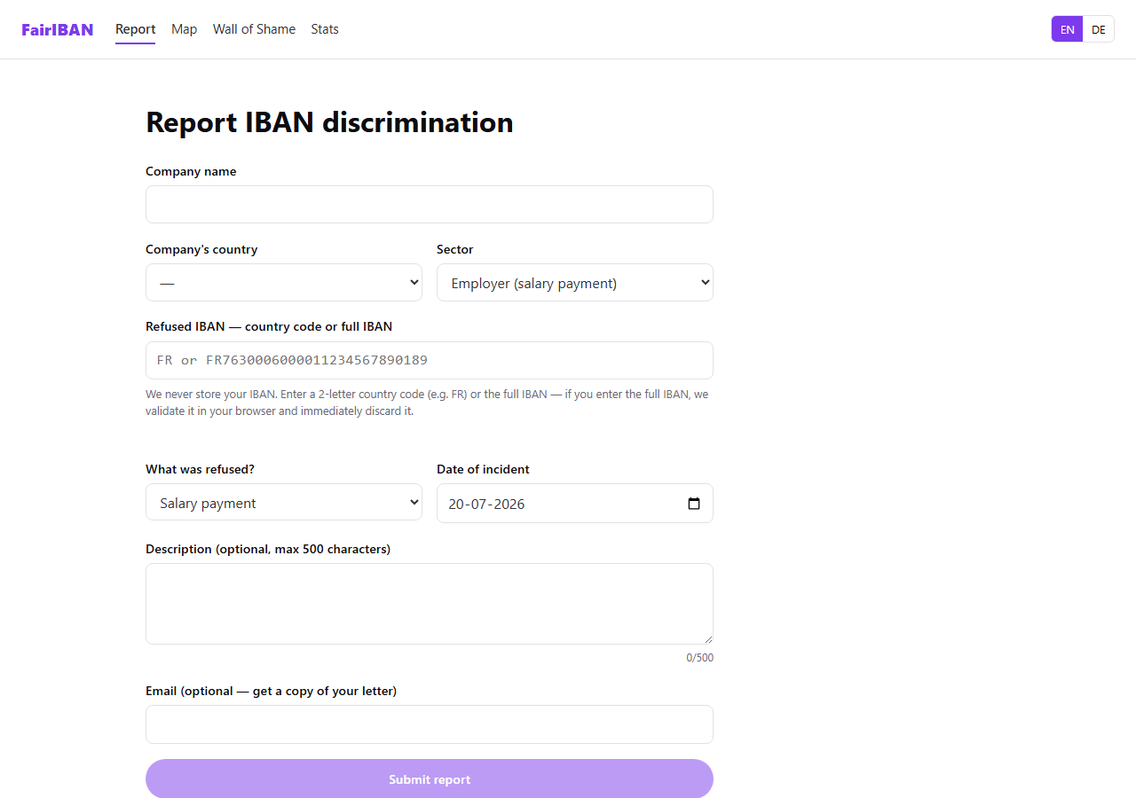

3. Invalid IBAN is rejected inline
Implements: FR-A3, FR-A4
When a full IBAN is typed in, it is validated client-side against the MOD-97 checksum (ISO 13616) in the browser — nothing is sent to a server yet. Here the IBAN has a deliberately broken checksum, so the form shows a clear inline error and blocks submission. The privacy note “We never store your IBAN” is always visible next to the field.
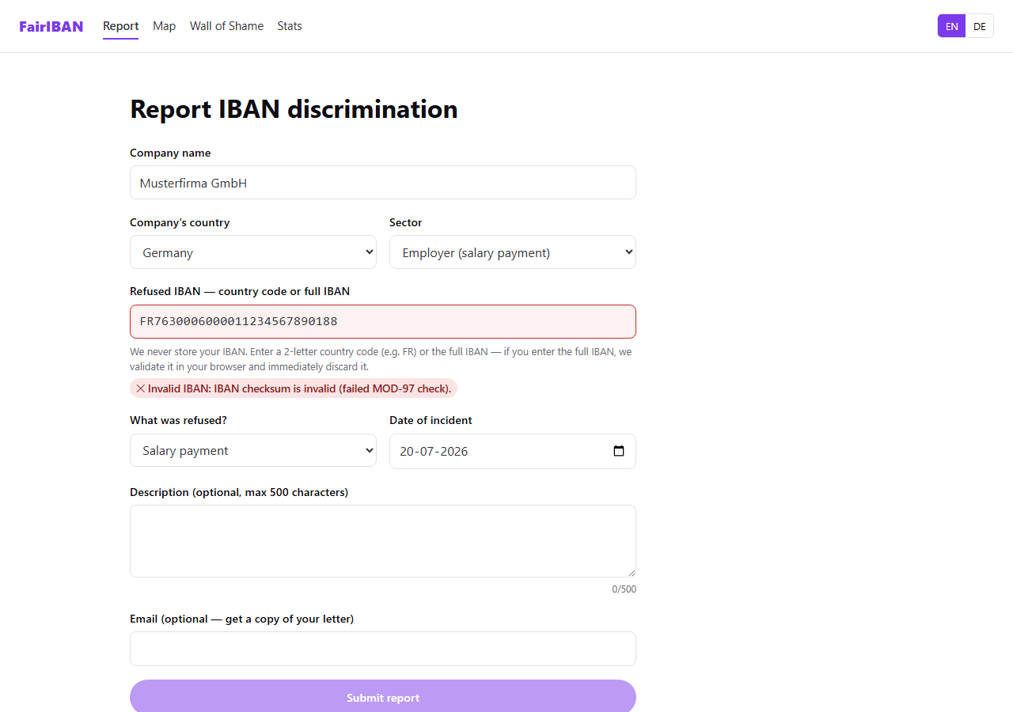

4. Valid IBAN is confirmed and the form is completed
Implements: FR-A3, FR-A4
Correcting the checksum immediately flips the field to a green, validated state with the detected country flag and name — the “great demo moment” called for in the spec. Only the two-letter country code extracted from this IBAN is ever transmitted or stored; the full IBAN never leaves the browser.
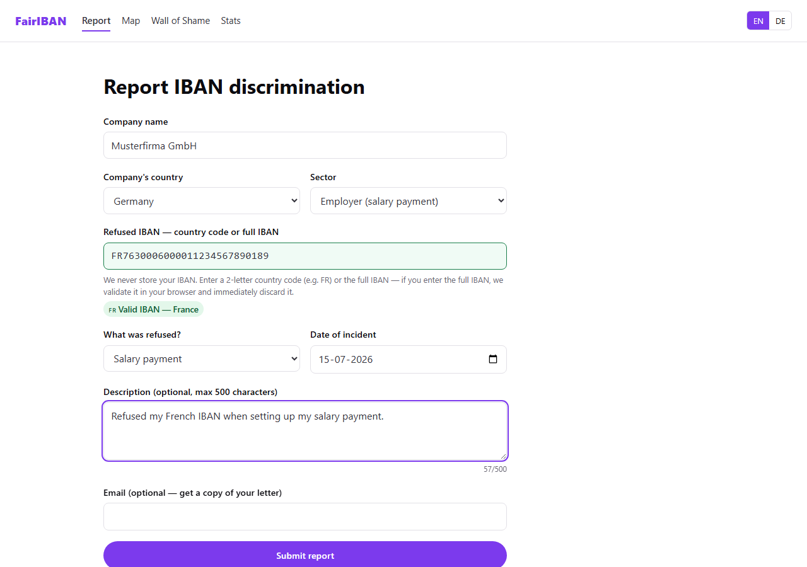

5. Complaint letter generated instantly (English)
Implements: FR-B1, FR-B2, FR-B3
On submit, the reporter is taken straight to a formal complaint letter, generated entirely client-side with zero backend dependency. It cites Article 9(2) of Regulation (EU) 260/2012, is addressed to the correct National Competent Authority for the company's country (BaFin for a German company, in this example) using the built-in 30-country NCA lookup table, and is pre-populated with every detail from the report. Copy, PDF download, plain-text download, and a pre-filled mailto link are all available from this screen.
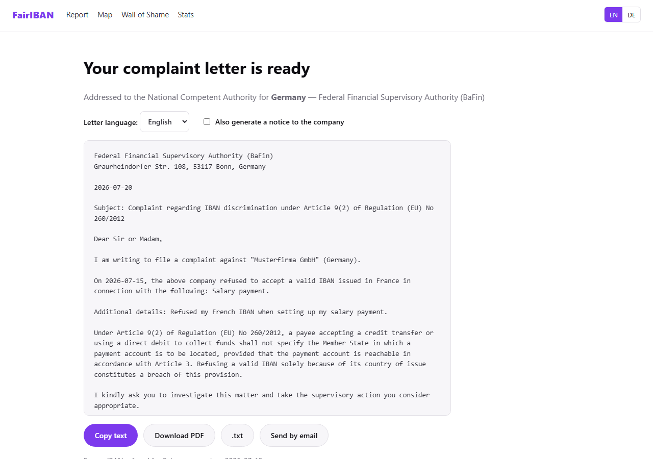

6. Letter language toggle (German)
Implements: FR-B4, FR-A7
The same letter can be regenerated in the National Competent Authority's own language with one click — German is shown here as the second locale, alongside English, satisfying the minimum bilingual requirement for the hackathon build. Country names and refusal-context labels are localized too, not just the surrounding template text.
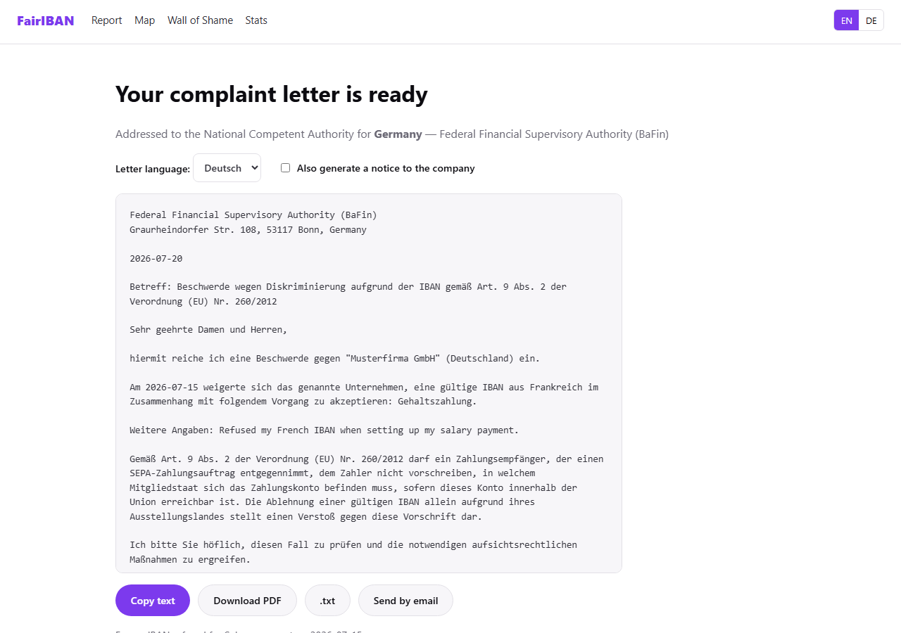

7. Optional “cease and comply” notice to the company
Implements: FR-B5
As an optional extra, the reporter can append a second, shorter letter addressed directly to the offending company itself, asking it to stop the practice before an official regulatory complaint is escalated. Both letters travel together in the same copy/PDF/download actions.
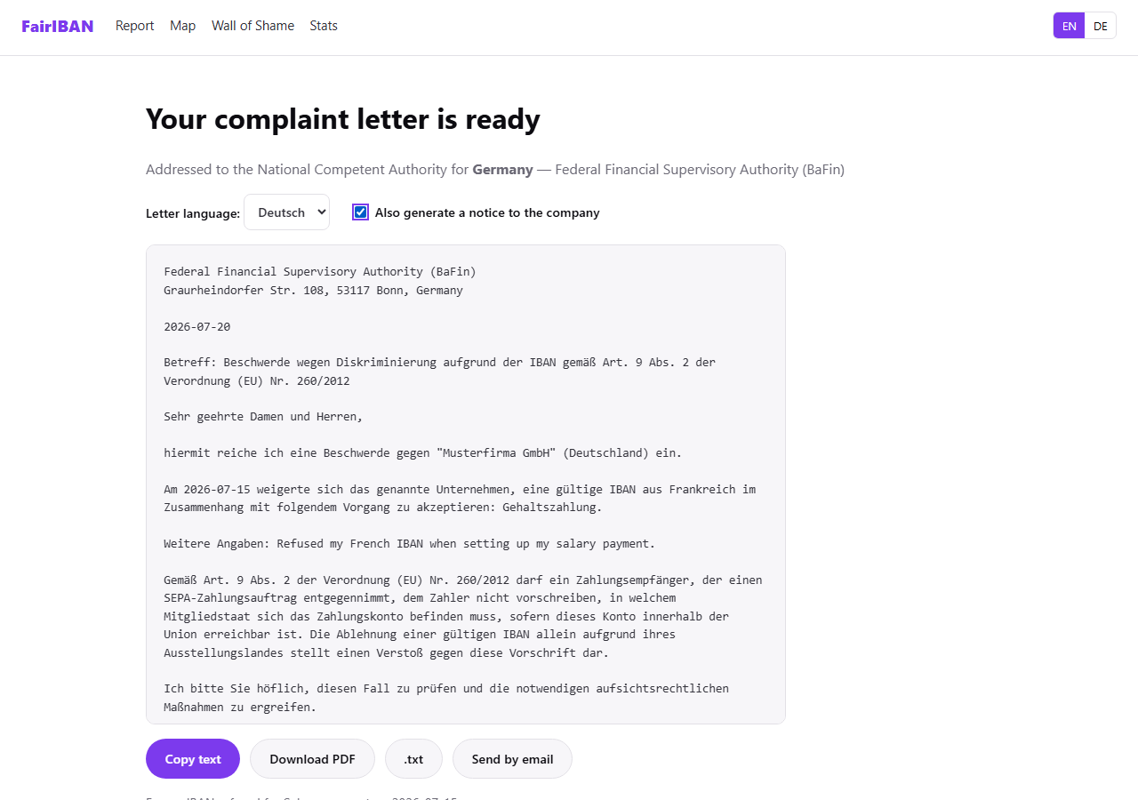

8. Public map of reports
Implements: FR-C1, FR-C2
Every submitted report is immediately reflected — anonymised, with no personal data — on an interactive map of Europe. Marker size scales with report count per company, and each marker's popup shows company name, sector, report count, the refused IBAN countries, and the most recent report date.
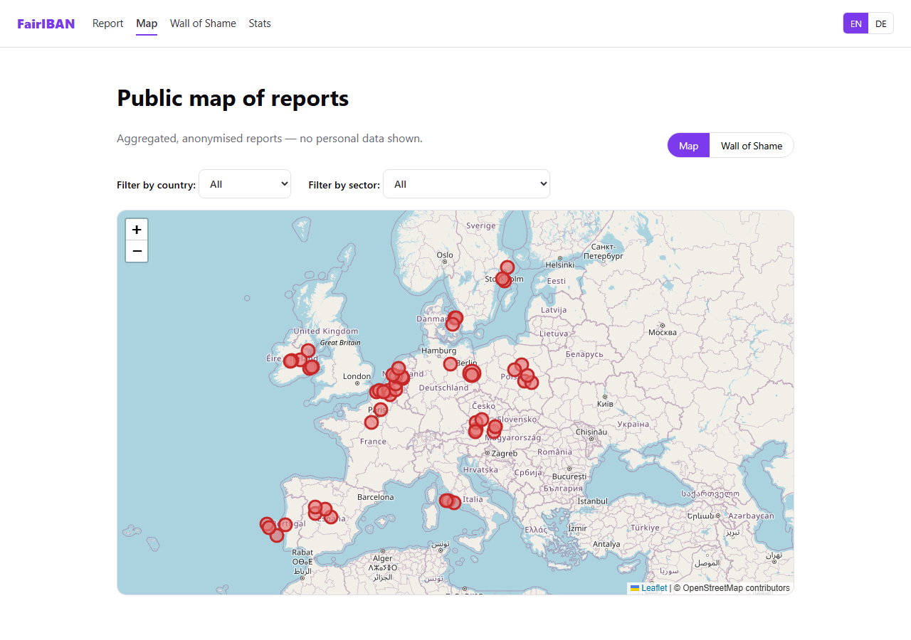

9. Wall of Shame
Implements: FR-C3
The same data is available as a ranked, sortable table — the “wall of shame” — so the worst offenders are visible at a glance without needing to interpret a map.
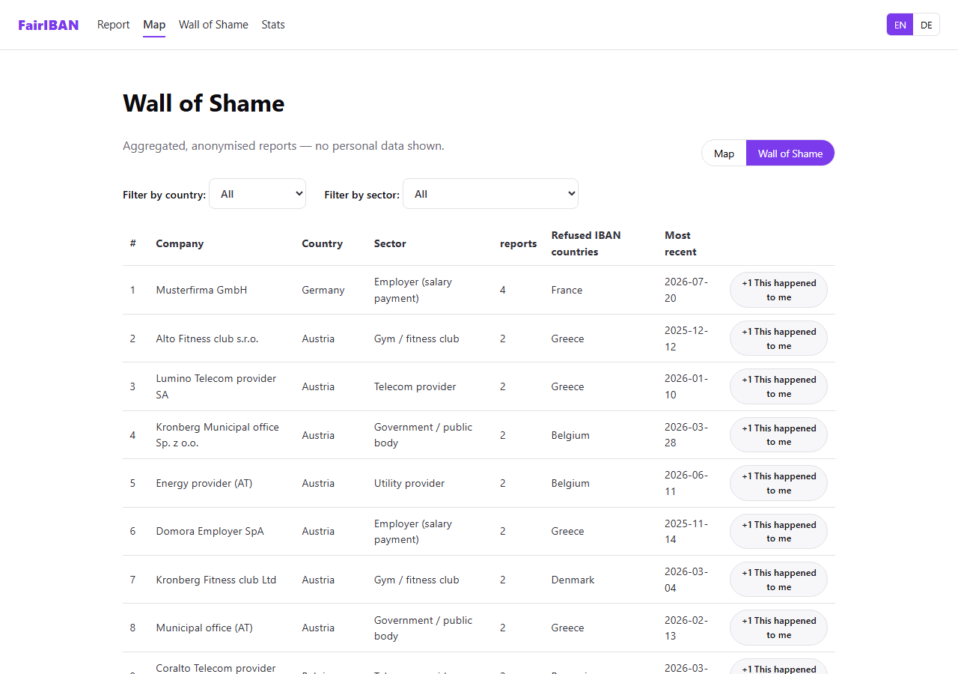

10. Filtering by country
Implements: FR-C3
Both the map and the wall of shame can be filtered by company country and by sector, so a visitor — or a journalist — can drill into, for example, only German companies, or only telecom providers, across the whole dataset.
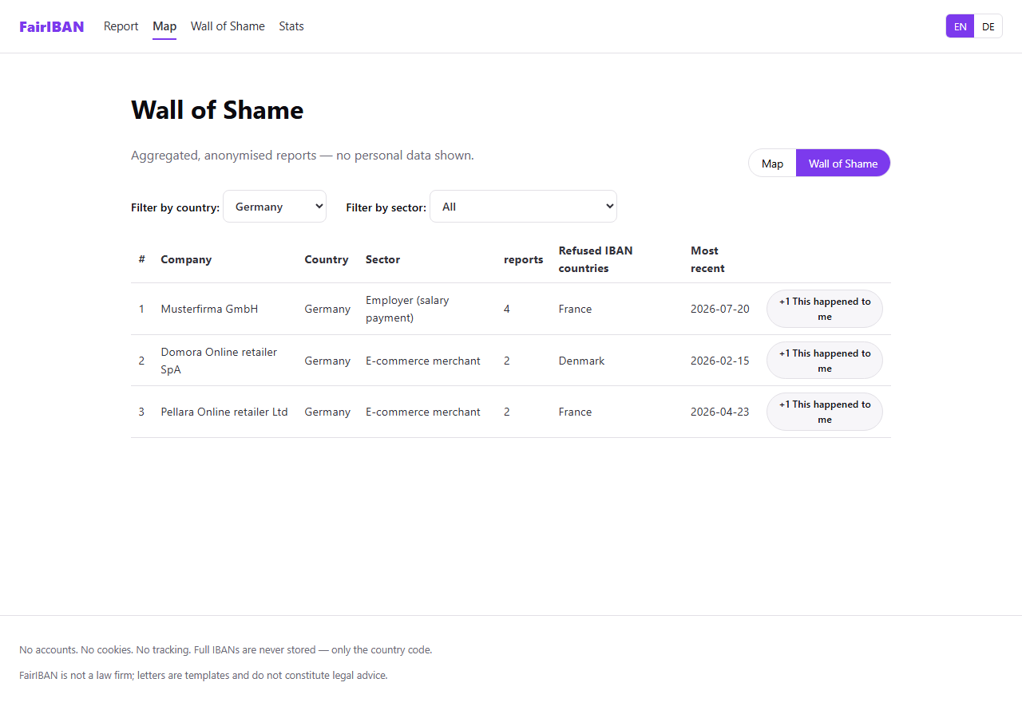

11. “This happened to me too”
Implements: FR-C4
A visitor who recognises a company already on the wall of shame doesn't need to fill out the full form again. One click opens a lightweight inline form asking only for their own refused IBAN's country, which adds a linked report and increments that company's count in place.
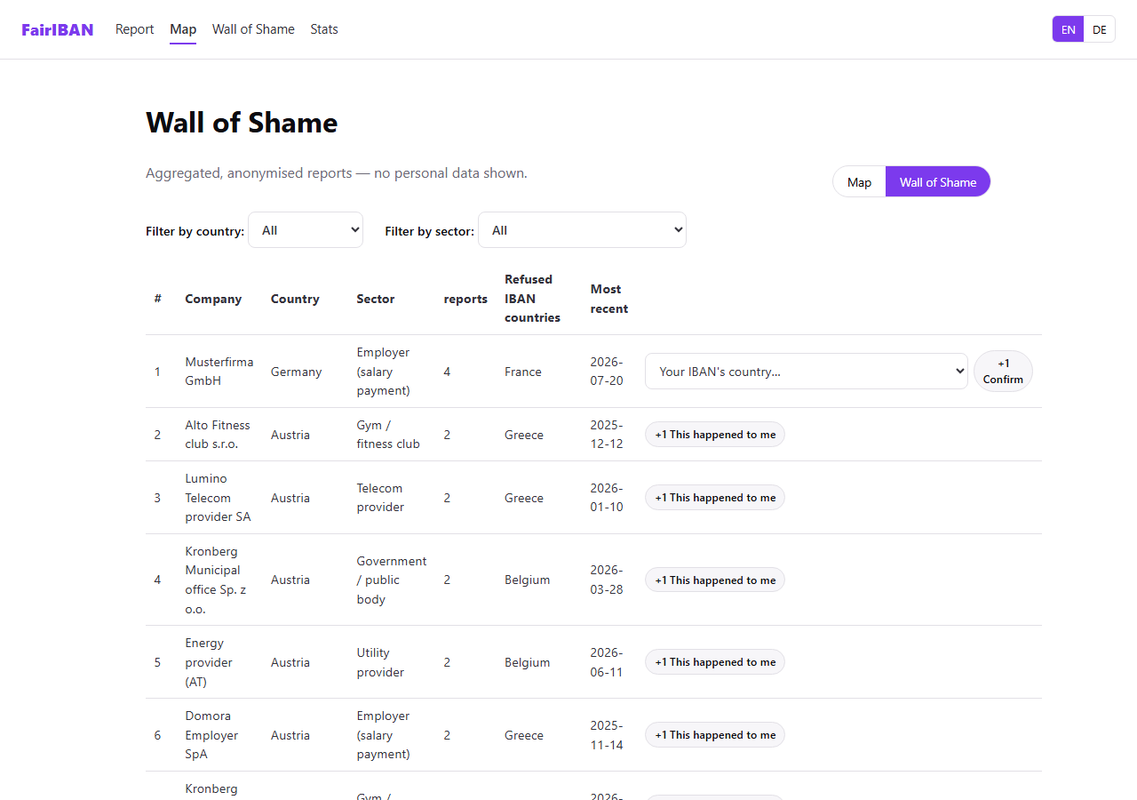

12. Statistics dashboard
Implements: FR-D1, FR-D2
The closing screen of the demo: total reports, distinct companies named, and countries involved, plus a breakdown of the worst-offending sectors and the most common “company country refusing IBAN country” pairs — the exact story beat the product's 3-minute demo script is built around. Figures refresh automatically without a page reload.
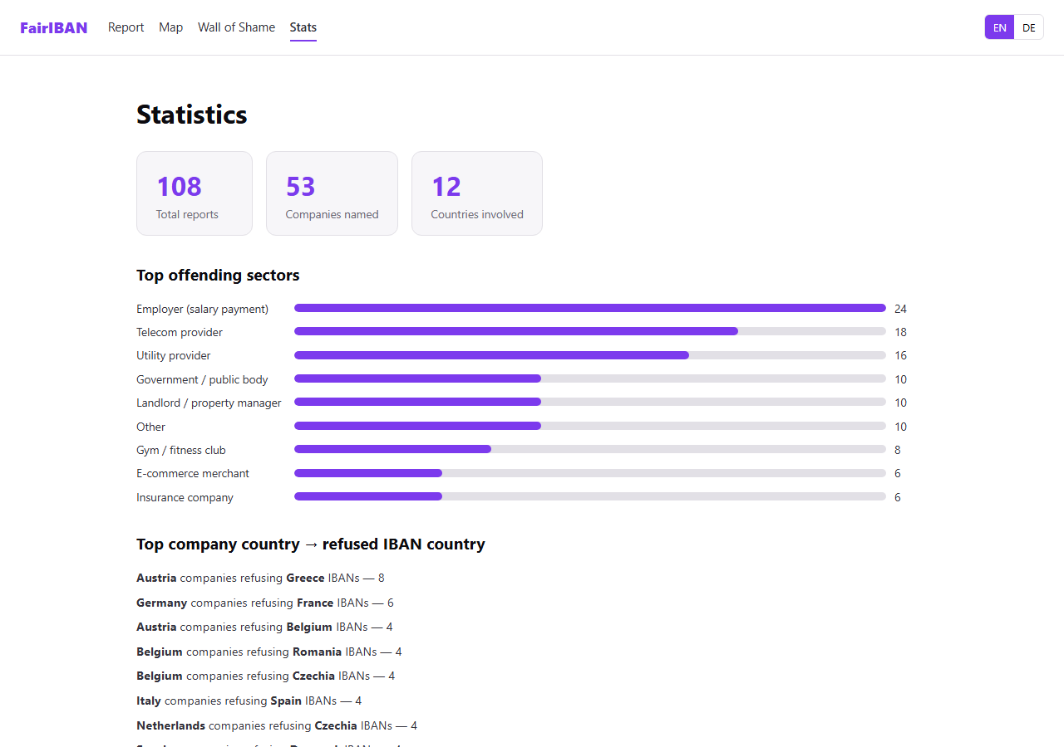

What's deliberately out of scope
No accounts, no cookies, and no tracking anywhere in the product — a deliberate trust and privacy stance, not a missing feature (FR-F1, FR-F2). Reports publish instantly rather than sitting in a moderation queue, which is disclosed openly rather than hidden (FR-F4, roadmap). Automatic submission of complaints to regulators, identity verification of reporters, evidence upload, company accounts, and a right-of-reply mechanism are all intentionally left for a post-hackathon roadmap — the letters generated by this tool are templates, not legal advice, and every letter carries that disclaimer.

