**ETL Process in SQL Server**

STEPS:

Creating Database:

create database db_churn

Import csv into SQL server staging table:

Import Wizard

Right click on the newly created database in the explorer window and then go to

Task >> Import >> Flat file >> Browse CSV file

Using ‘select’ to see the entire dataset:

select * from stg_churn

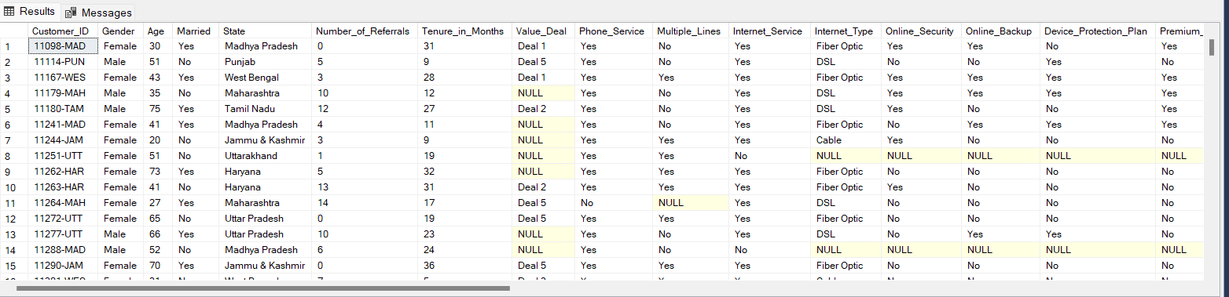

Data Exploration :

SELECT Gender, Count(Gender) as TotalCount,

Count(Gender) * 100.0 / (Select Count(*) from stg_Churn) as Percentage

from stg_Churn

Group by Gender

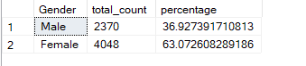

SELECT Contract, Count(Contract) as TotalCount,

Count(Contract) * 100.0 / (Select Count(*) from stg_Churn) as Percentage

from stg_Churn

Group by Contract

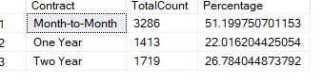

SELECT Customer_Status, Count(Customer_Status) as TotalCount, Sum(Total_Revenue) as TotalRev,

Sum(Total_Revenue) / (Select sum(Total_Revenue) from stg_Churn) * 100 as RevPercentage

from stg_Churn

Group by Customer_Status

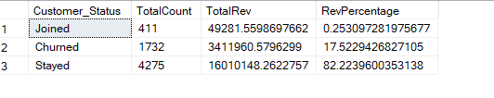

SELECT State, Count(State) as TotalCount,

Count(State) * 100.0 / (Select Count(*) from stg_Churn) as Percentage

from stg_Churn

Group by State

Order by Percentage desc

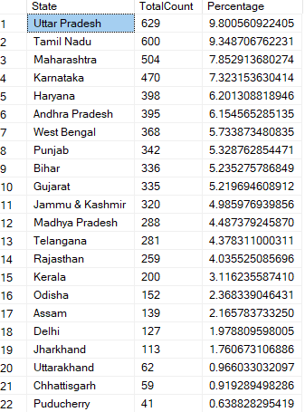

Data Exploration – Check Nulls

SELECT

SUM(CASE WHEN Customer_ID IS NULL THEN 1 ELSE 0 END) AS Customer_ID_Null_Count,

SUM(CASE WHEN Gender IS NULL THEN 1 ELSE 0 END) AS Gender_Null_Count,

SUM(CASE WHEN Age IS NULL THEN 1 ELSE 0 END) AS Age_Null_Count,

SUM(CASE WHEN Married IS NULL THEN 1 ELSE 0 END) AS Married_Null_Count,

SUM(CASE WHEN State IS NULL THEN 1 ELSE 0 END) AS State_Null_Count,

SUM(CASE WHEN Number_of_Referrals IS NULL THEN 1 ELSE 0 END) AS Number_of_Referrals_Null_Count,

SUM(CASE WHEN Tenure_in_Months IS NULL THEN 1 ELSE 0 END) AS Tenure_in_Months_Null_Count,

SUM(CASE WHEN Value_Deal IS NULL THEN 1 ELSE 0 END) AS Value_Deal_Null_Count,

SUM(CASE WHEN Phone_Service IS NULL THEN 1 ELSE 0 END) AS Phone_Service_Null_Count,

SUM(CASE WHEN Multiple_Lines IS NULL THEN 1 ELSE 0 END) AS Multiple_Lines_Null_Count,

SUM(CASE WHEN Internet_Service IS NULL THEN 1 ELSE 0 END) AS Internet_Service_Null_Count,

SUM(CASE WHEN Internet_Type IS NULL THEN 1 ELSE 0 END) AS Internet_Type_Null_Count,

SUM(CASE WHEN Online_Security IS NULL THEN 1 ELSE 0 END) AS Online_Security_Null_Count,

SUM(CASE WHEN Online_Backup IS NULL THEN 1 ELSE 0 END) AS Online_Backup_Null_Count,

SUM(CASE WHEN Device_Protection_Plan IS NULL THEN 1 ELSE 0 END) AS Device_Protection_Plan_Null_Count,

SUM(CASE WHEN Premium_Support IS NULL THEN 1 ELSE 0 END) AS Premium_Support_Null_Count,

SUM(CASE WHEN Streaming_TV IS NULL THEN 1 ELSE 0 END) AS Streaming_TV_Null_Count,

SUM(CASE WHEN Streaming_Movies IS NULL THEN 1 ELSE 0 END) AS Streaming_Movies_Null_Count,

SUM(CASE WHEN Streaming_Music IS NULL THEN 1 ELSE 0 END) AS Streaming_Music_Null_Count,

SUM(CASE WHEN Unlimited_Data IS NULL THEN 1 ELSE 0 END) AS Unlimited_Data_Null_Count,

SUM(CASE WHEN Contract IS NULL THEN 1 ELSE 0 END) AS Contract_Null_Count,

SUM(CASE WHEN Paperless_Billing IS NULL THEN 1 ELSE 0 END) AS Paperless_Billing_Null_Count,

SUM(CASE WHEN Payment_Method IS NULL THEN 1 ELSE 0 END) AS Payment_Method_Null_Count,

SUM(CASE WHEN Monthly_Charge IS NULL THEN 1 ELSE 0 END) AS Monthly_Charge_Null_Count,

SUM(CASE WHEN Total_Charges IS NULL THEN 1 ELSE 0 END) AS Total_Charges_Null_Count,

SUM(CASE WHEN Total_Refunds IS NULL THEN 1 ELSE 0 END) AS Total_Refunds_Null_Count,

SUM(CASE WHEN Total_Extra_Data_Charges IS NULL THEN 1 ELSE 0 END) AS Total_Extra_Data_Charges_Null_Count,

SUM(CASE WHEN Total_Long_Distance_Charges IS NULL THEN 1 ELSE 0 END) AS Total_Long_Distance_Charges_Null_Count,

SUM(CASE WHEN Total_Revenue IS NULL THEN 1 ELSE 0 END) AS Total_Revenue_Null_Count,

SUM(CASE WHEN Customer_Status IS NULL THEN 1 ELSE 0 END) AS Customer_Status_Null_Count,

SUM(CASE WHEN Churn_Category IS NULL THEN 1 ELSE 0 END) AS Churn_Category_Null_Count,

SUM(CASE WHEN Churn_Reason IS NULL THEN 1 ELSE 0 END) AS Churn_Reason_Null_Count

FROM stg_Churn;



Only two columns had not null values

Remove null and insert the new data into Prod table

SELECT

Customer_ID, Gender,Age, Married, State,

Number_of_Referrals,

Tenure_in_Months,

ISNULL(Value_Deal, 'None') AS Value_Deal,

Phone_Service,

ISNULL(Multiple_Lines, 'No') As Multiple_Lines,

Internet_Service,

ISNULL(Internet_Type, 'None') AS Internet_Type,

ISNULL(Online_Security, 'No') AS Online_Security,

ISNULL(Online_Backup, 'No') AS Online_Backup,

ISNULL(Device_Protection_Plan, 'No') AS Device_Protection_Plan,

ISNULL(Premium_Support, 'No') AS Premium_Support,

ISNULL(Streaming_TV, 'No') AS Streaming_TV,

ISNULL(Streaming_Movies, 'No') AS Streaming_Movies,

ISNULL(Streaming_Music, 'No') AS Streaming_Music,

ISNULL(Unlimited_Data, 'No') AS Unlimited_Data,

Contract,

Paperless_Billing,

Payment_Method,

Monthly_Charge,

Total_Charges,

Total_Refunds,

Total_Extra_Data_Charges,

Total_Long_Distance_Charges,

Total_Revenue,

Customer_Status,

ISNULL(Churn_Category, 'Others') AS Churn_Category,

ISNULL(Churn_Reason , 'Others') AS Churn_Reason

SELECT * FROM prod_Churn

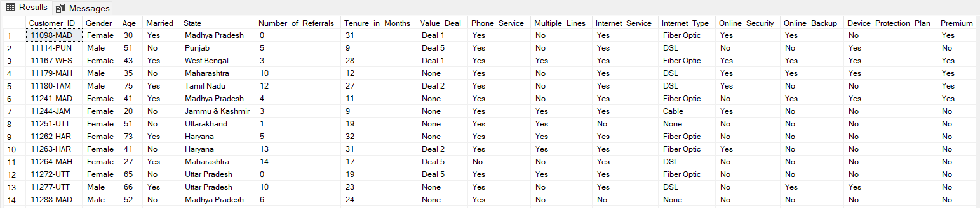

Create View for Power BI

Create View vw_churnData as

select * from prod_Churn where Customer_Status In ('Churned', 'Stayed')

SELECT * FROM vw_churndata

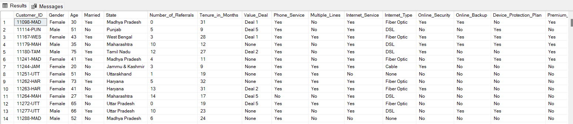

Create View vw_JoinData as

select * from prod_Churn where Customer_Status = 'Joined'

SELECT * FROM vw_joindata

