Questions :

(Mostly Intermediate and Advanced)

Calculate the percentage contribution of each pizza type to total revenue.

-----percentage contribution with respect to pizza category

with cte as

(select

round(sum(od.quantity * pz.price), 2 ) as total_revenue

from order_details as od

join pizza as pz

on od.pizza_id = pz.pizza_id),

rev as

(select

pizza_types.category,

sum(order_details.quantity * pizza.price) as revenue

from order_details join pizza

on order_details.pizza_id = pizza.pizza_id

join pizza_types on pizza_types.pizza_type_id = pizza.pizza_type_id

group by pizza_types.category)

select rev.category,

round((rev.revenue / cte.total_revenue *100.0 ),2) as percentage

from rev, cte

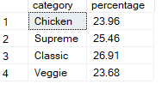

Determine the top 3 most ordered pizza types** based on revenue for each pizza category

select name, revenue from

(select category, name, revenue,

rank() over (partition by category order by revenue desc) as rn

from

(select pizza_types.category, pizza_types.name,

sum((order_details.quantity) * pizza.price) as revenue from pizza_types

join pizza

on pizza_types.pizza_type_id = pizza.pizza_type_id

join order_details

on order_details.pizza_id = pizza.pizza_id

group by pizza_types.category, pizza_types.name) as a) as b

where rn <= 3

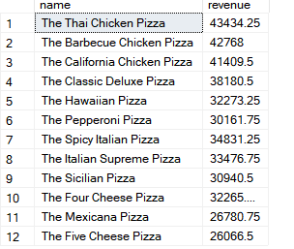

Analyze the cumulative revenue generated over time

select date,

sum(revenue) over (order by date) as cum_revenue

from

(select orders.date,

sum(order_details.quantity * pizza.price) as revenue

from order_details join pizza

on order_details.pizza_id = pizza.pizza_id

join orders

on orders.order_id = order_details.order_id

group by orders.date ) as sales

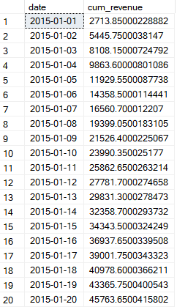

Determine the top 3 most ordered pizza category based on revenue

select top 3

pizza_types.category,

round(sum(order_details.quantity * pizza.price),2) as revenue

from order_details join pizza

on order_details.pizza_id = pizza.pizza_id

join pizza_types on pizza_types.pizza_type_id = pizza.pizza_type_id

group by pizza_types.category

order by revenue desc

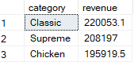

Retrieve the total number of orders placed.

select count(distinct(order_id)) as total_orders

from orders

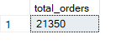

Calculate the total revenue generated from pizza sales.

select top 10

pz.pizza_id,

sum(pz.price * od.quantity) as revenue

from order_details as od

join pizza as pz

on od.pizza_id = pz.pizza_id

group by pz.pizza_id

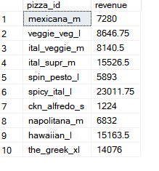

select

sum(pz.price * od.quantity) as total_revenue

from order_details as od

join pizza as pz

on od.pizza_id = pz.pizza_id



Identify the highest-priced pizza.

select top 1

pizza_id,

MAX(price) AS maximum

from pizza

group by pizza_id

order by MAX(price) desc;



Identify the most common pizza size ordered.

select pizza.size, count(od.order_details_id) as order_count

from pizza

join order_details as od

on pizza.pizza_id = od.pizza_id

group by pizza.size

order by order_count desc

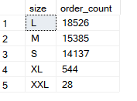

List the top 5 most ordered pizza types along with their quantities.

select top 5

pt.name,

sum(od.quantity) as quantity

from pizza_types as pt

join pizza as pz

on pt.pizza_type_id = pz.pizza_type_id

join order_details as od

on od.pizza_id =pz.pizza_id

group by pt.name

order by quantity desc

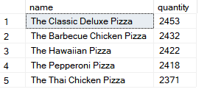

Join the necessary tables to find the total quantity of each pizza category ordered.

select

pt.category ,

sum(od.quantity) as total_quantity

from order_details as od

join pizza as pz

on od.pizza_id = pz.pizza_id

join pizza_types as pt

on pt.pizza_type_id = pz.pizza_type_id

group by pt.category

order by total_quantity

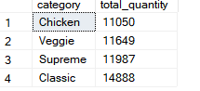

Determine the distribution of orders by hour of the day.

select

DATEPART(HOUR, time) AS hour_of_day,

COUNT(*) AS order_count

from orders

group by DATEPART(HOUR, time)

order by hour_of_day;

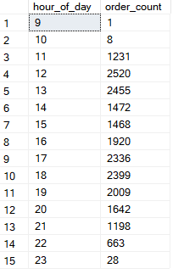

Join relevant tables to find the category-wise distribution of pizzas.

select

category,

count(category) as total

from pizza_types

group by category

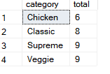

Calculate the percentage contribution of each pizza type to total revenue.

--total revenue : 817860.05

with rev as

(select

round(sum(od.quantity * pz.price), 2 ) as total_revenue

from order_details as od

join pizza as pz

on od.pizza_id = pz.pizza_id),

cte as

(select

order_details.pizza_id,

sum((order_details.quantity * pizza.price)) as revenue

from order_details

join pizza

on order_details.pizza_id = pizza.pizza_id

group by order_details.pizza_id)

SELECT

cte.pizza_id,

round((cte.revenue * 100.0 / rev.total_revenue),3) AS percentage

FROM

cte, rev;

Calculate the percentage contribution of each pizza type to total revenue.

select

round(sum(od.quantity * pz.price), 2 ) as total_revenue

from order_details as od

join pizza as pz

on od.pizza_id = pz.pizza