PIZZA SALES ANALYSIS KPIs :

* Data Used

select top 5 *

from pizza_sales

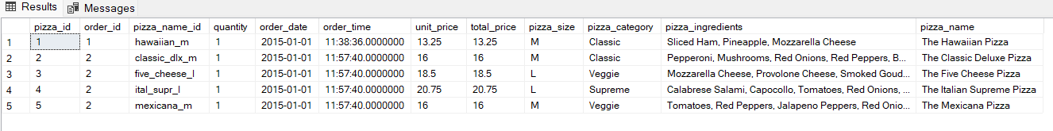

* Total Revenue Generated

select

round(sum(quantity * unit_price),2) as total_revenue

from pizza_sales

/*another way*/

select round(sum(total_price), 2) as total_revenue

from pizza_sales

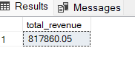

* Total Orders

select count( distinct order_id) AS total_orders

from pizza_sales



* Average Order Value

select sum(total_price) / count(distinct order_id) as average_order_value

from pizza_sales



* Total Pizzas Sold

select sum(quantity) as total_pizzas

from pizza_sales



* Average Pizzas Per Order

select cast(

cast(sum(quantity) as decimal (10, 2)) /

cast(count( distinct order_id) as decimal (10,2)) as decimal (10,2))

as average_pizzas_per_order

from pizza_sales



* Daily Trend for Total Orders

select

DATENAME(DW, order_date) as order_day,

count(distinct order_id) as total_orders

from pizza_sales

group by DATENAME(DW, order_date)

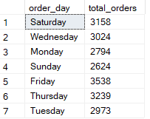

* **DATENAME** : The DATENAME function in SQL is used to return a specific part of a date as a string, such as the day, month, year, weekday, hour, minute, or second.
* Here, DW is mentioned hence, it will retrieve Day of the week (Monday, Tuesday, Wednesday… etc) from the date column
* Monthly Trend for Total Orders

select DATENAME(MM, order_date) as month_name,

count(distinct order_id) as total_orders

from pizza_sales

group by DATENAME(MM, order_date)

order by total_orders desc

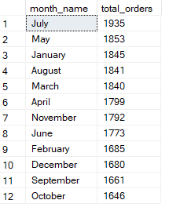

* Percentage of Sales by PIZZA category

**(USING CTE/WITH CLAUSE METHOD)**

with pizza_prices as

(select pizza_category,

round(sum(total_price),2) as price from pizza_sales

group by pizza_category)

,

total_sales_price as

(select round(sum(total_price), 2) as total_price from pizza_sales)

select pizza_category,

round((price / total_price * 100.0), 3) as percentage

from pizza_prices, total_sales_price

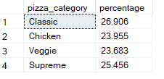

/*another method*/

**(USING SUBQUERY METHOD)**

select

pizza_category, round(sum(total_price), 3)as total_sales,

round(sum(total_price) * 100.0 / (select sum(total_price) from pizza_sales), 3) as percentage

from pizza_sales

group by pizza_category

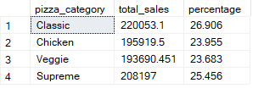

* **NOTE : If we need to specifically see the sales for a particular month, hence, we use ‘WHERE’ clause**

select

pizza_category, round(sum(total_price), 3)as total_sales,

round(sum(total_price) * 100.0 / (select sum(total_price) from pizza_sales where MONTH(order_date) = 1), 3) as percentage

from pizza_sales

where MONTH(order_date) = 1

group by pizza_category

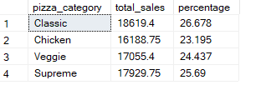

* Percentage of Sales by PIZZA size

select pizza_size,

sum(total_price) as total_sales,

cast (sum(total_price) * 100.0 / (select sum(total_price) from pizza_sales) as decimal (10,2)) as pct

from pizza_sales

group by pizza_size

order by pct

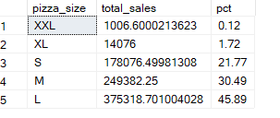

* **USING WHERE CLASUSE FOR SPECIFICATION IN ORDER TO SHOW THE DATA**

select pizza_size,

sum(total_price) as total_sales,

cast (sum(total_price) * 100.0 / (select sum(total_price) from pizza_sales where datepart (quarter, order_date) = 1)as decimal (10, 2)

) as pct

from pizza_sales

where datepart (quarter, order_date) = 1

group by pizza_size

order by pct

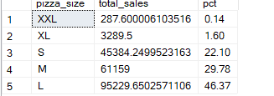

* Top 5 Best Sellers Pizza by Revenue

select top 5

pizza_name,

sum(total_price) as total_revenue

from pizza_sales

group by pizza_name

order by total_revenue desc

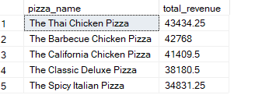

* Bottom 5 Sellers Pizza by Revenue

select top 5

pizza_name,

sum(total_price) as total_revenue

from pizza_sales

group by pizza_name

order by total_revenue asc

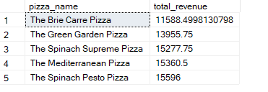

* Top 5 Best Sellers Pizza by Quantity

select top 5

pizza_name,

sum(quantity) as total_sales

from pizza_sales

group by pizza_name

order by total_sales desc

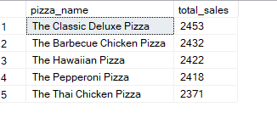

* Bottom 5 Sellers Pizza by Quantity

select top 5

pizza_name,

sum(quantity) as total_sales

from pizza_sales

group by pizza_name

order by total_sales asc

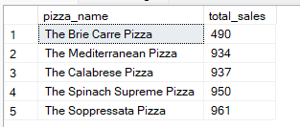

* Top 5 Best Sellers Pizza by Orders

select top 5

pizza_name,

count(distinct order_id) as total_orders

from pizza_sales

group by pizza_name

order by total_orders desc

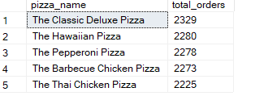

* Bottom 5 Sellers Pizza by Orders

select top 5

pizza_name,

count(distinct order_id) as total_orders

from pizza_sales

group by pizza_name

order by total_orders asc

