Basics of C++
Structure of program
#include <iostream>
using namespace std;

int main ()
{
cout << "Hello World!";
return 0;
}
# include <iostream> header file. Increases functionality helps in input output.
int main() main is entry point. Int means gives integer value in last.
Syntax:
#include<iostream>
#include<climits> includes these 2 constants - INT_MAX(shows maximum int value that can be stored inside the integer), INT_MIN(shows minimum int value that can be stored inside the integer)
using namespace std;
int main(){
return0;
}

Variables
a variable as a portion of memory to store a determined value.
a = 5;
b = 2;
a = a + 1;
result = a - b;
Int p, q; declaring variables
Float r, s;
unsigned short int NumberOfSisters;
int p = 1; assigning the values to the variables./ initialization of variables
float q = 2;
int a (0);
Scope of variables
A global variable is a variable declared in the main body of the source code, outside all functions, while a local variable is one declared within the body of a function or a block.
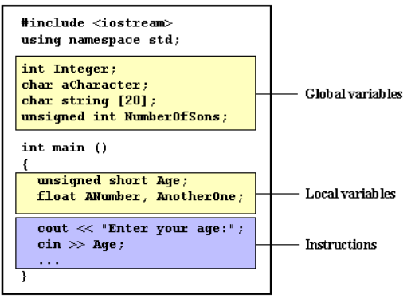
Strings
Variables that can store non-numerical values that are longer than one single character are known as strings.
string mystring = "This is a string";

Data types
int, bool, char, double, float
Int – only stores integers int x = 100;
Float – stores decimals float x = 10.14;
Boolean – stores true/false/0/1 bool x = true;
Double – stores bigger values than float double x = 10.10294829824;
Char – stores characters char ch = ‘A’;
Name | Description | Size* | Range*
char | Character or small integer. | 1byte | signed: -128 to 127  unsigned: 0 to 255
short int (short) | Short Integer. | 2bytes | signed: -32768 to 32767  unsigned: 0 to 65535
int | Integer. | 4bytes | signed: -2147483648 to 2147483647  unsigned: 0 to 4294967295
long int (long) | Long integer. | 4bytes | signed: -2147483648 to 2147483647  unsigned: 0 to 4294967295
bool | Boolean value. It can take one of two values: true or false. | 1byte | true or false
float | Floating point number. | 4bytes | +/- 3.4e +/- 38 (~7 digits)
double | Double precision floating point number. | 8bytes | +/- 1.7e +/- 308 (~15 digits)
long double | Long double precision floating point number. | 8bytes | +/- 1.7e +/- 308 (~15 digits)
wchar_t | Wide character. | 2 or 4 bytes | 1 wide character

Sizeof – tells how much memory does it occupy cout<<”int”<<sizeof(x)<<endl;

// single line comment

/* */ multi line comment

Cout<< output statement

“ ” used in cout to print the line or word as it is

Endl for next line

Syntax:
Cout<<”what is your phn no ”<<no<<endl;

Cin>> input statement
Syntax:
Cin>>no;

*every statement should be terminated by a semi colon(;) in c++*

** dividing integer by integer gives output in integer only (int/int=int)
Float/ integer = Float
Integer / float = Float
These are called typecasting**

Typecasting is of 2 types
- Implicit which happens automatically

*loop must have initialization, stopping criteria, update condition*
*While loop*
Syntax :
int sum = 0; (initialization)
While(i<=n(terminating condition))// stopping criteria
{
i = i+1; (Update condition)
}
*Do while loop* (this is executed atleast once)(it is exit controlled loop)(it doesn’t check the initial condition whether it’s true or false)
Syntax:
Do{
}
While(condition);

*For loop*
Syntax:
For(int, stop, update){
Statement;
}
*If else if else* (conditional statements)
Syntax:
If(n%2==0(condtion)){
Cout<<”hi”<<endl;}
Else if(n%==3){
Cout<<”hlw”<<endl;
}
Else{
Cout<<”bye”<<endl;
}
/* if
Else if
Else if
Else
*/
Else if is used when we want only one block to execute if we want 2 to execute we will use if again

% modulus – gives the remainder

!= not equals to

*Data type modifiers*:
Unsigned int – store only positive value, gives 1 bit more
(By default)signed int - stores both negative and positive values, gives one bit less
Long - expands the storage of the datatype
Short – decrease the storage of the datatype

Wrap around whenever we try to exceed the maximum range of int we will end upon the opposite side.

