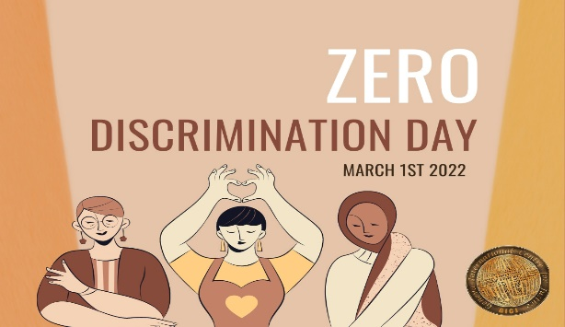Discrimination, in all its forms, continues to plague societies around the world, perpetuating inequality and hindering progress. However, on March 1st every year, the world comes together to observe Zero Discrimination Day, a moment to reflect on the importance of embracing diversity and eliminating discrimination in all its forms.

Originating from the United Nations AIDS program, Zero Discrimination Day aims to promote equality before the law and in practice throughout all member countries of the United Nations. Discrimination takes many shapes and forms, whether based on race, gender, sexual orientation, religion, disability, or any other characteristic. It not only infringes upon fundamental human rights but also obstructs social and economic development.

The significance of Zero Discrimination Day lies in its call to action for individuals, communities, and governments worldwide. It serves as a reminder of the collective responsibility to challenge discriminatory attitudes and practices, fostering environments of inclusivity and respect for diversity. By acknowledging and celebrating our differences, we can create a more harmonious and equitable society for all.

One of the key principles of Zero Discrimination Day is the promotion of education and awareness. Education plays a vital role in dismantling stereotypes and prejudices, empowering individuals to challenge discrimination and promote tolerance. Schools, workplaces, and communities can all serve as platforms for promoting diversity and inclusion through educational initiatives and awareness campaigns.

Furthermore, Zero Discrimination Day underscores the importance of enacting and enforcing laws and policies that safeguard against discrimination. Governments have a responsibility to ensure that legislation is in place to protect the rights of all individuals, regardless of their background or identity. Moreover, effective enforcement mechanisms must be established to hold accountable those who perpetrate acts of discrimination.

Beyond legislative measures, fostering a culture of empathy and understanding is essential in the fight against discrimination. Empathy enables individuals to recognize the humanity in others, transcending differences and fostering solidarity. Through dialogue and engagement, we can bridge divides and cultivate environments where everyone feels valued and respected.

On Zero Discrimination Day, individuals are encouraged to take action in their own lives and communities to promote inclusivity and equality. Whether through advocacy, volunteerism, or simply acts of kindness, each person has the power to make a difference in the fight against discrimination. By standing up against injustice and embracing diversity, we can create a world where everyone has the opportunity to thrive, free from discrimination.

As we commemorate Zero Discrimination Day, let us reaffirm our commitment to building a more just and equitable world. Let us reject discrimination in all its forms and embrace the richness of diversity. Together, we can create a future where every individual is treated with dignity and respect, regardless of who they are or where they come from. Zero Discrimination Day serves as a poignant reminder that by working together, we can create a world where everyone can live without fear of discrimination and prejudice.

