Docker Assignment 4: create jobs for port binding 90,8001, 8081 to jenkins master, slave-1,slave-2. Each instance should be connect to each branch and all 3ports
Ans-
Launch 3 instances and connect to it, download java21, docker25, Jenkins2.5, tomcat11, git
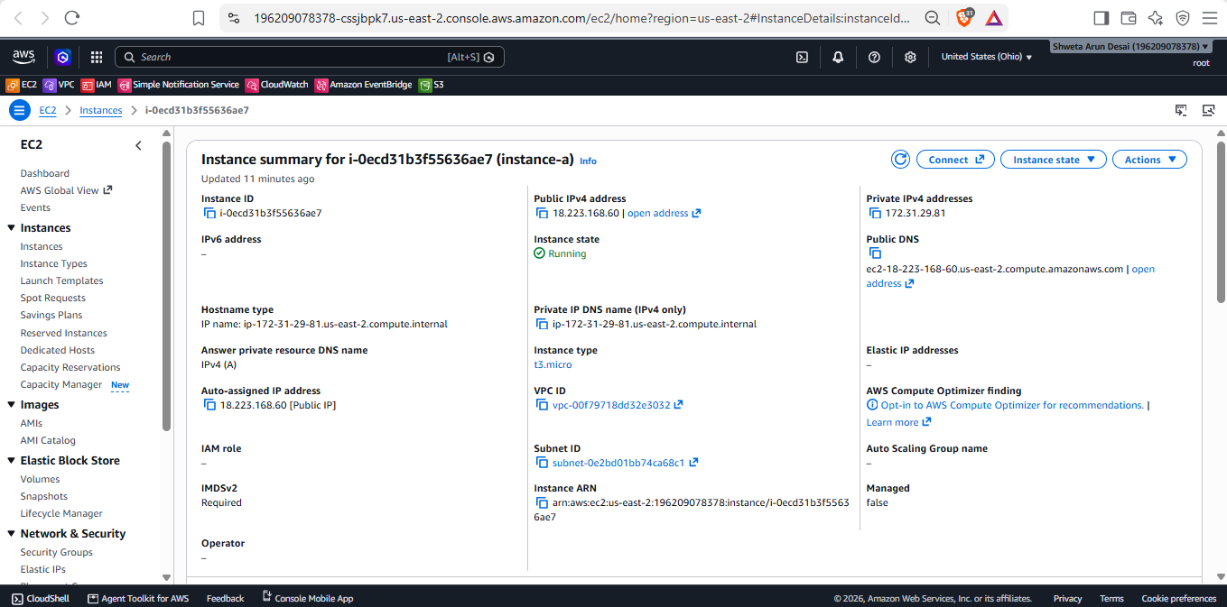
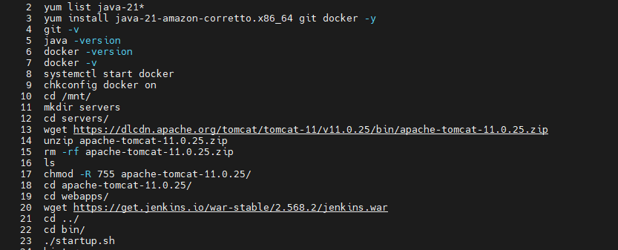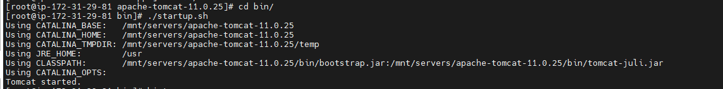
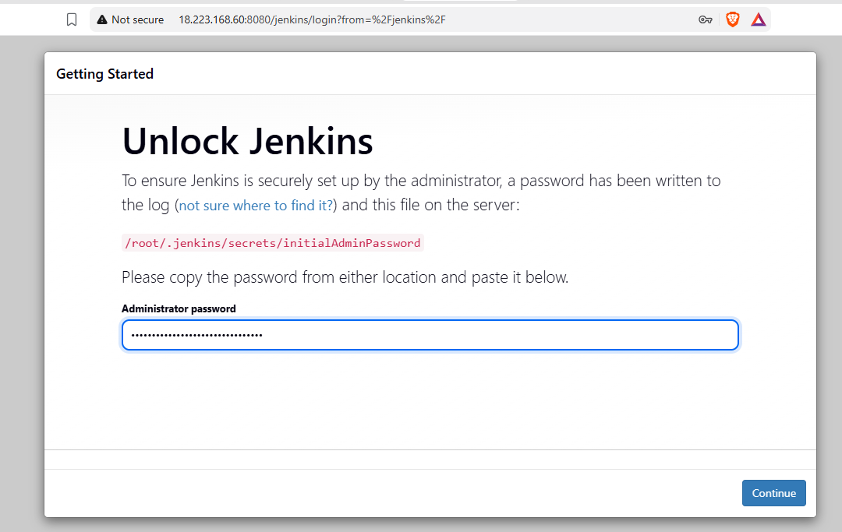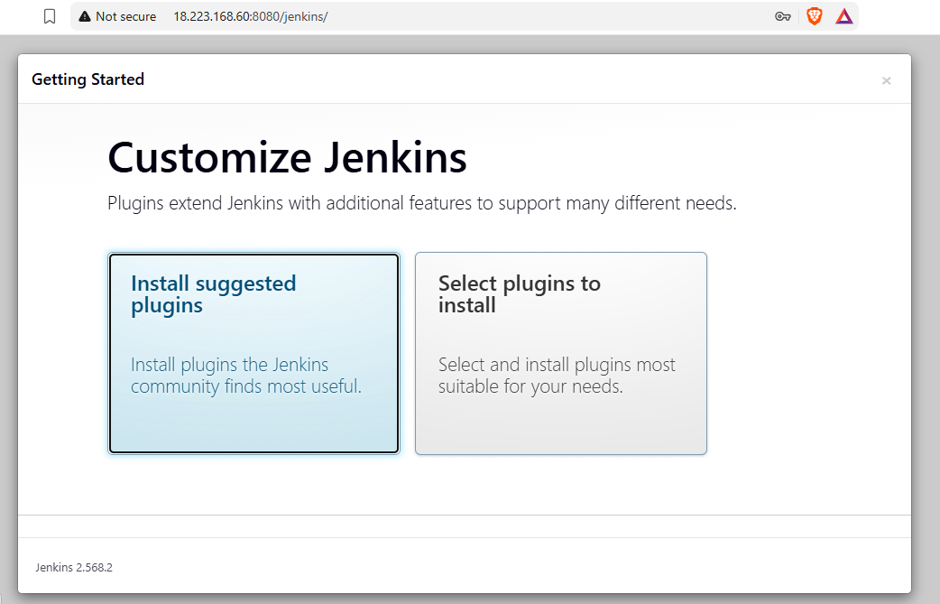
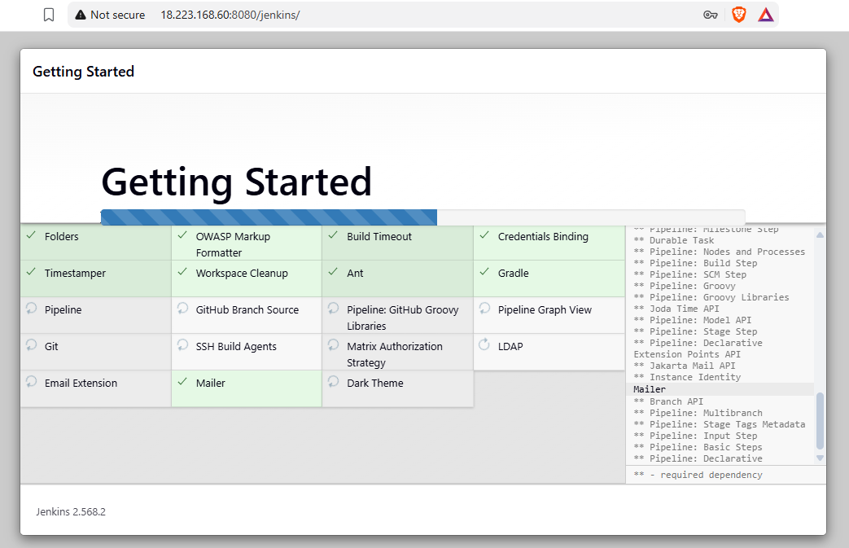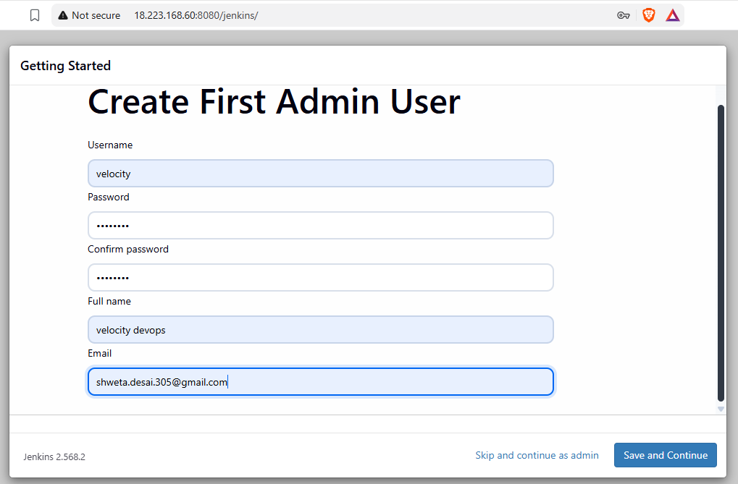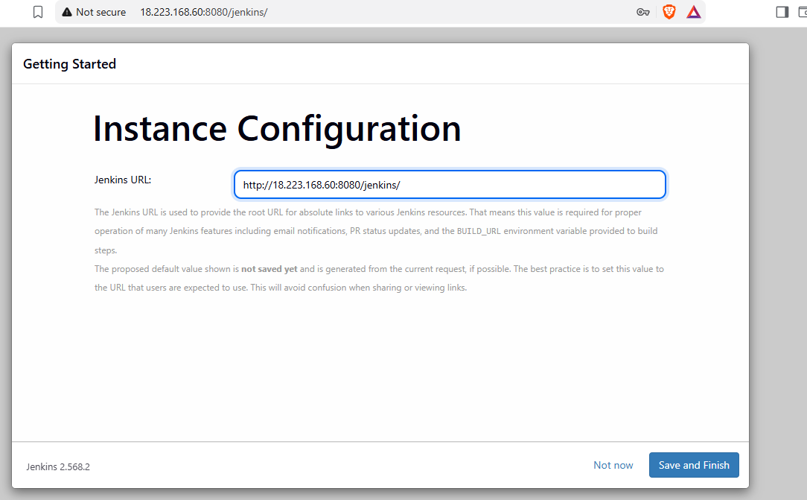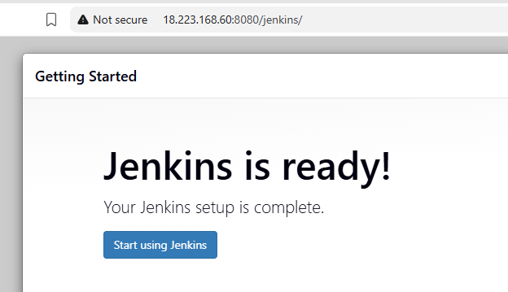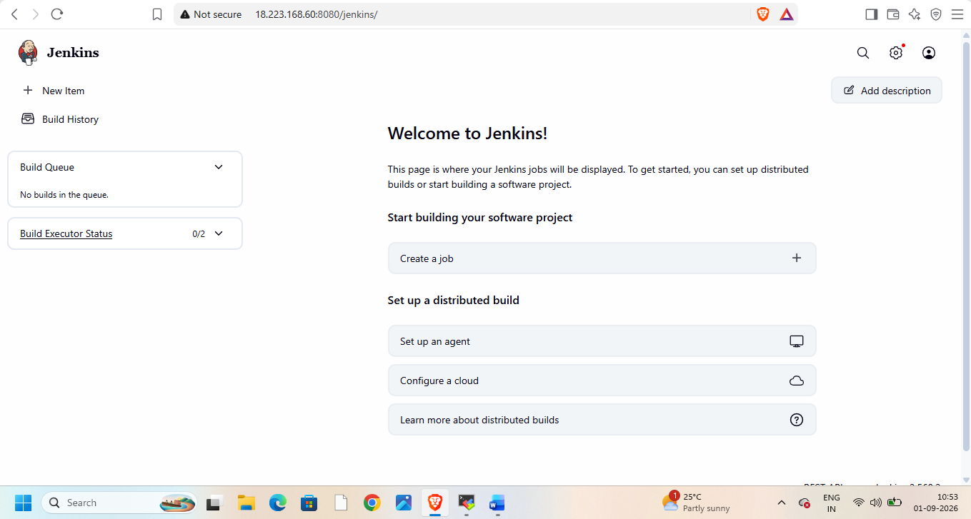
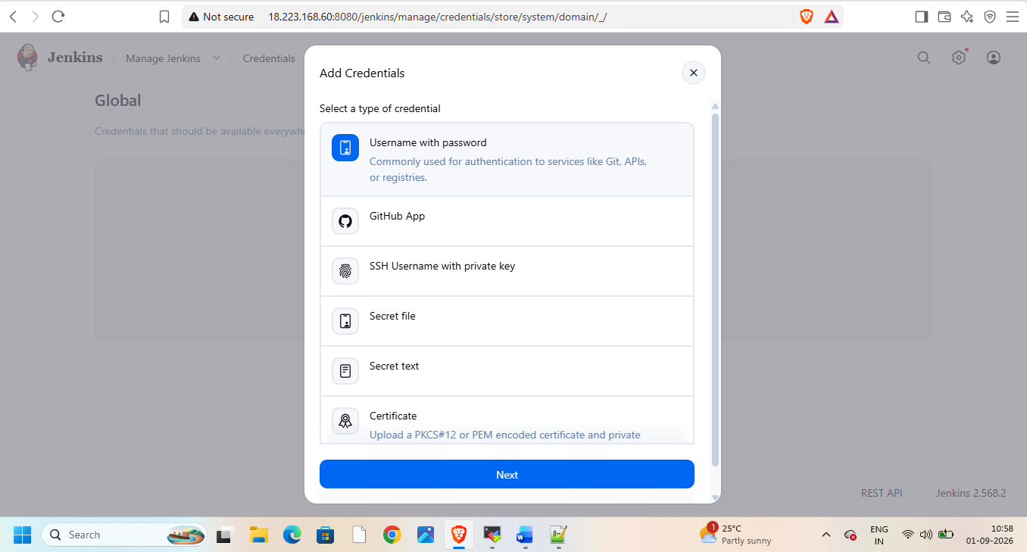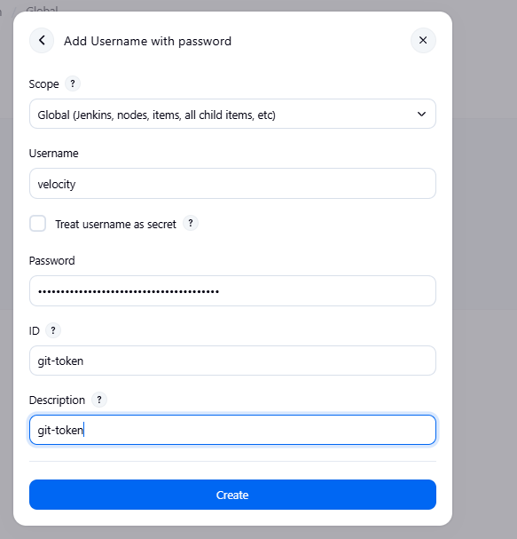

Go to Jenkins nodes and create node slave-1
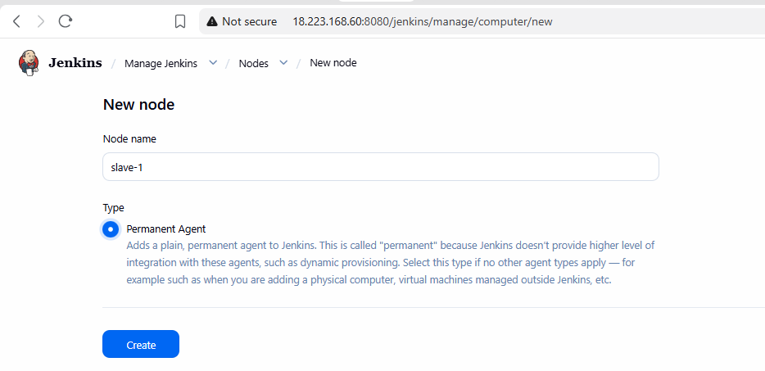
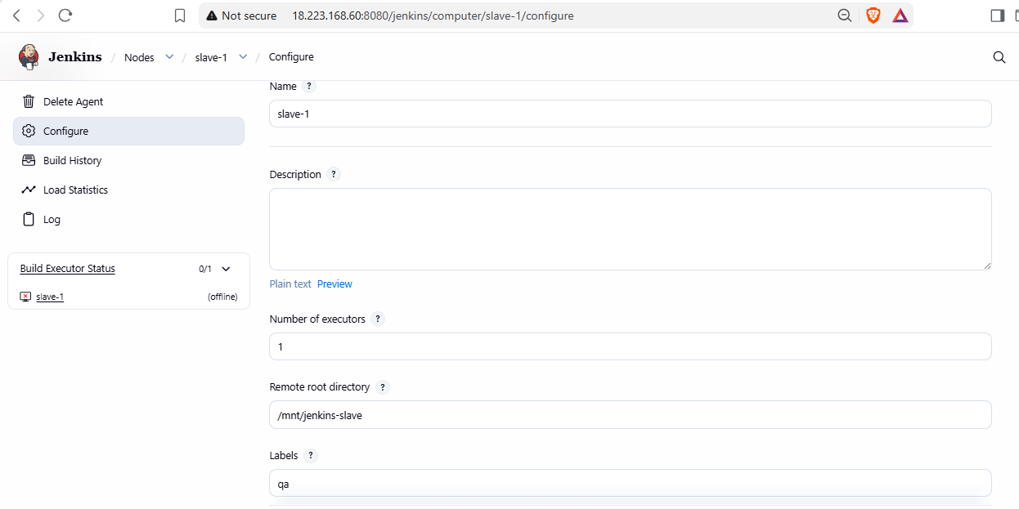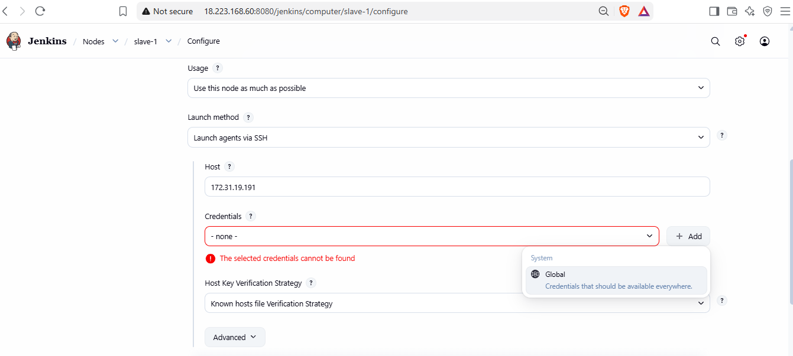
Add global credentials
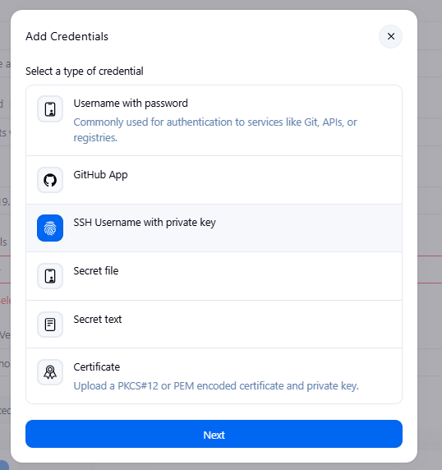
Add key from .pem file
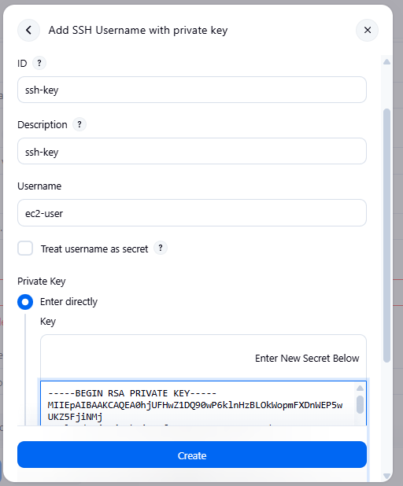
add create key
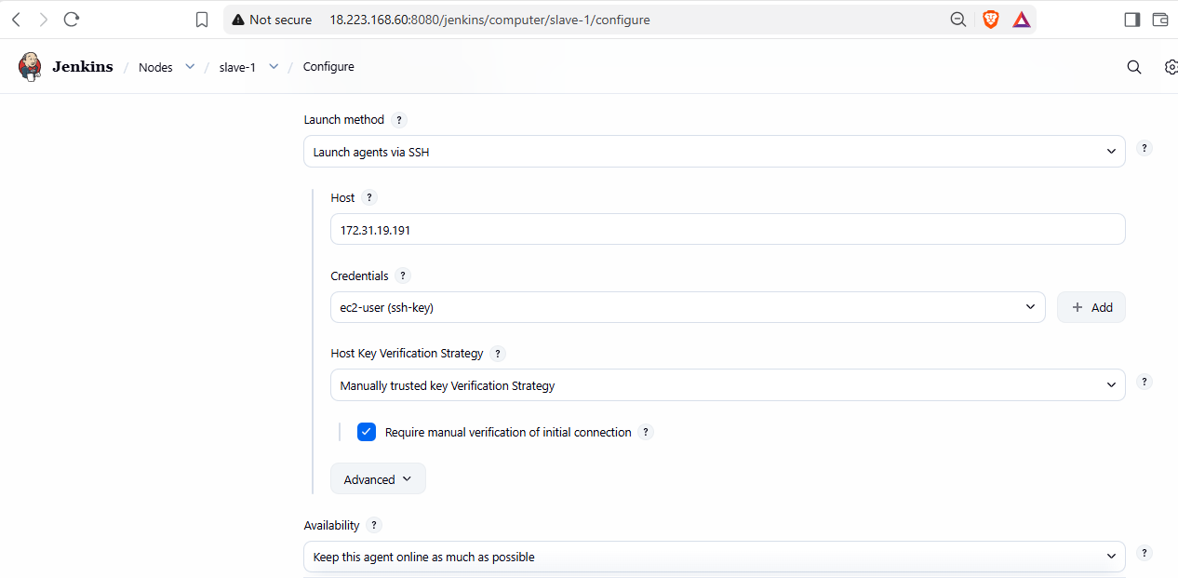
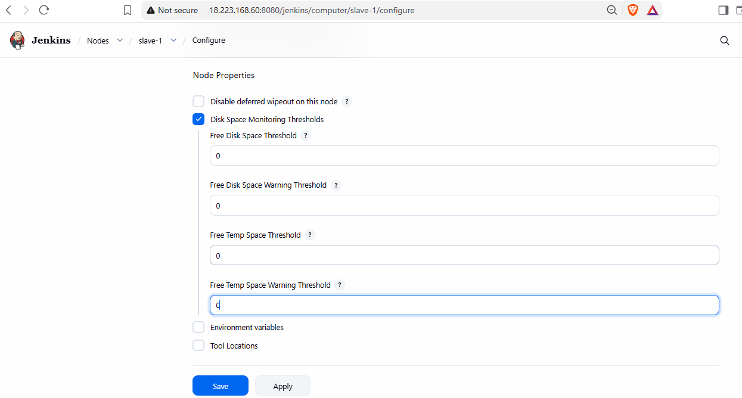
Apply and save. Manually trust key and relaunch agent
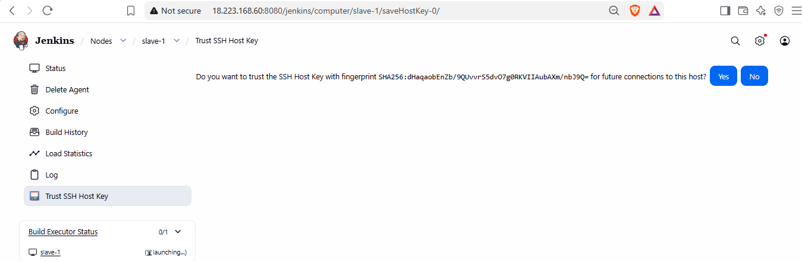
Now do this on slave-1 and 2 as well
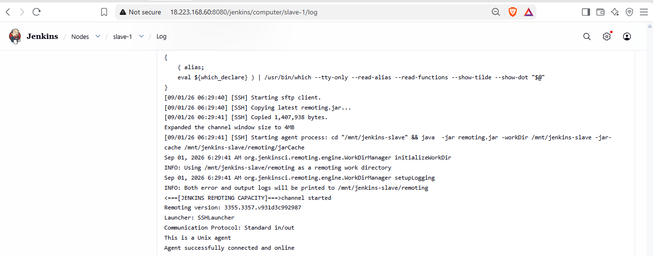
Now create slave-2 with its private ip
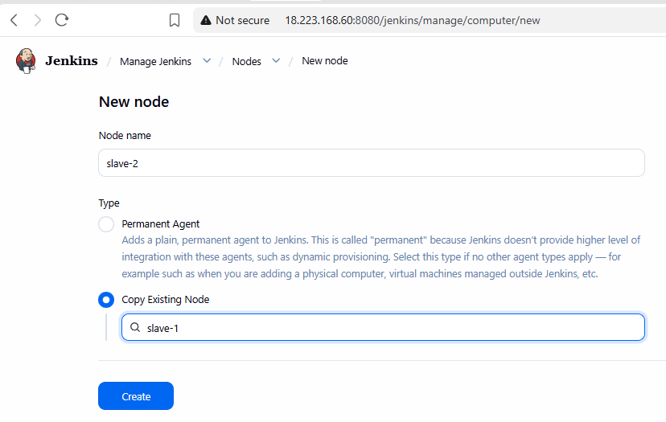
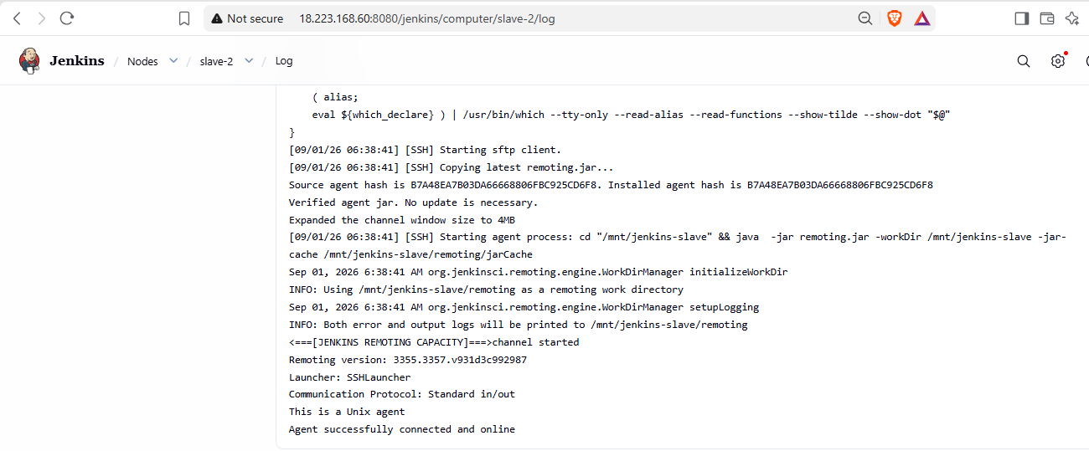
Now we have 3 nodes
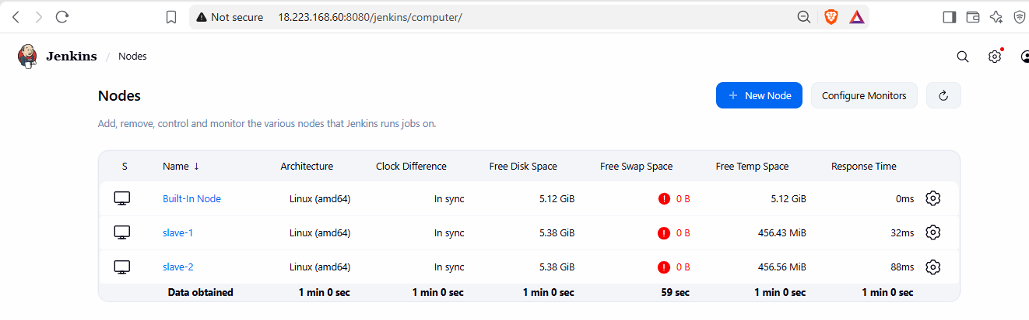
Now create job for master
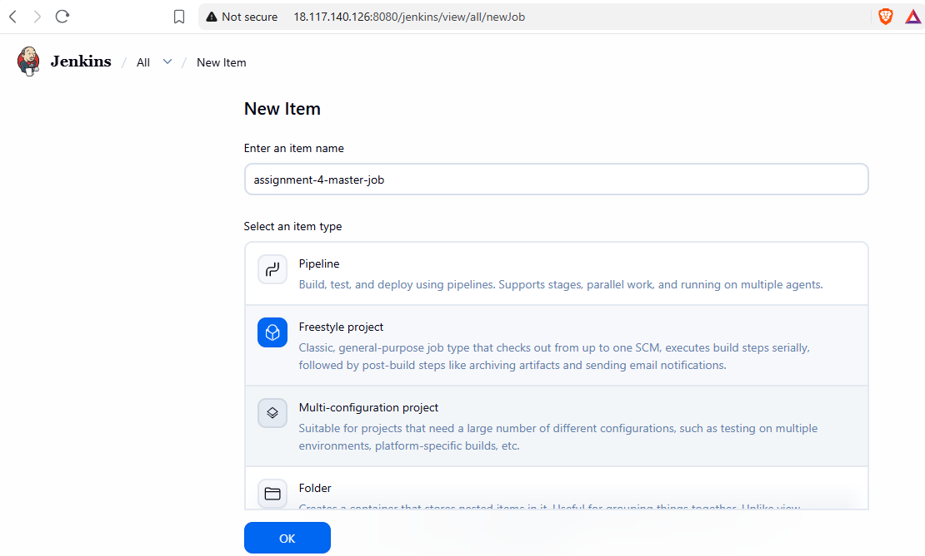

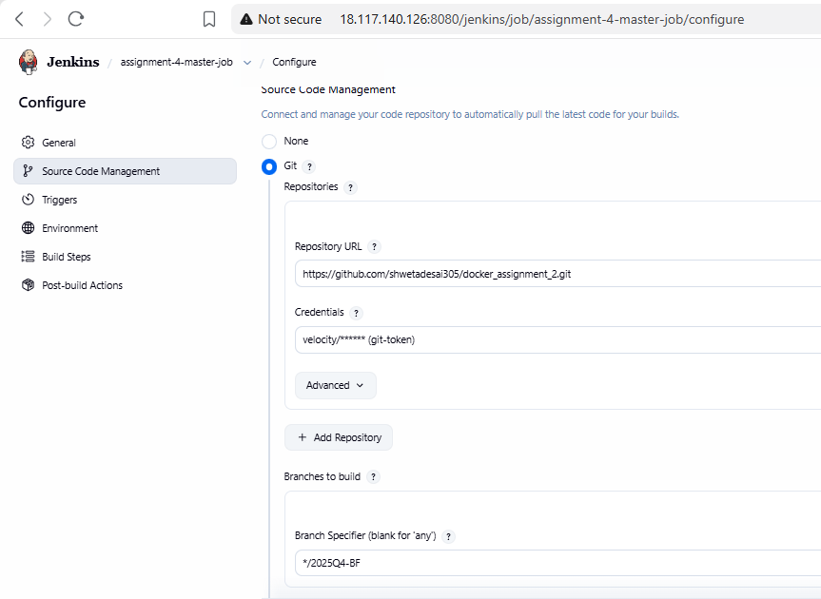
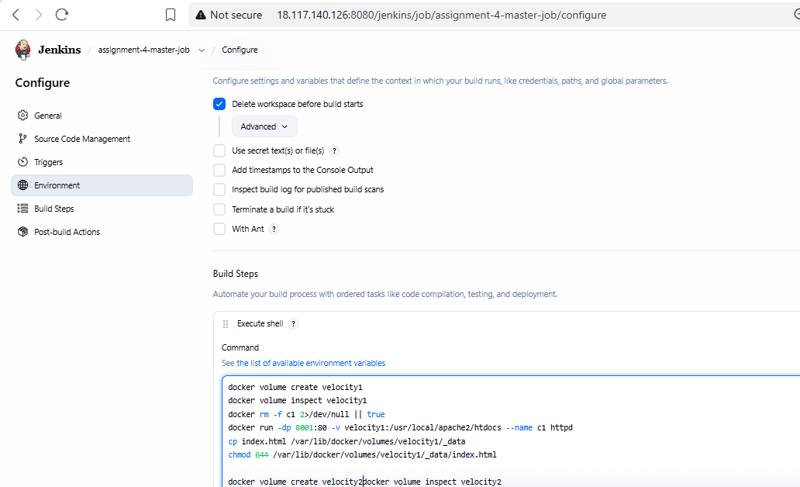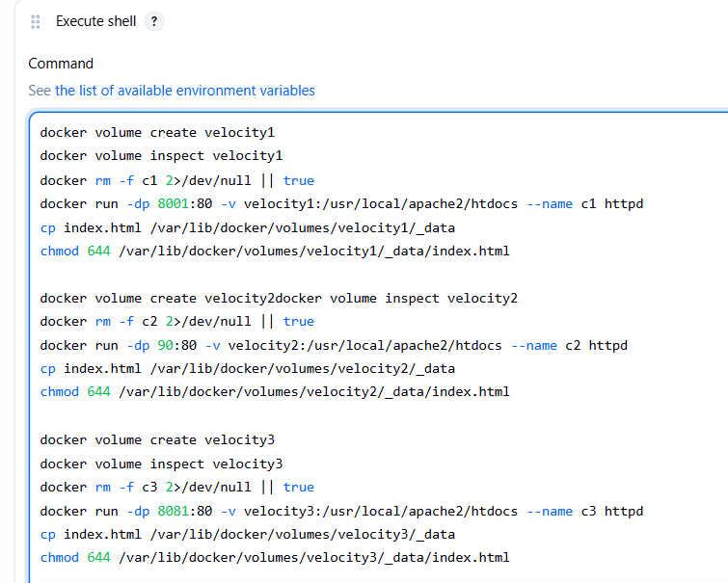
NOW we can see all ports on jenkins master
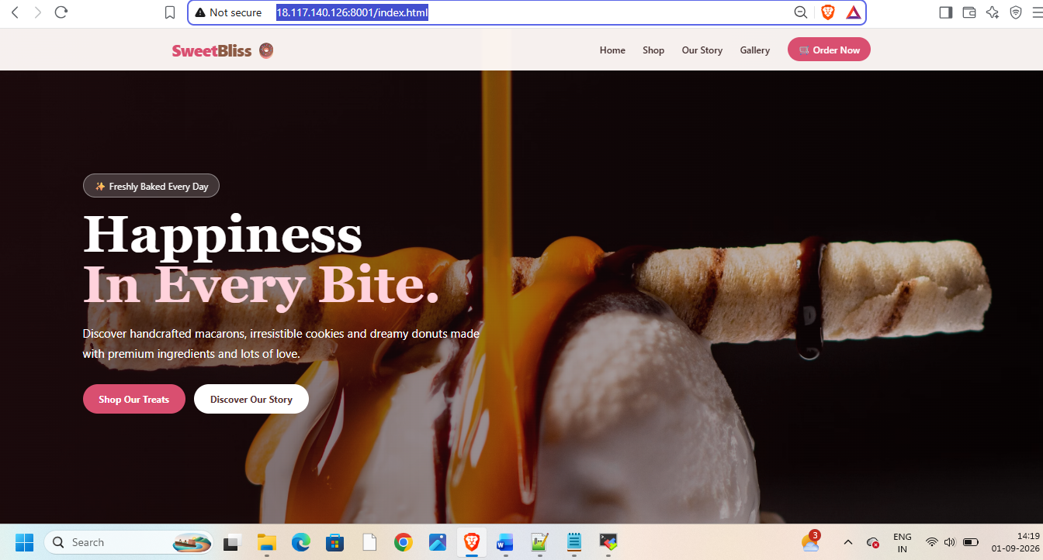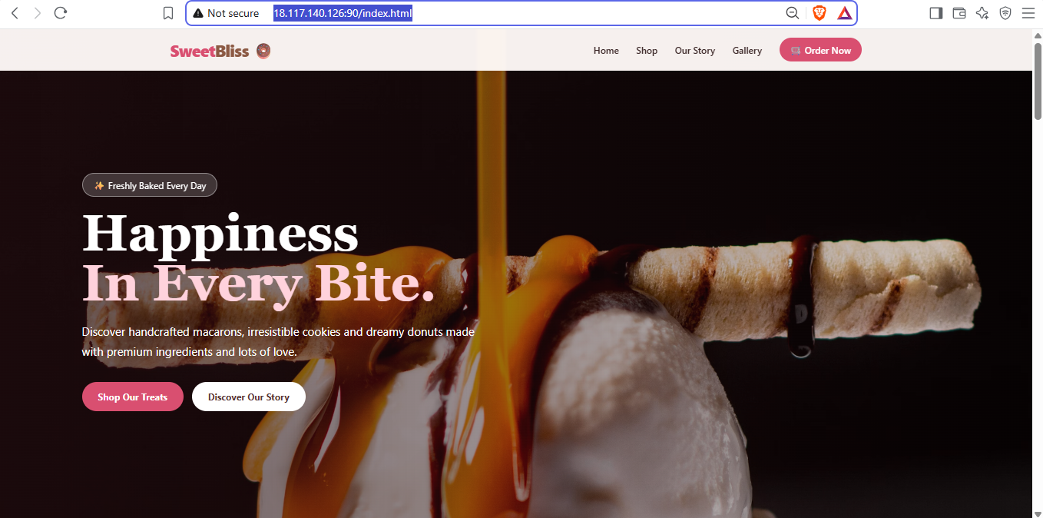
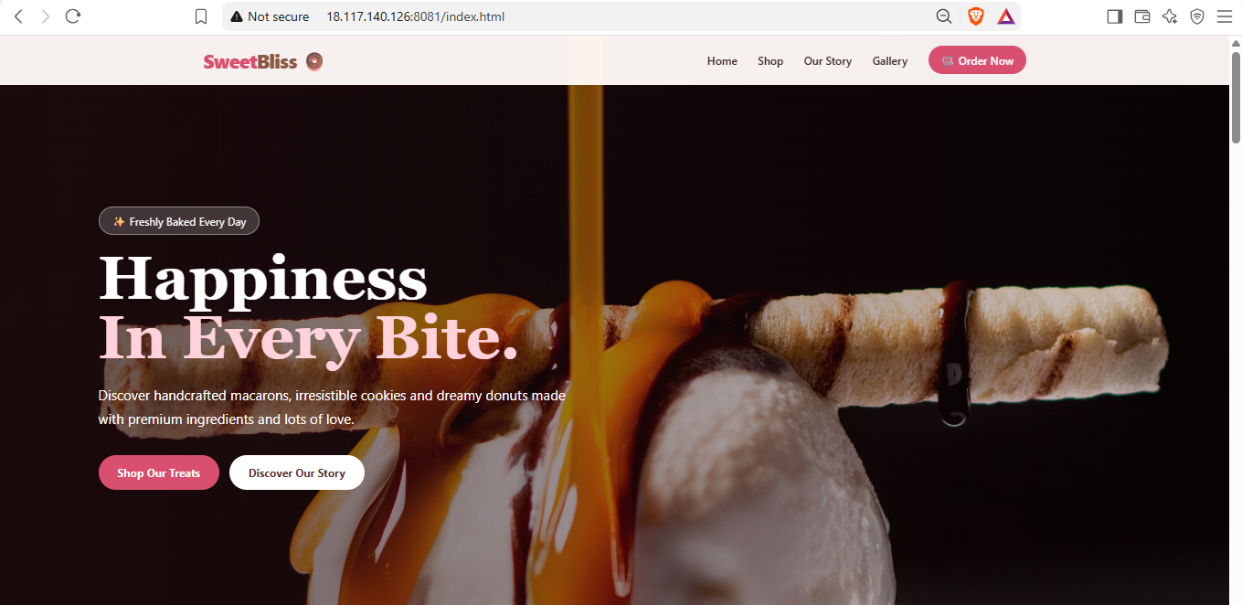
Now create job with git branch 2026Q1-MR and check on browser  
Now create job for master integrating with branch 2026Q2-PR


Use below shell script for this job
git branch:'2025Q4-BF', credentialsId:'git-token', url:'https://github.com/shwetadesai305/docker_assignment_2.git'
docker volume inspect velocity1
docker rm -f c1 2>/dev/null || true
docker run -dp 8001:80 -v velocity1:/usr/local/apache2/htdocs --name c1 httpd
docker volume create velocity1
cp index.html /var/lib/docker/volumes/velocity1/_data
chmod 644 /var/lib/docker/volumes/velocity1/_data/index.html

docker volume create velocity2
docker volume inspect velocity2
docker rm -f c2 2>/dev/null || true
docker run -dp 90:80 -v velocity2:/usr/local/apache2/htdocs --name c2 httpd
cp index.html /var/lib/docker/volumes/velocity2/_data
chmod 644 /var/lib/docker/volumes/velocity2/_data/index.html

docker volume create velocity3
docker volume inspect velocity3
docker rm -f c3 2>/dev/null || true
docker run -dp 8081:80 -v velocity3:/usr/local/apache2/htdocs --name c3 httpd
cp index.html /var/lib/docker/volumes/velocity3/_data
chmod 644 /var/lib/docker/volumes/velocity3/_data/index.html

