Docker Assignment 4: create pipeline for port binding 90,8001, 8081 to jenkins master, slave-1,slave-2. Each instance should be connect to each branch and all 3ports
Ans-
Launch 3 instances and connect to it, download java21, docker25, Jenkins2.5, tomcat11, git
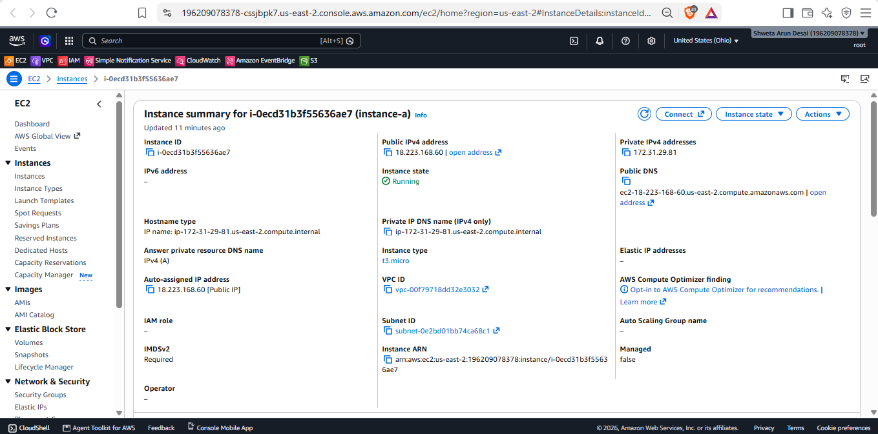
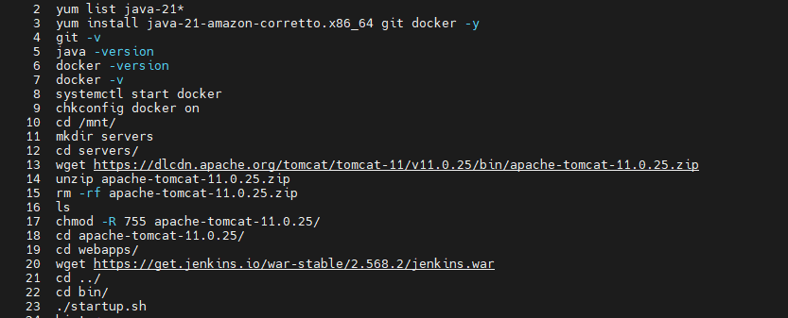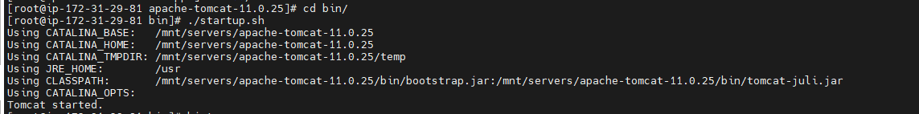
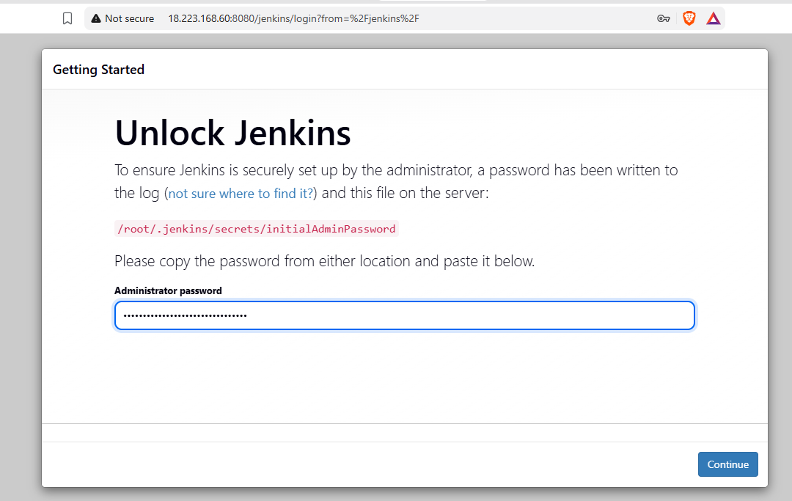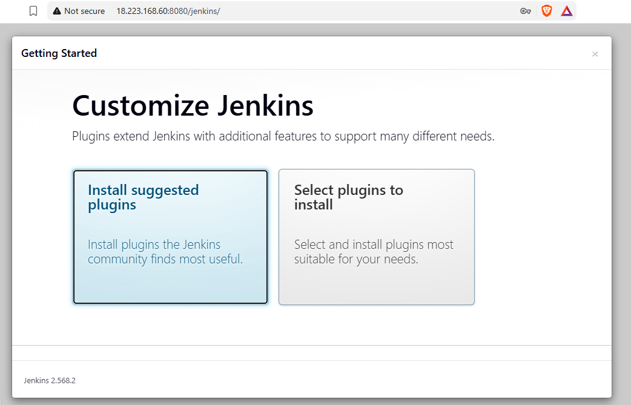
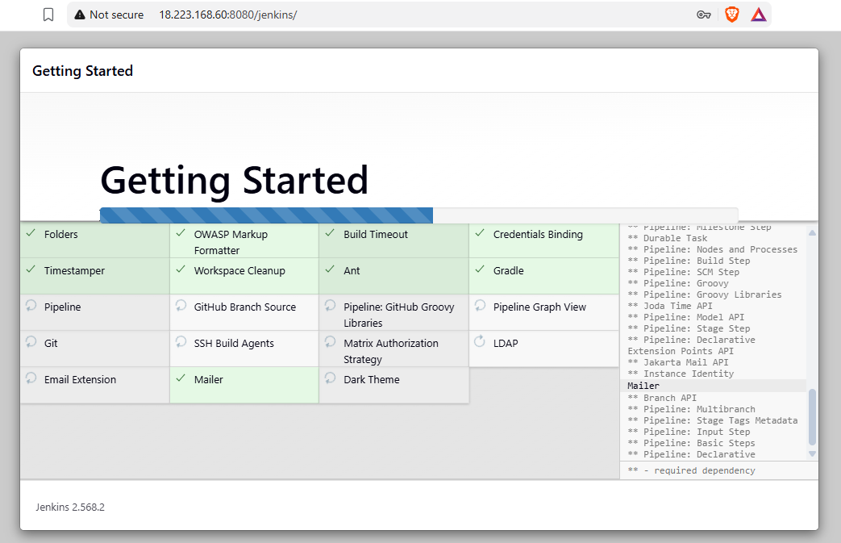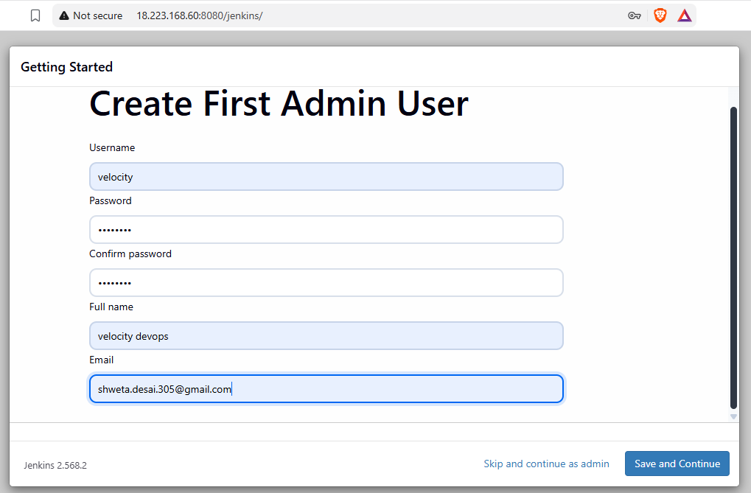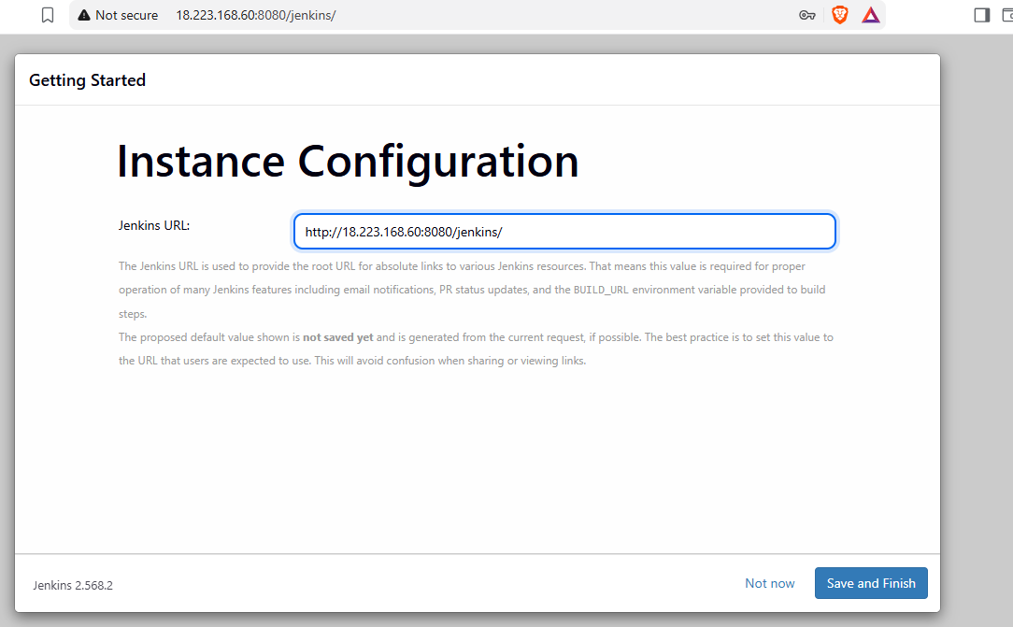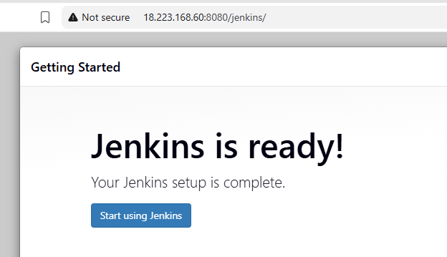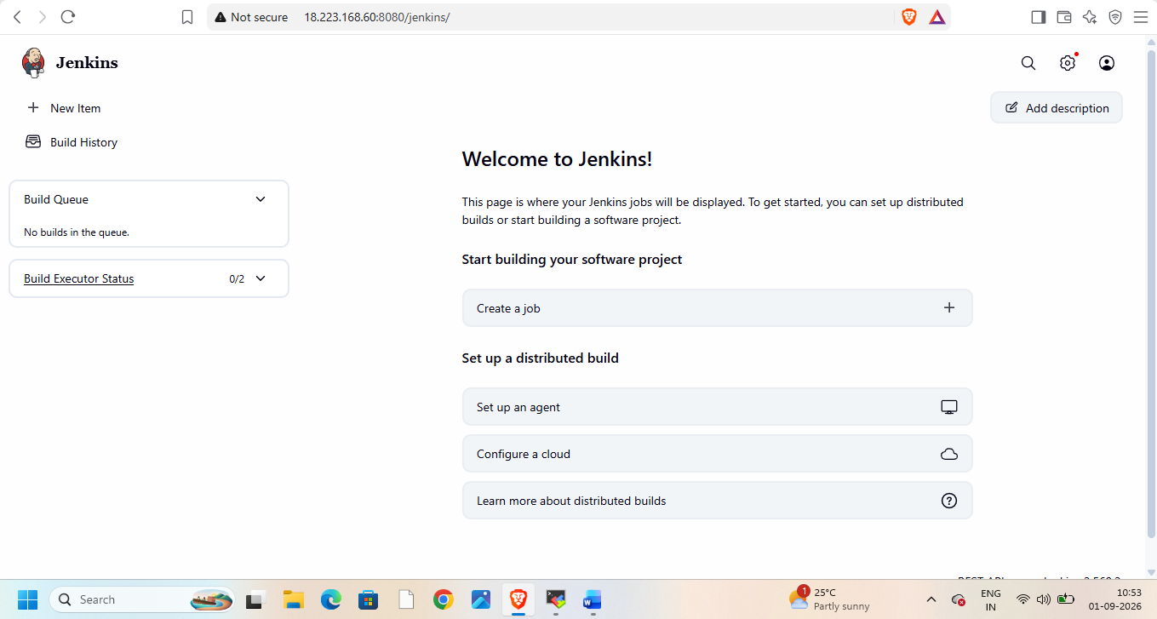
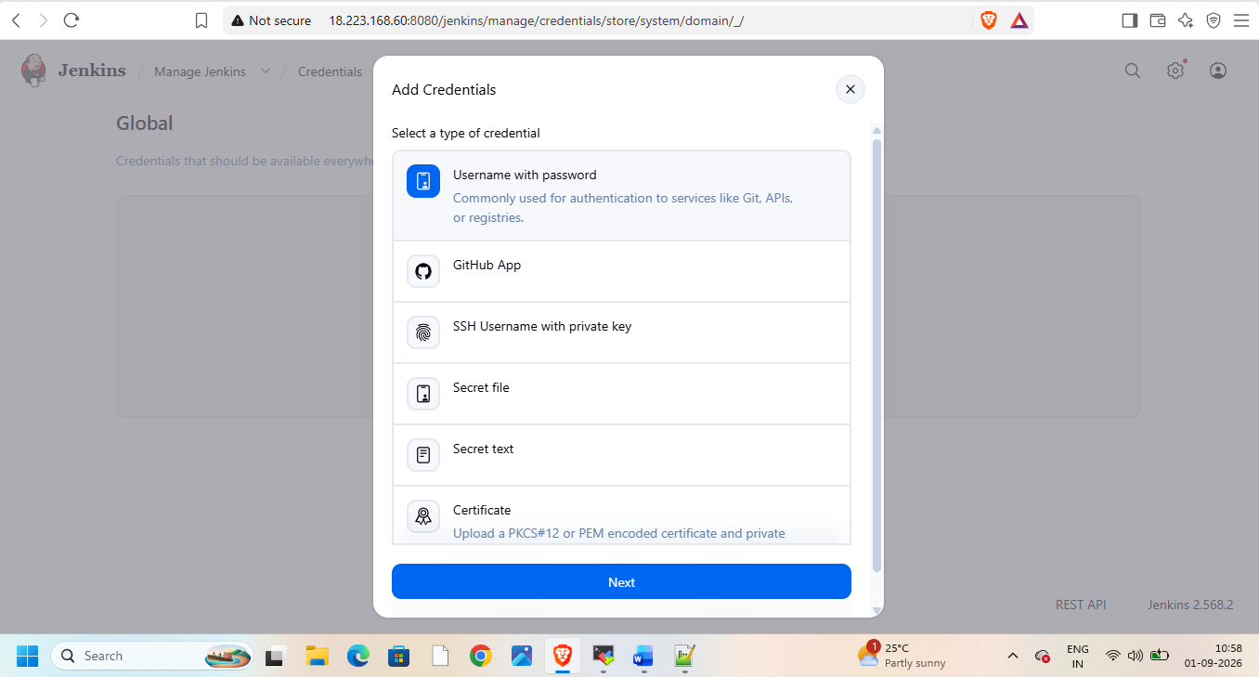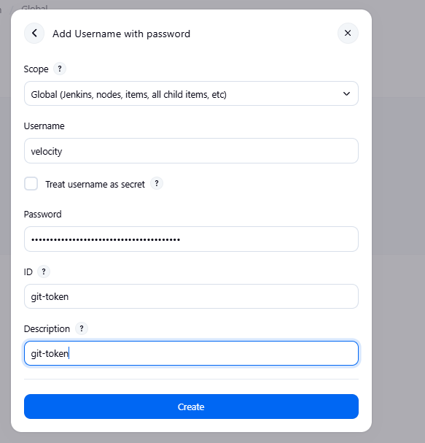

Go to Jenkins nodes and create node slave-1
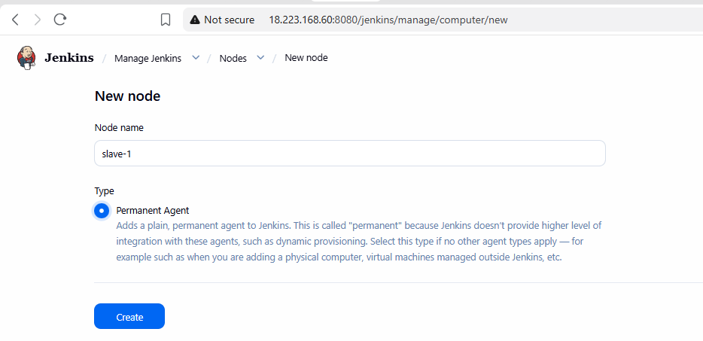
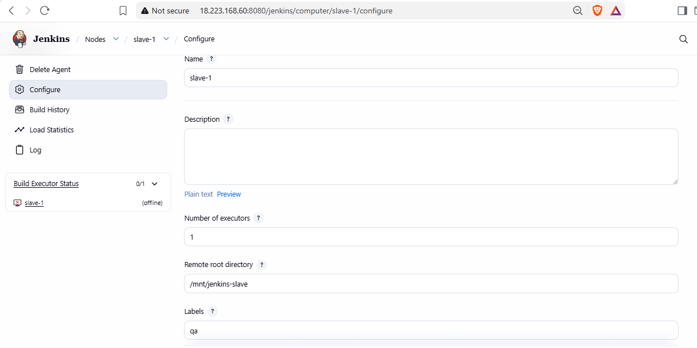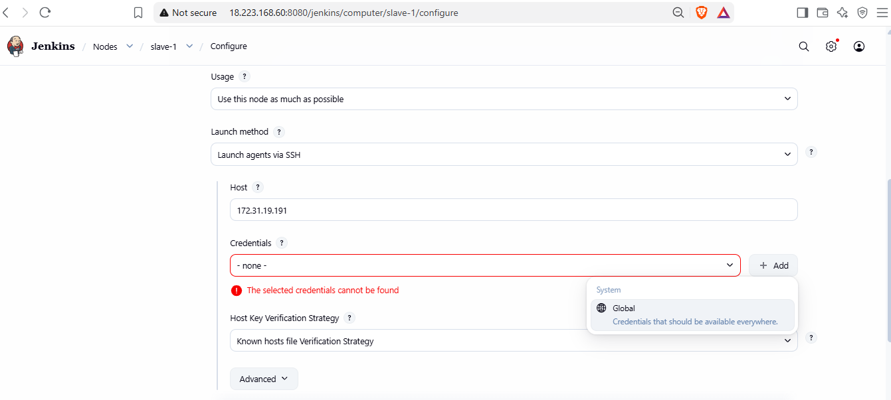
Add global credentials
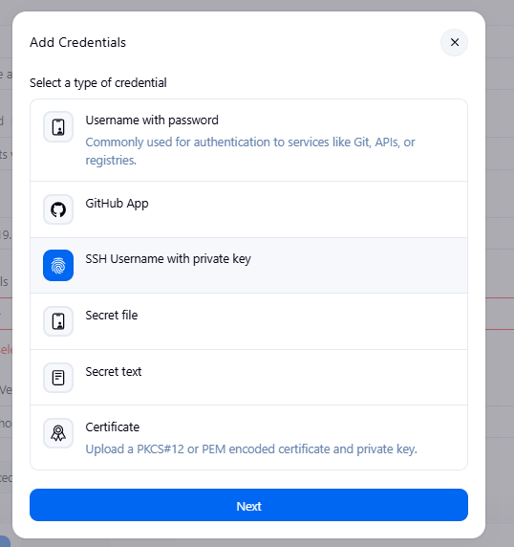
Add key from .pem file
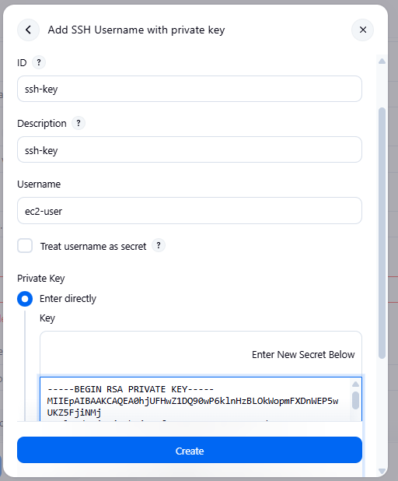
add create key
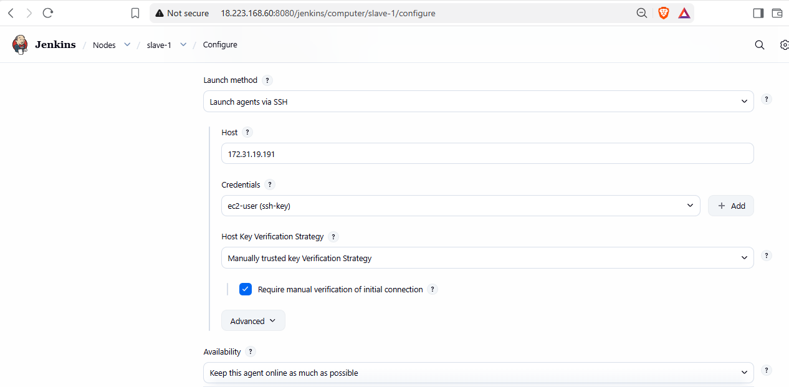
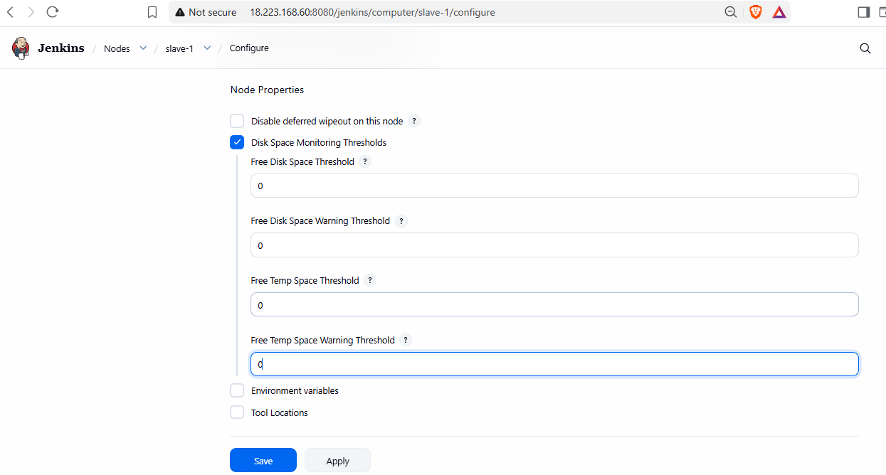
Apply and save. Manually trust key and relaunch agent
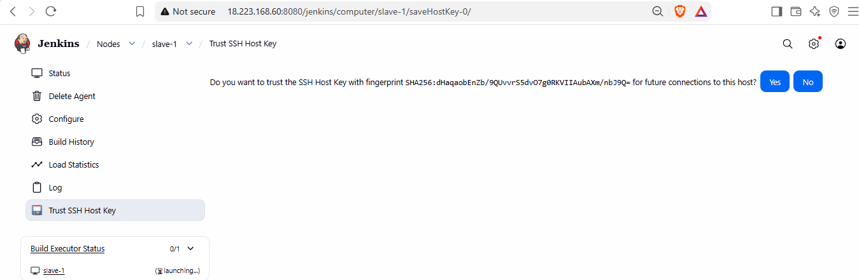
Now do this on slave-1 and 2 as well
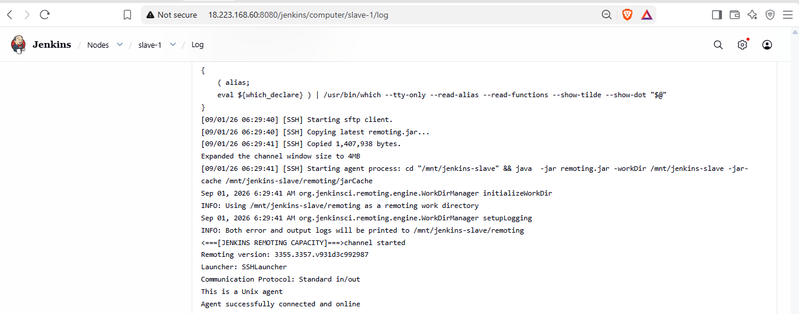
Now create slave-2 with its private ip
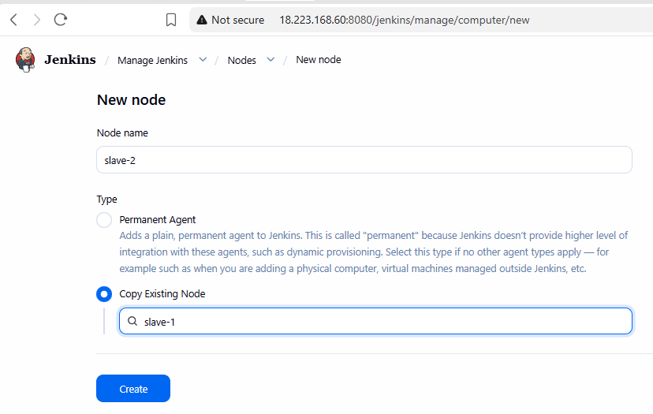
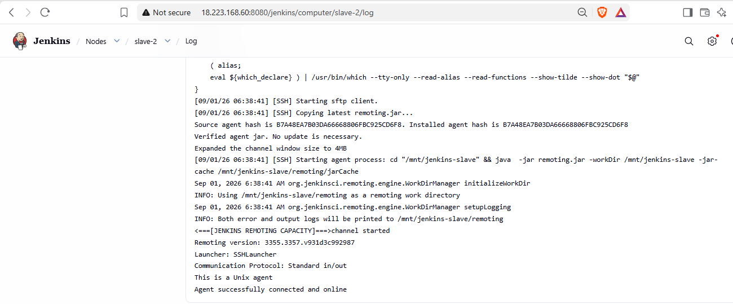
Now we have 3 nodes
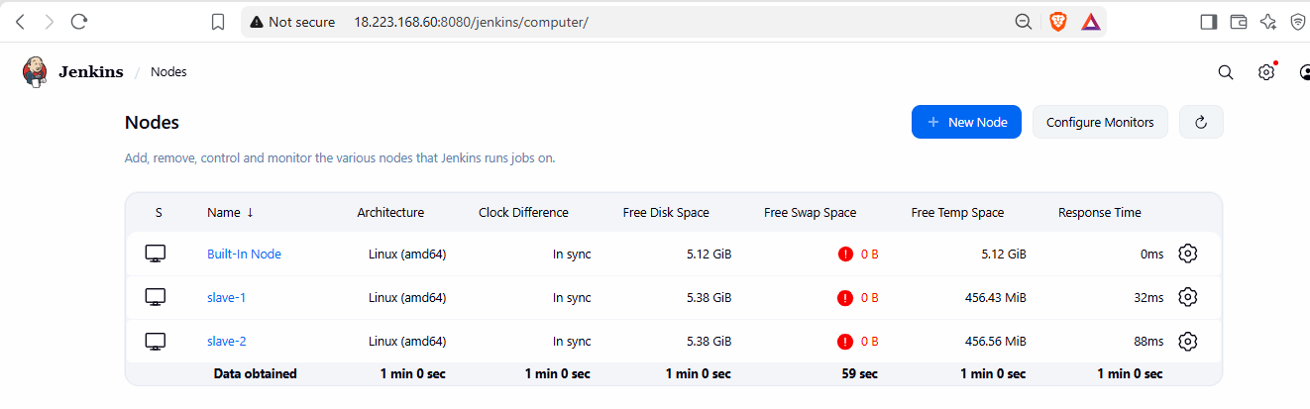
Now create pipeline for connecting all 3 branches with 3 ports and 3 git branches
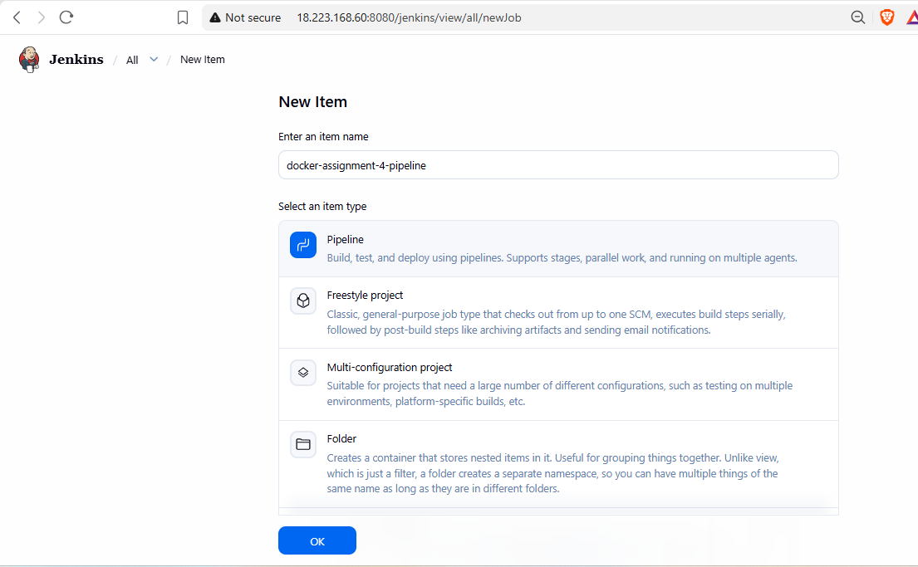
Write pipeline
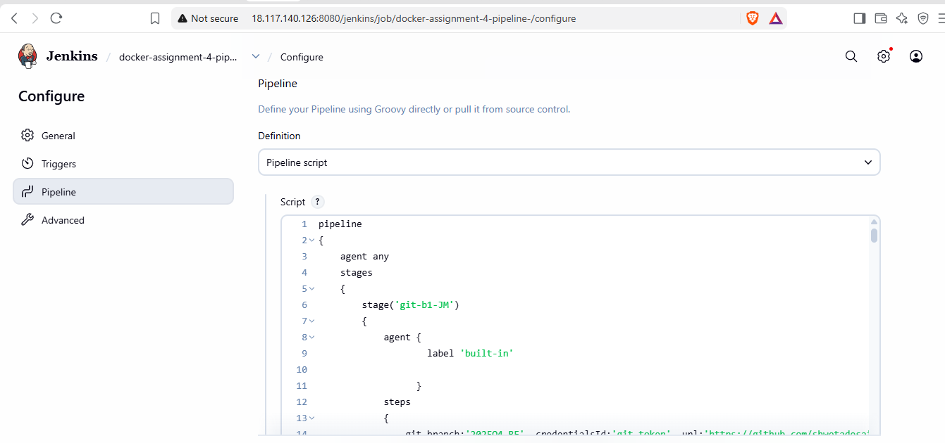
Add pipeline script in it
Build and check on console output
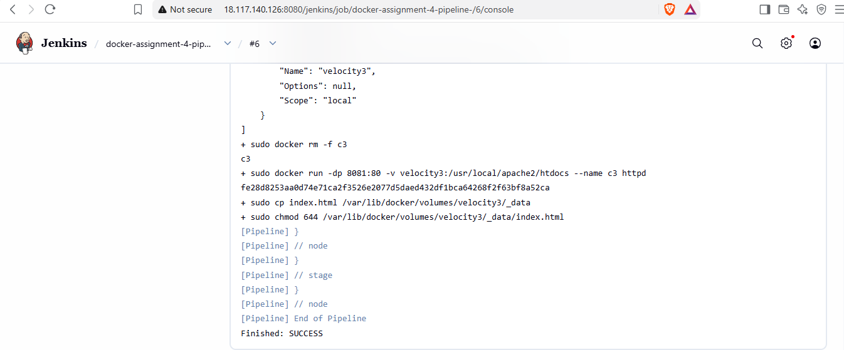
Now check on browser all 3 ports on master  

Now check on slave-1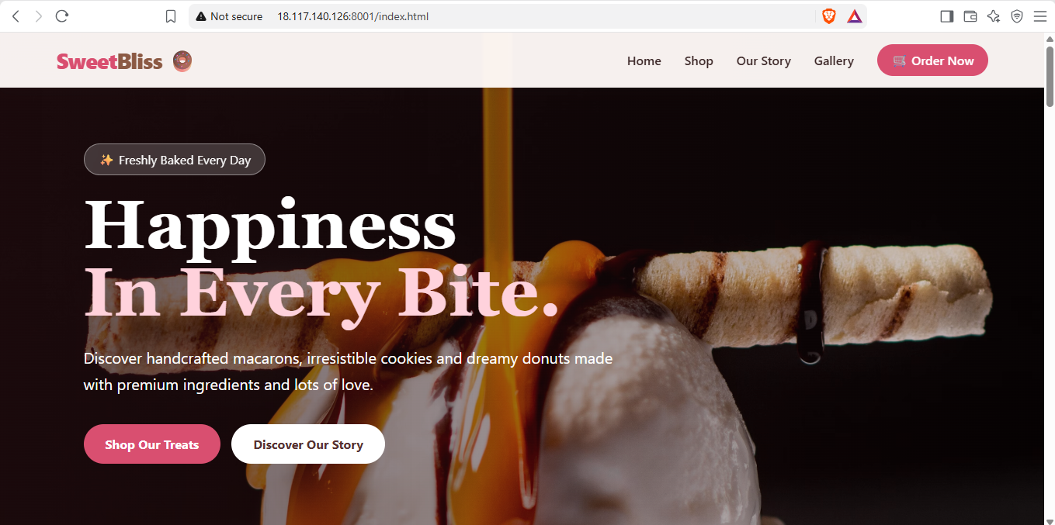  

Now check on slave-2  
Here is pipeline script used to achieve above output
pipeline
{
agent any
stages
{
stage('git-b1-JM')
{
agent {
label 'built-in'

}
steps
{
git branch:'2025Q4-BF', credentialsId:'git-token', url:'https://github.com/shwetadesai305/docker_assignment_2.git'
sh '''
docker volume create velocity1
docker volume inspect velocity1
docker rm -f c1 2>/dev/null || true
docker run -dp 8001:80 -v velocity1:/usr/local/apache2/htdocs --name c1 httpd
cp index.html /var/lib/docker/volumes/velocity1/_data
chmod 644 /var/lib/docker/volumes/velocity1/_data/index.html
'''
}

}

stage('git-b2-JM')
{
agent {
label 'built-in'

}
steps
{
git branch:'2026Q1-MR', credentialsId:'git-token', url:'https://github.com/shwetadesai305/docker_assignment_2.git'
sh '''
docker volume create velocity2
docker volume inspect velocity2
docker rm -f c2 2>/dev/null || true
docker run -dp 90:80 -v velocity2:/usr/local/apache2/htdocs --name c2 httpd
cp index.html /var/lib/docker/volumes/velocity2/_data
chmod 644 /var/lib/docker/volumes/velocity2/_data/index.html
'''
}

}

stage('git-b3-JM')
{
agent {
label 'built-in'

}
steps
{
git branch:'2026Q2-PR', credentialsId:'git-token', url:'https://github.com/shwetadesai305/docker_assignment_2.git'
sh '''
docker volume create velocity3
docker volume inspect velocity3
docker rm -f c3 2>/dev/null || true
docker run -dp 8081:80 -v velocity3:/usr/local/apache2/htdocs --name c3 httpd
cp index.html /var/lib/docker/volumes/velocity3/_data
chmod 644 /var/lib/docker/volumes/velocity3/_data/index.html
'''
}

}

stage('git-b1-s1')
{
agent {
label 'slave-1'

}
steps
{
git branch:'2025Q4-BF', credentialsId:'git-token', url:'https://github.com/shwetadesai305/docker_assignment_2.git'
sh '''
sudo docker volume create velocity1
sudo docker volume inspect velocity1
sudo docker rm -f c1 2>/dev/null || true
sudo docker run -dp 8001:80 -v velocity1:/usr/local/apache2/htdocs --name c1 httpd
sudo cp index.html /var/lib/docker/volumes/velocity1/_data
sudo chmod 644 /var/lib/docker/volumes/velocity1/_data/index.html
'''
}

}

stage('git-b2-s1')
{
agent {
label 'slave-1'

}
steps
{
git branch:'2026Q1-MR', credentialsId:'git-token', url:'https://github.com/shwetadesai305/docker_assignment_2.git'
sh '''
sudo docker volume create velocity2
sudo docker volume inspect velocity2
sudo docker rm -f c2 2>/dev/null || true
sudo docker run -dp 90:80 -v velocity2:/usr/local/apache2/htdocs --name c2 httpd
sudo cp index.html /var/lib/docker/volumes/velocity2/_data
sudo chmod 644 /var/lib/docker/volumes/velocity2/_data/index.html
'''
}

}

stage('git-b3-s1')
{
agent {
label 'slave-1'

}
steps
{
git branch:'2026Q2-PR', credentialsId:'git-token', url:'https://github.com/shwetadesai305/docker_assignment_2.git'
sh '''
sudo docker volume create velocity3
sudo docker volume inspect velocity3
sudo docker rm -f c3 2>/dev/null || true
sudo docker run -dp 8081:80 -v velocity3:/usr/local/apache2/htdocs --name c3 httpd
sudo cp index.html /var/lib/docker/volumes/velocity3/_data
sudo chmod 644 /var/lib/docker/volumes/velocity3/_data/index.html
'''
}

}

stage('git-b1-s2')
{
agent {
label 'slave-2'

}
steps
{
git branch:'2025Q4-BF', credentialsId:'git-token', url:'https://github.com/shwetadesai305/docker_assignment_2.git'
sh '''
sudo docker volume create velocity1
sudo docker volume inspect velocity1
sudo docker rm -f c1 2>/dev/null || true
sudo docker run -dp 8001:80 -v velocity1:/usr/local/apache2/htdocs --name c1 httpd
sudo cp index.html /var/lib/docker/volumes/velocity1/_data
sudo chmod 644 /var/lib/docker/volumes/velocity1/_data/index.html
'''
}

}

stage('git-b2-s2')
{
agent {
label 'slave-2'

}
steps
{
git branch:'2026Q1-MR', credentialsId:'git-token', url:'https://github.com/shwetadesai305/docker_assignment_2.git'
sh '''
sudo docker volume create velocity2
sudo docker volume inspect velocity2
sudo docker rm -f c2 2>/dev/null || true
sudo docker run -dp 90:80 -v velocity2:/usr/local/apache2/htdocs --name c2 httpd
sudo cp index.html /var/lib/docker/volumes/velocity2/_data
sudo chmod 644 /var/lib/docker/volumes/velocity2/_data/index.html
'''
}

}

stage('git-b3-s2')
{
agent {
label 'slave-2'

}
steps
{
git branch:'2026Q2-PR', credentialsId:'git-token', url:'https://github.com/shwetadesai305/docker_assignment_2.git'
sh '''
sudo docker volume create velocity3
sudo docker volume inspect velocity3
sudo docker rm -f c3 2>/dev/null || true
sudo docker run -dp 8081:80 -v velocity3:/usr/local/apache2/htdocs --name c3 httpd
sudo cp index.html /var/lib/docker/volumes/velocity3/_data
sudo chmod 644 /var/lib/docker/volumes/velocity3/_data/index.html
'''
}

}

}
}

