Docker Assignment 2 – create git repository with 3 branches and bind ports 80,90,8081 to each branch and check on browser
Ans-
Create git repo with three branches having index.html in it.
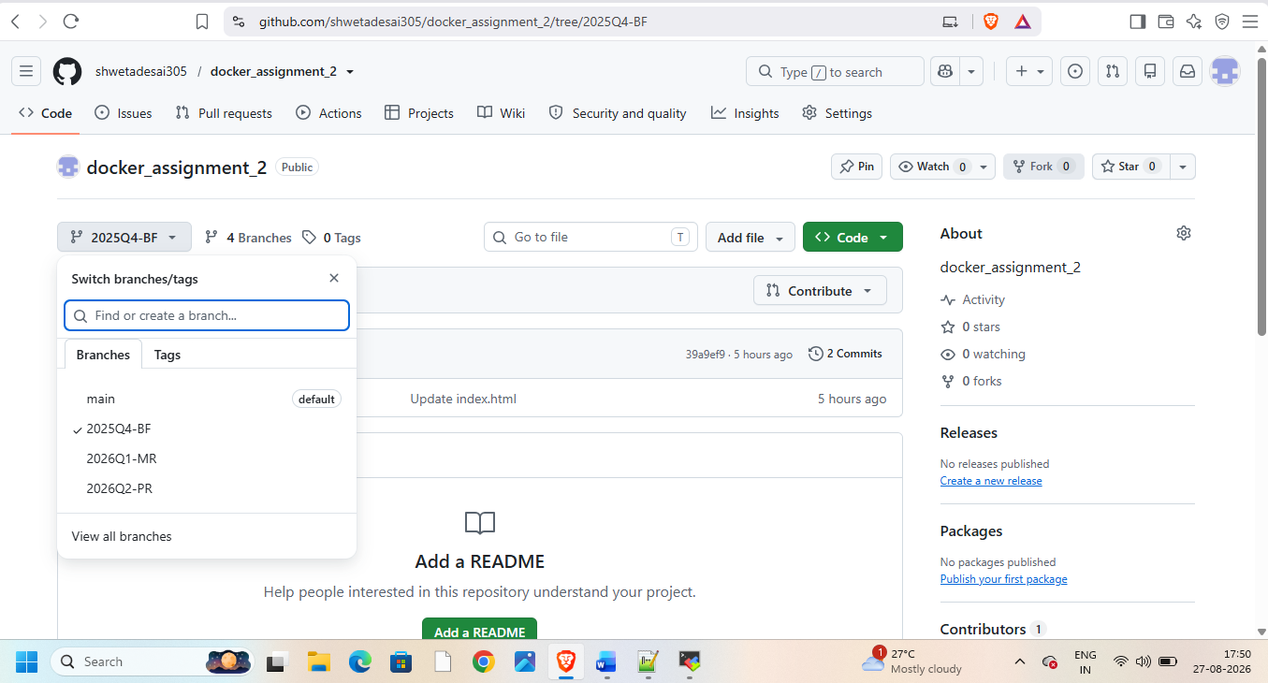
Launch instance and connect to it and download java21,git,tomcat11,Jenkins,docker on it
Start docker
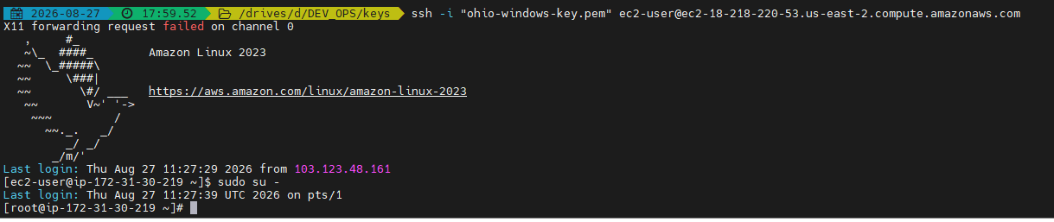
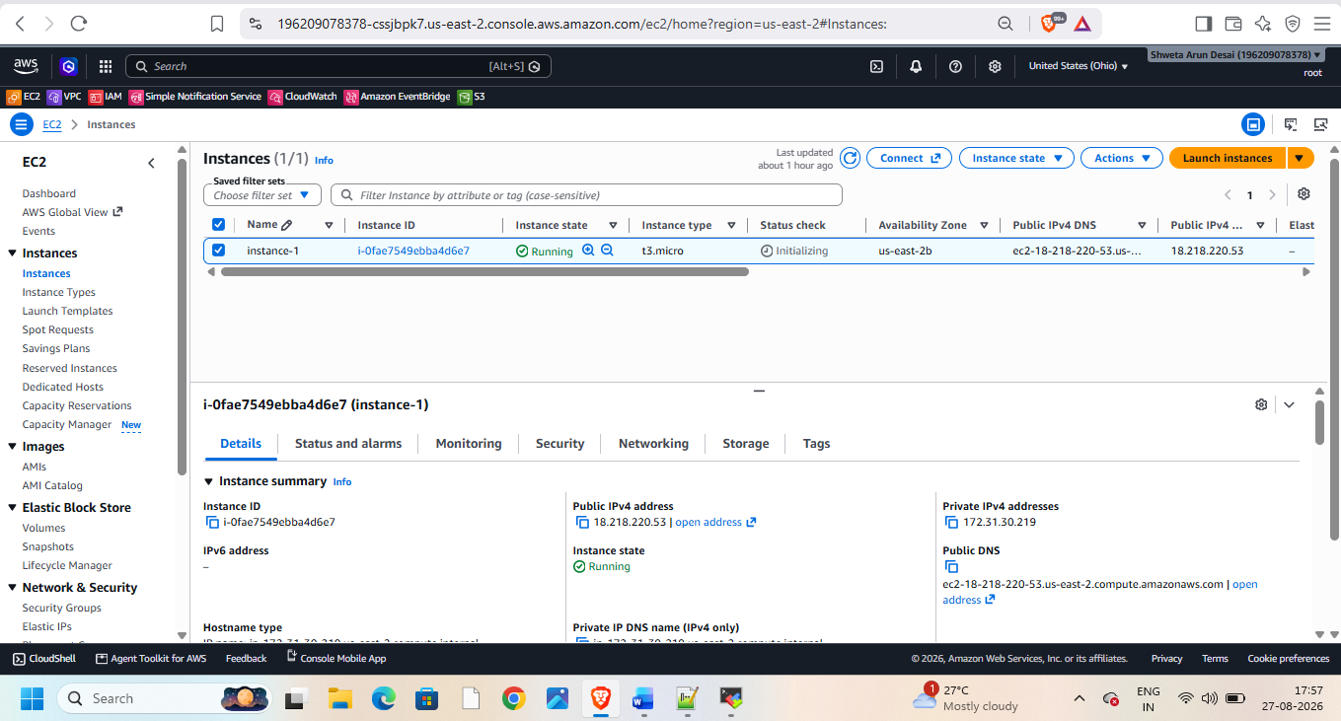
Then start Jenkins and create pipeline for it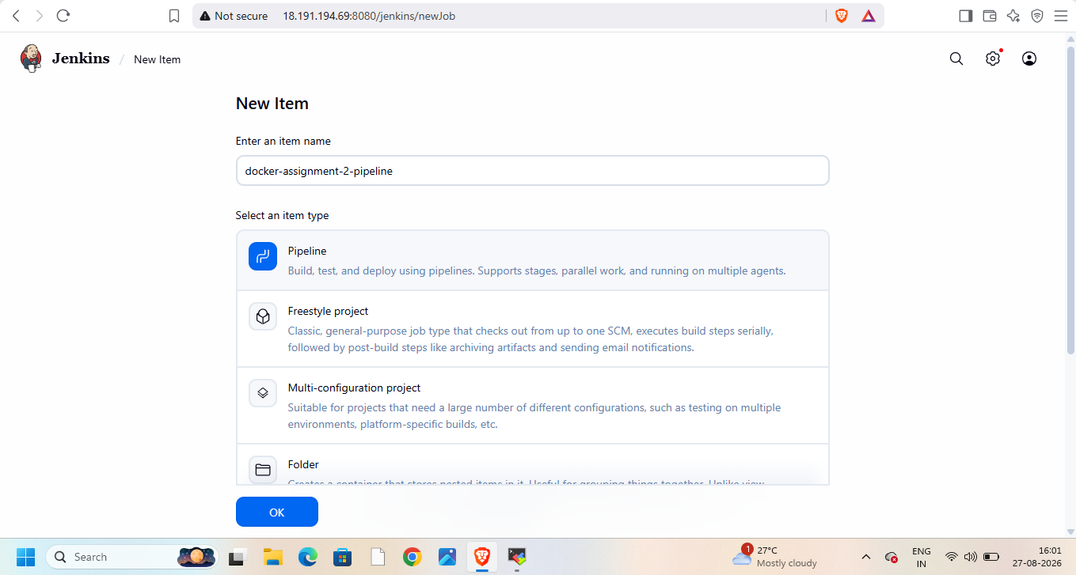

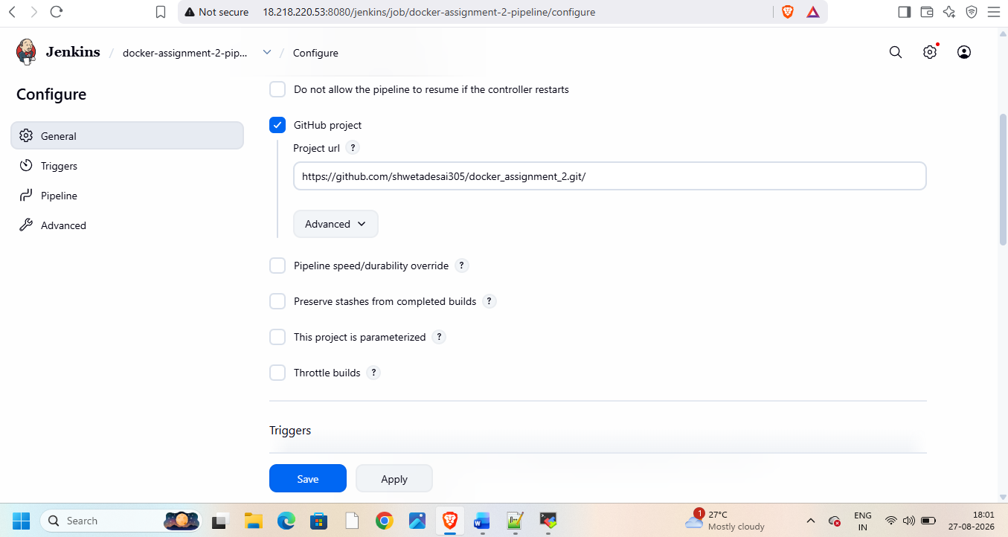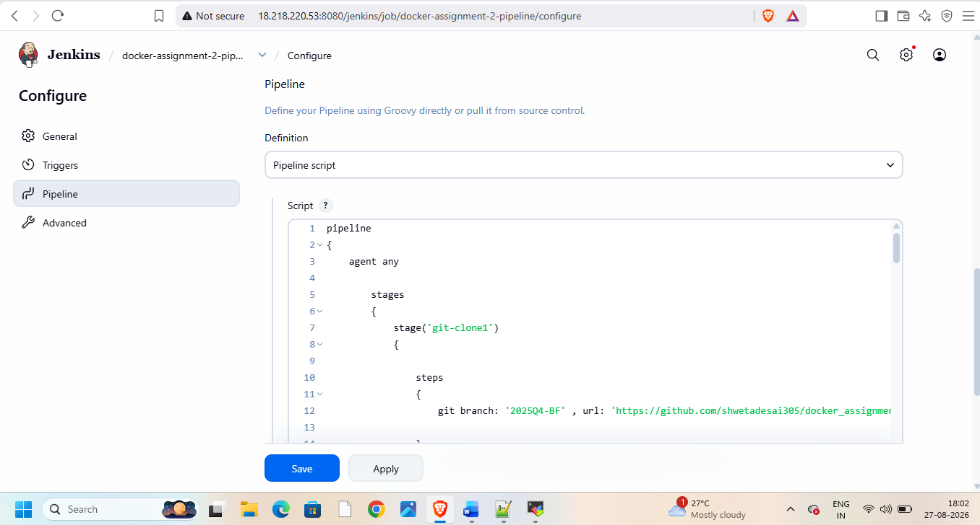
Add pipeline script in it

pipeline
{
agent any

stages
{
stage('git-clone1')
{

steps
{
git branch: '2025Q4-BF' , url: 'https://github.com/shwetadesai305/docker_assignment_2.git'

}

}

stage('docker-integration1')
{

steps
{
sh '''
sudo chmod 755 /mnt/c1
sudo cp index.html /mnt/c1/
sudo chmod 644 /mnt/c1/index.html
docker ps
docker rm -f c1 2>/dev/null || true
docker ps
docker run -dp 80:80 -v /mnt/c1/:/usr/local/apache2/htdocs --name c1 httpd
'''

}

}

stage('git-clone2')
{

steps
{
git branch: '2026Q1-MR' , url: 'https://github.com/shwetadesai305/docker_assignment_2.git'

}

}

stage('docker-integration2')
{

steps
{
sh '''
sudo chmod 755 /mnt/c2
sudo cp index.html /mnt/c2/
sudo chmod 644 /mnt/c2/index.html
docker ps
docker rm -f c2 2>/dev/null || true
docker ps
docker run -dp 90:80 -v /mnt/c2/:/usr/local/apache2/htdocs --name c2 httpd
'''

}

}
stage('git-clone3')
{

steps
{
git branch: '2026Q2-PR' , url: 'https://github.com/shwetadesai305/docker_assignment_2.git'

}

}

stage('docker-integration3')
{

steps
{
sh '''
sudo chmod 755 /mnt/c3
sudo cp index.html /mnt/c3/
sudo chmod 644 /mnt/c3/index.html
docker ps
docker rm -f c3 2>/dev/null || true
docker ps
docker run -dp 8081:80 -v /mnt/c3/:/usr/local/apache2/htdocs --name c3 httpd
'''

}

}

}
}
Check on browser with public ip and ports 80,80,8081
