Docker Assignment 2 – create git repository with 3 branches and bind ports 80,90,8081 to each branch and check on browser
Ans-
Create git repo with three branches having index.html in it.
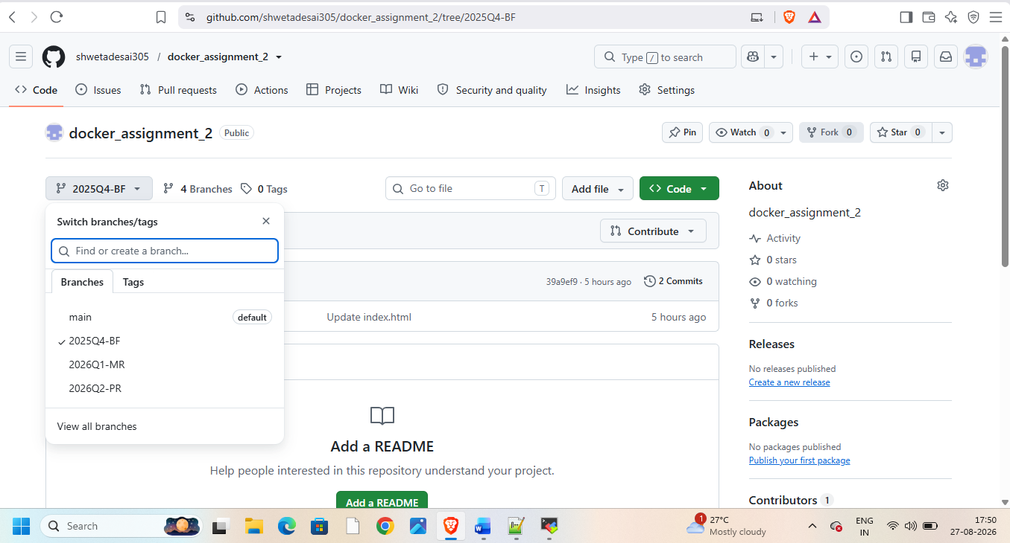
Launch instance and connect to it and download java21,git,tomcat11,Jenkins,docker on it
Start docker
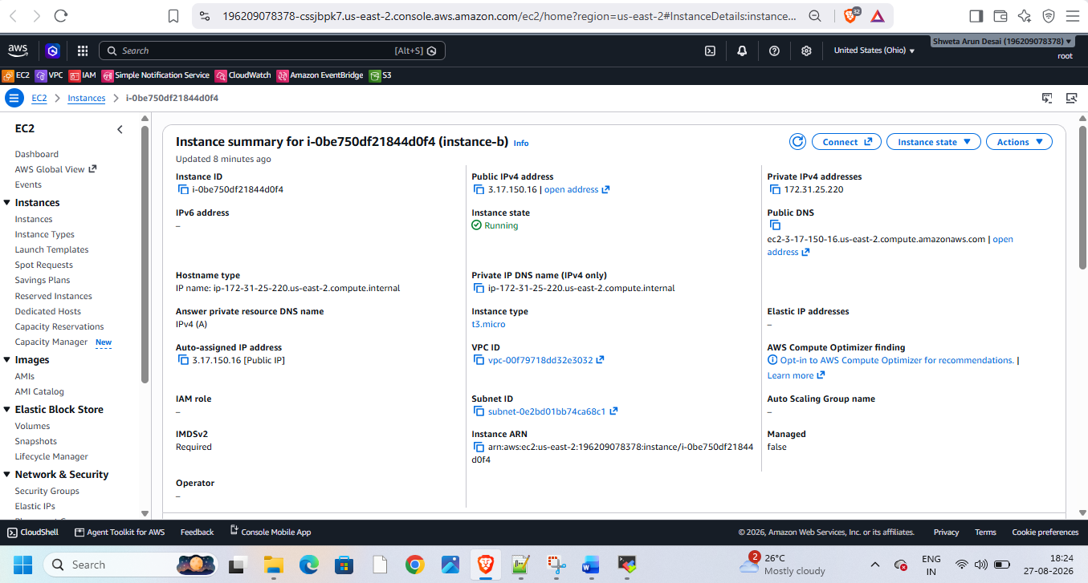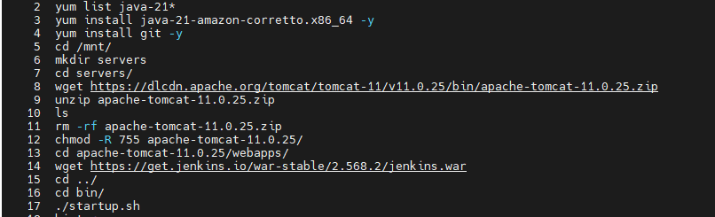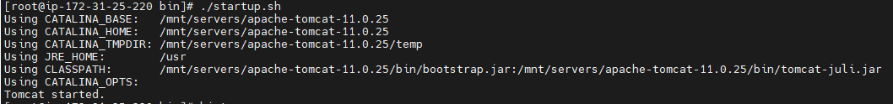
Start jenkins
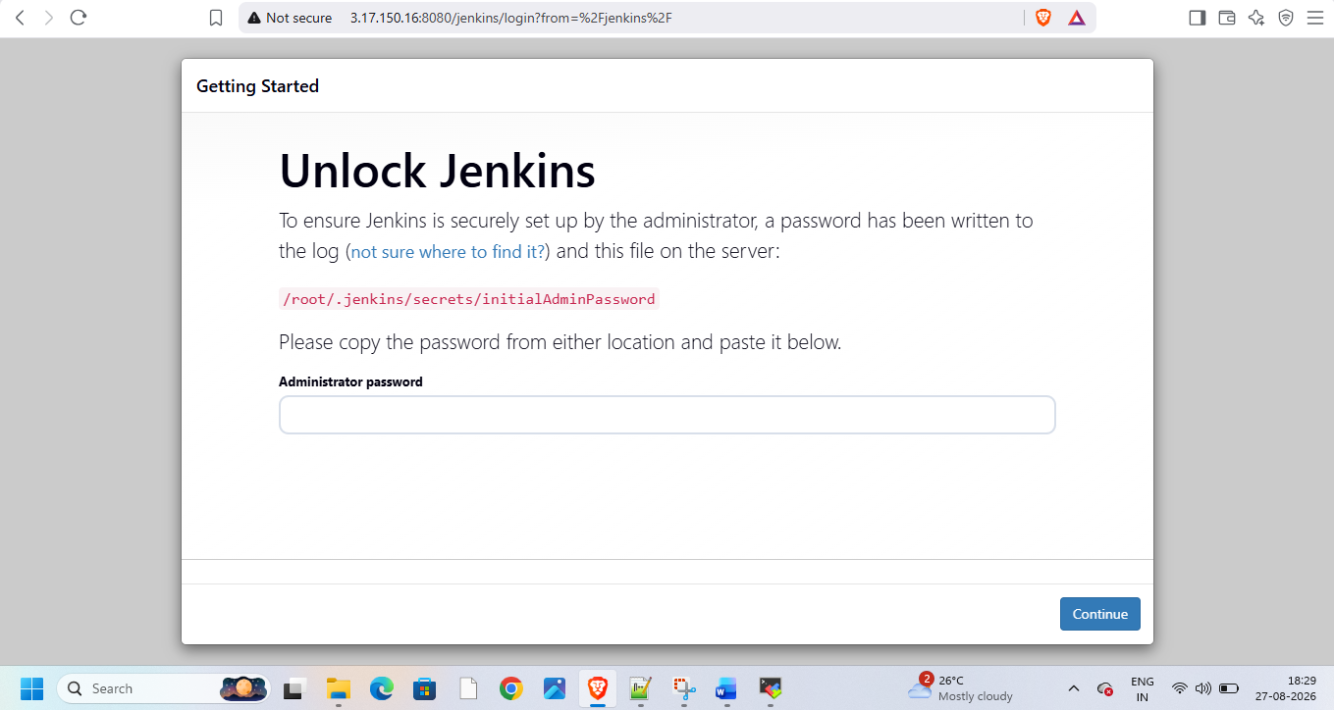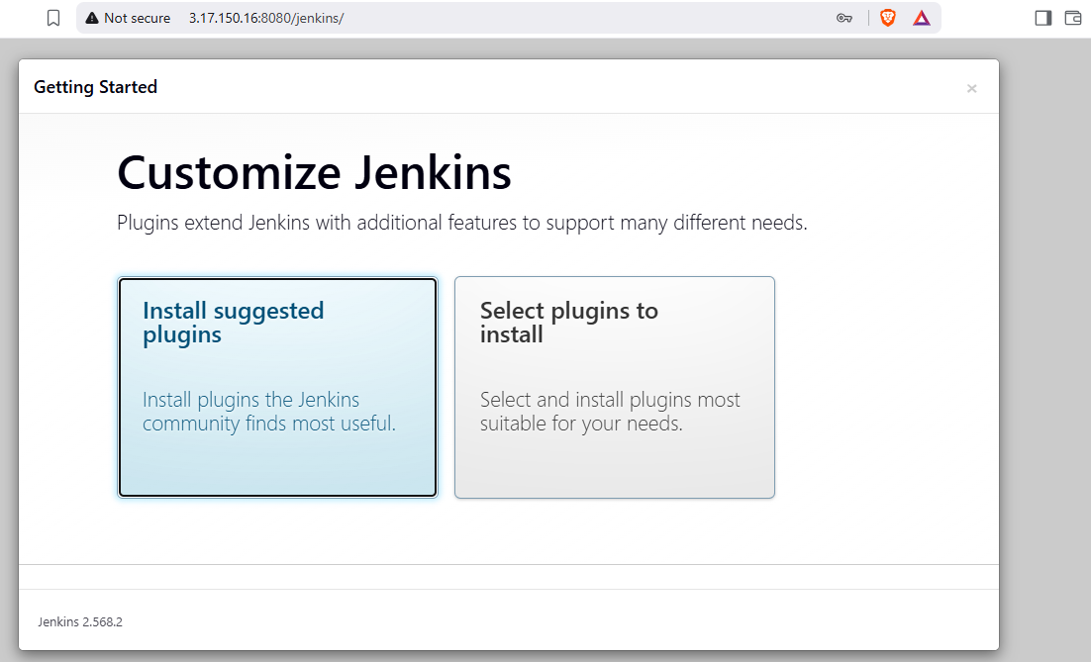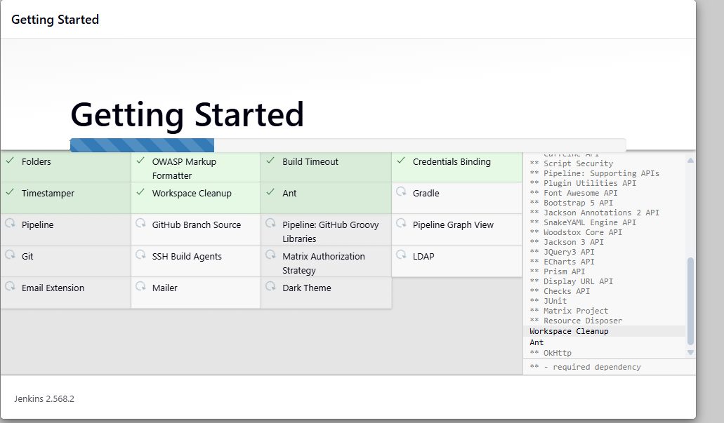
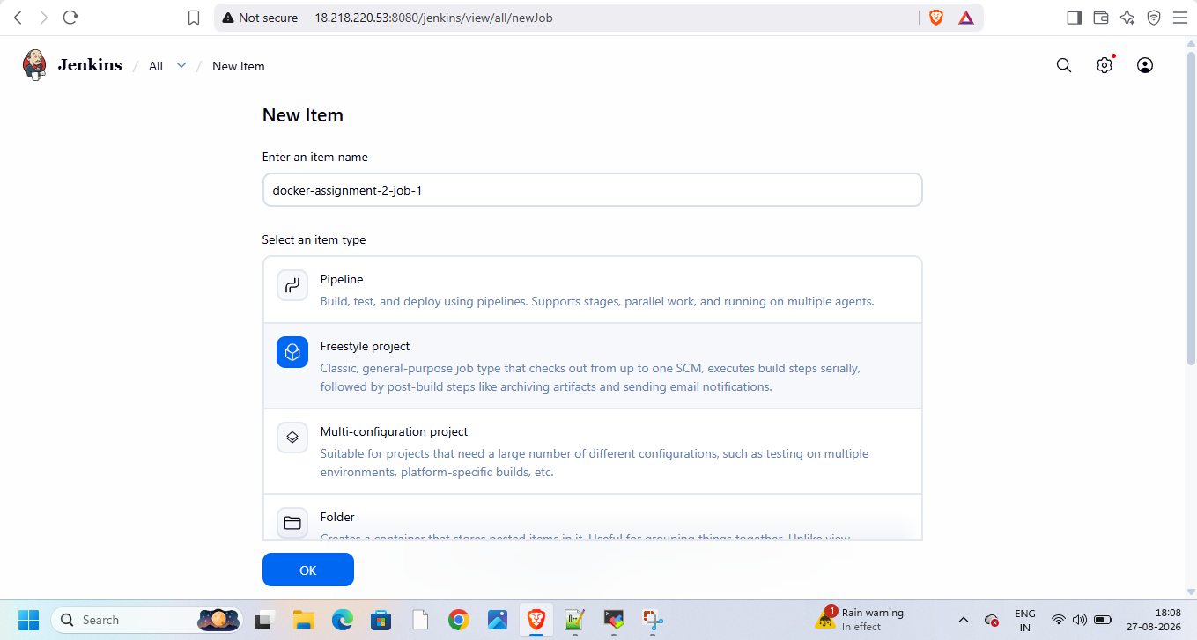
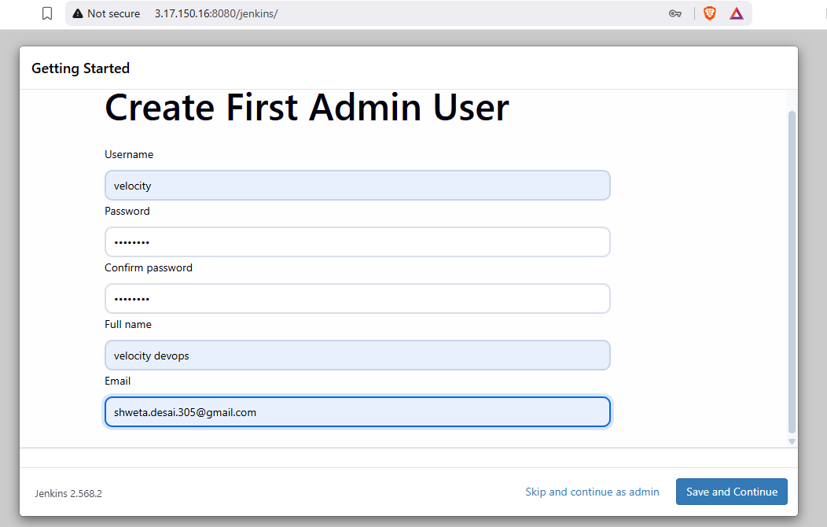
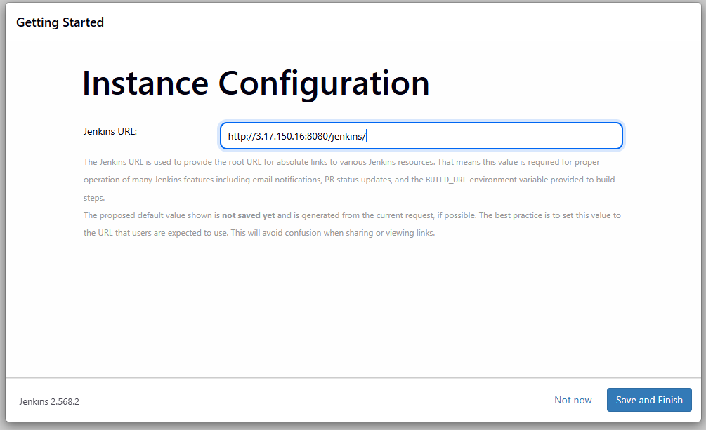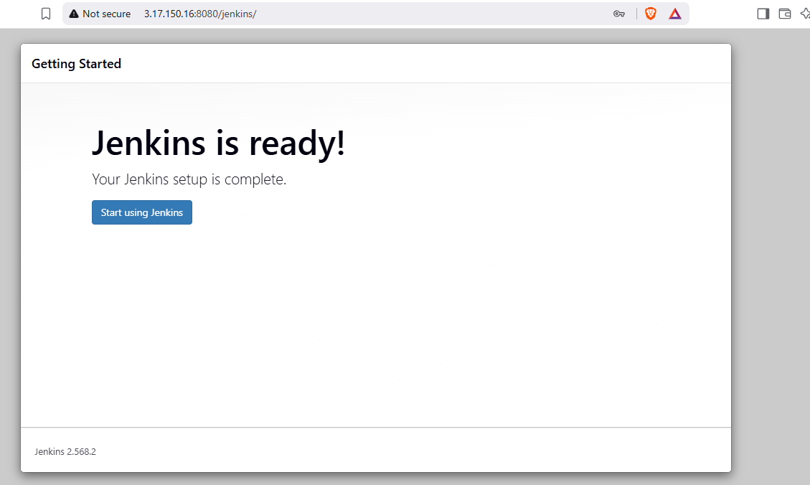
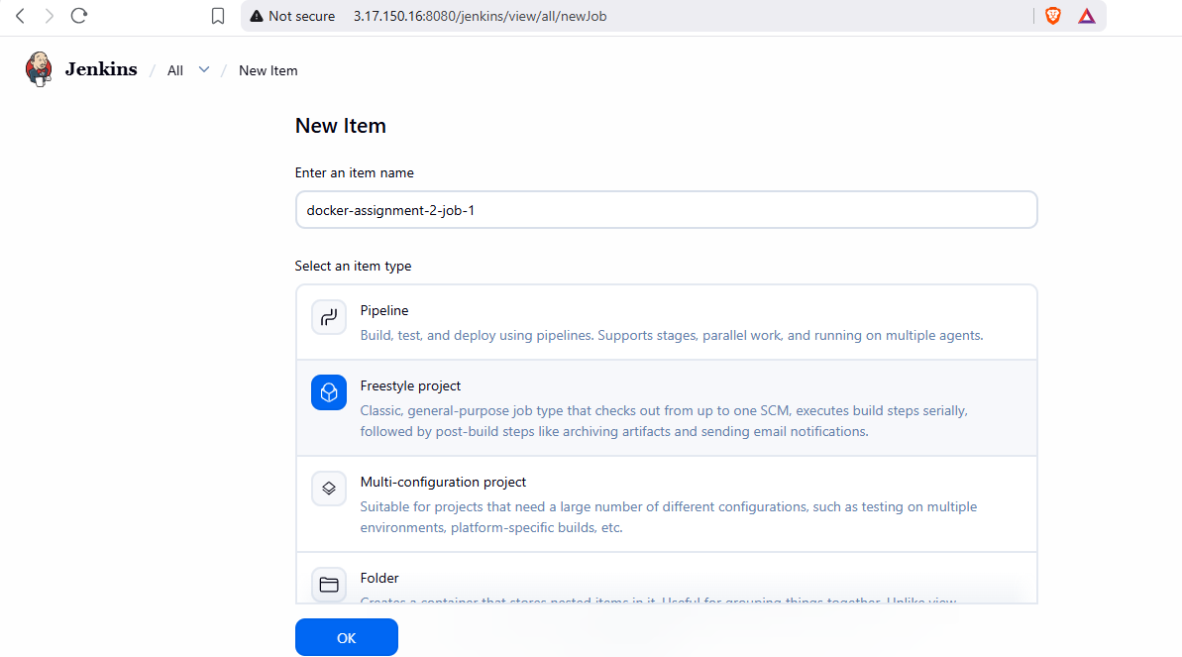
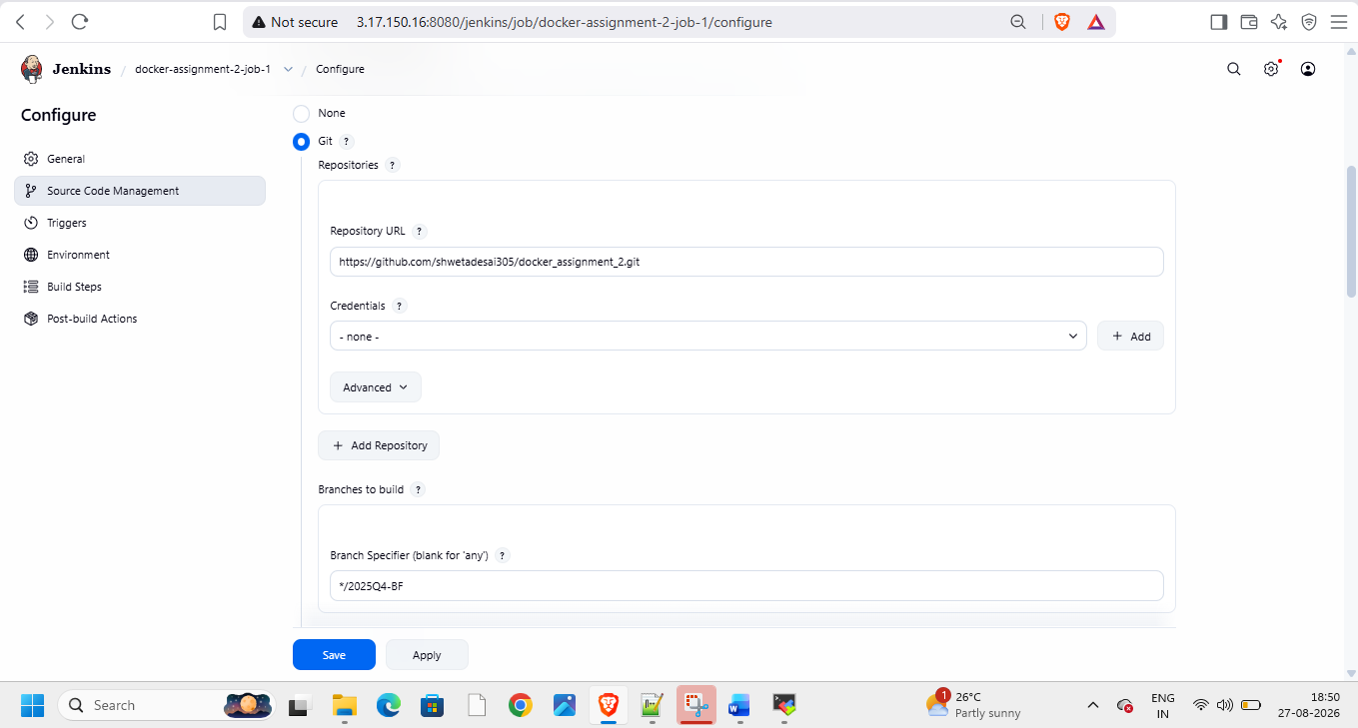
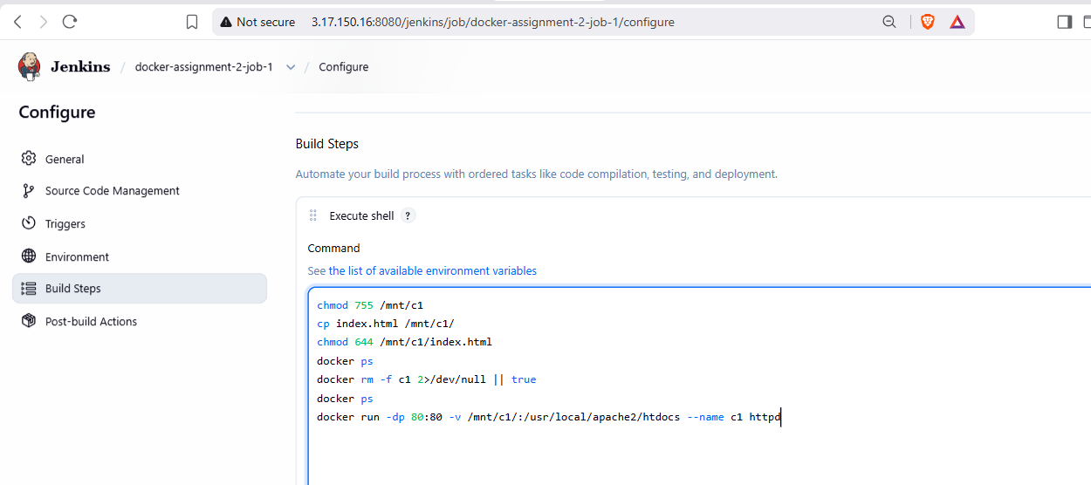
Add job script
chmod 755 /mnt/c1
cp index.html /mnt/c1/
chmod 644 /mnt/c1/index.html
docker ps
docker rm -f c1 2>/dev/null || true
docker ps
docker run -dp 80:80 -v /mnt/c1/:/usr/local/apache2/htdocs --name c1 httpd
Build it
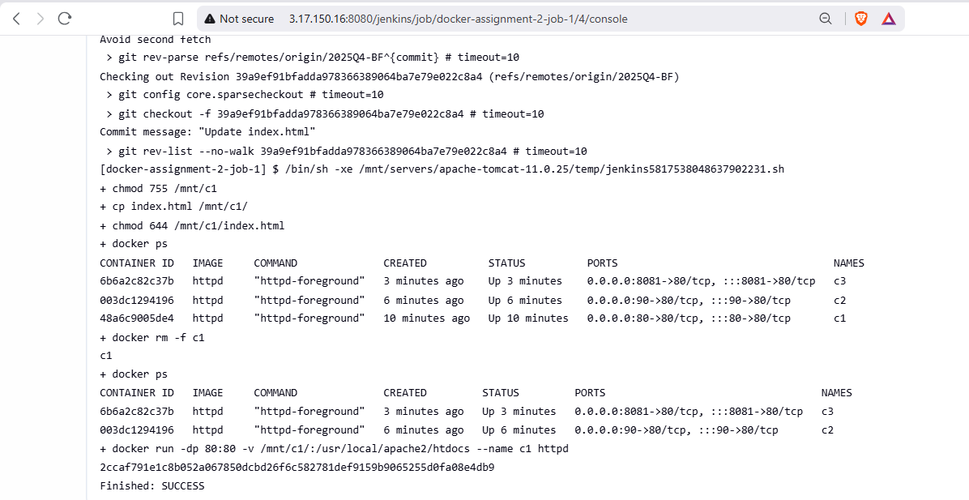
Build and check on browser


Create job 2 for port 90 and branch 2026Q1-MR
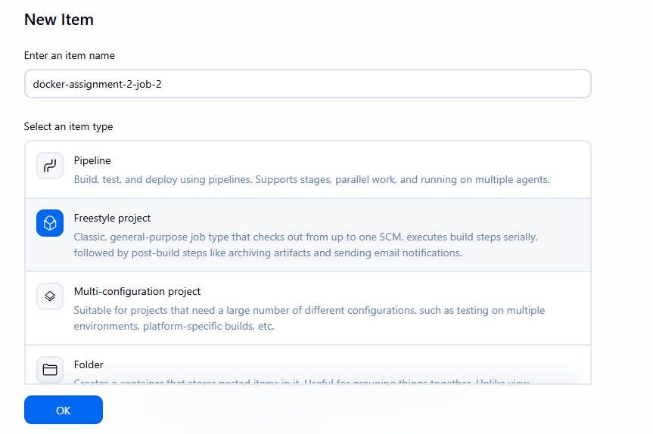
Add job script
chmod 755 /mnt/c2
cp index.html /mnt/c2/
chmod 644 /mnt/c2/index.html
docker ps
docker rm -f c2 2>/dev/null || true
docker ps
docker run -dp 90:80 -v /mnt/c2/:/usr/local/apache2/htdocs --name c2 httpd
And job 3 for branch 2026Q2-PR
Build and check on browser


Create job3 for branch 2026Q2-PR
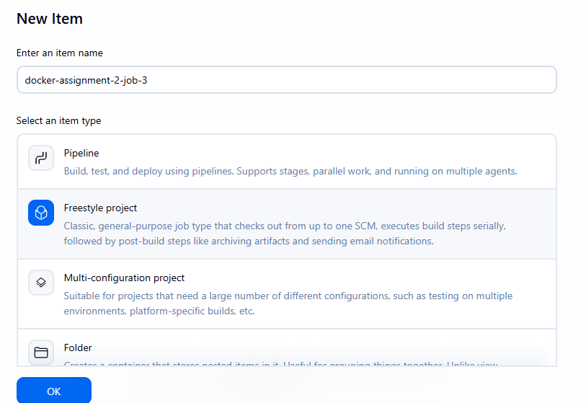
Add script in job
chmod 755 /mnt/c3
cp index.html /mnt/c3/
chmod 644 /mnt/c3/index.html
docker ps
docker rm -f c3 2>/dev/null || true
docker ps
docker run -dp 8081:80 -v /mnt/c3/:/usr/local/apache2/htdocs --name c3 httpd
build and check on browser

