Launch instance and connect to it, download java21, docker25, Jenkins2.5, tomcat11, git
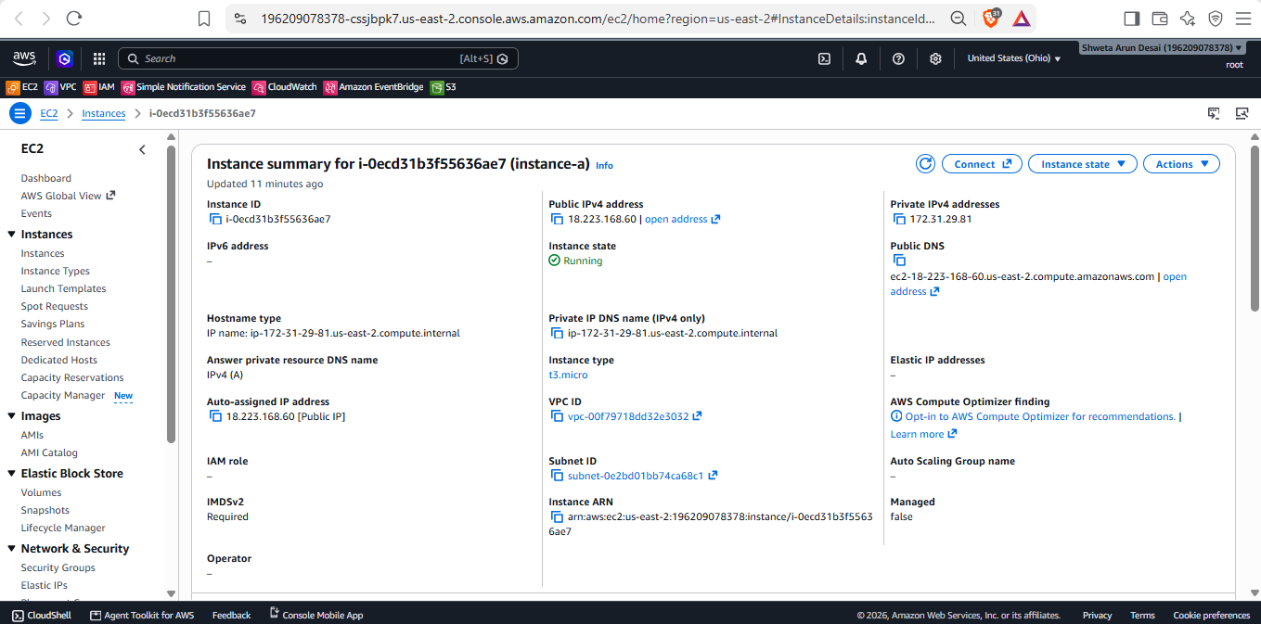
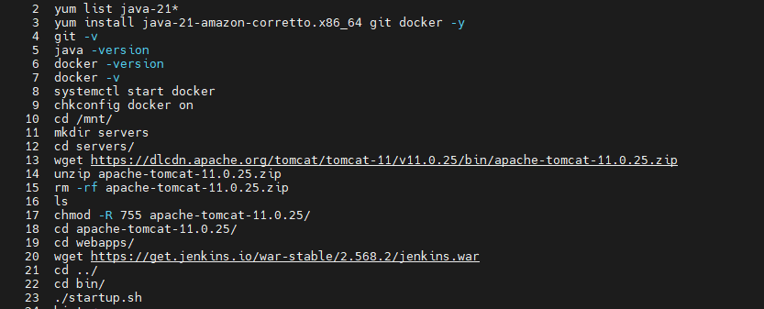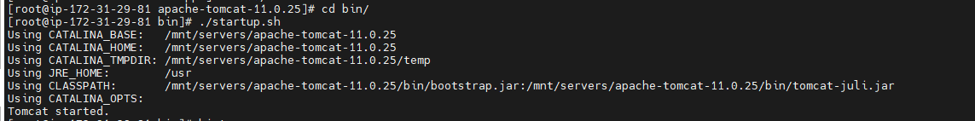
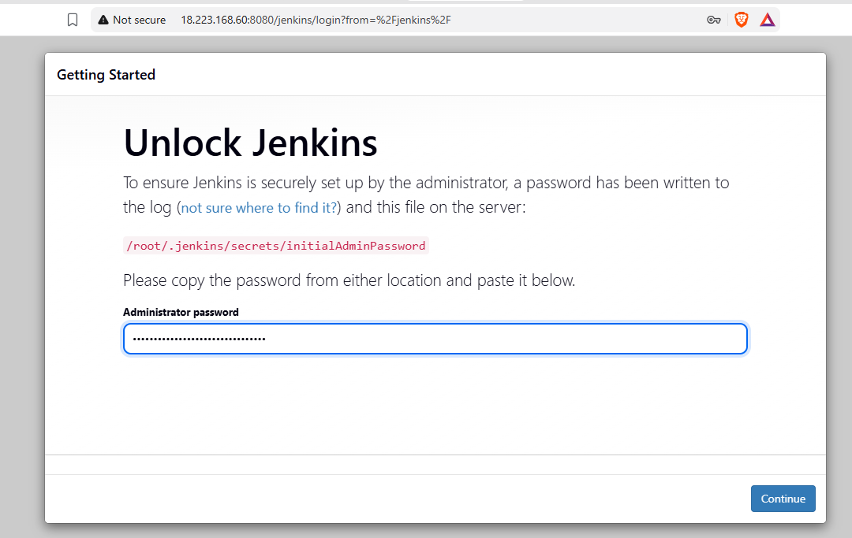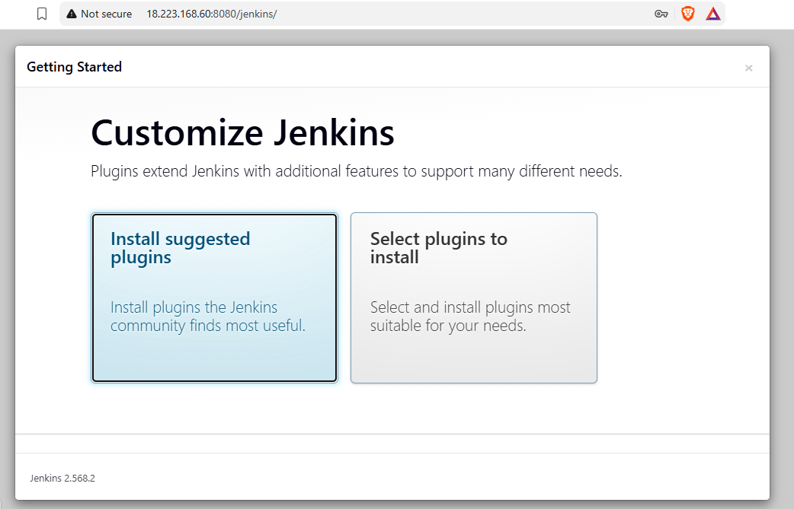
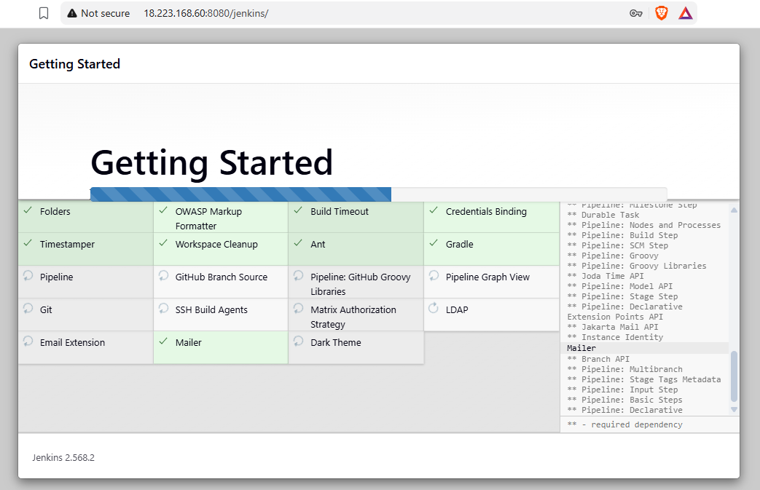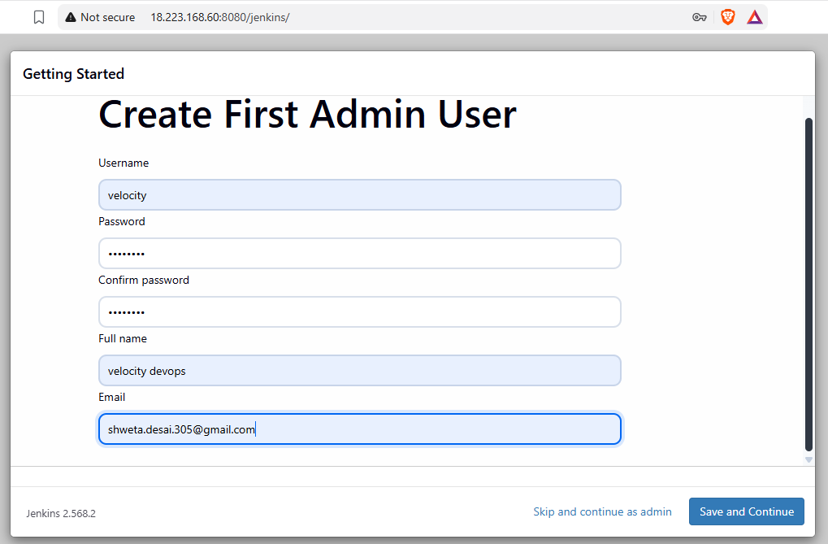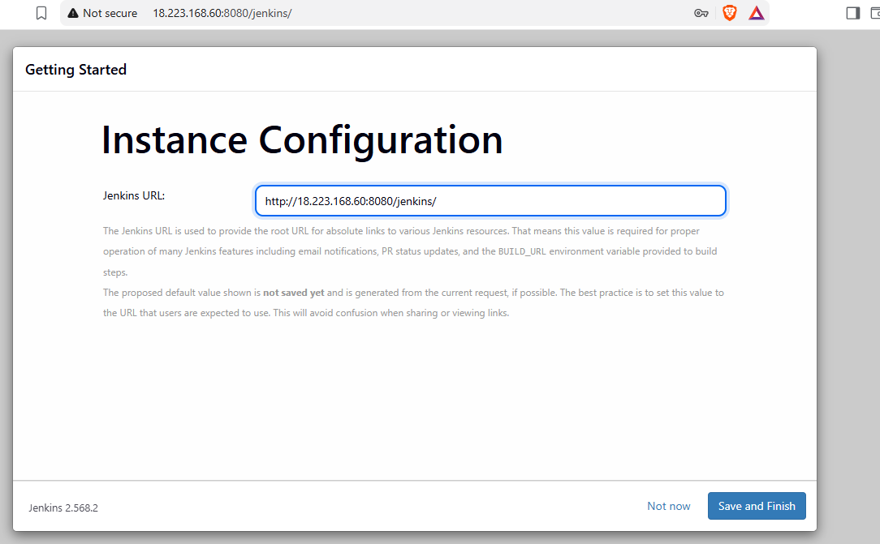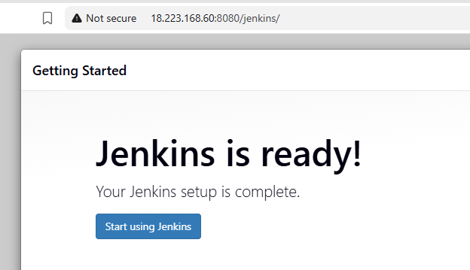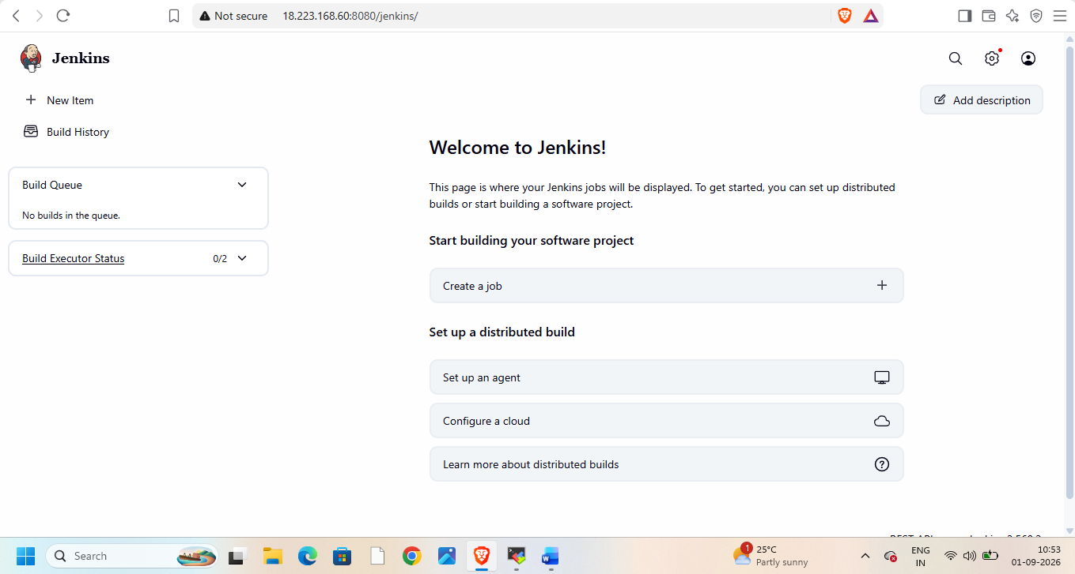
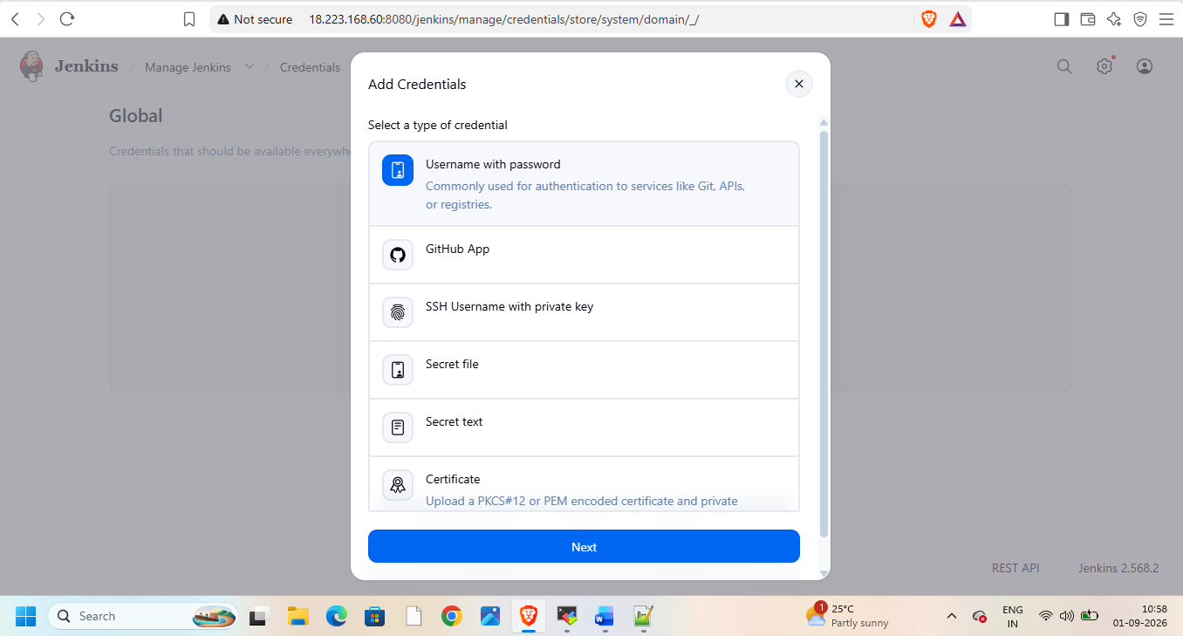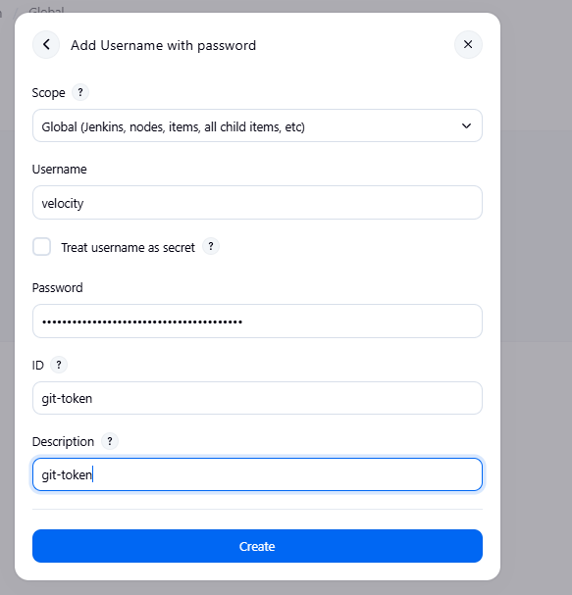
Create pipeline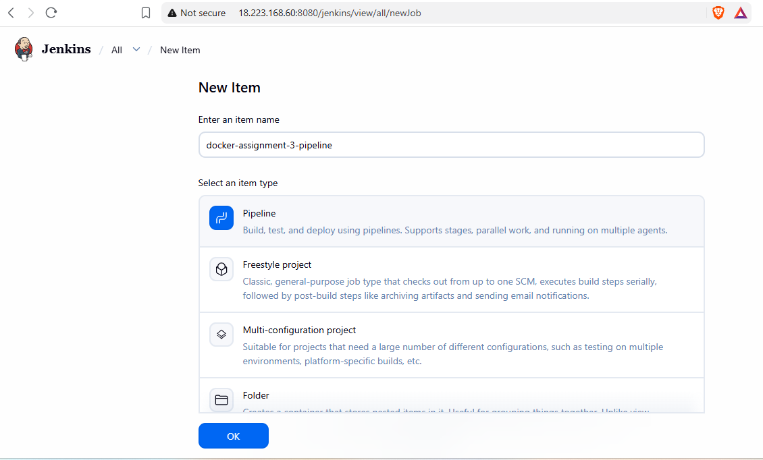
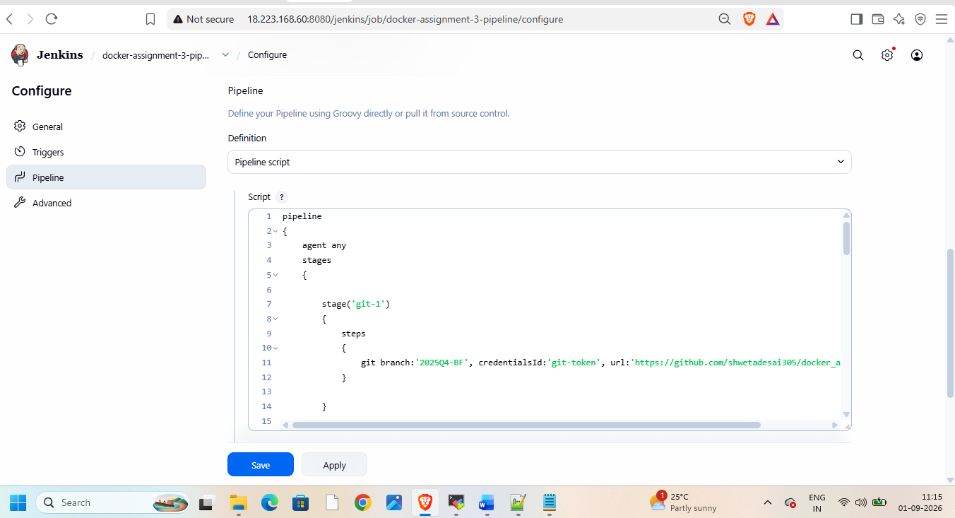
Take repo url from git having required branches
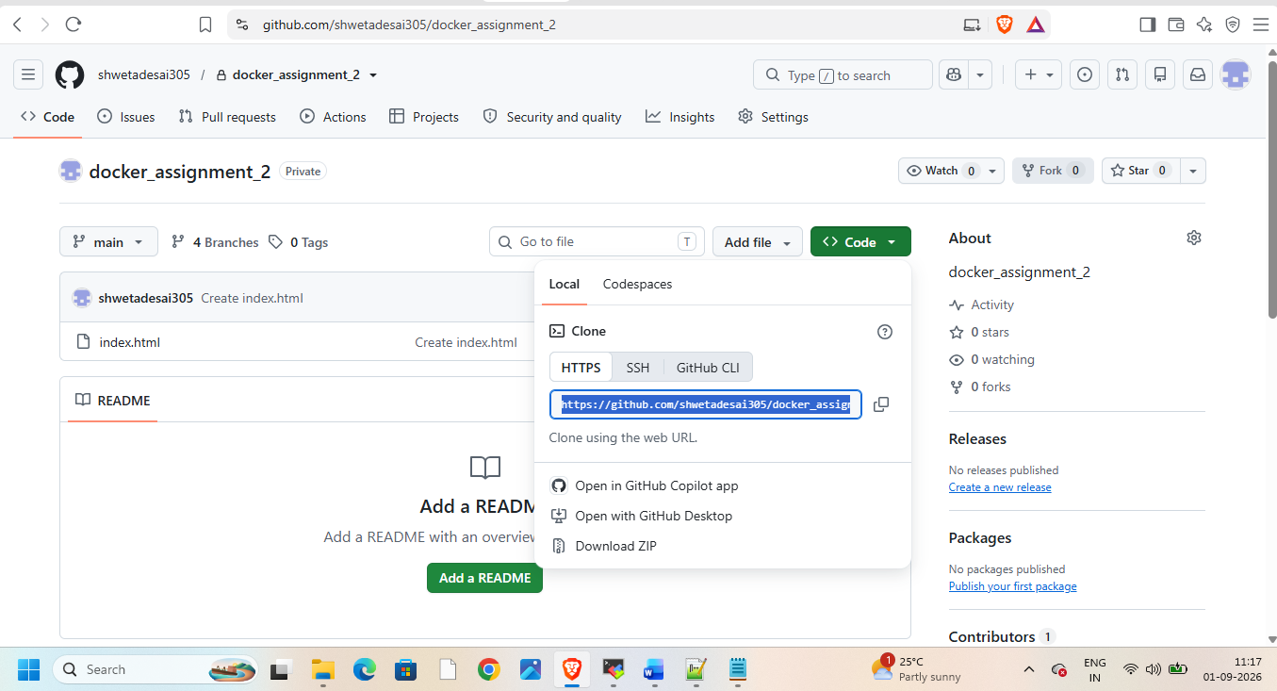
Add pipeline script
pipeline
{
agent any
stages
{

stage('git-1')
{
steps
{
git branch:'2025Q4-BF', credentialsId:'git-token', url:'https://github.com/shwetadesai305/docker_assignment_2.git'
}

}

stage('volume-1')
{
steps
{
sh '''
docker volume create velocity1
docker volume inspect velocity1
docker rm -f c1 2>/dev/null || true
docker run -dp 80:80 -v velocity1:/usr/local/apache2/htdocs --name c1 httpd
cp index.html /var/lib/docker/volumes/velocity1/_data
chmod 644 /var/lib/docker/volumes/velocity1/_data/index.html
'''
}
}

stage('git-2')
{
steps
{
git branch:'2026Q1-MR', credentialsId:'git-token', url:'https://github.com/shwetadesai305/docker_assignment_2.git'
}

}
stage('volume-2')
{
steps
{
sh '''
docker volume create velocity2
docker volume inspect velocity2
docker rm -f c2 2>/dev/null || true
docker run -dp 90:80 -v velocity2:/usr/local/apache2/htdocs --name c2 httpd
cp index.html /var/lib/docker/volumes/velocity2/_data
chmod 644 /var/lib/docker/volumes/velocity2/_data/index.html
'''
}

}

stage('git-3')
{
steps
{
git branch:'2026Q2-PR', credentialsId:'git-token', url:'https://github.com/shwetadesai305/docker_assignment_2.git'
}

}
stage('branch-3')
{
steps
{
sh '''
docker volume create velocity3
docker volume inspect velocity3
docker rm -f c3 2>/dev/null || true
docker run -dp 8081:80 -v velocity3:/usr/local/apache2/htdocs --name c3 httpd
cp index.html /var/lib/docker/volumes/velocity3/_data
chmod 644 /var/lib/docker/volumes/velocity3/_data/index.html
'''
}

}

}
}
Then build and check console output and stages
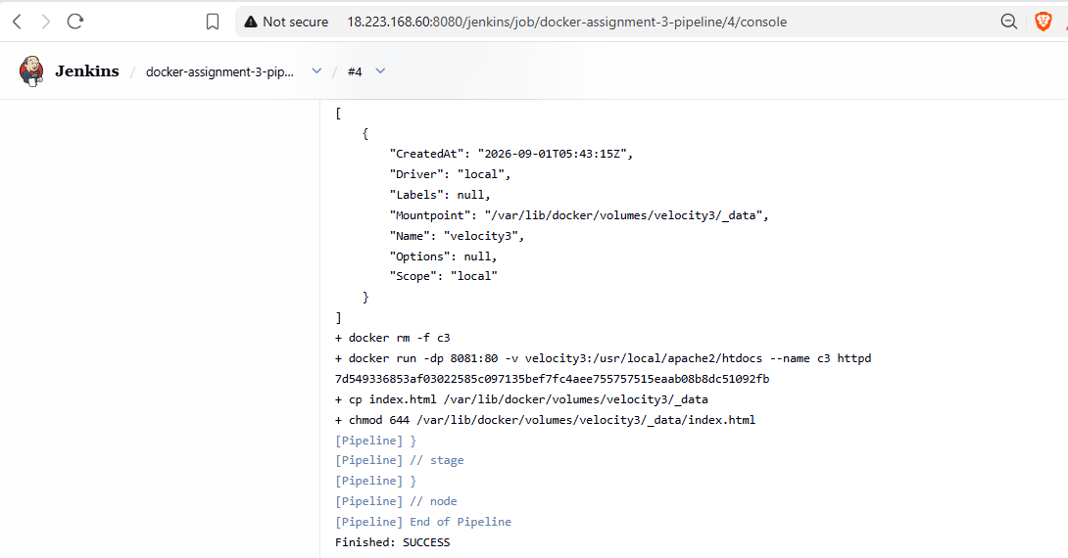
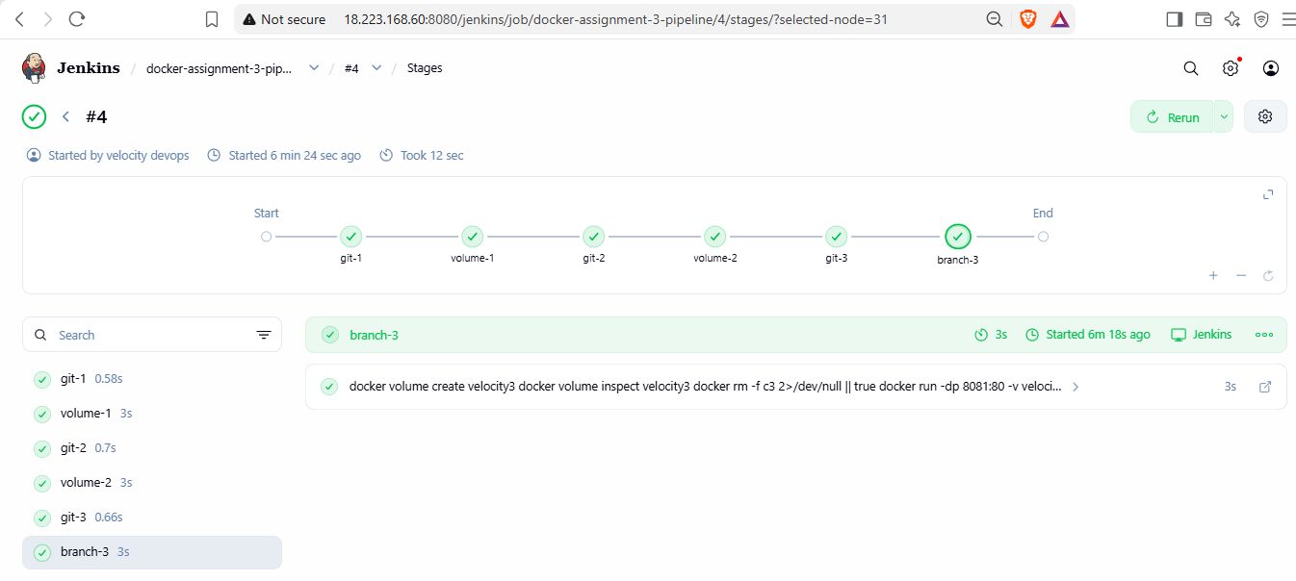
Now check on browser with port 80,90,8081
