Assignment-21- Create 3 repositories r1- branch – 2026Q1-MR, repository r2- branch – 2025Q4-PR, repository r3- branch – 2024Q4-BF and push index.html on each repo.
Create 3 different jobs for each one of them and keep httpd installed on Jenkins master and check each job build.
Ans- launch instance and connect
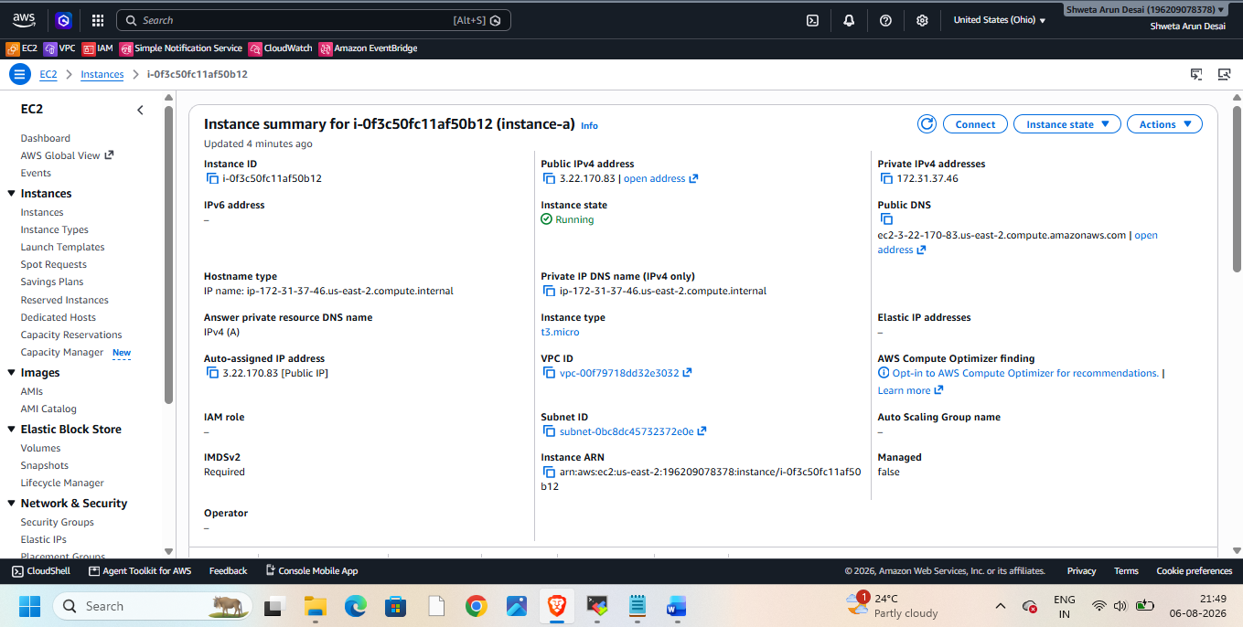
Then install java, tomcat, httpd, Jenkins, git on it
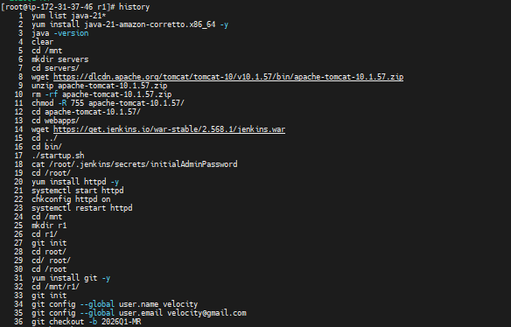
Push index.html file in it
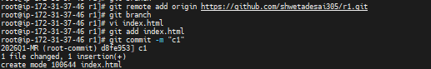
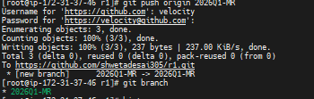
Then start Jenkins – install suggested plugins
Go to manage Jenkins and add credentials
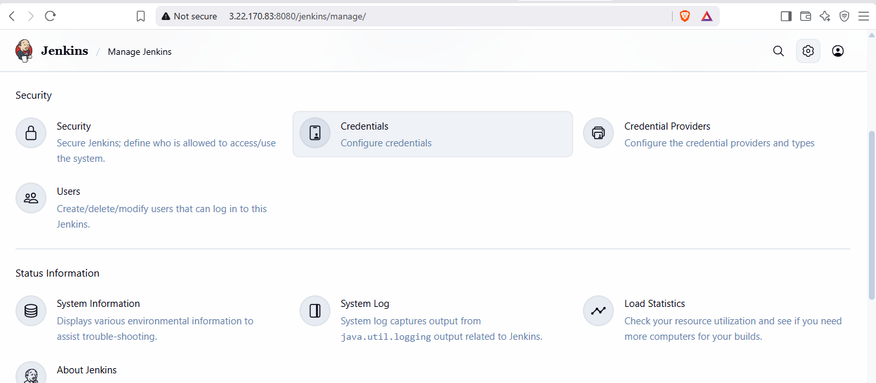
Add credentials – global
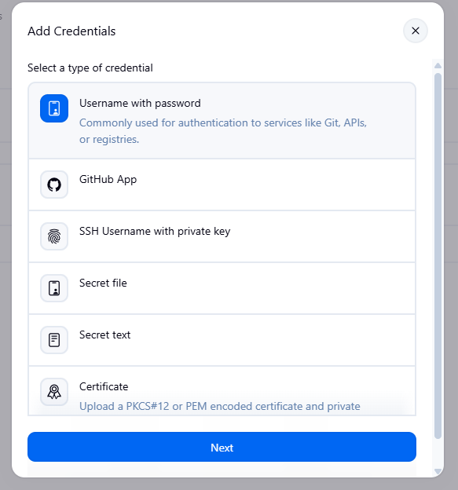
Provide username and git token
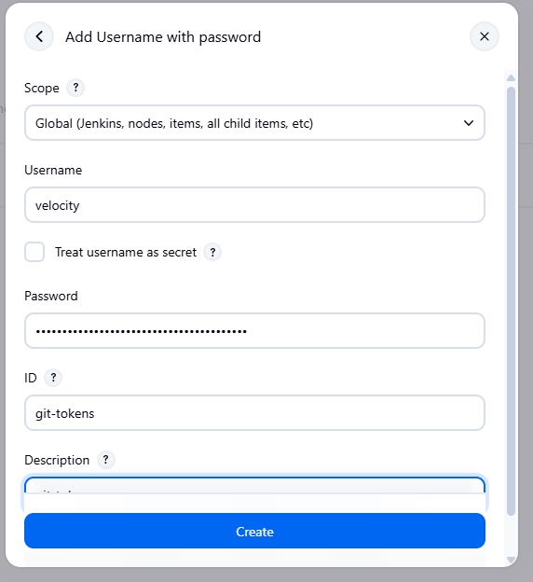
Then create
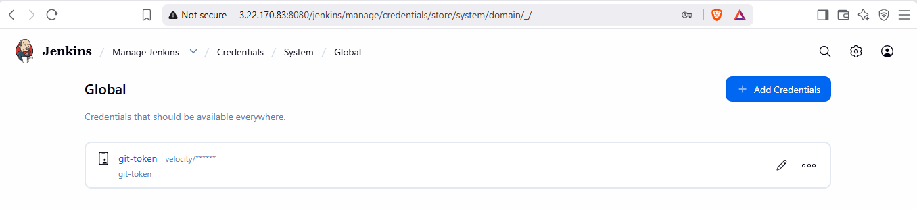
Now create job – freestyle project

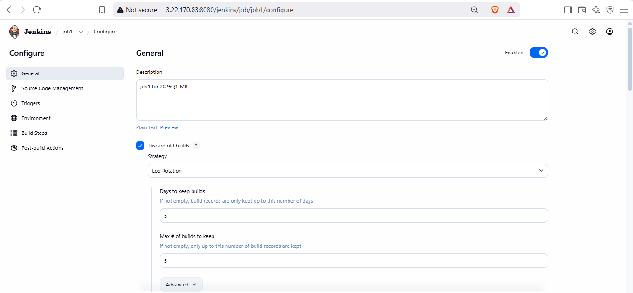
Goto git and take repo url and provide here on jenkins
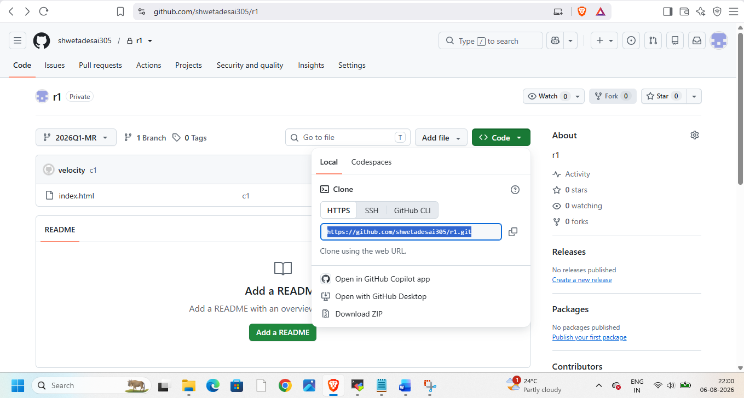
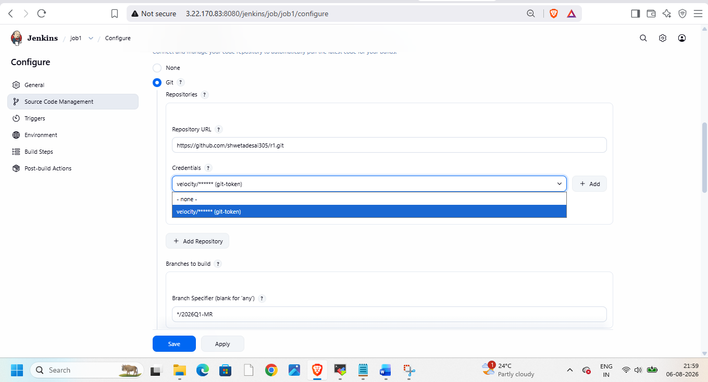
Then delete old workspace before every build and add execute shell cmds to copy index.html file from git to var/www/html/ to deploy
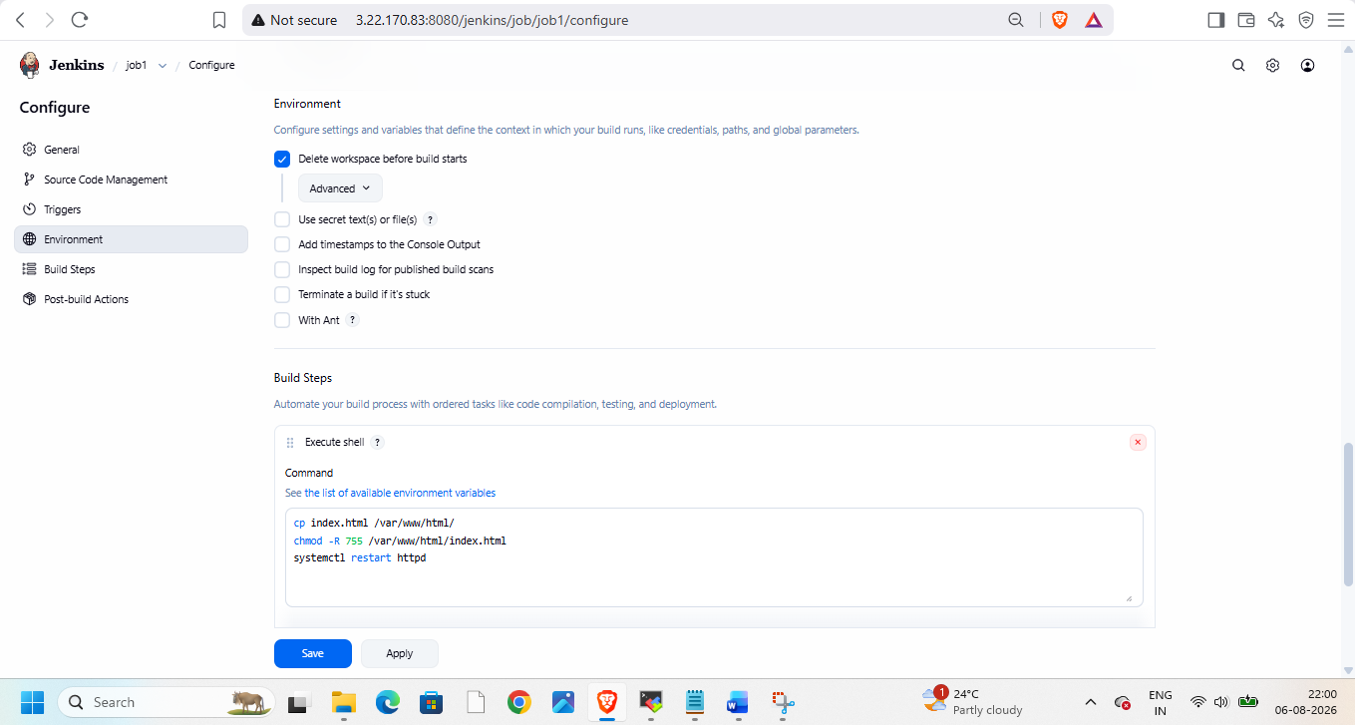
Then apply and save and build it then build and check consol output
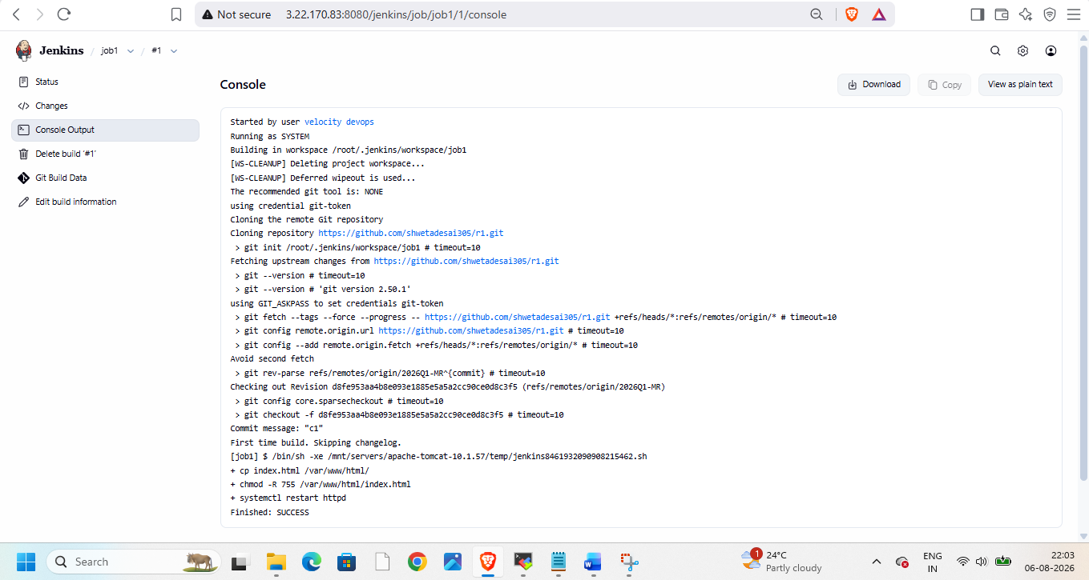
Succeeded! Now check with public ip on browser
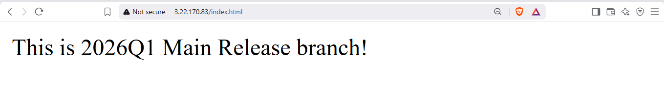
Goto linux and check
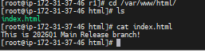
Now repeat procedure for job2 and job3
Always make sure to keep repository private
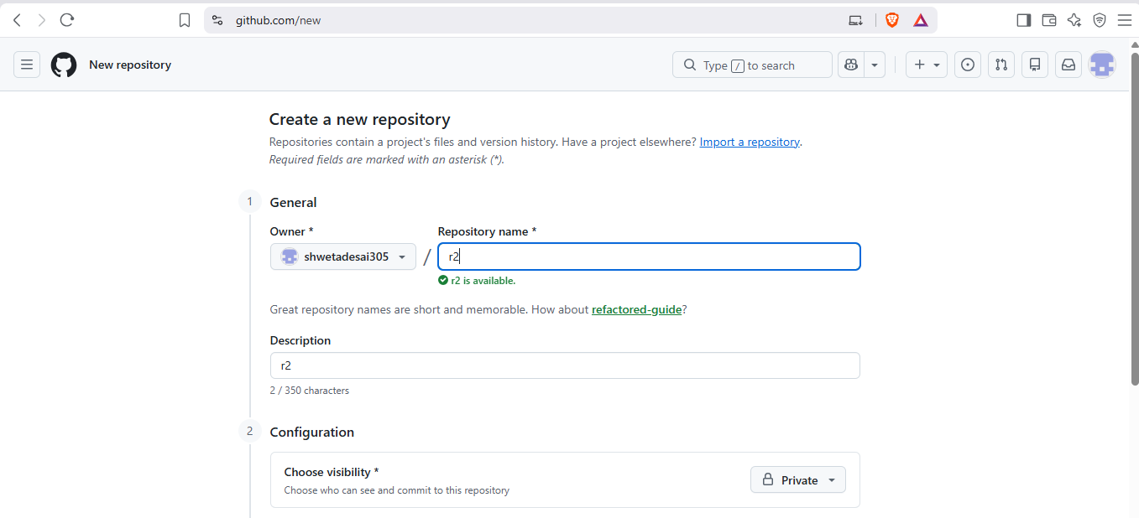

For job 2
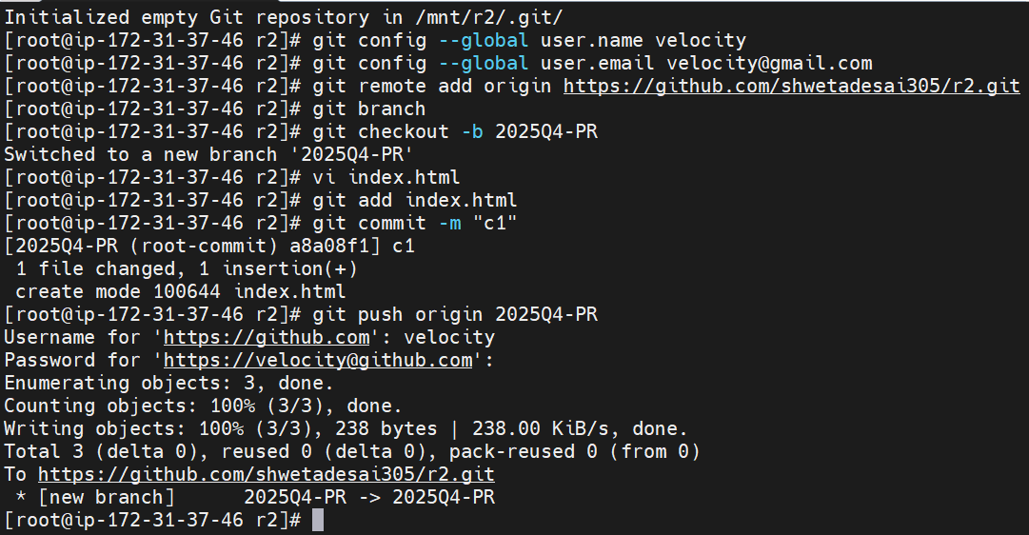
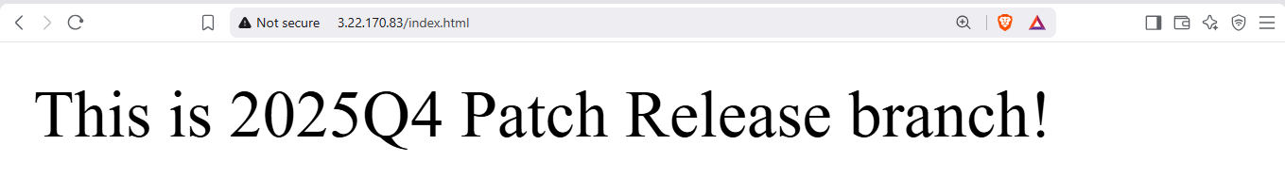
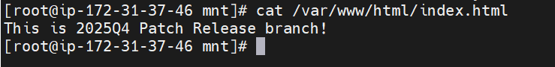
For job3
Create repo r3 and push branch, index file in it
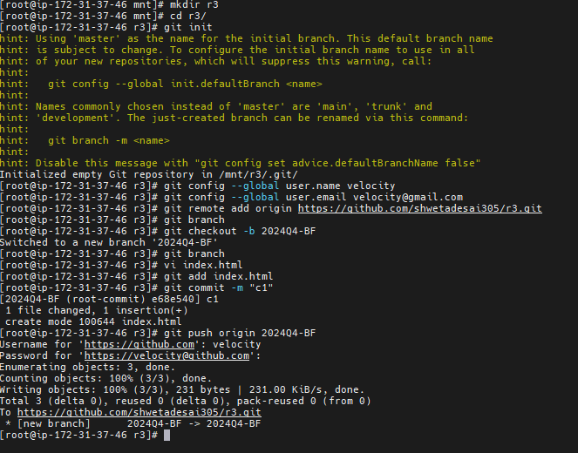
Create job for it and build and check on browser
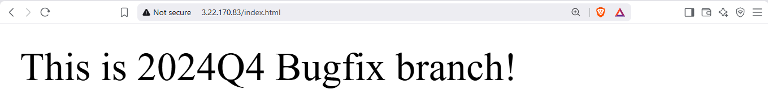
Check in linux
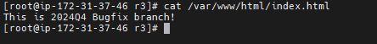
Now delete all jobs created in jenkins and repos created in git and terminate instance.

