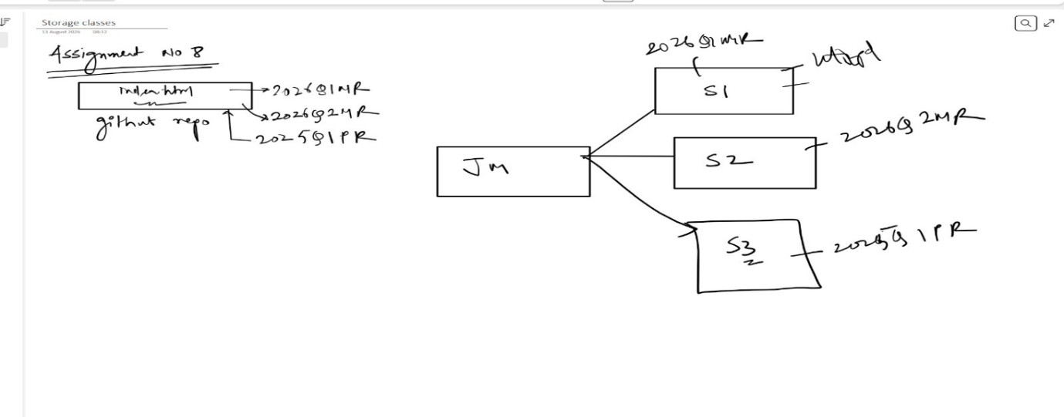
Jenkins assignment 8 pipeline
Que: create a Jenkins master and connect it with 3 slaves and run pipeline on each slave accessing 3 different branches.
Ans:
Create git repo with 3 branches
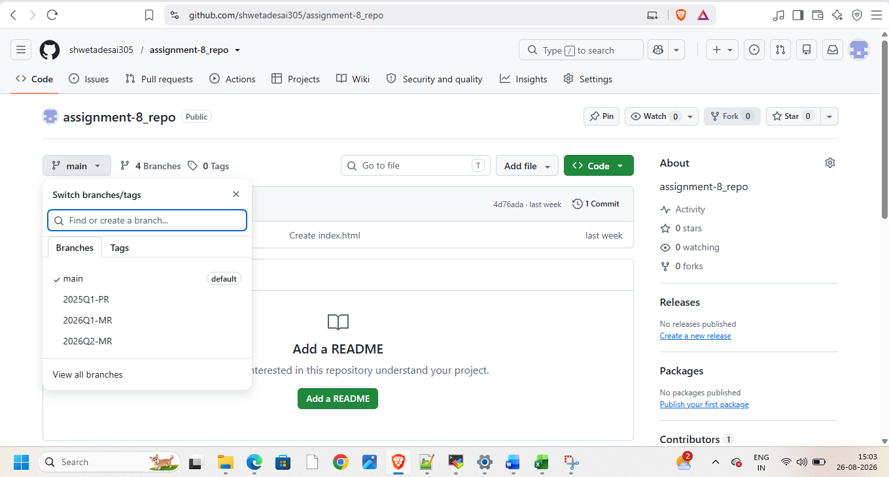
Launch 4 instance
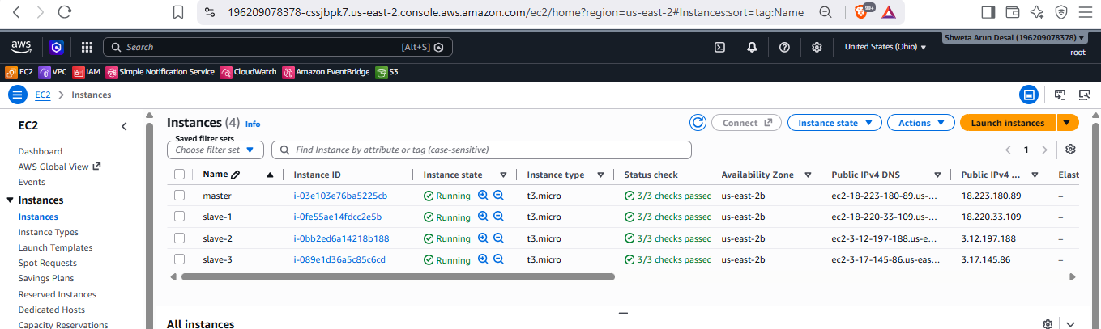
1 – master and 3-slaves connect them and install Jenkins, java, tomcat
Start Jenkins on master and create node in it
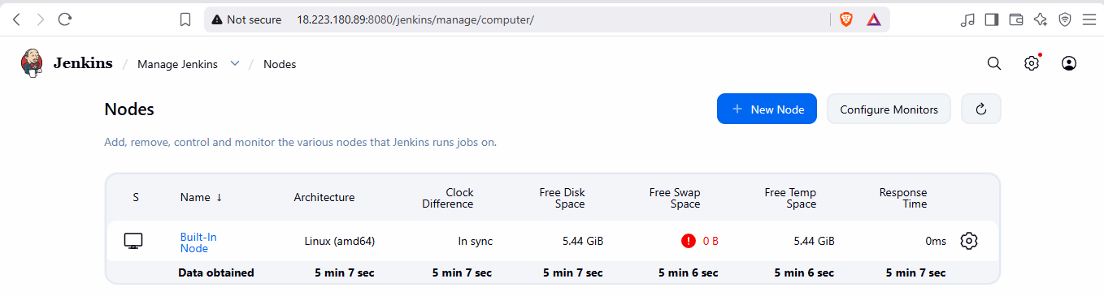
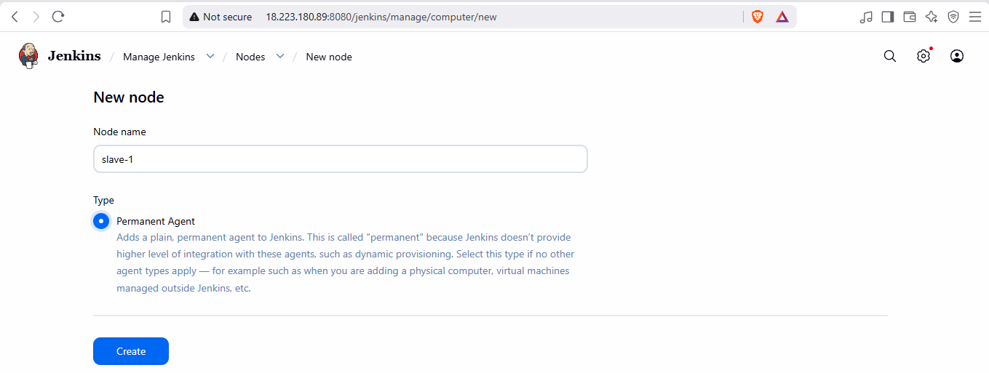
Goto slave -1
Give all permissions on /mnt do this for all three instances
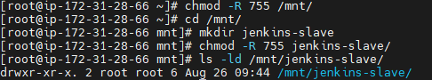
Add details while creating nodes
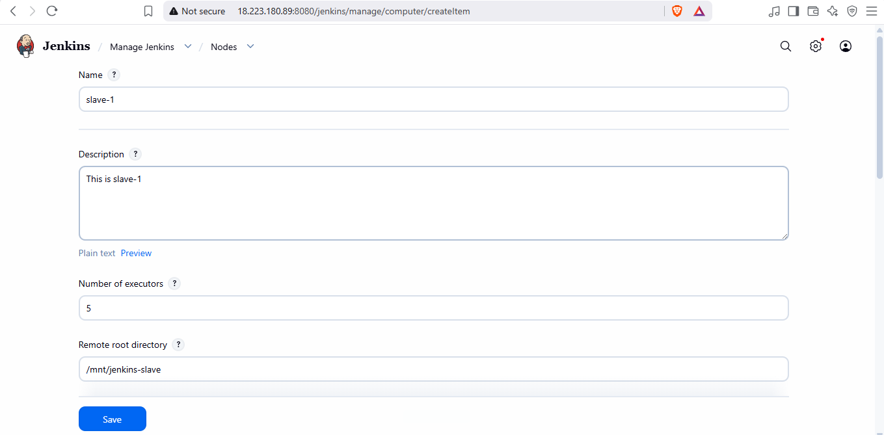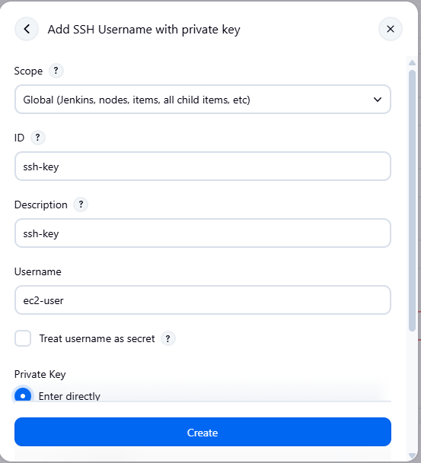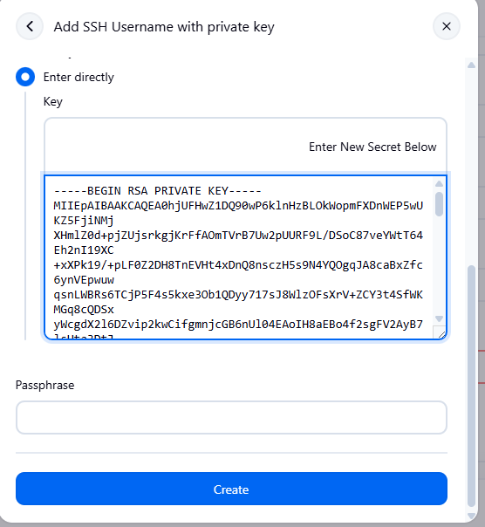
Add private ip of slave instance
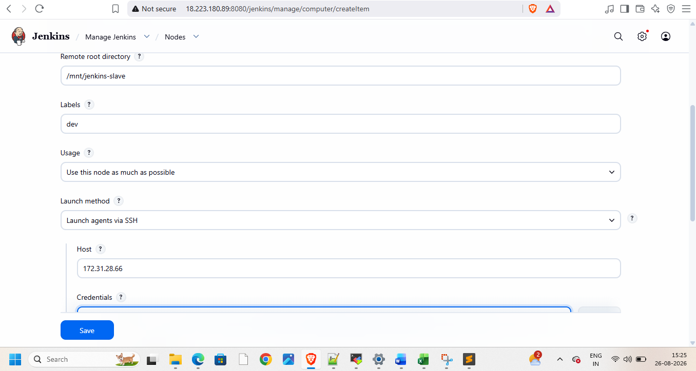
Create and add credentials
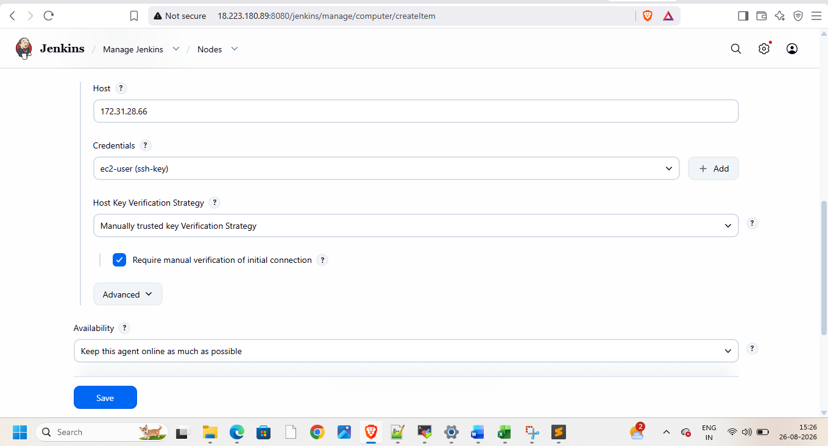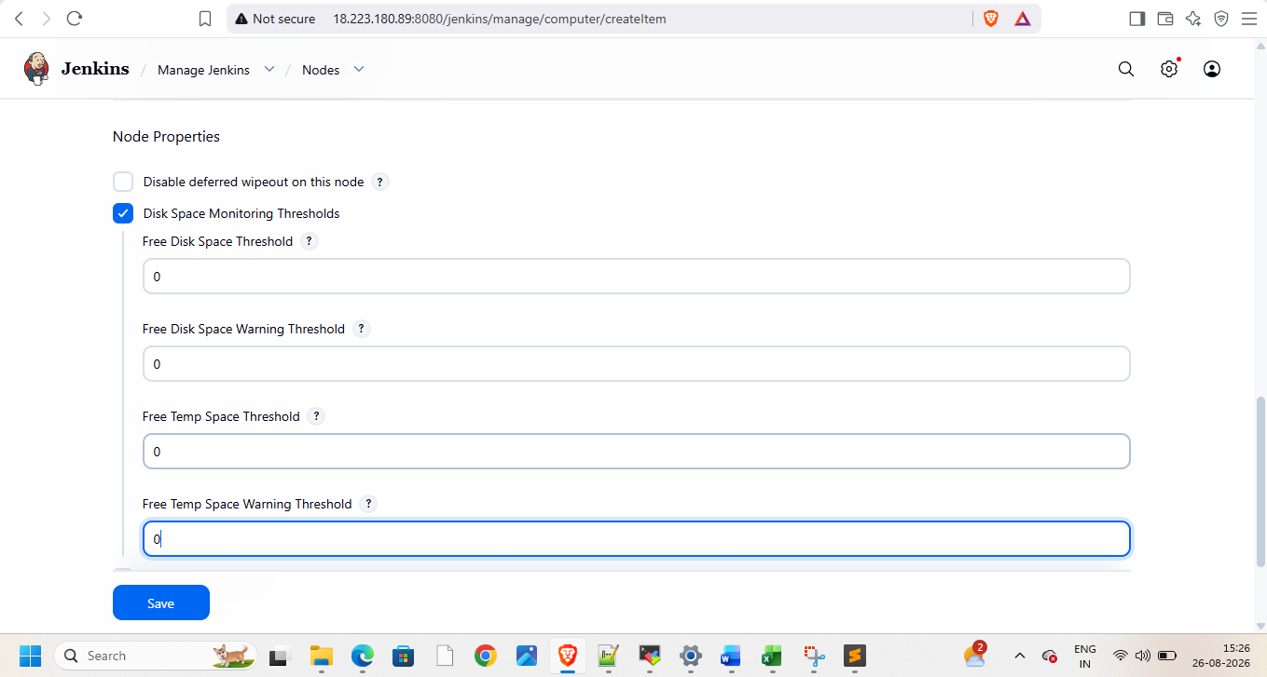
Do this on slave
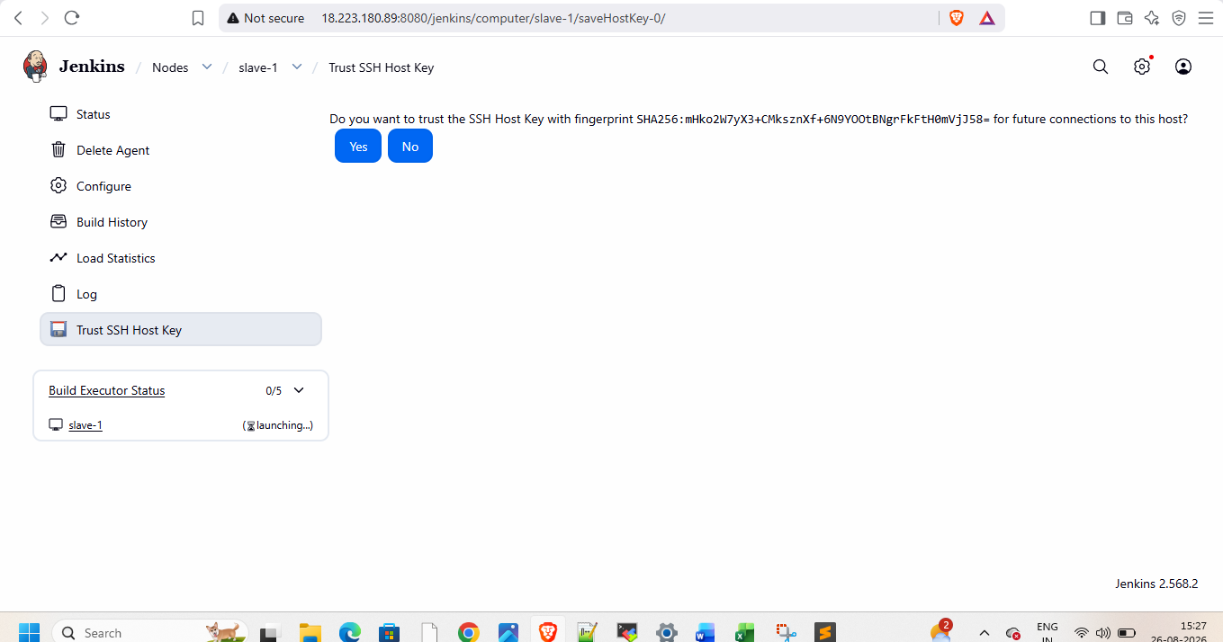
Relaunch agent
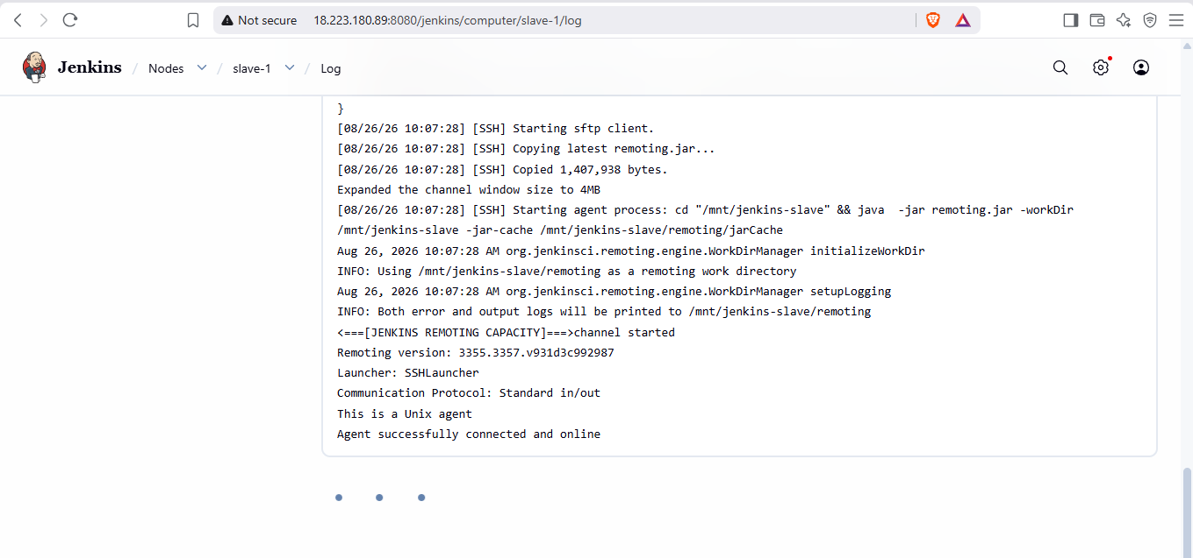
Create slave-2 and slave-3 from slave-1 but update their private ips
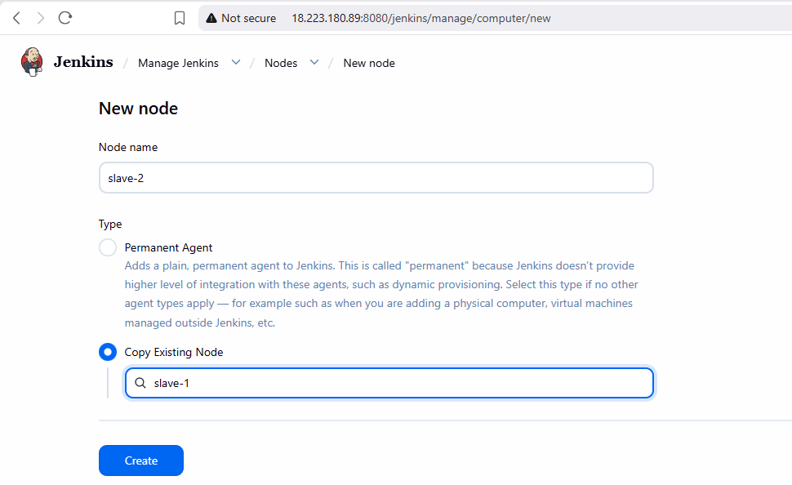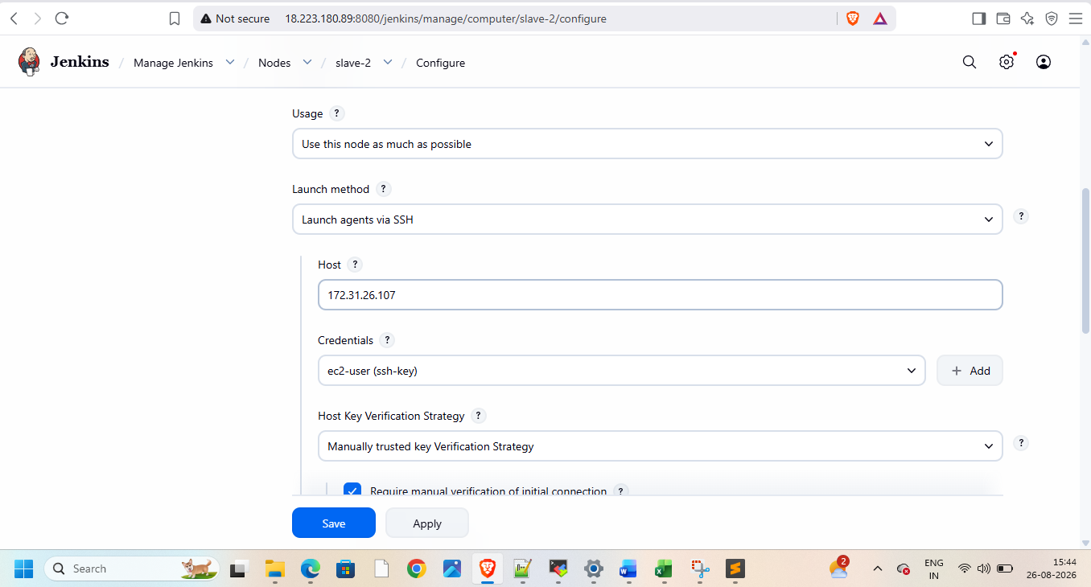
Now all 4 nodes are ready
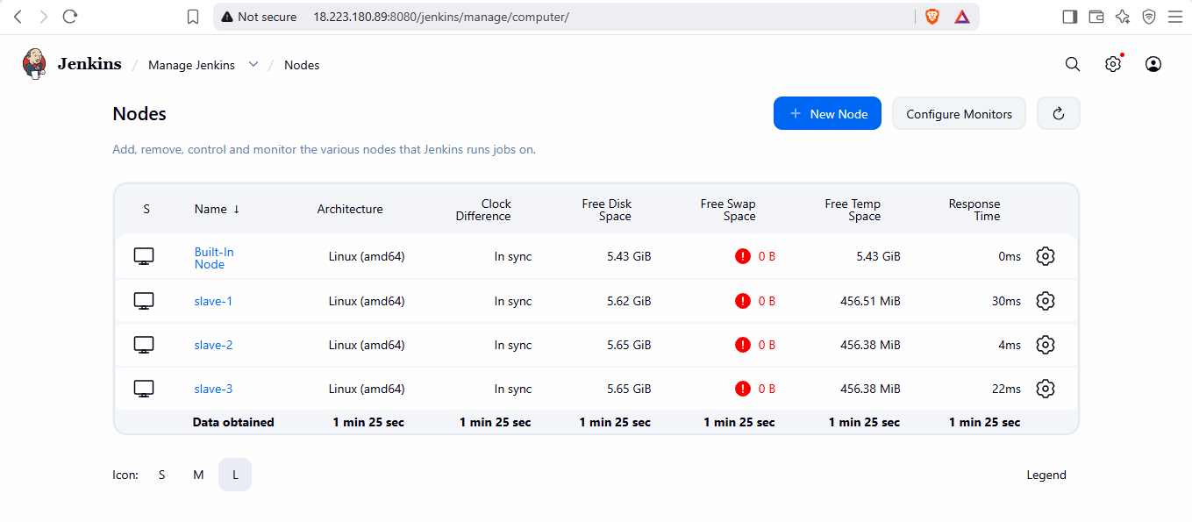
Create new pipeline
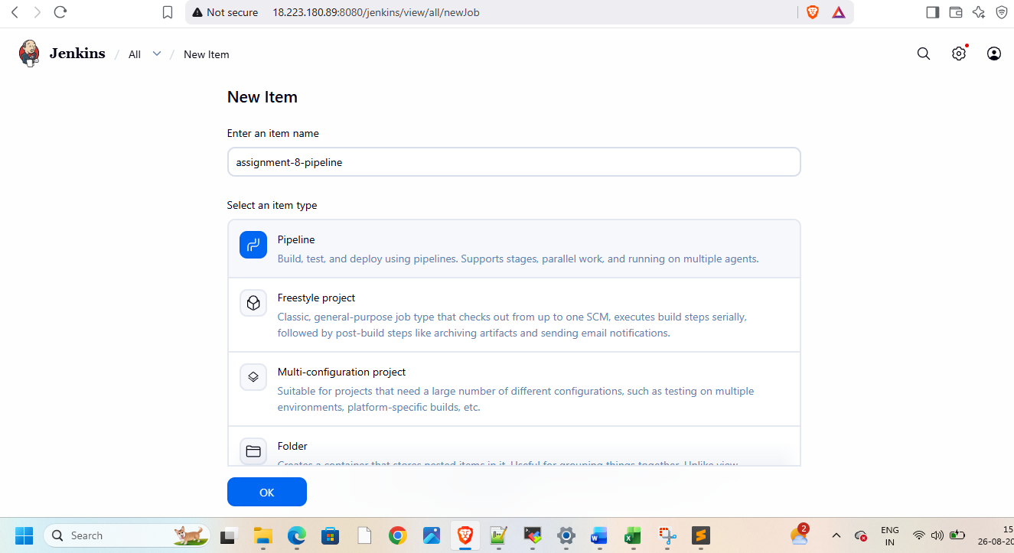
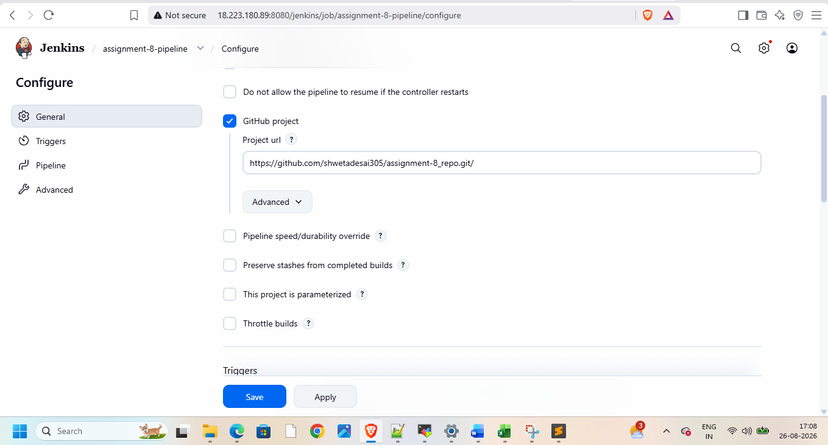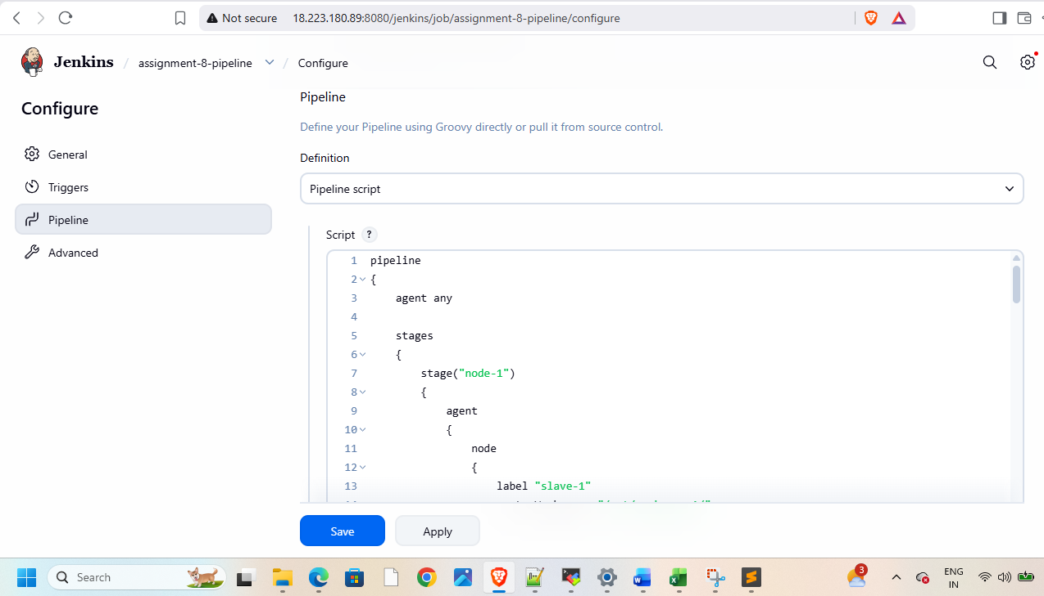
And write pipeline script
pipeline
{
agent any

stages
{
stage("node-1")
{
agent
{
node
{
label "slave-1"
customWorkspace "/mnt/workspace1/"
}

}
steps
{
sh '''
sudo yum install httpd -y
sudo systemctl start httpd
sudo systemctl enable httpd

'''

deleteDir()
//sh "sudo rm -rf /mnt/workspace1/"
git branch: '2025Q1-PR' , url: 'https://github.com/shwetadesai305/assignment-8_repo.git'
sh "sudo cp index.html /var/www/html/ "
sh "sudo chmod -R 755 /var/www/html/index.html"

}
}
stage("node-2")
{
agent
{
node
{
label "slave-2"
customWorkspace "/mnt/workspace1/"
}
}
steps
{
sh '''
sudo yum install httpd -y
sudo systemctl start httpd
sudo systemctl enable httpd

'''

deleteDir()
//sh "sudo rm -rf /mnt/workspace1/"
git branch: '2026Q1-MR' , url: 'https://github.com/shwetadesai305/assignment-8_repo.git'
sh "sudo cp index.html /var/www/html/ "
sh "sudo chmod -R 755 /var/www/html/index.html"
}
}
stage("node-3")
{
agent
{
node
{
label "slave-3"
customWorkspace "/mnt/workspace1/"
}

}
steps
{
sh '''
sudo yum install httpd -y
sudo systemctl start httpd
sudo systemctl enable httpd

'''
deleteDir()

//sh "sudo rm -rf /mnt/workspace1/"
git branch: '2026Q2-MR' , url: 'https://github.com/shwetadesai305/assignment-8_repo.git'
sh "sudo cp index.html /var/www/html/ "
sh "sudo chmod -R 755 /var/www/html/index.html"
}
}
}
}
Give permissions on each slave
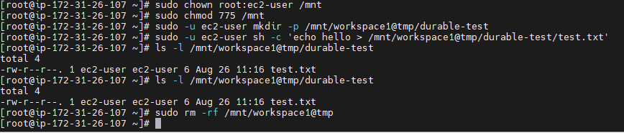
Then build
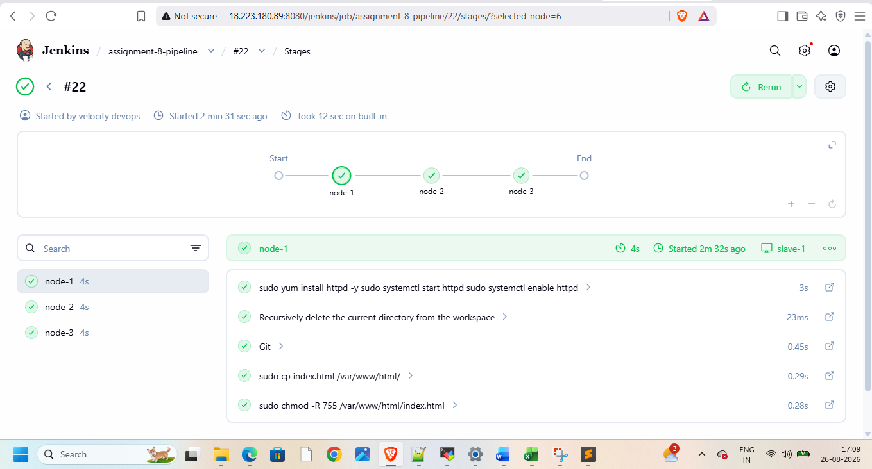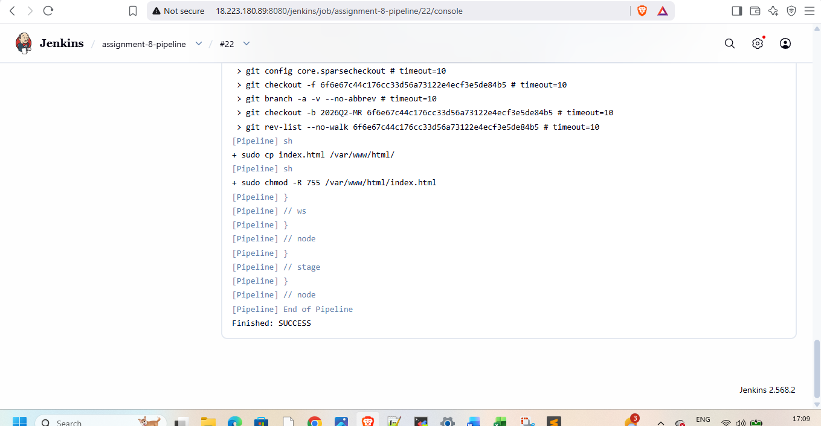
Now check with public ip of each instance

Then terminate instances after use

