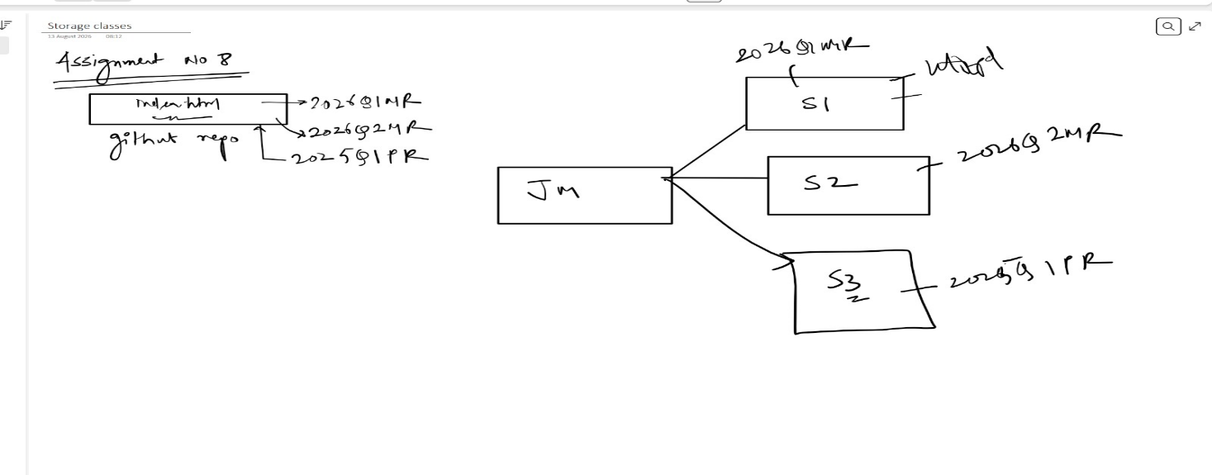
Assignment-26-jenkins-8
Que: create a Jenkins master and connect it with 3 slaves and run 3 different jobs on each slave accessing 3 different branches.
Ans: for this we need to launch 4 instances : 1 master and 3 slaves
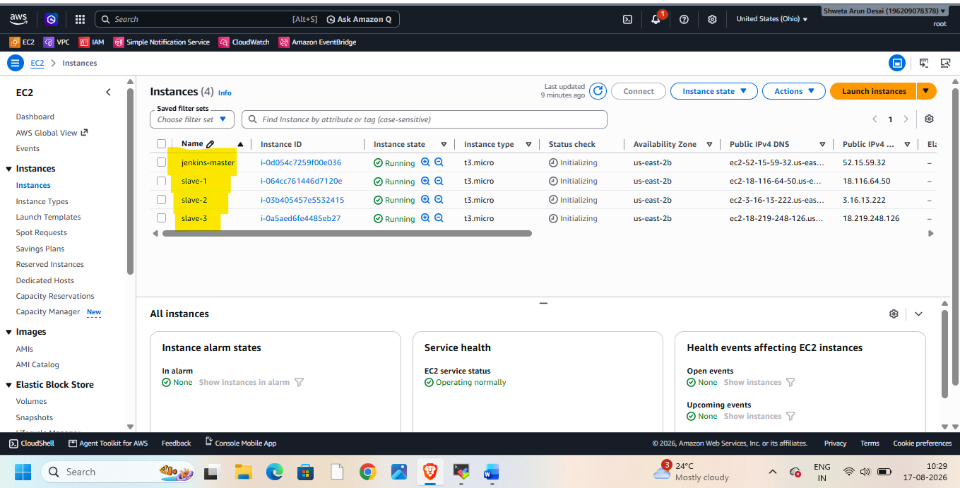
Connect with master and install java21, git, Jenkins2.5 WAR, tomcat10
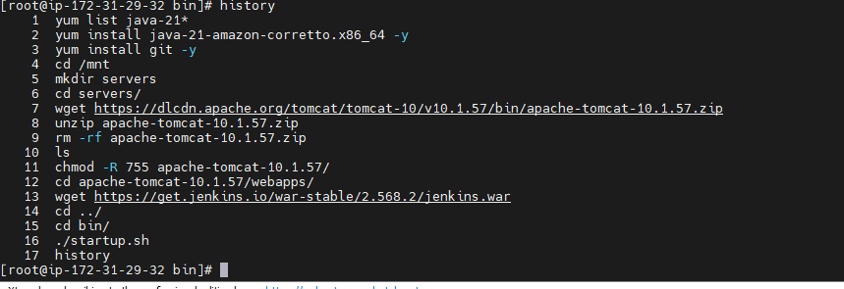
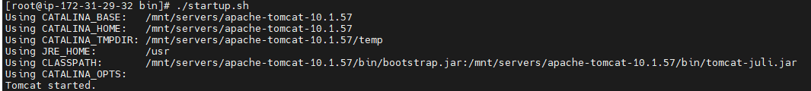
Take http://public-ip of master:8080/Jenkins
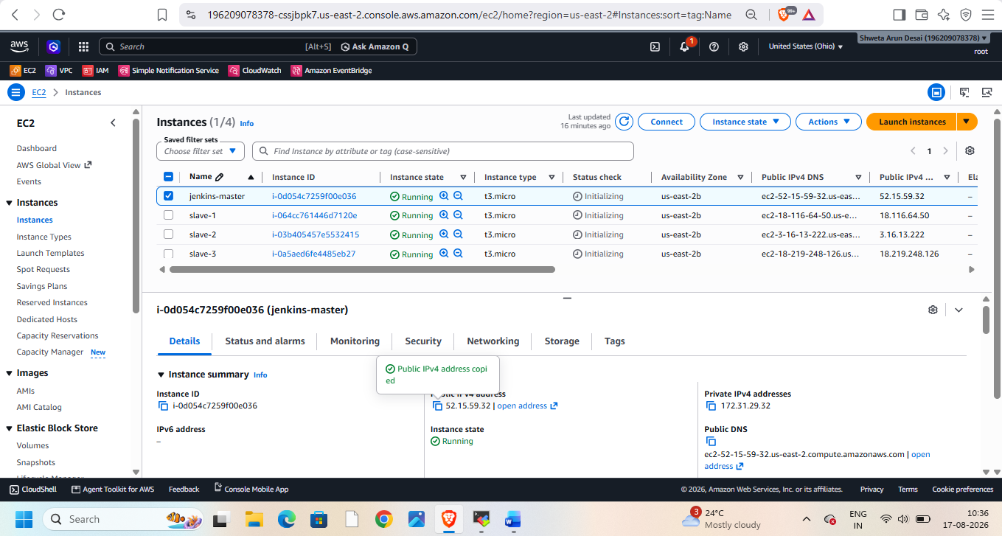
Make sure security group – inbound rule has port no 8080-custom TCP available
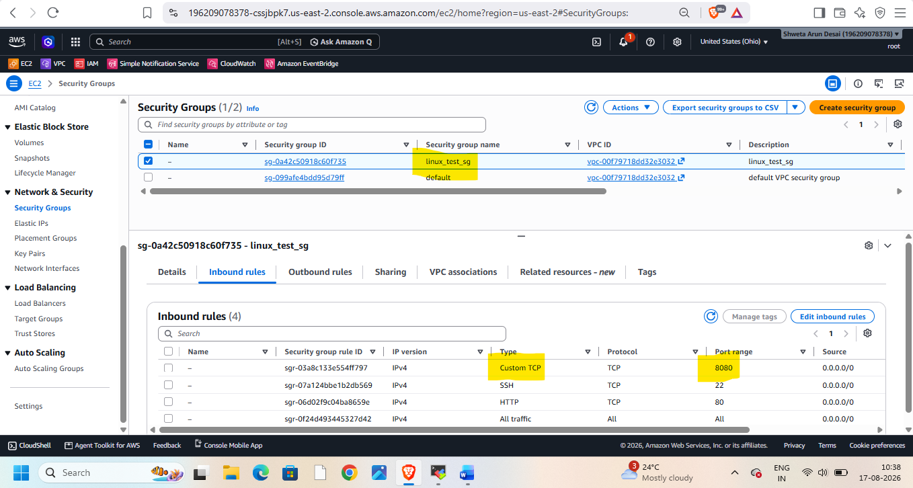
Goto Jenkins using http:// public-ip of master:8080/Jenkins
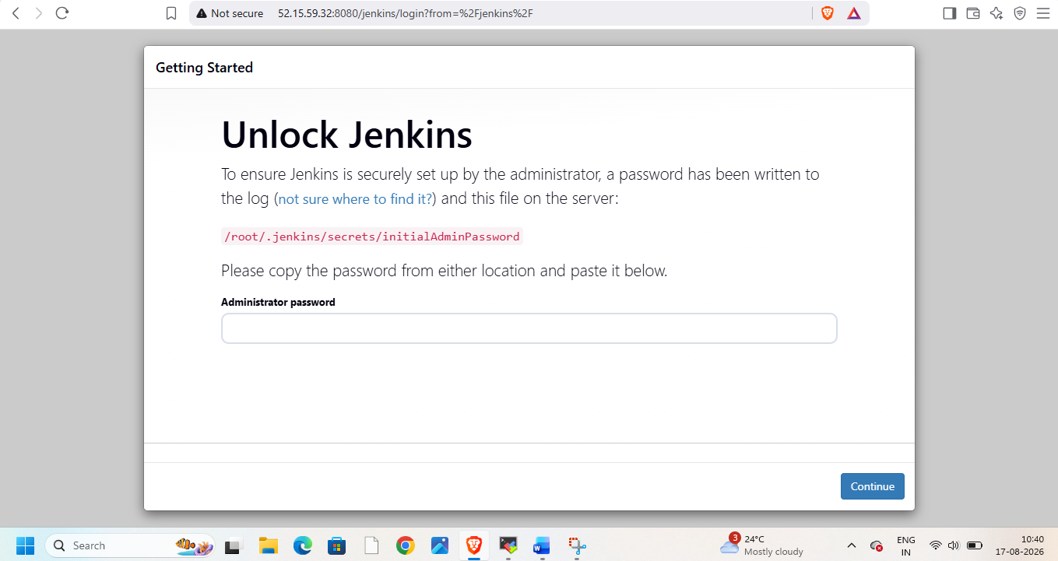
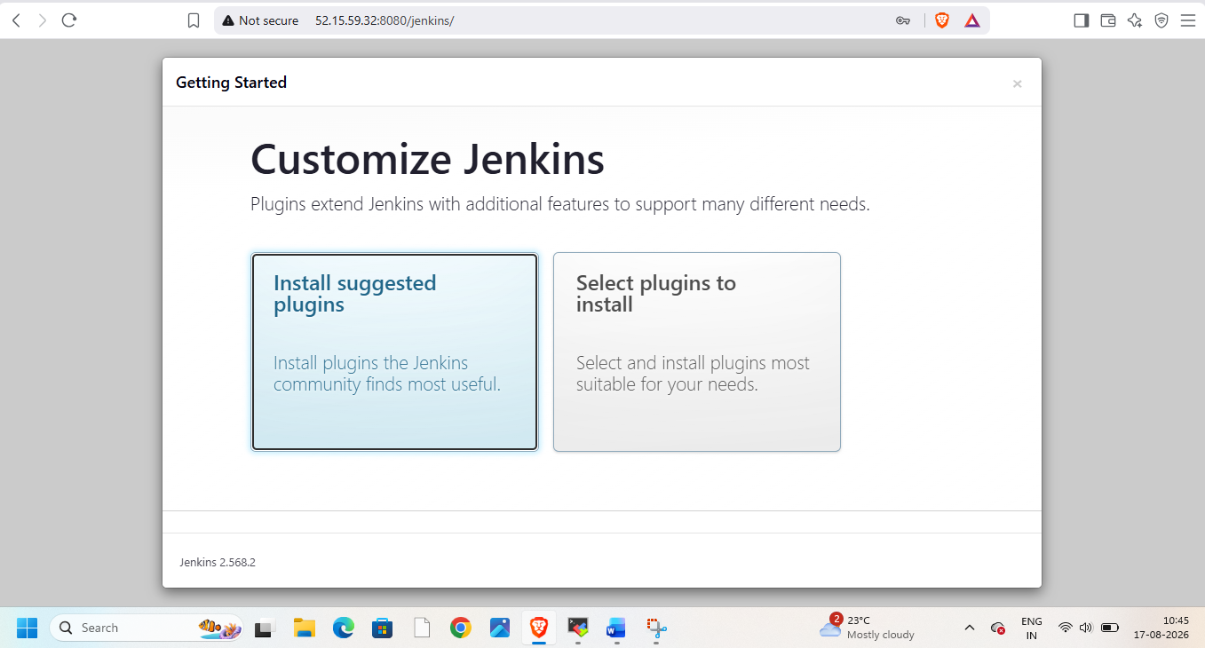
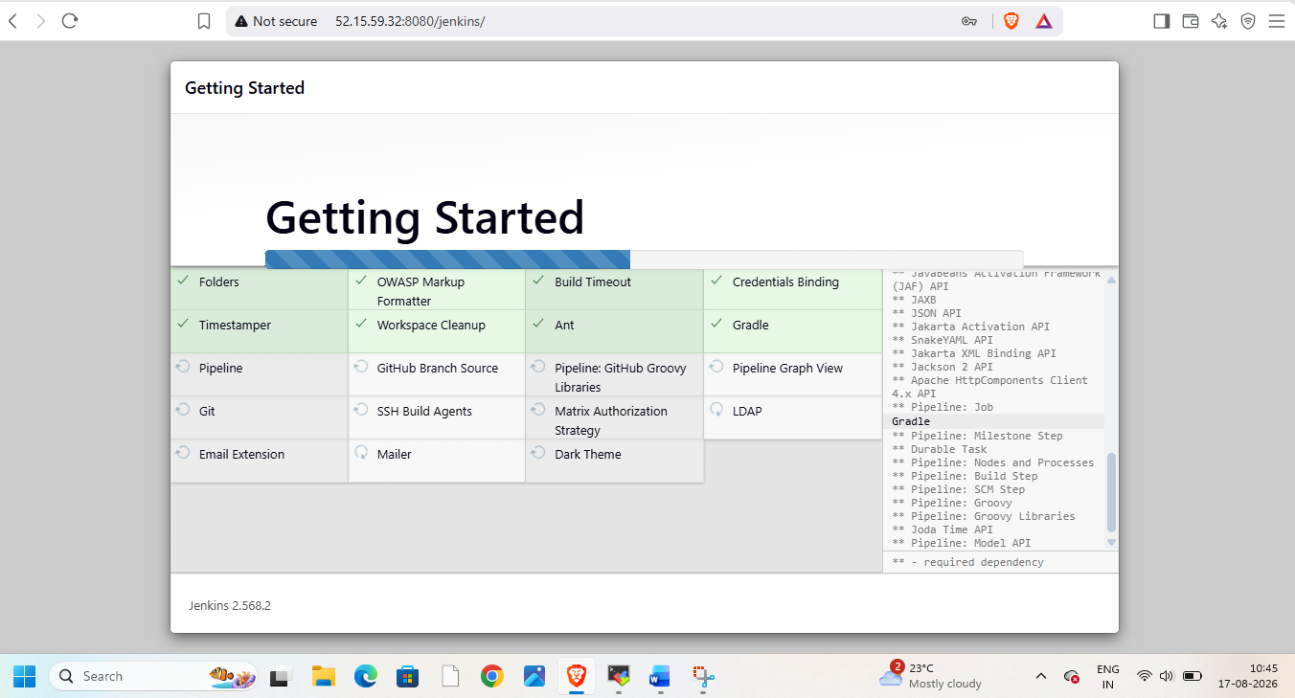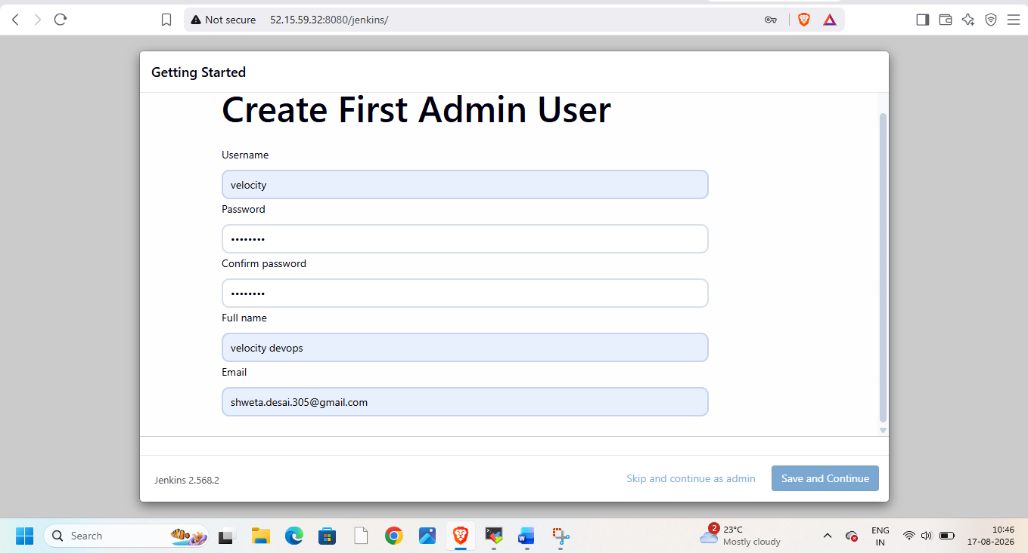
Check both the urls are correct 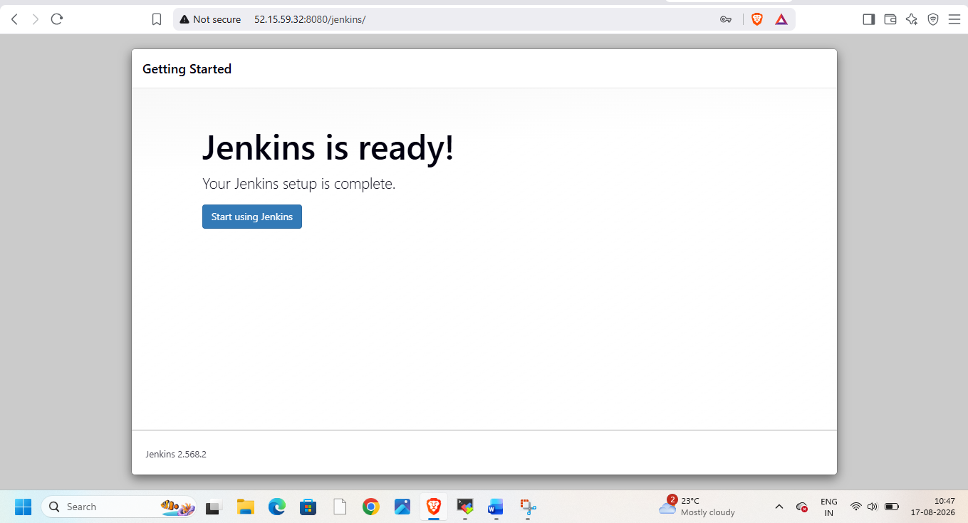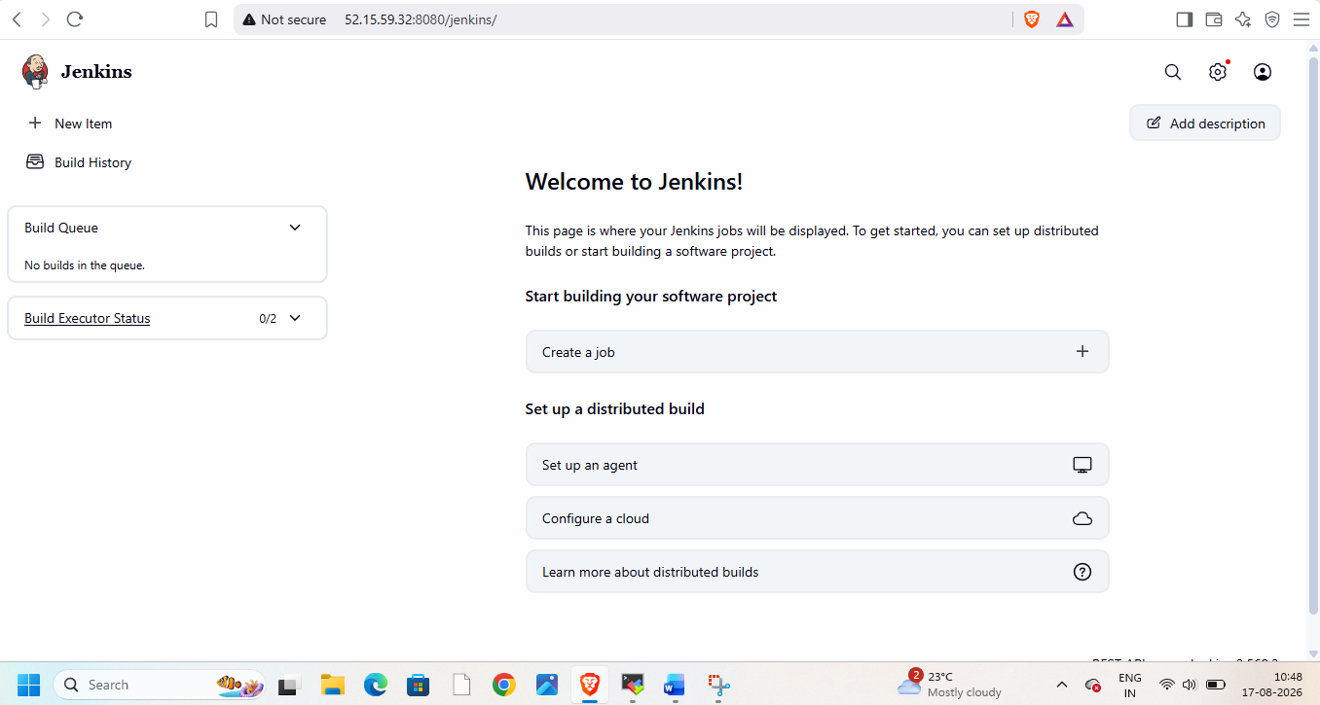
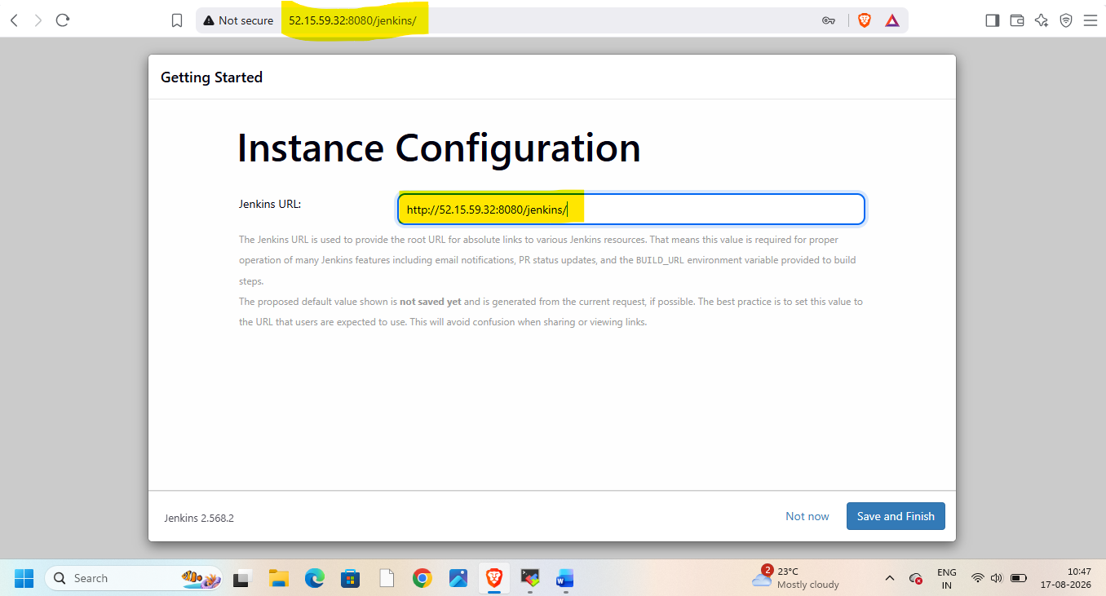
Goto manage Jenkins/nodes
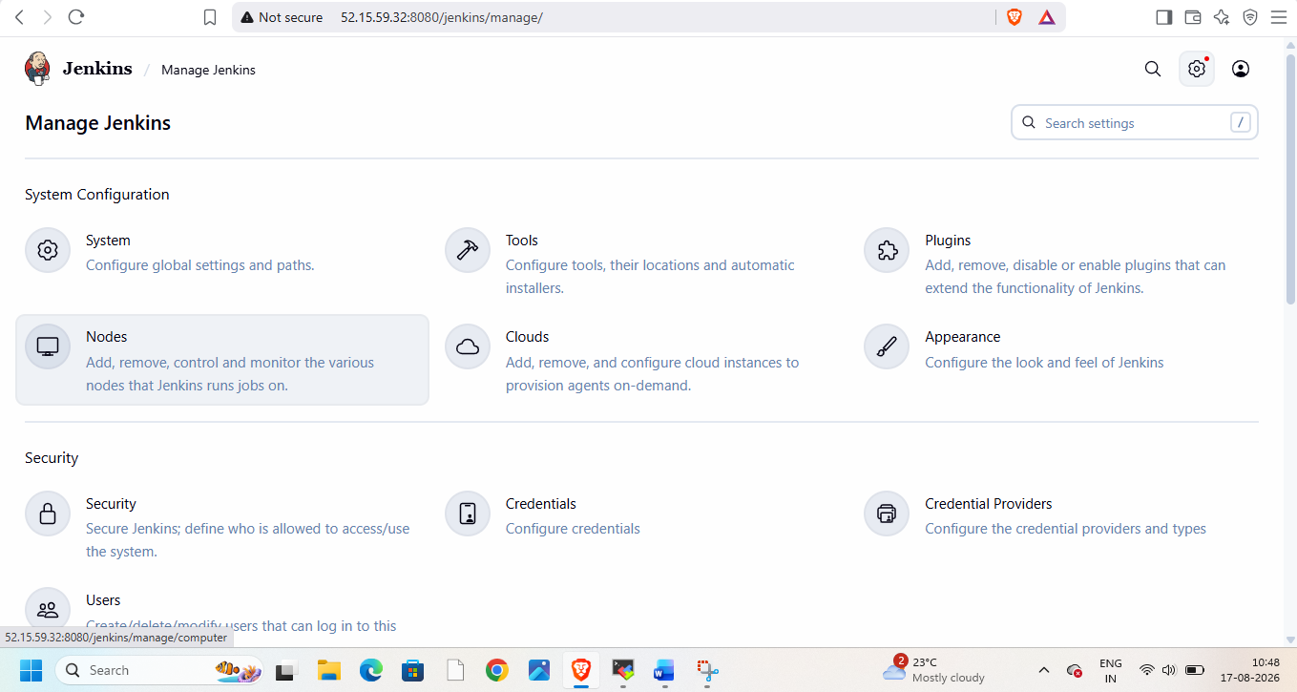
Create new node
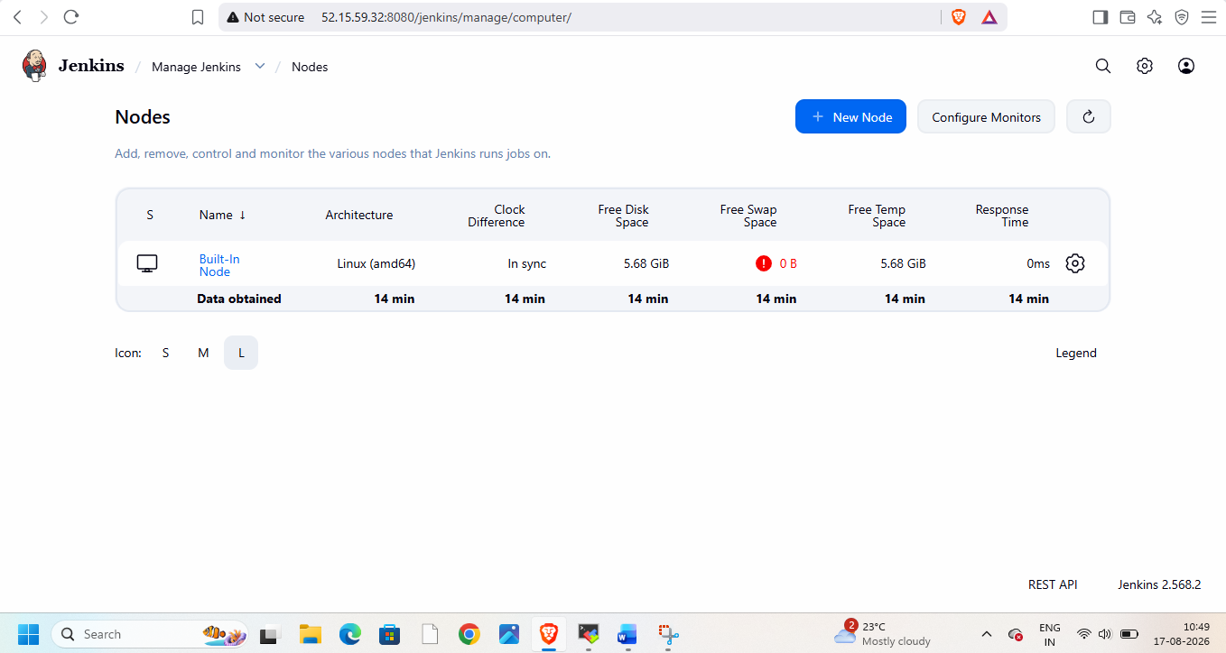slave-1
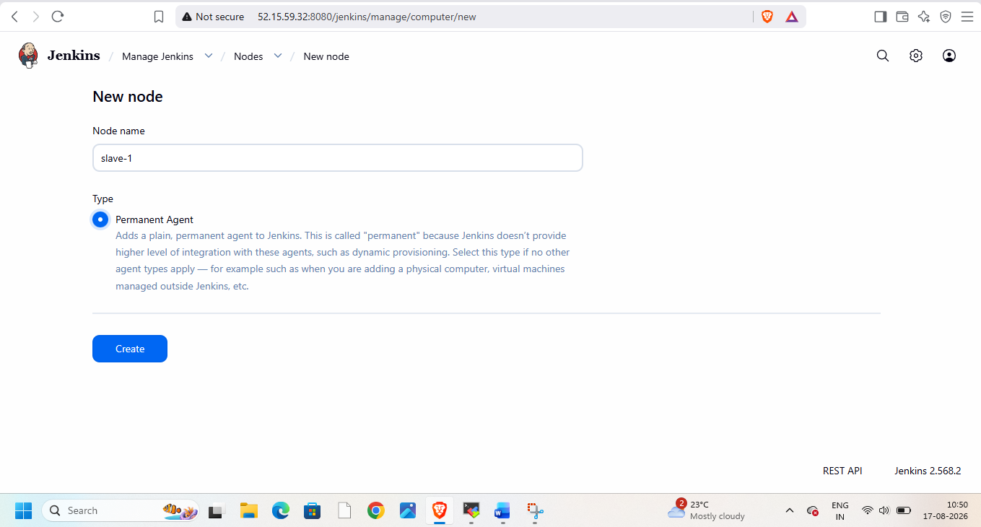
Goto slave -1
Give all permissions on /mnt do this for all three instances
Add details while creating node
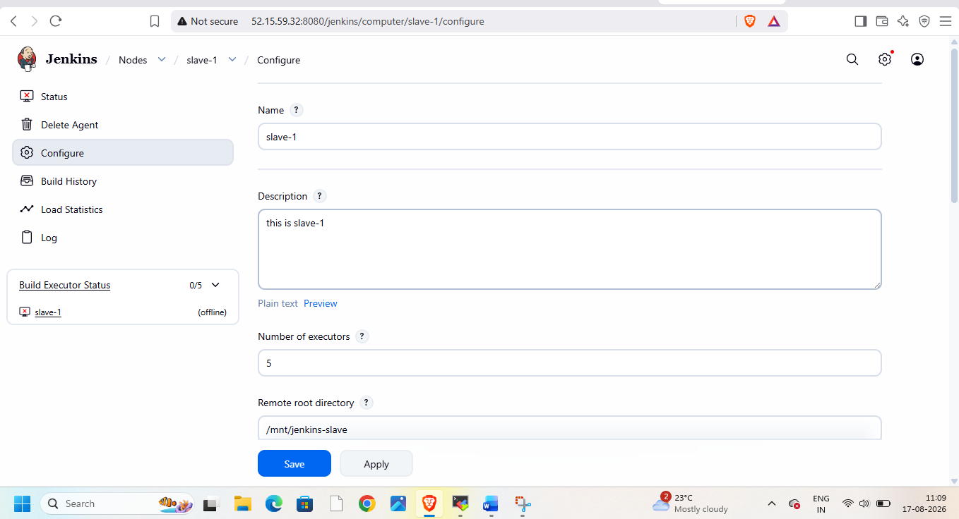
Create new credentials
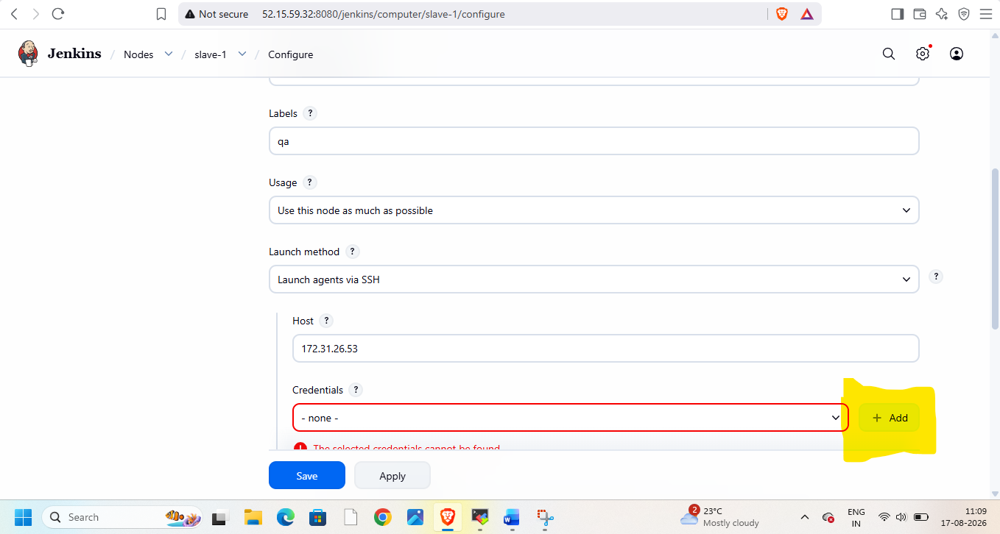
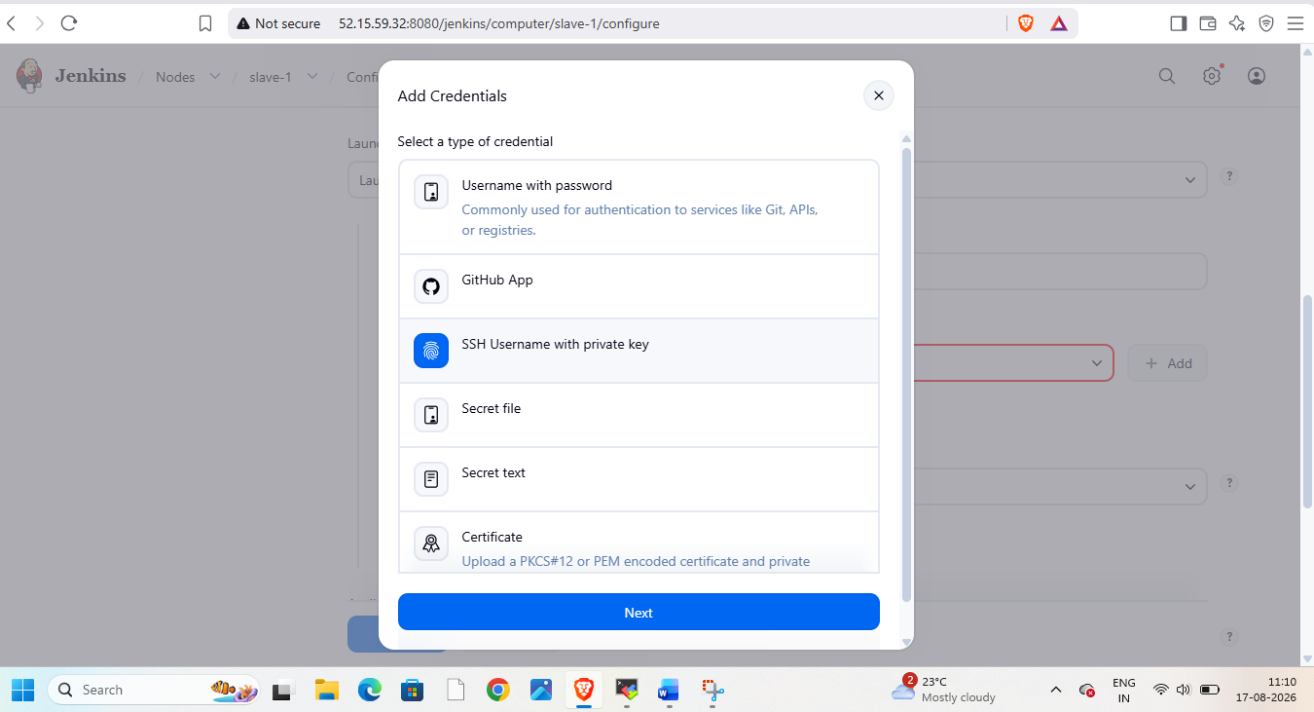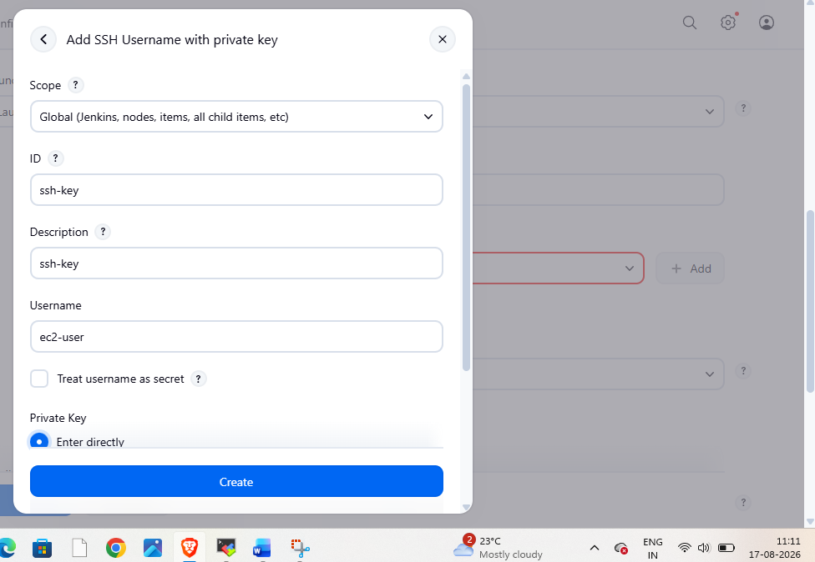
Add private key
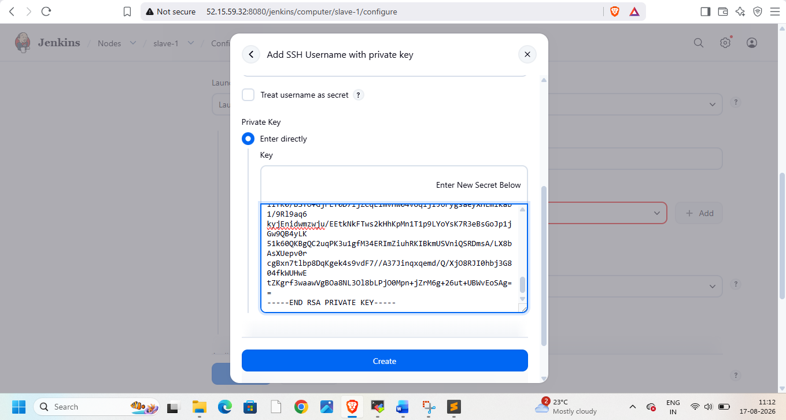
Use created credentials
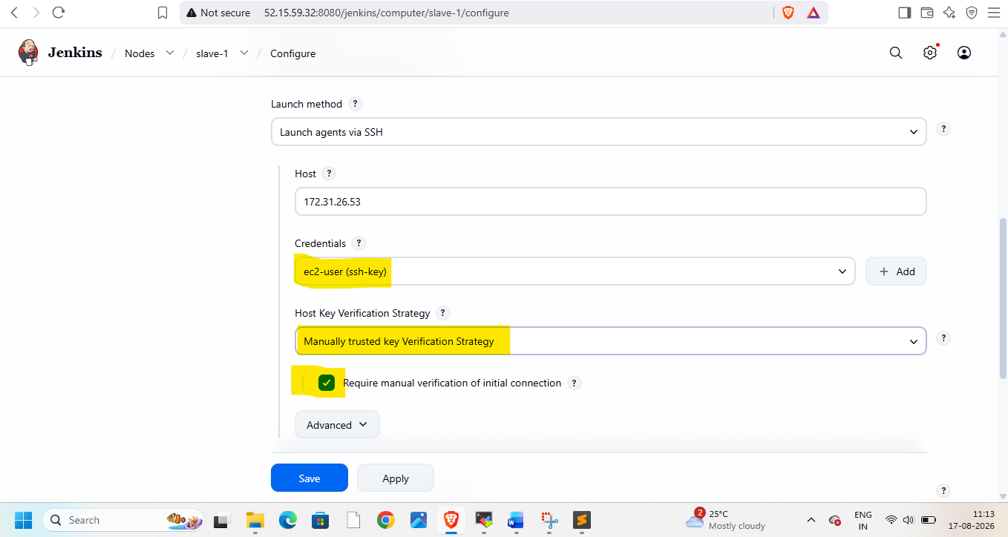
Make all threshold values to zero
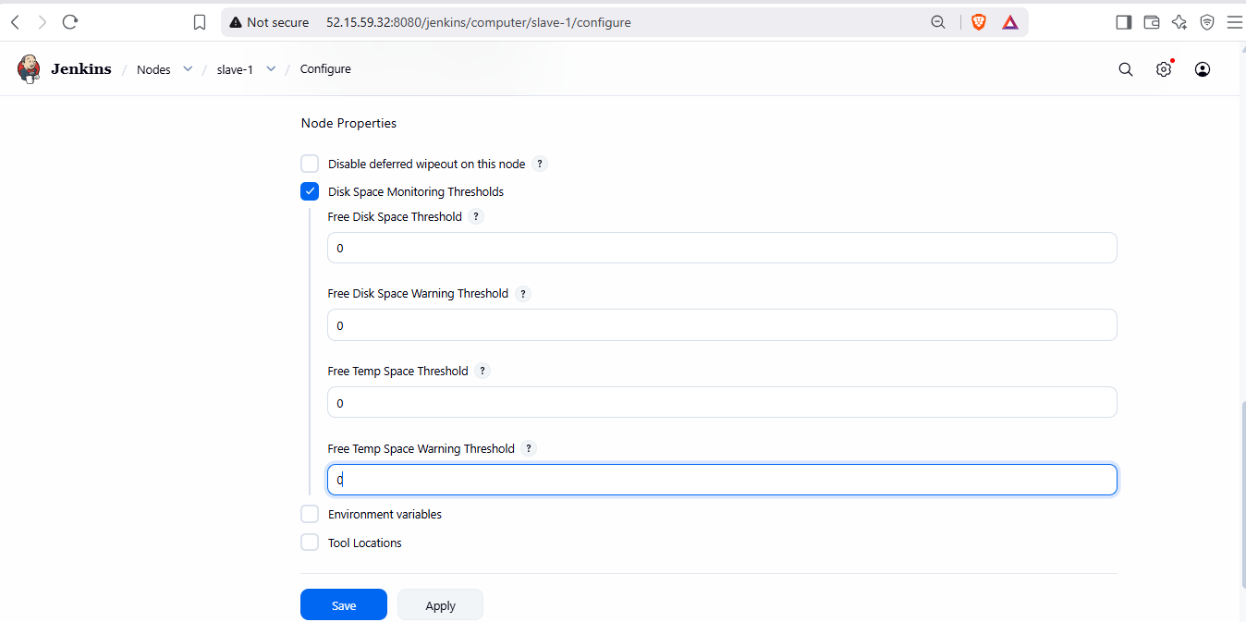

Save and trust ssh-key manually
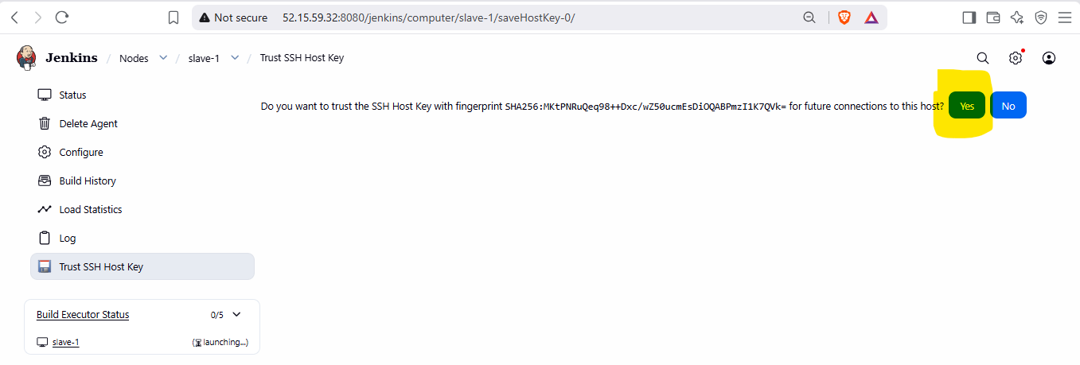
Create slave-2 and slave-3
Create new repo with 3 branches having index.html
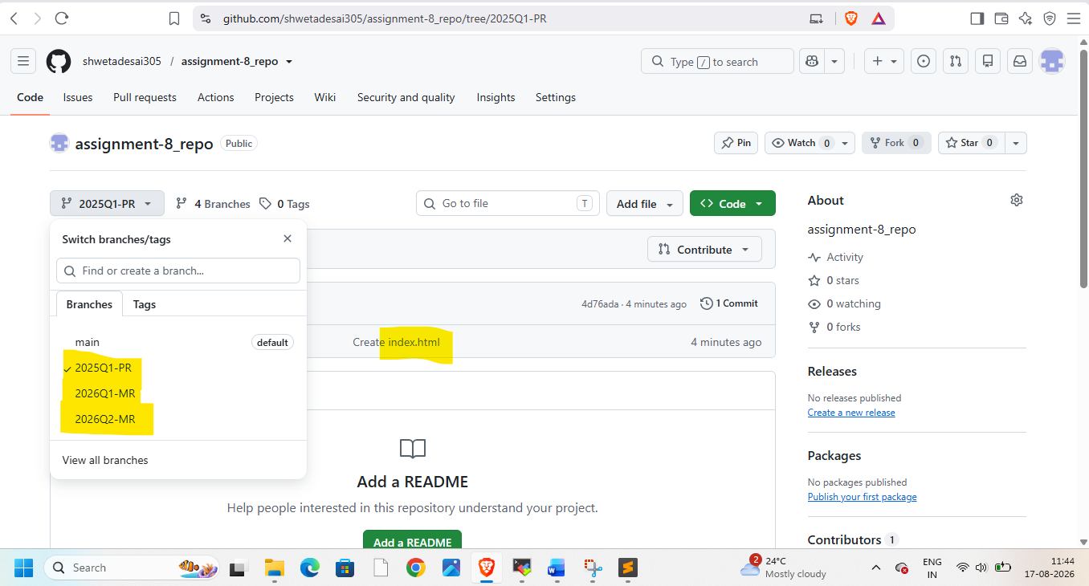
Create job-1
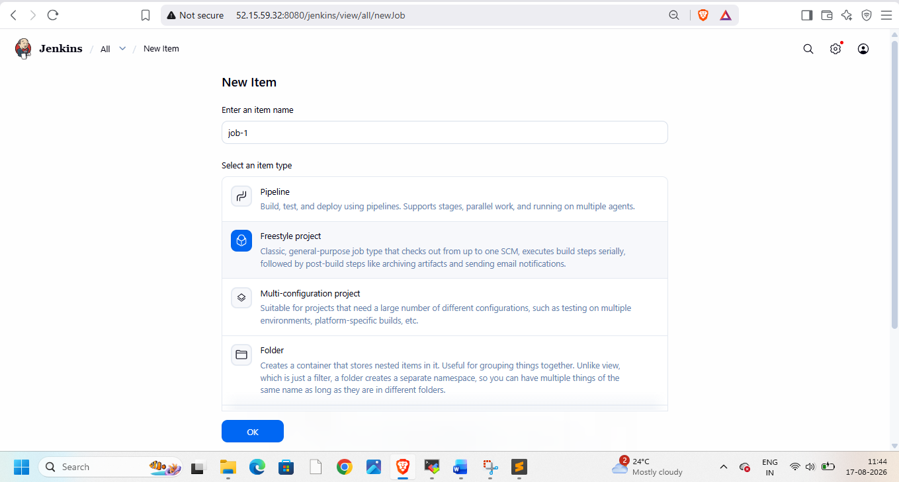

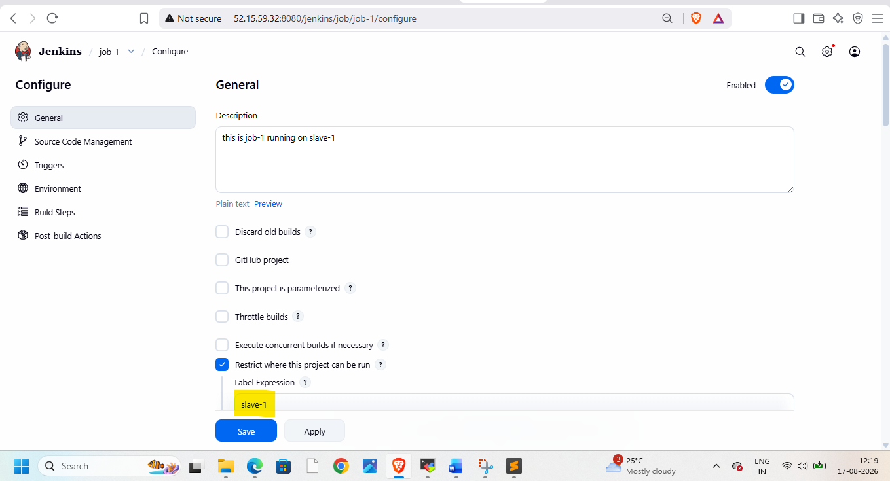
Add git repo and branch name – 2026Q1-MR
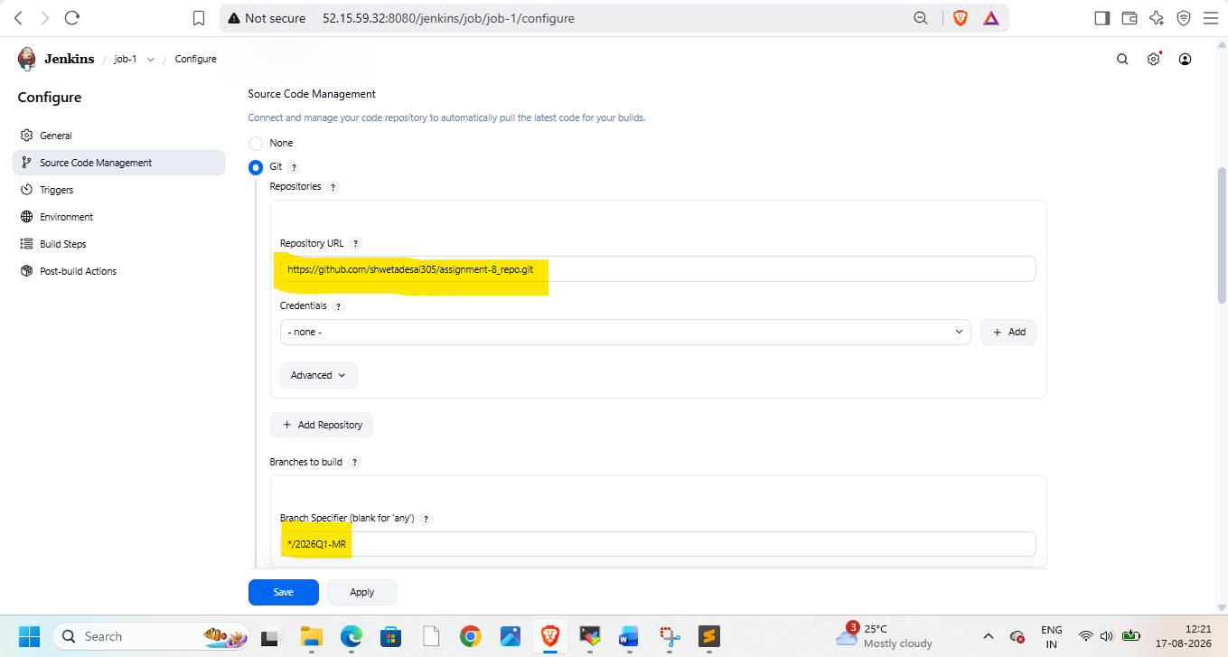
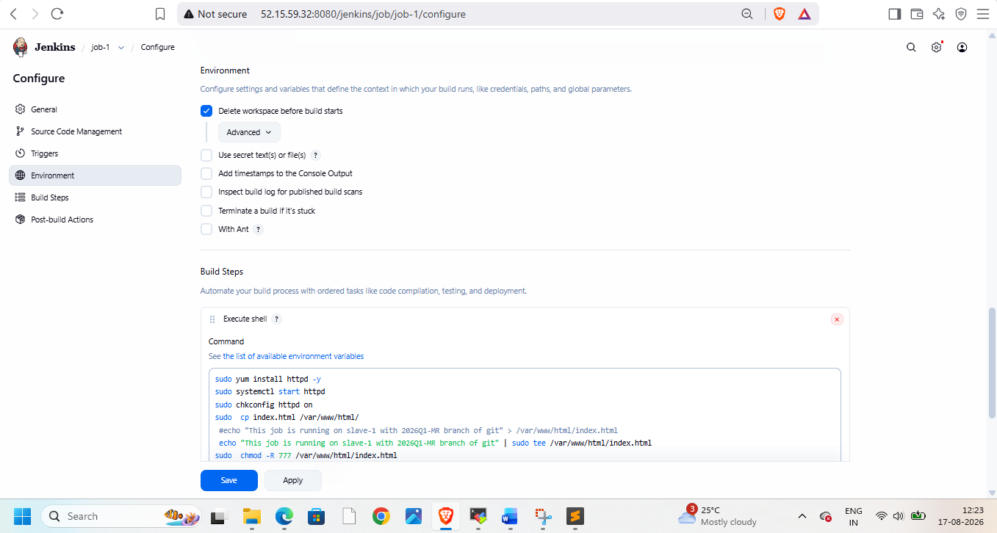
sudo yum install httpd -y
sudo systemctl start httpd
sudo chkconfig httpd on
sudo cp index.html /var/www/html/
echo "This job is running on slave-1 with 2026Q1-MR branch of git" | sudo tee /var/www/html/index.html
sudo chmod -R 777 /var/www/html/index.html
sudo systemctl restart httpd
NOW check this on browser – for that take public ip of instance-1
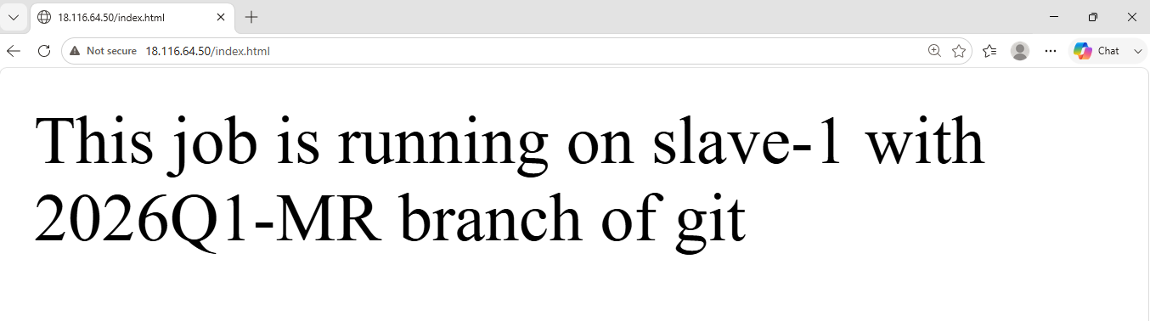

Create job-2 on slave-2
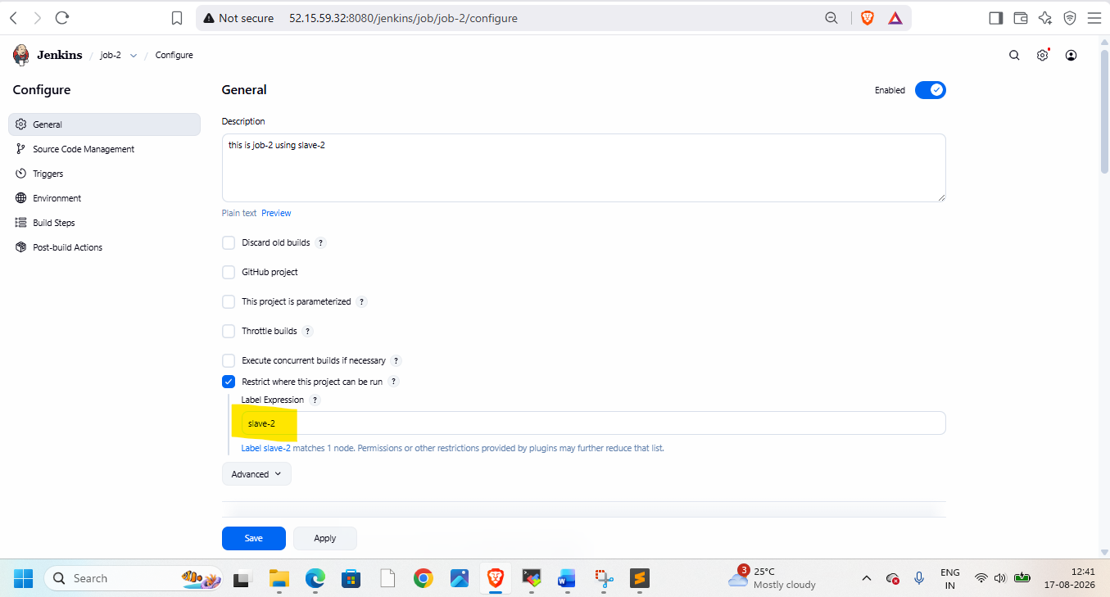
Use 2026Q2-MR branch
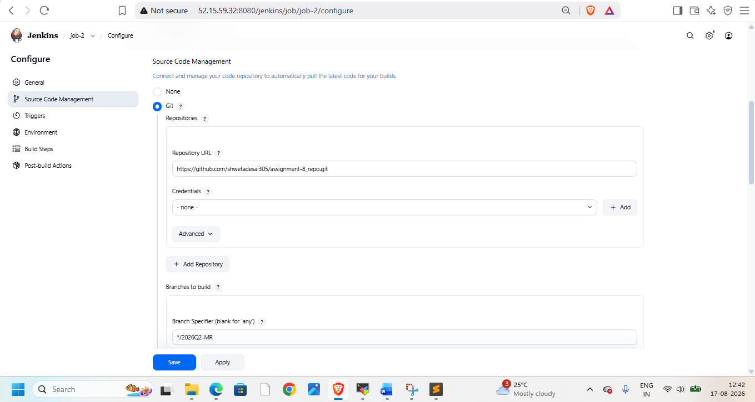
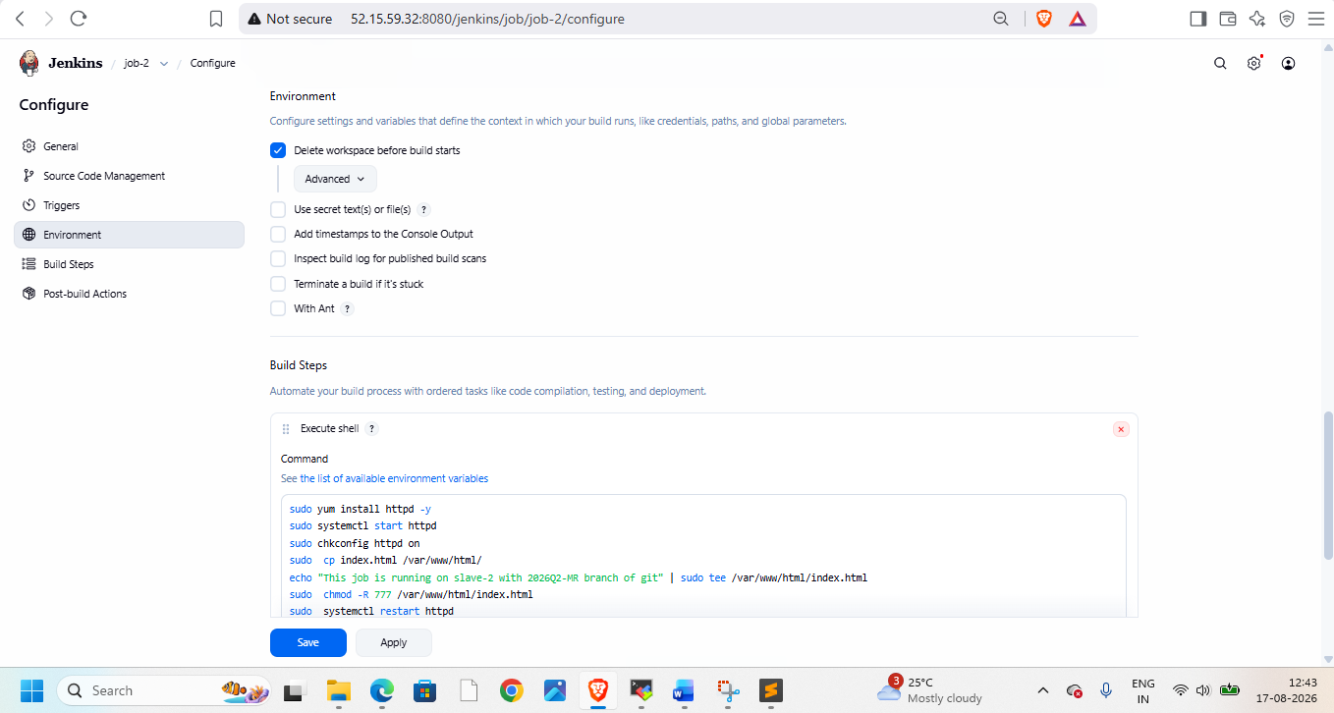
sudo yum install httpd -y
sudo systemctl start httpd
sudo chkconfig httpd on
sudo cp index.html /var/www/html/
echo "This job is running on slave-2 with 2026Q2-MR branch of git" | sudo tee /var/www/html/index.html
sudo chmod -R 777 /var/www/html/index.html
sudo systemctl restart httpd
Create job -2 and check on browser
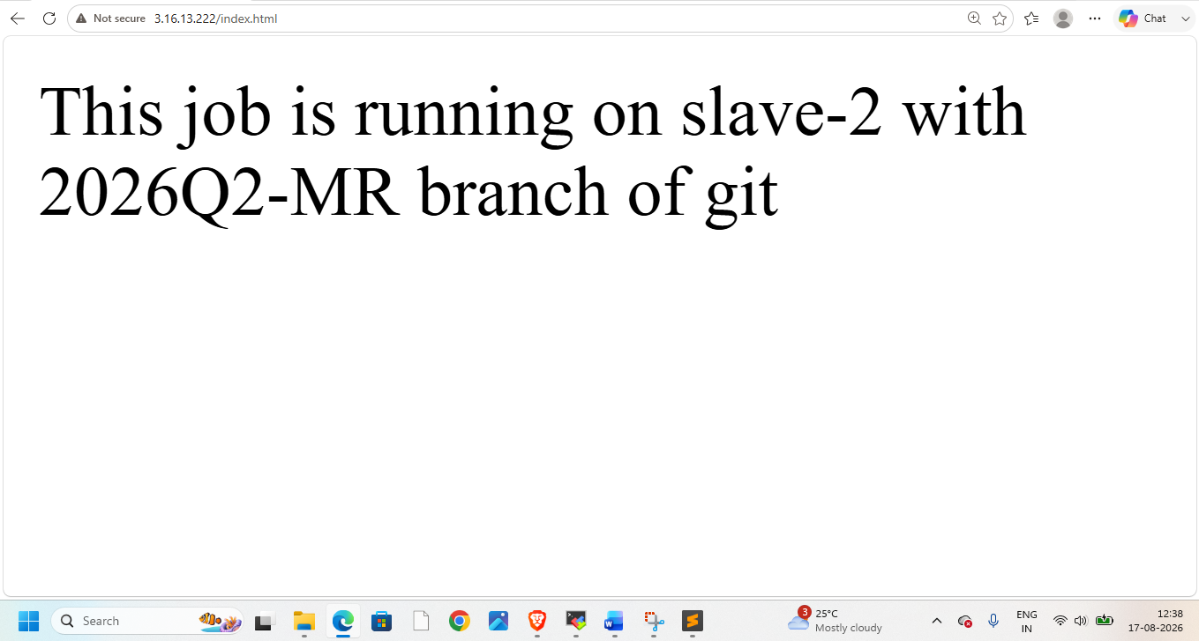

Now create job-3 using slave-3
