Create 2 instance master and slave
Connect and download java,Jenkins,git, tomcat on it
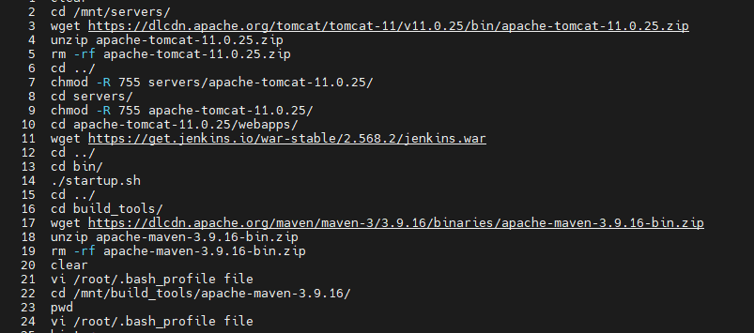
Create /mnt/workspace1 on slave and give permissions
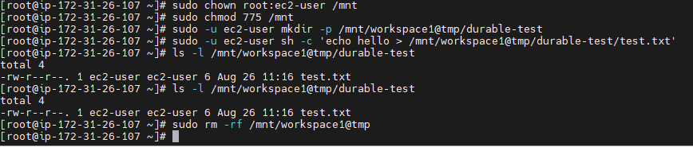
Now start Jenkins and goto Jenkins tools and Add maven details in Jenkins tools
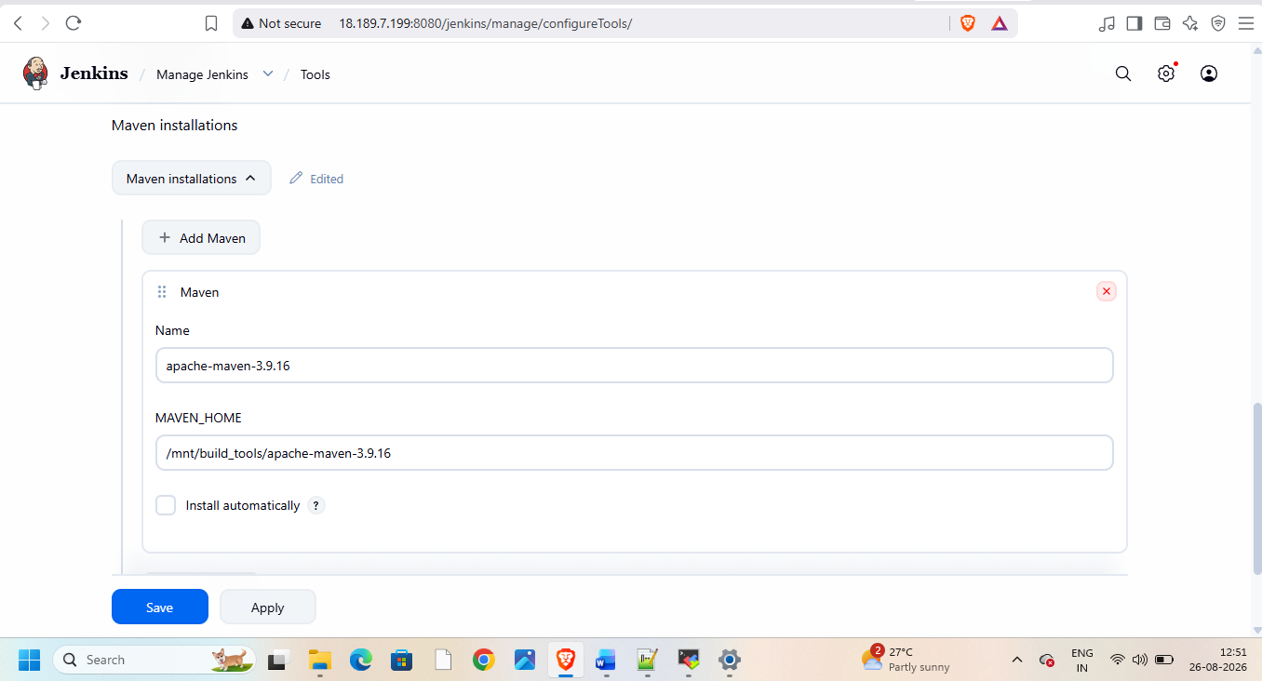
Start Jenkins on master and create node in it
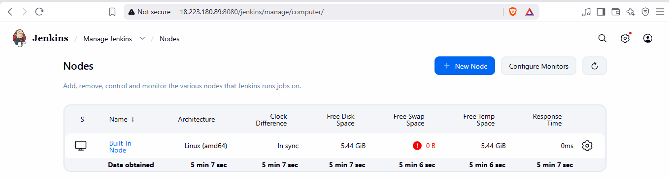
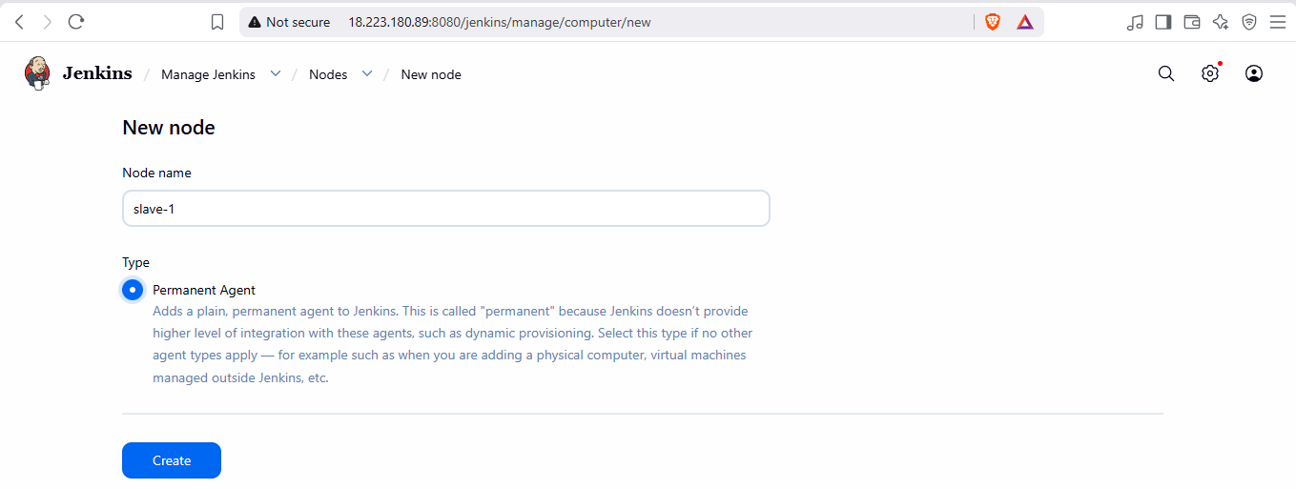
Goto slave -1
Give all permissions on /mnt do this for all three instances
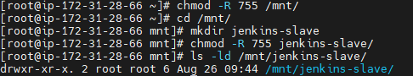
Add details while creating nodes
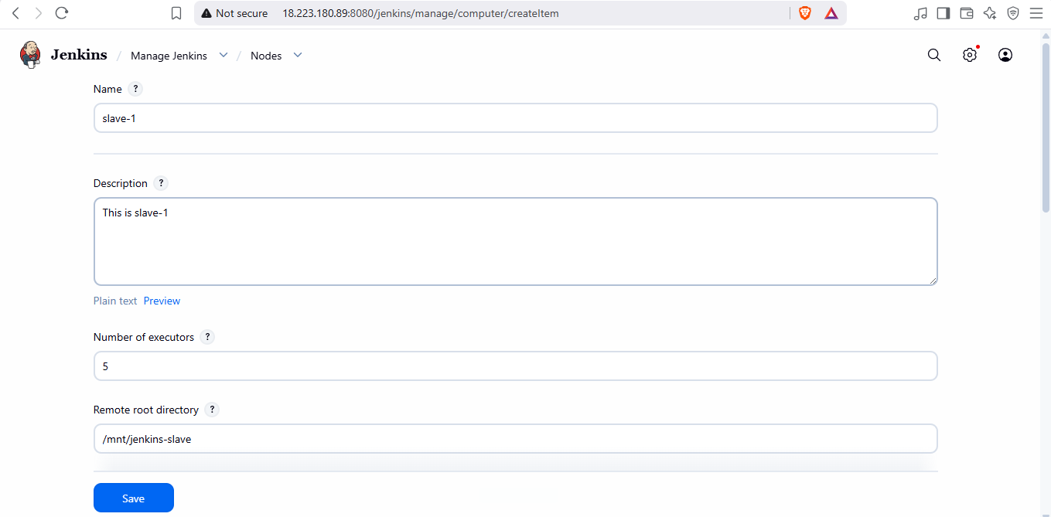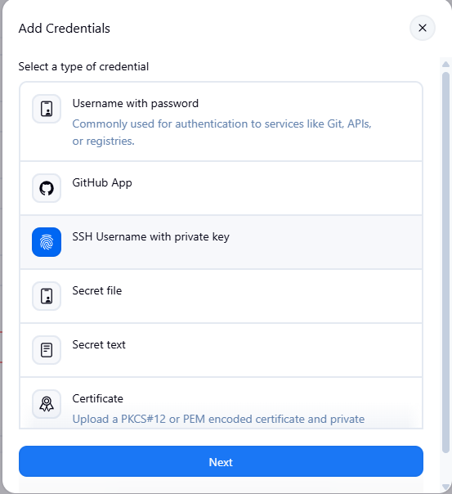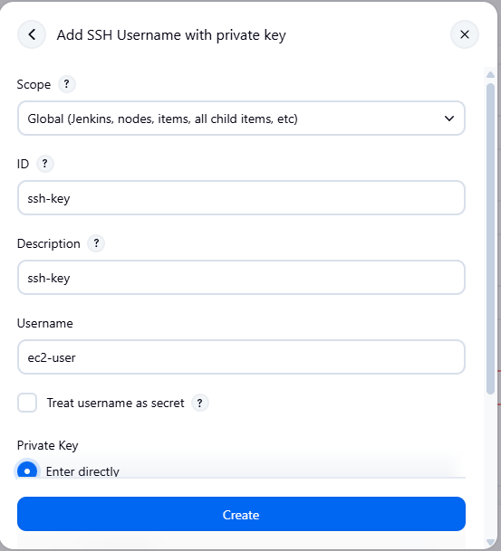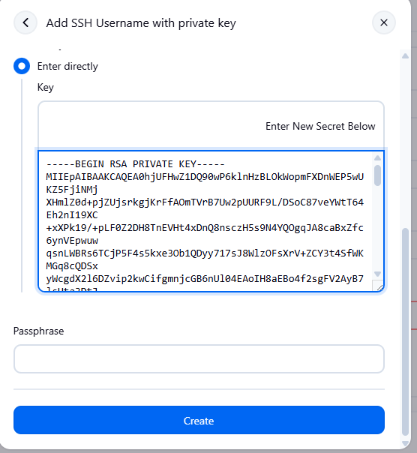
Add private ip of slave instance
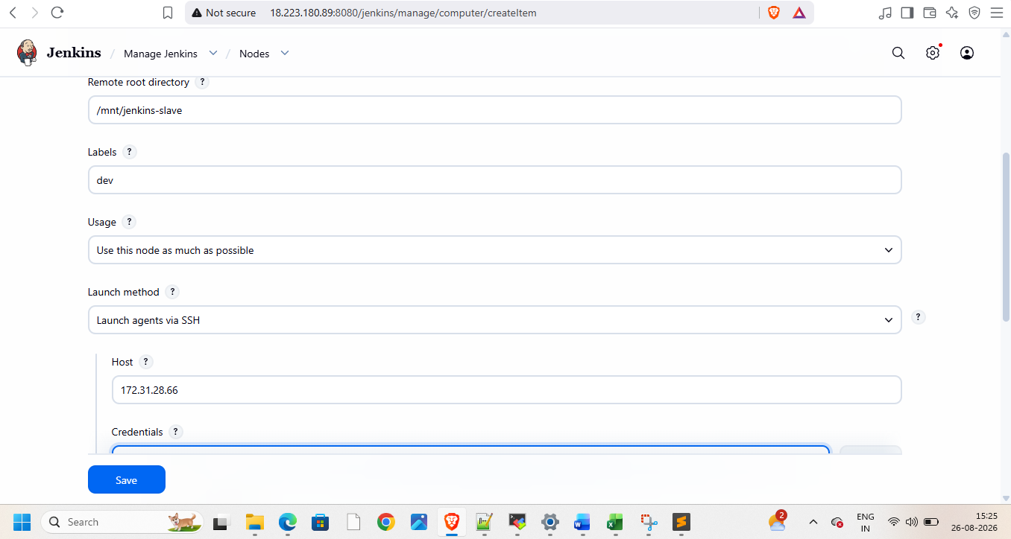
Create and add credentials
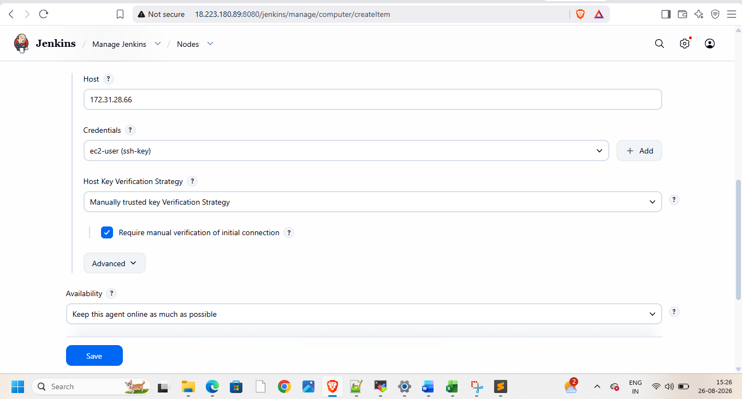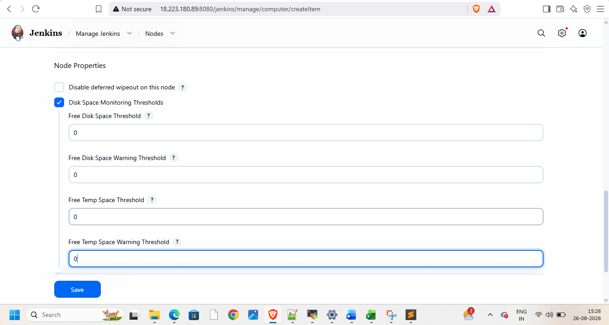
Do this on slave
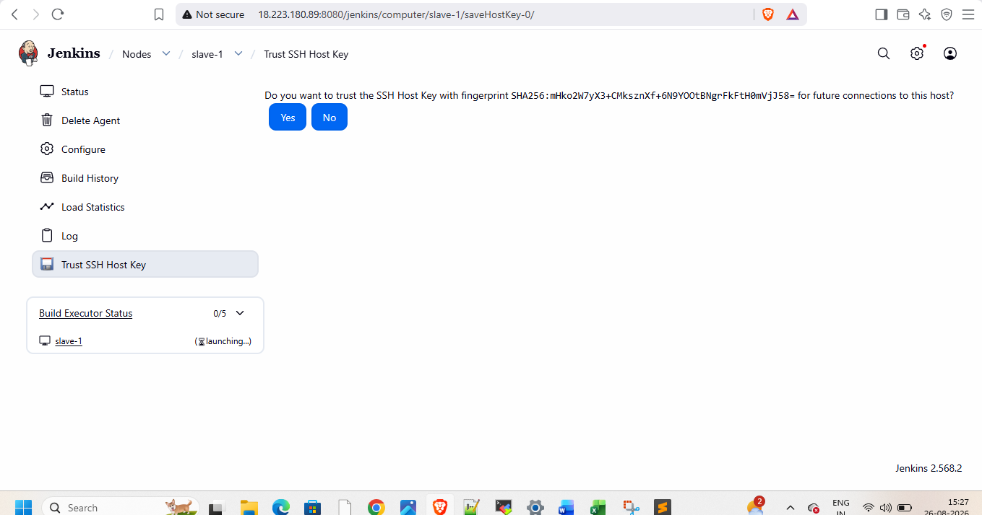
Relaunch agent
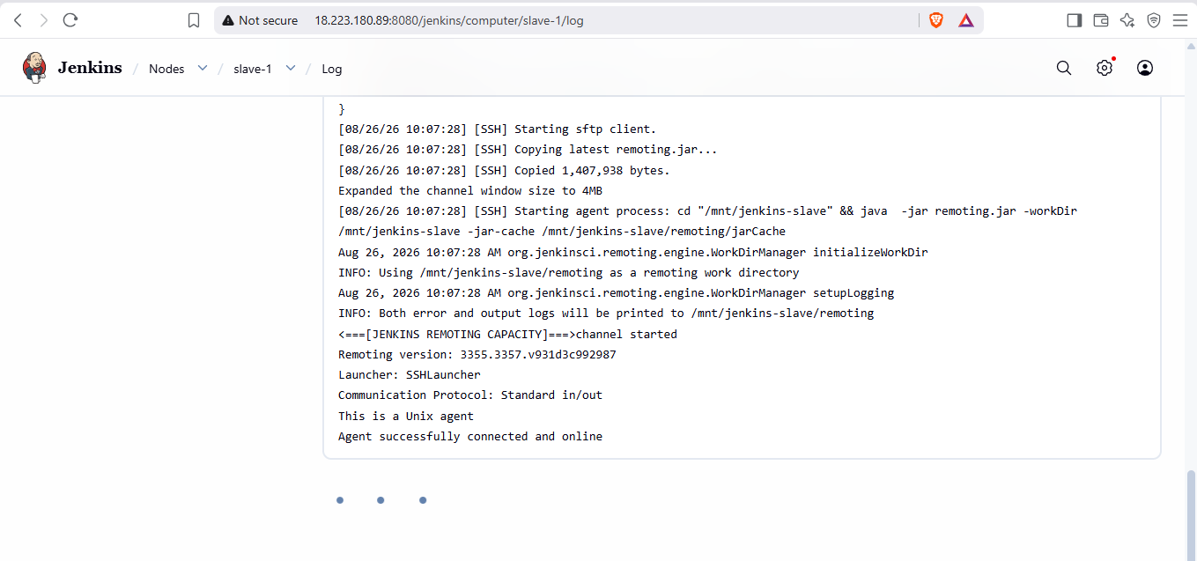

Create pipeline and add git url from git repo in it
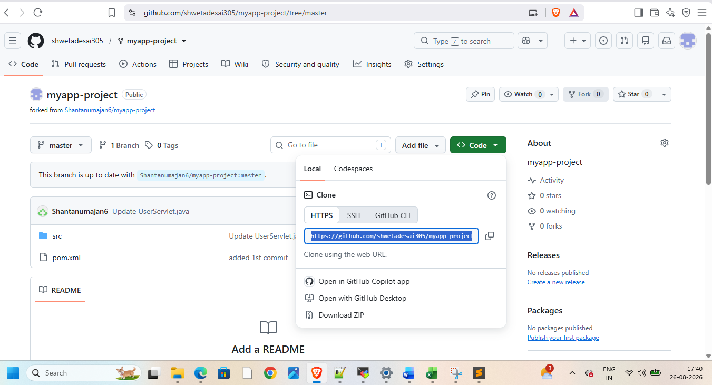
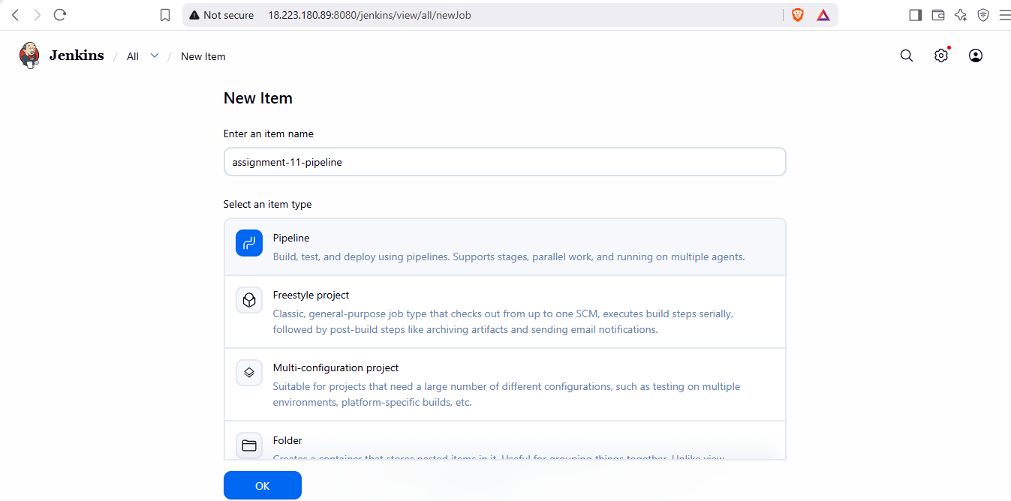
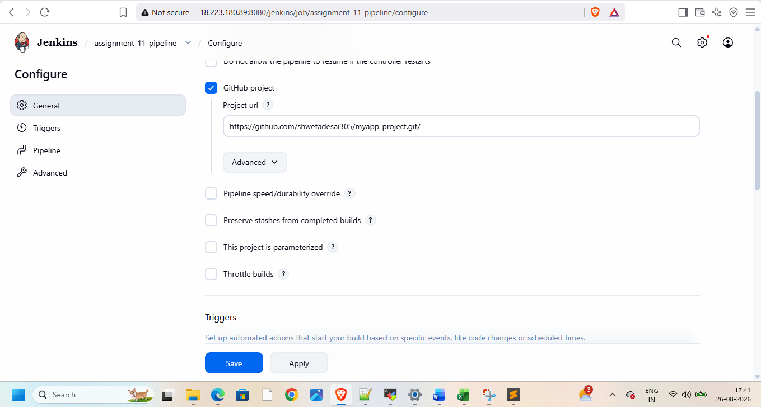
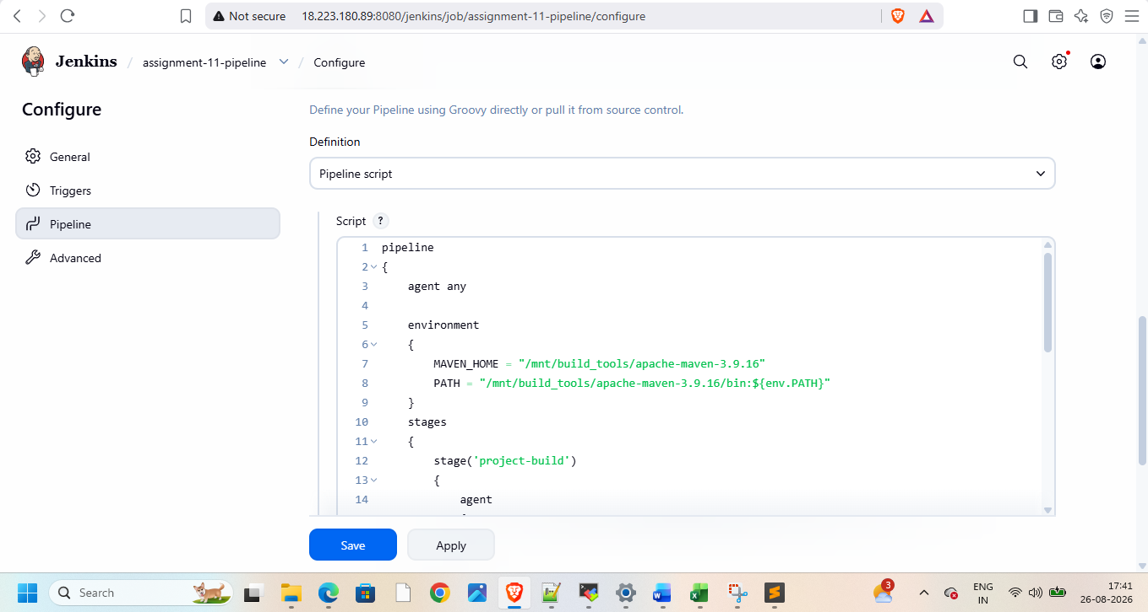
Add pipeline script to create and deploy war file on slave-1
pipeline
{
agent any

environment
{
MAVEN_HOME = "/mnt/build_tools/apache-maven-3.9.16"
PATH = "/mnt/build_tools/apache-maven-3.9.16/bin:${env.PATH}"
}
stages
{
stage('project-build')
{
agent
{
node
{
label "slave-1"
customWorkspace "/mnt/myapp-project"
}

}
steps
{
sh 'sudo rm -rf /root/.m2/repository'
git branch: 'master' , url: 'https://github.com/shwetadesai305/myapp-project.git'
sh '''
mvn clean package -DskipTests=true
sudo rm -rf /mnt/servers/apache-tomcat-11.0.25/webapps/java17-mysql-webapp-1*
sudo cp -r target/java17-mysql-webapp-1.0.war /mnt/servers/apache-tomcat-11.0.25/webapps

'''
}
}
}
}

Build pipeline
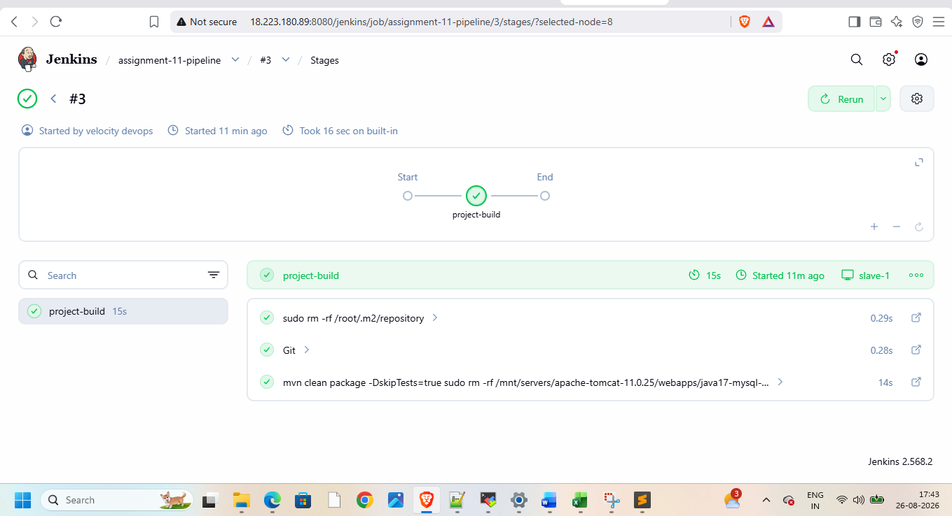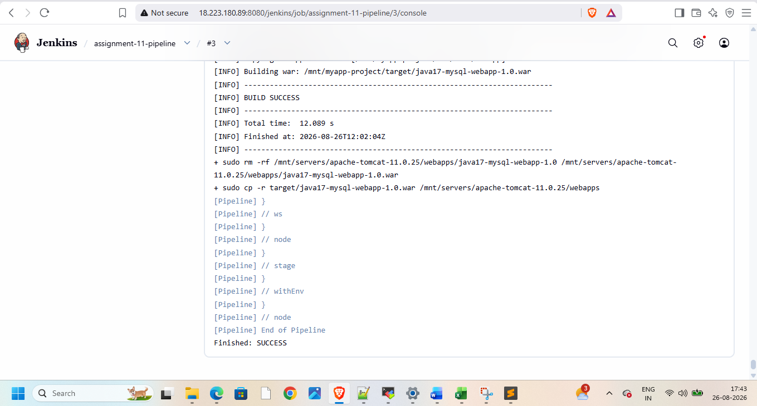
Now check on browser using public ip of slave-1
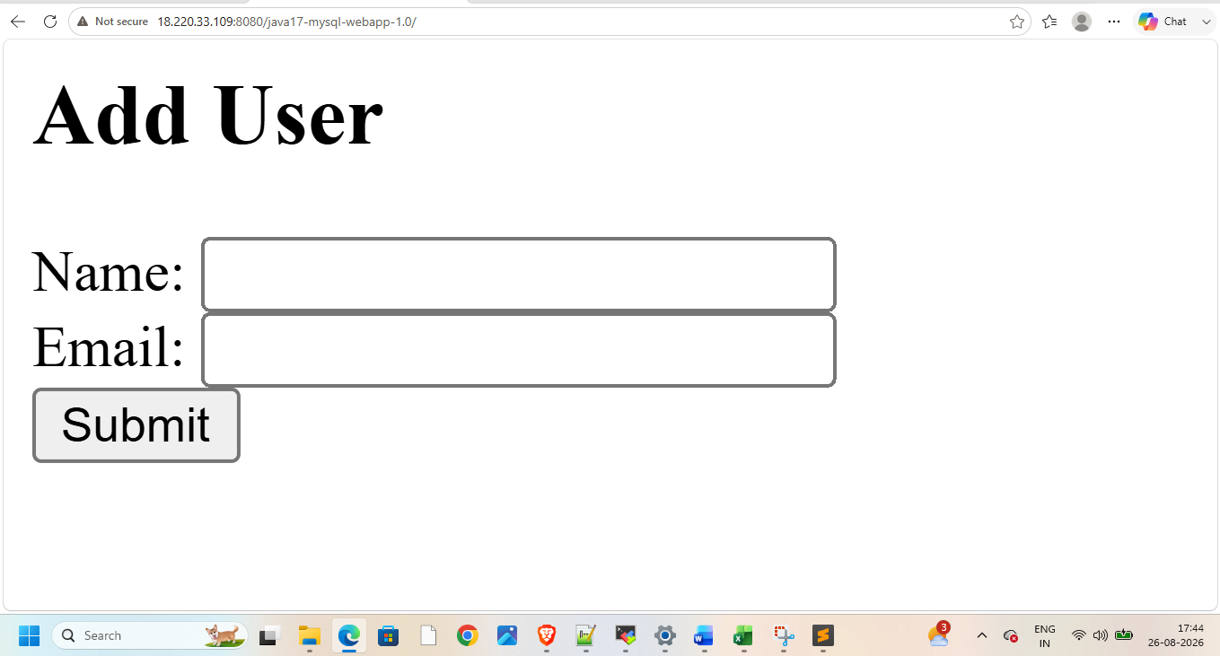
Also on master’s public ip
