Jenkins_Assignment_4_pipeline - create 1 repository in git and make 4 branches of it and deploy index file from each branch with 4 different jobs
Here in pipeline we will create multisatges to perform this task.
Ans – create instance and connect to it and install java,tomcat,Jenkins and git in it
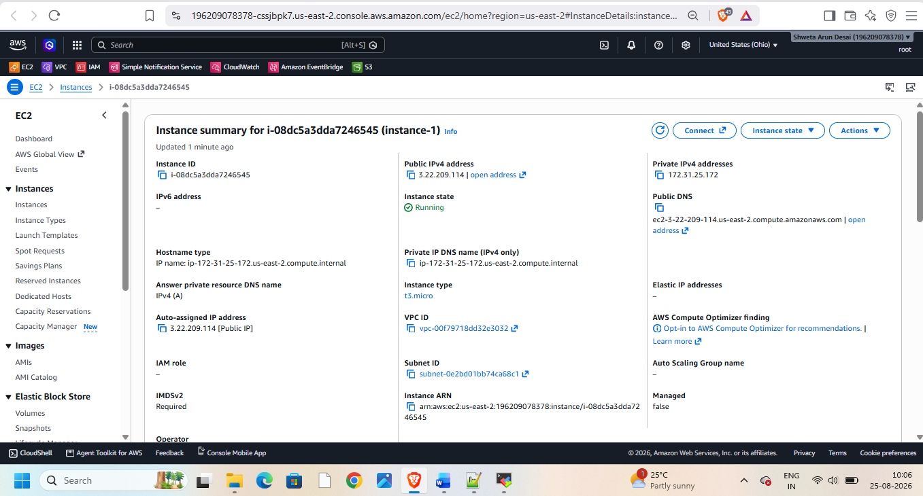
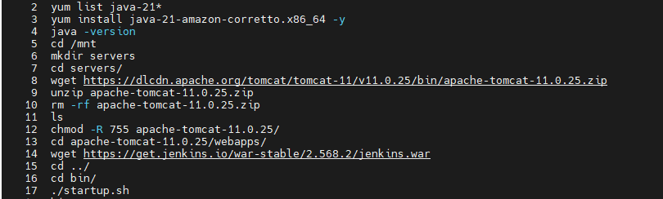
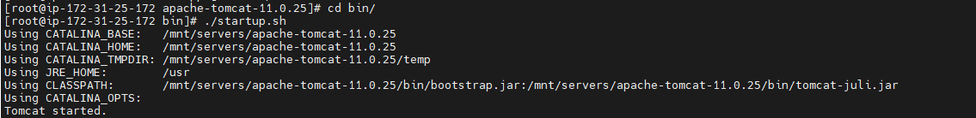
Take public-ip:8080/Jenkins
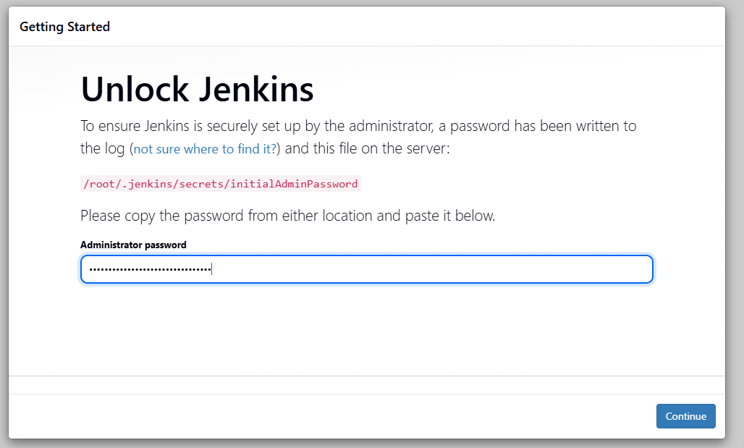
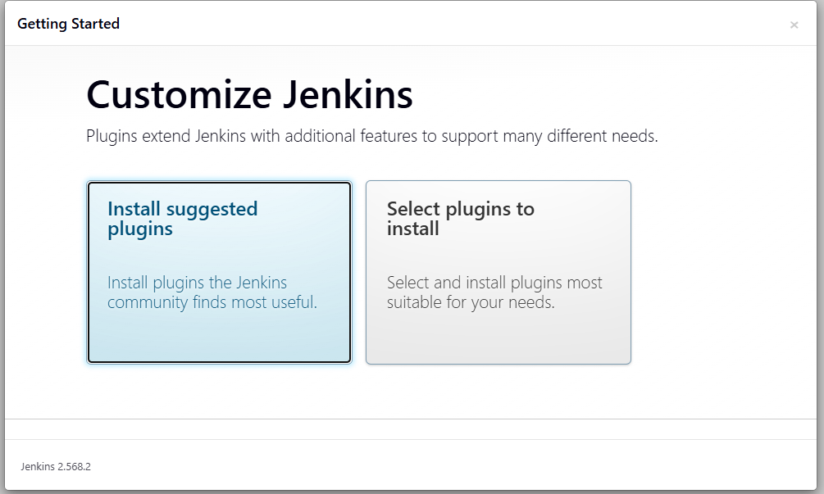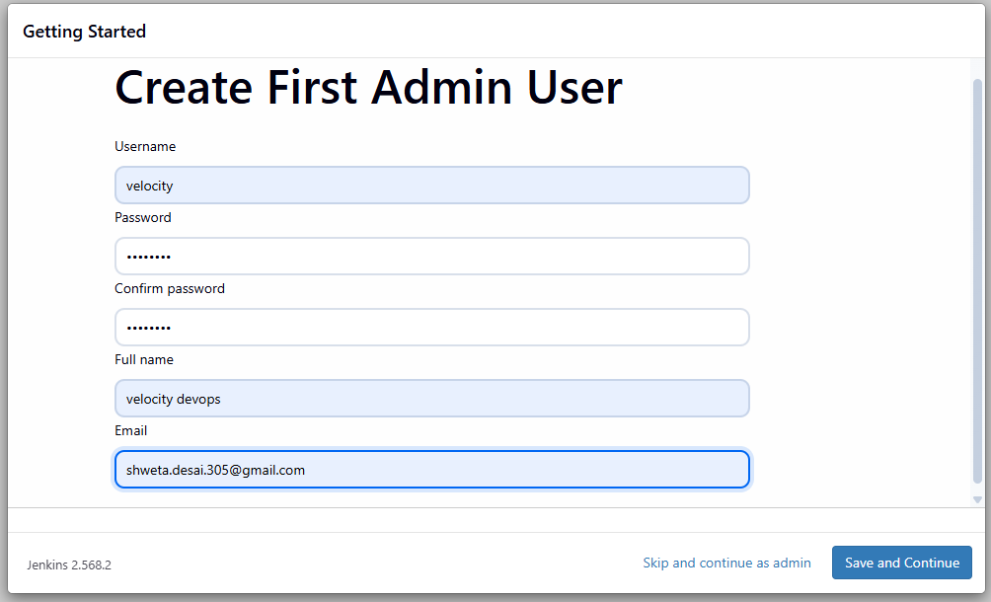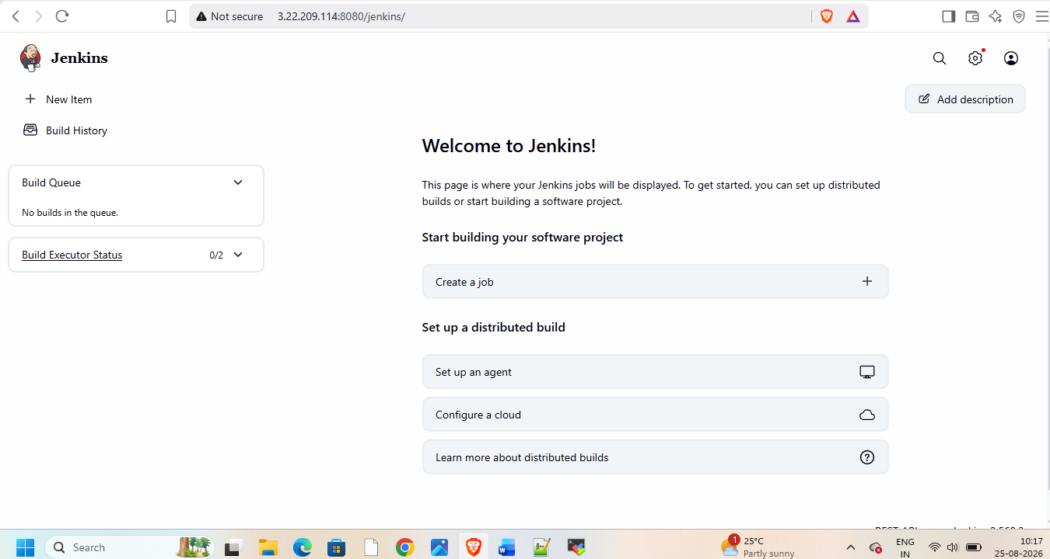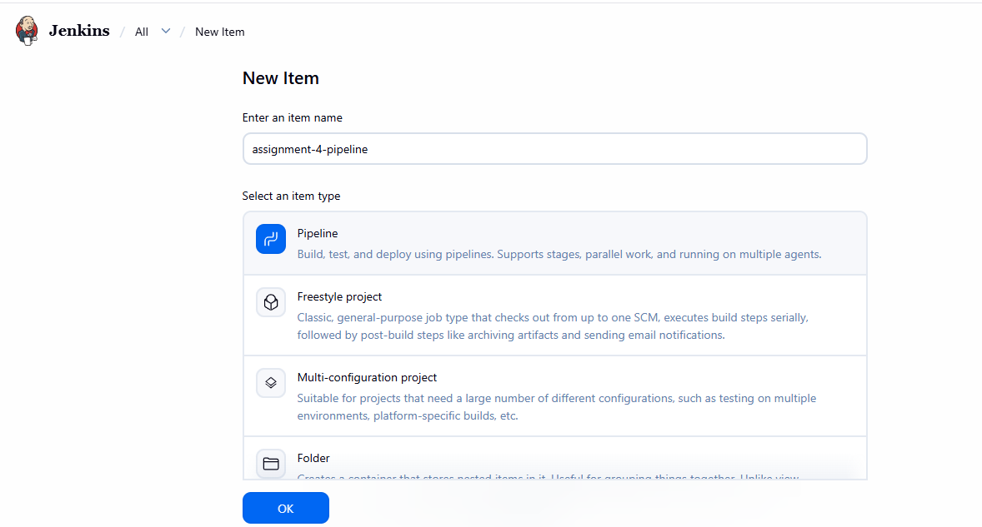
Add pipeline code in it
pipeline
{
agent any
stages
{
stage('clean-wsp')
{
steps
{
sh 'rm -rf "$WORKSPACE"/* '
}
}

stage('httpd install')
{
steps
{
sh '''
yum install httpd -y
systemctl start httpd
chkconfig httpd on
'''
}
}

stage('git-clone1')
{
steps
{
sh '''
git clone -b 2026Q1-MR https://github.com/shwetadesai305/r1.git
'''

}
}

stage('copy-index1')
{
steps
{
sh '''
rm -rf /var/www/html/first
mkdir /var/www/html/first
cp r1/index.html /var/www/html/first/
chmod -R 755 /var/www/html/first
'''
}
}

stage('git-clone2')
{
steps
{
sh '''
git clone -b 2025Q4-PR https://github.com/shwetadesai305/r2.git
'''

}
}
stage('copy-index2')
{
steps
{
sh '''
rm -rf /var/www/html/second
mkdir /var/www/html/second
cp r2/index.html /var/www/html/second/
chmod -R 755 /var/www/html/second
systemctl restart httpd
'''
}
}

stage('git-clone3')
{
steps
{
sh '''
git clone -b 2024Q4-BF https://github.com/shwetadesai305/r3.git
'''

}
}
stage('copy-index3')
{
steps
{
sh '''
rm -rf /var/www/html/three
mkdir /var/www/html/three
cp r3/index.html /var/www/html/three/
chmod -R 755 /var/www/html/three
systemctl restart httpd
'''
} } }}
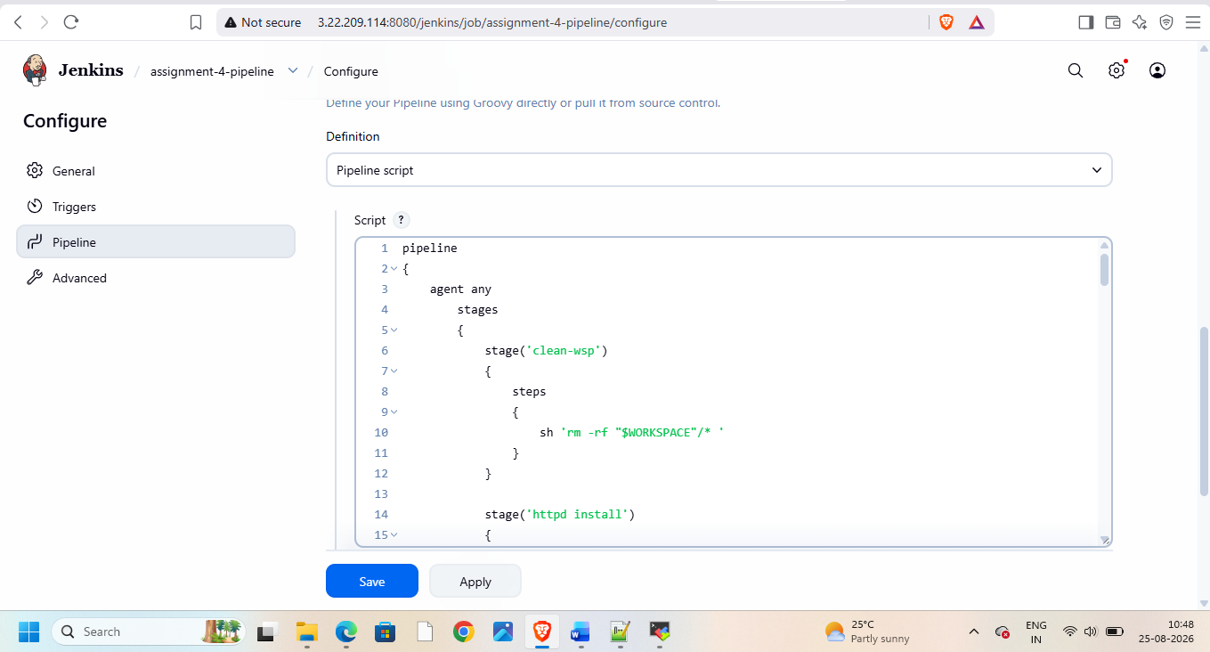
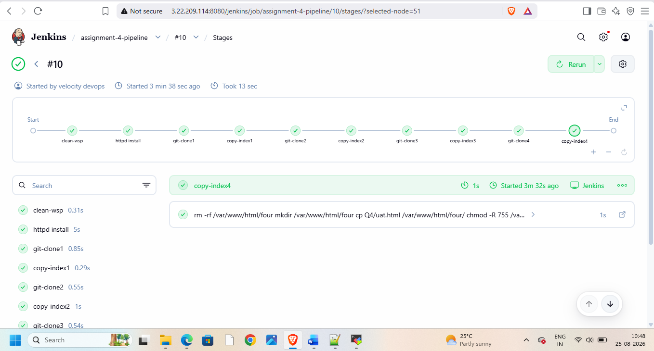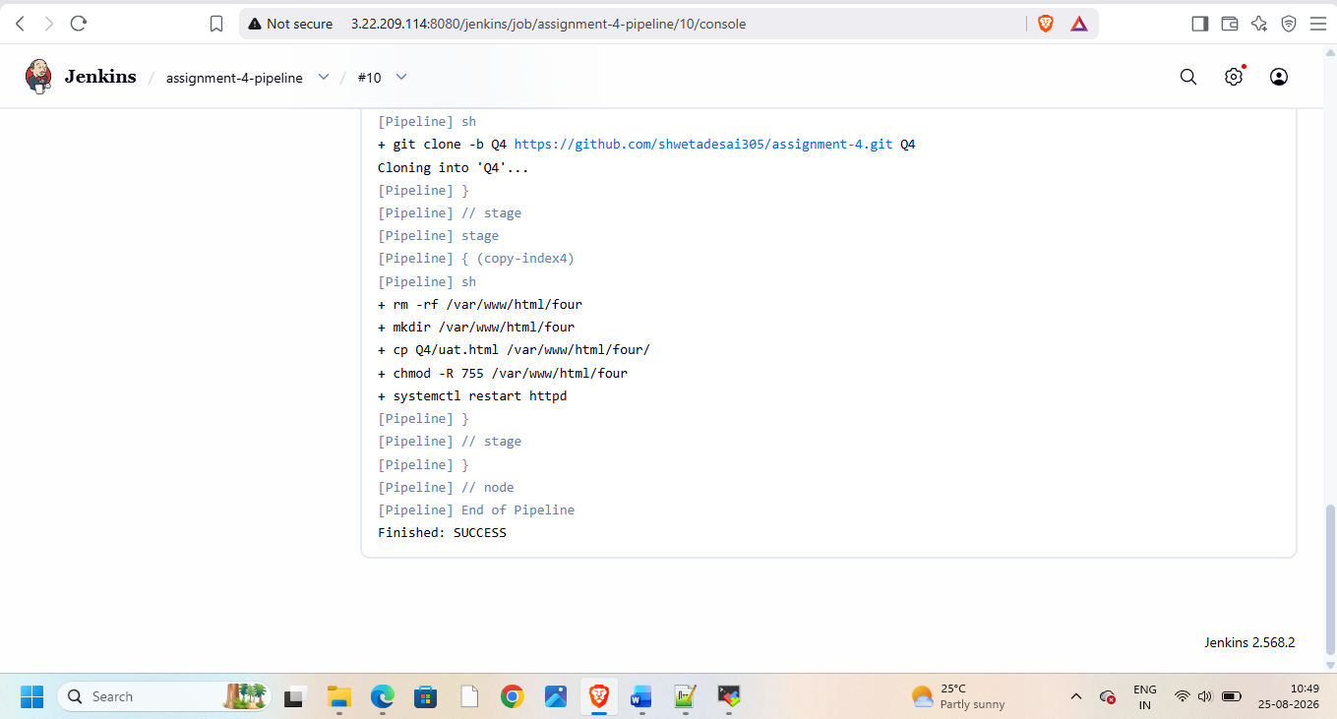
Then check on browser


