Assignment 23 – Jenkins-5 – create a job which will pull then changes of github repo of LoginWebApp war and deploy the App on the tomcat server after building and packing it.
Ans
Launch and connect to an instance
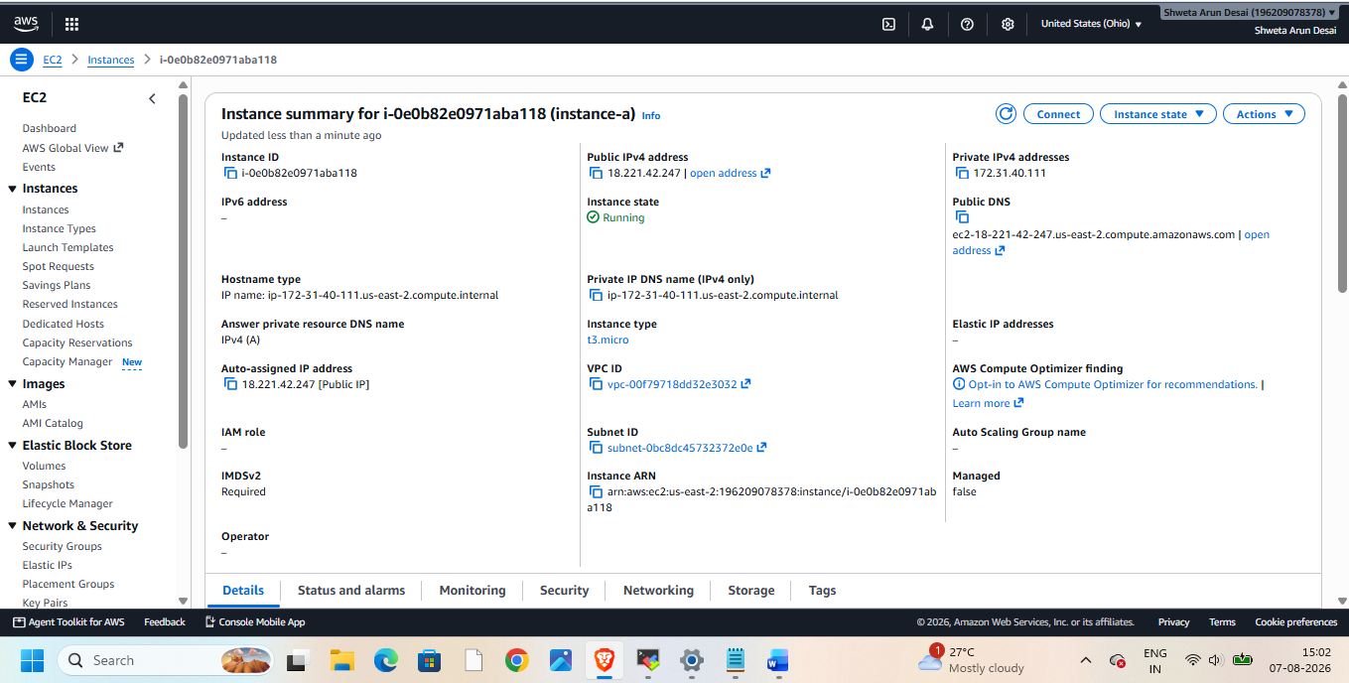
Then install java,git, tomcat, maven, Jenkins
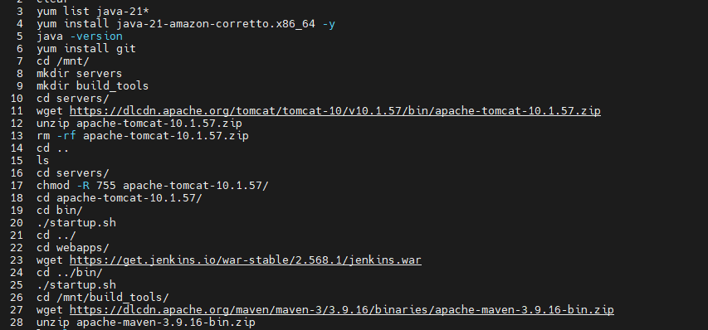
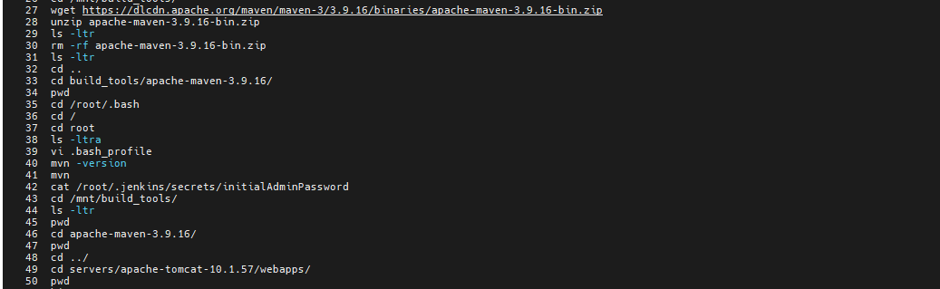
Start Jenkins install plugins. Then create Jenkins job to integrate with maven
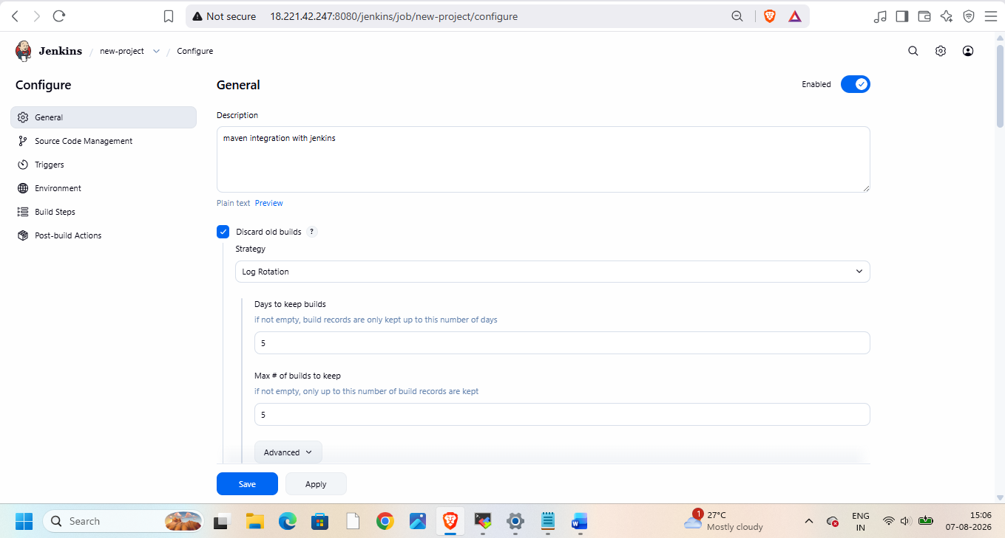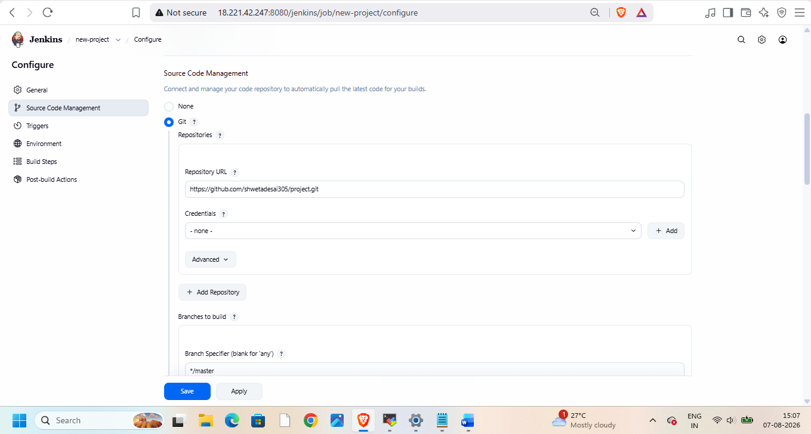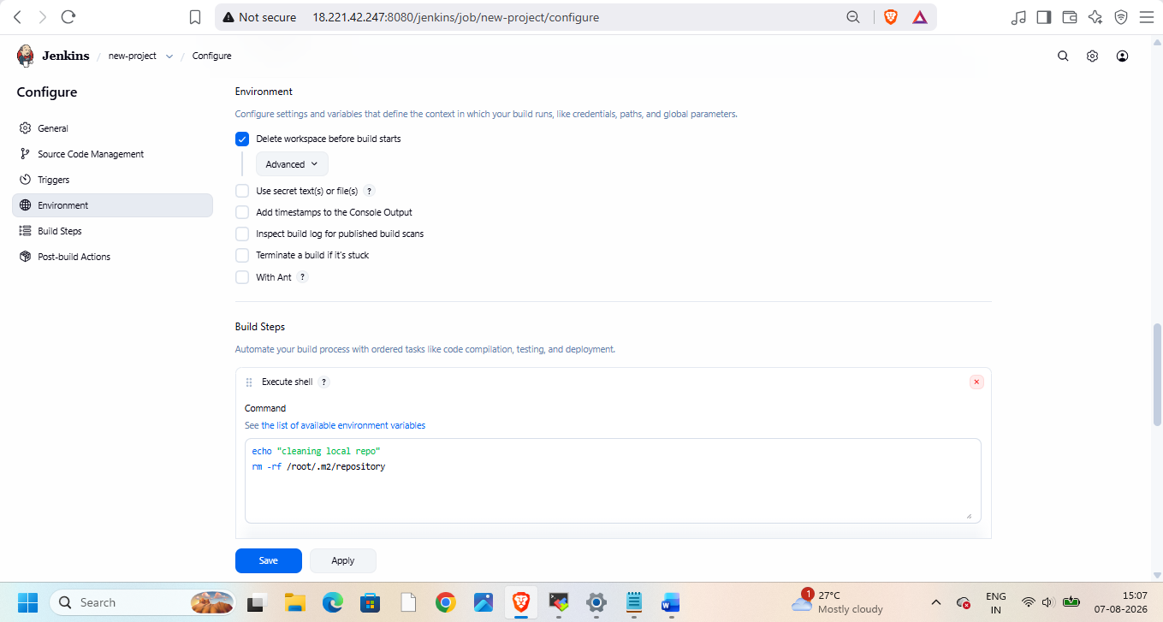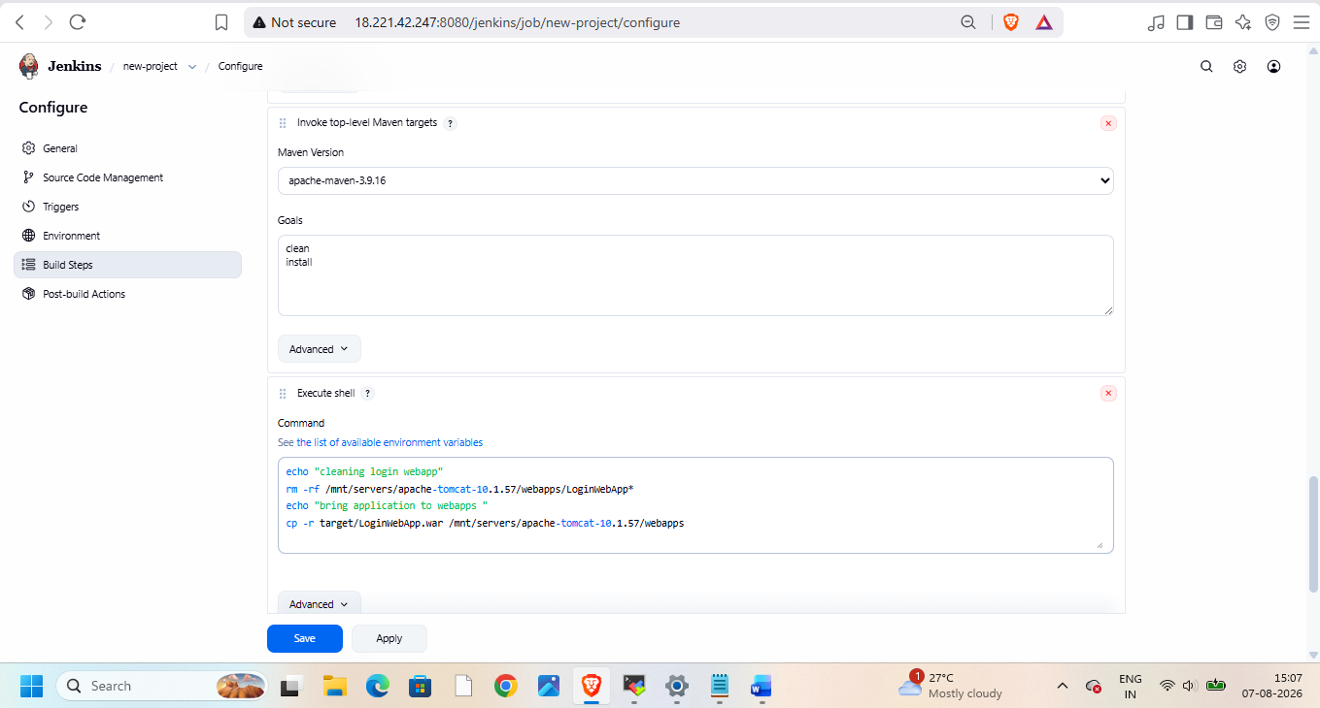
Then build and check on browser
