Jenkins Assignment 2 pipeline: install and start httpd and deploy file from git to Jenkins using a Jenkins pipeline.
Ans: launch instance and connect to it and install java21,Jenkins, tomcat, git
Start Jenkins and create pipeline
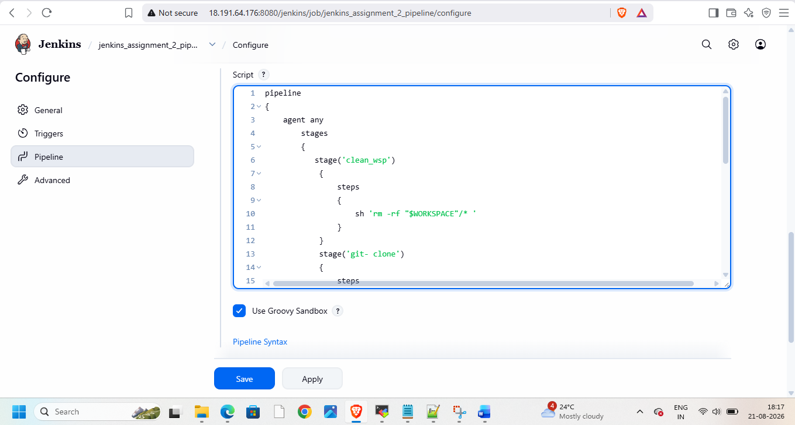
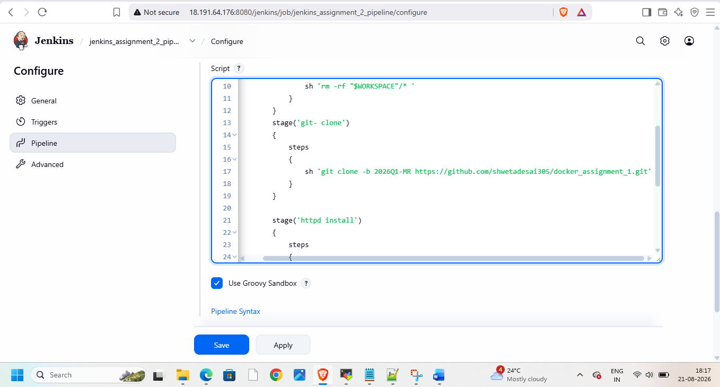
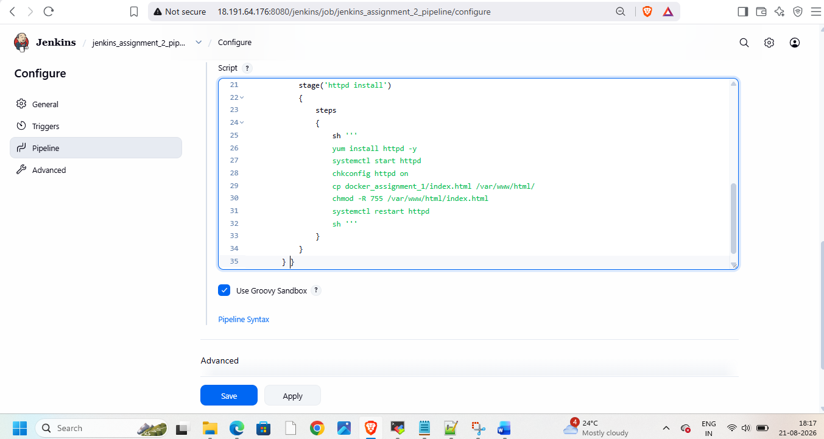
Then build and check on browser


