Assignment-3-using pipeline- Create 3 repositories r1- branch – 2026Q1-MR, repository r2- branch – 2025Q4-PR, repository r3- branch – 2024Q4-BF and push index.html on each repo.
Create 3 different jobs for each one of them and keep httpd installed on Jenkins master and check each job build.
Ans- we can create pipeline which will deploy index file from all 3 repositories on our Jenkins master
Launch instance and download java21, tomcat11, jenkins2.5
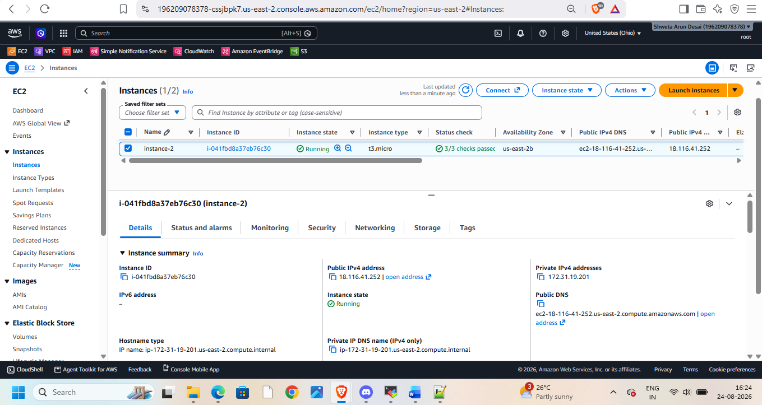
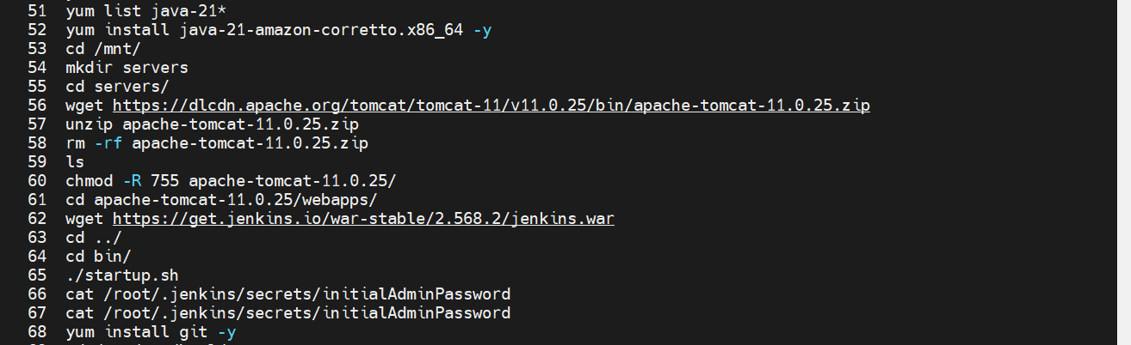
And start Jenkins
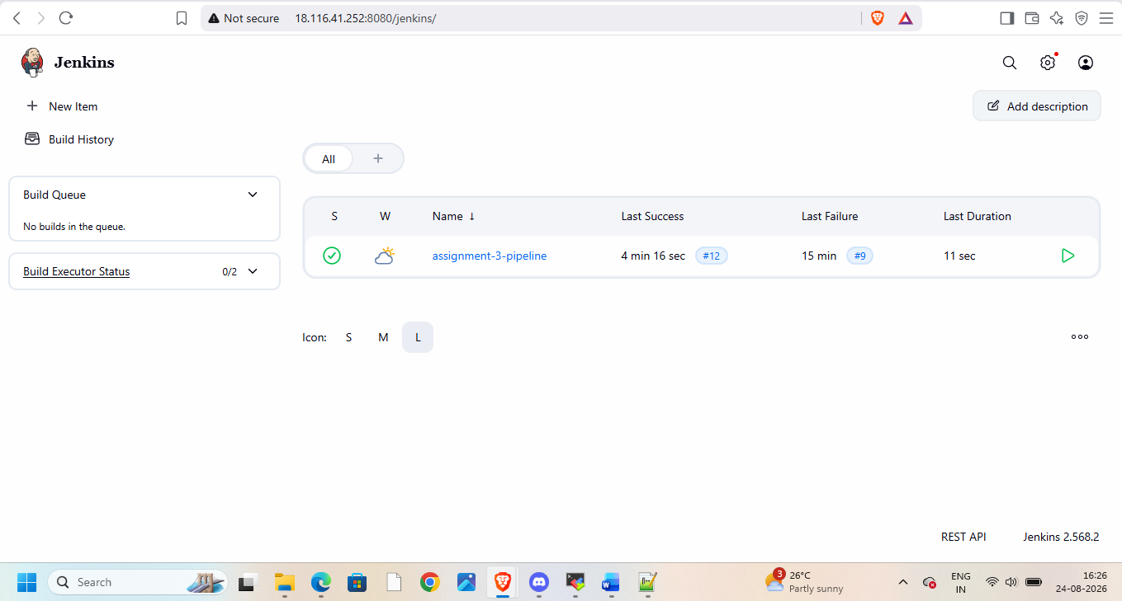
Now goto git and create 3 reositories with different index.html
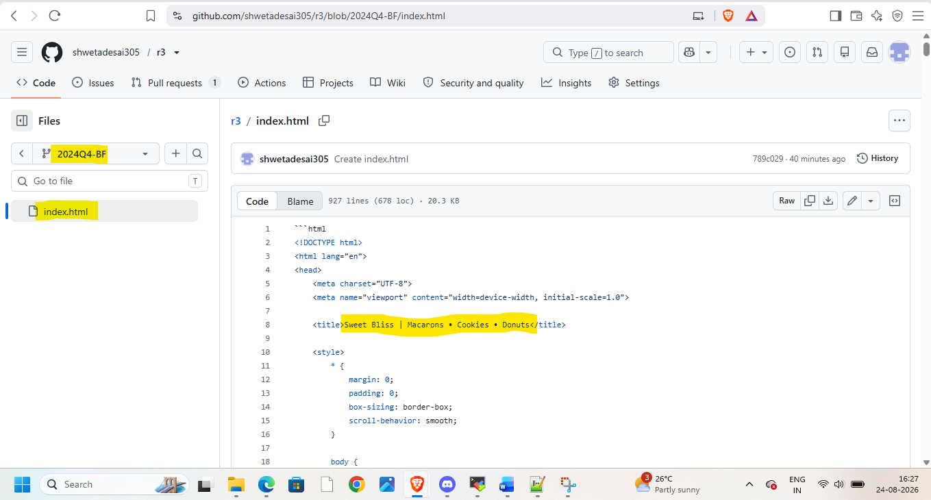
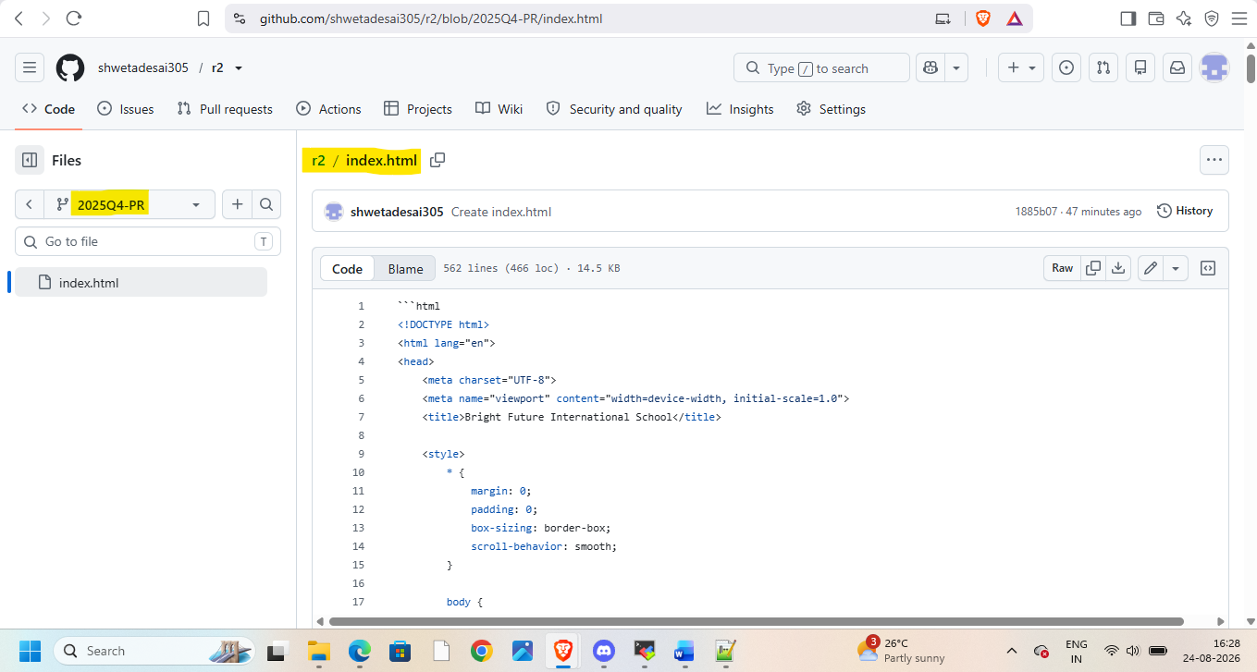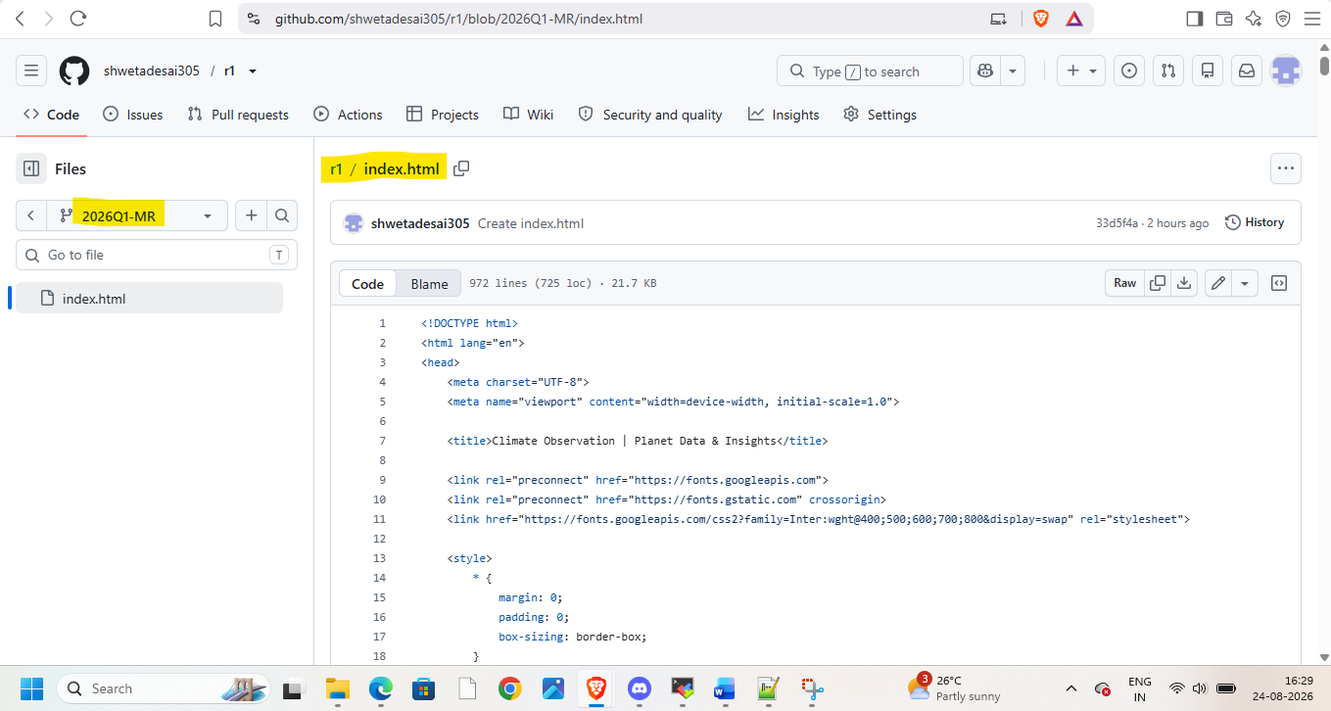
Now go to Jenkins and create pipeline to clean workspace and clone each repository and take their index files on Jenkins master
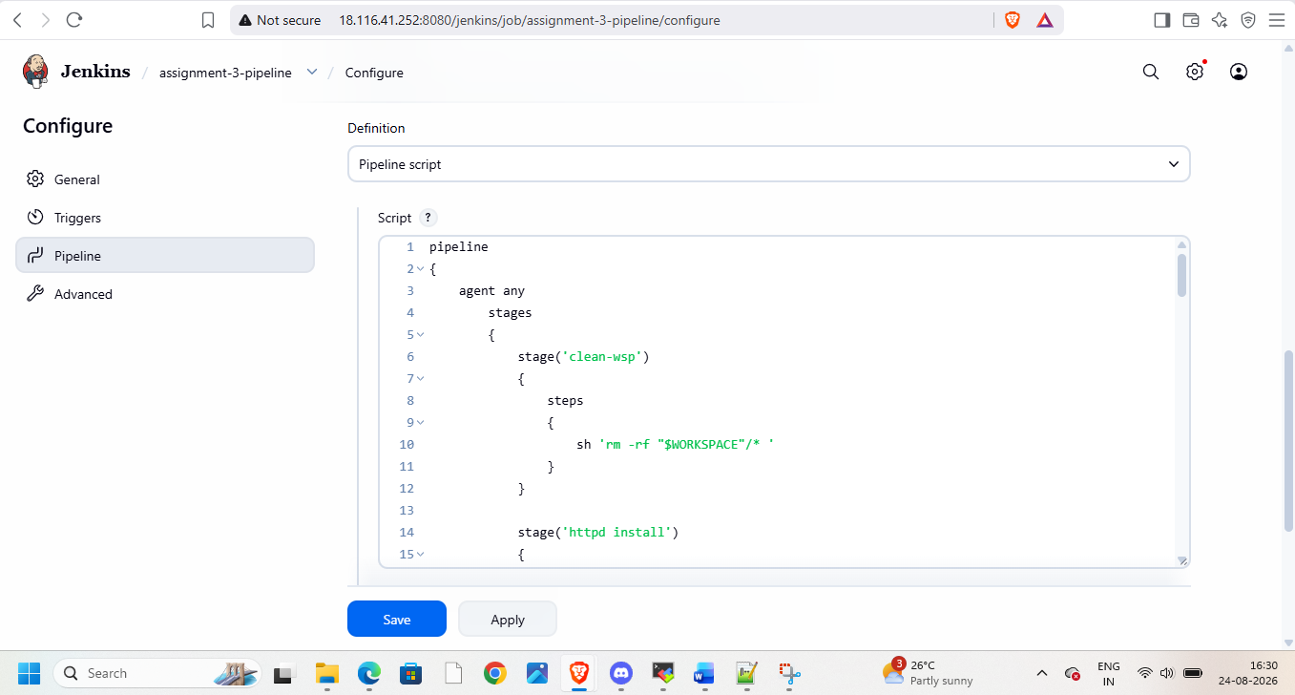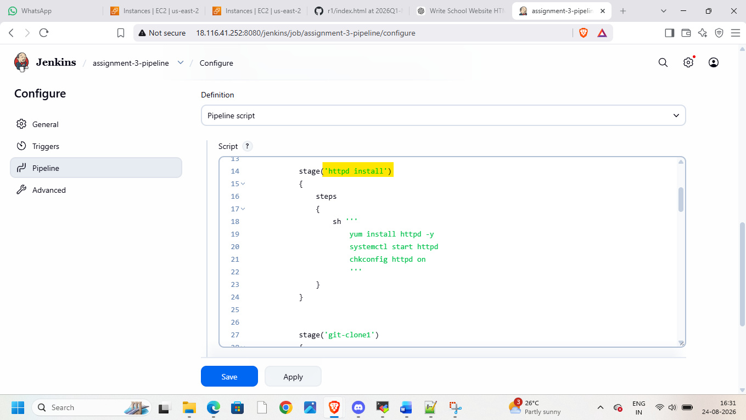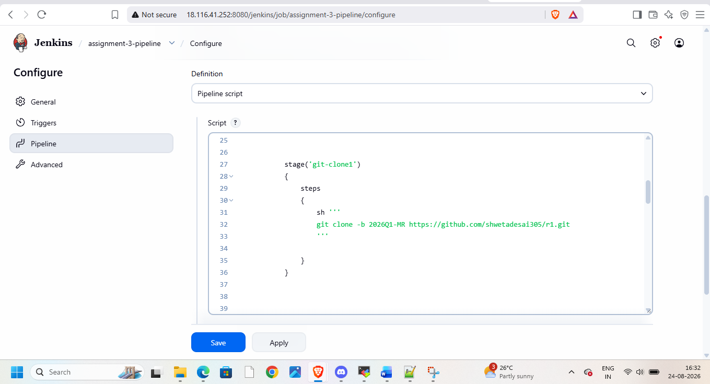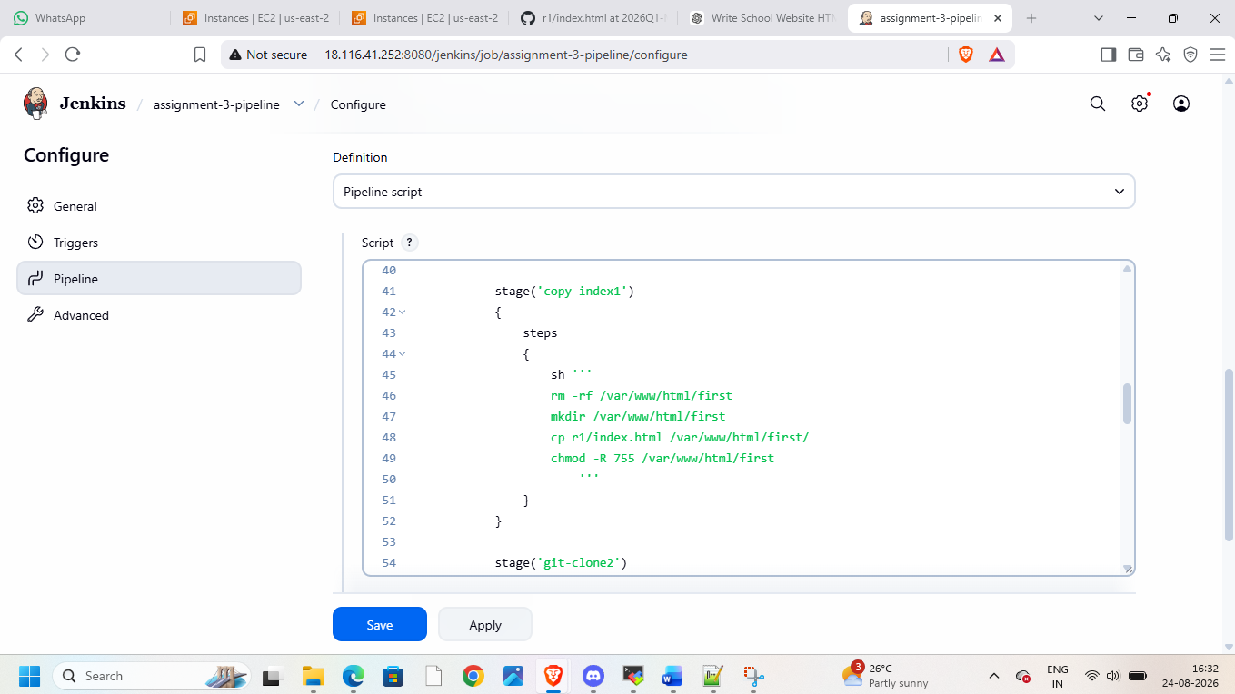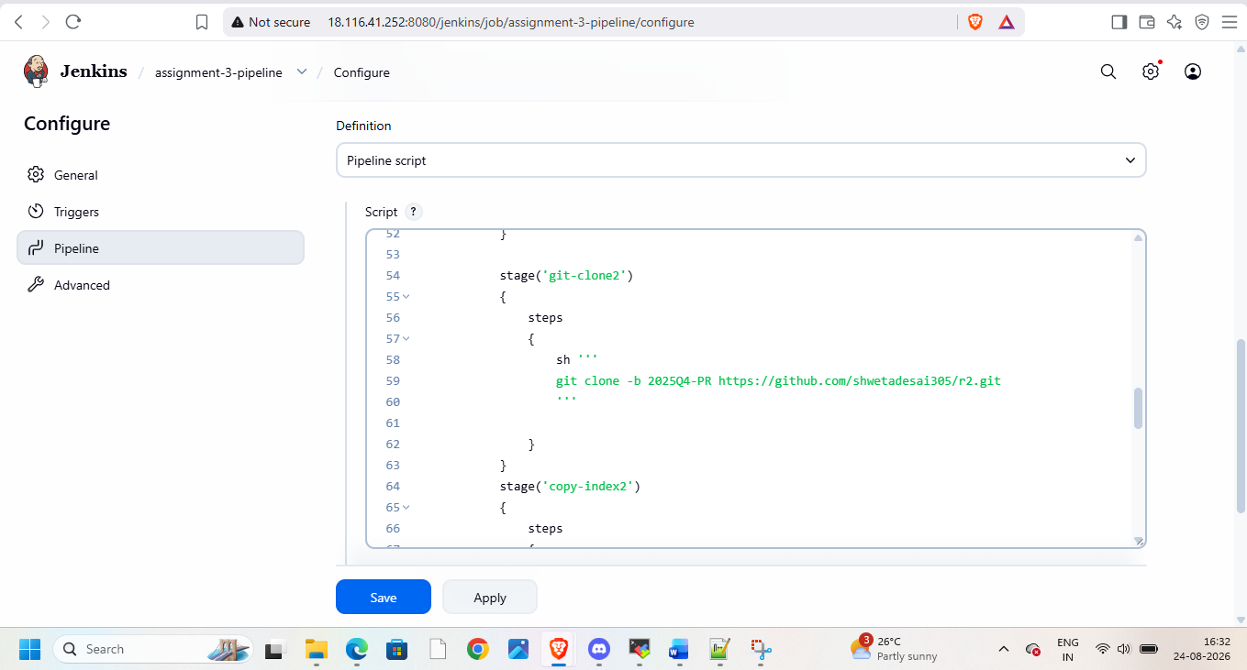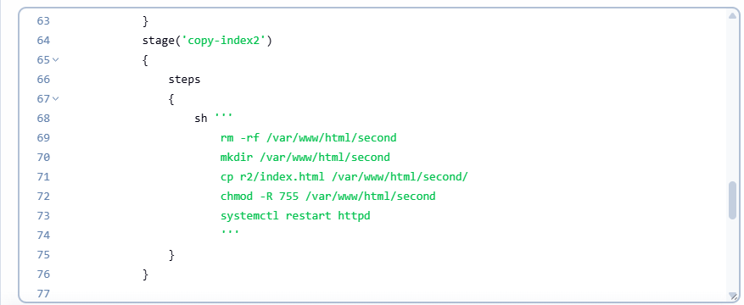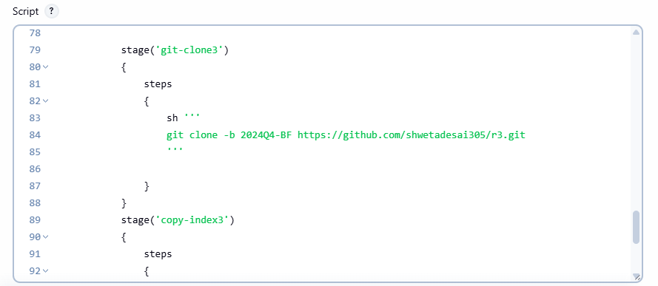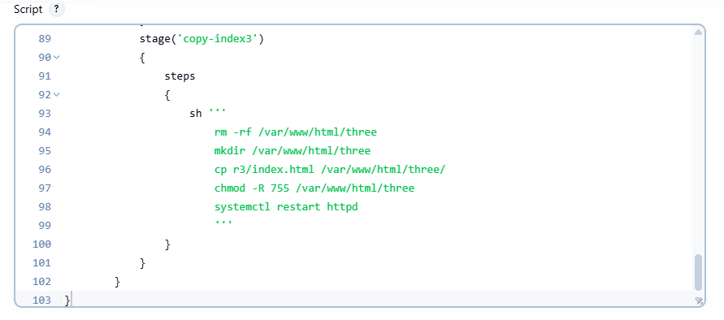
Then save and apply and build pipeline and check console output
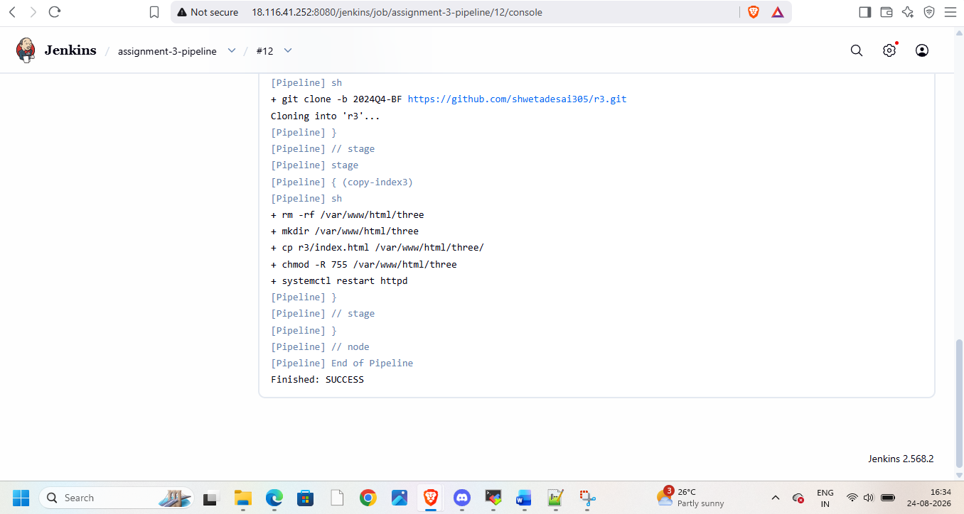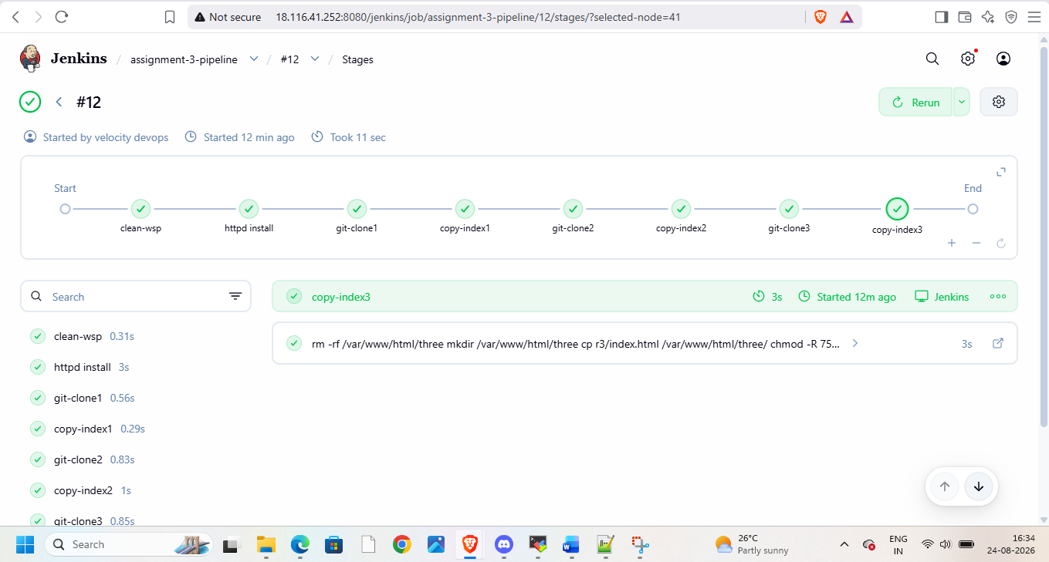
Goto linux and check for index files
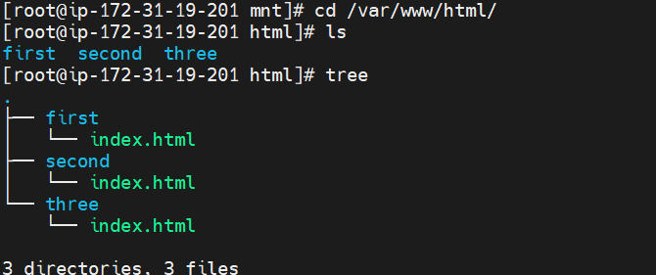

Then goto web browser and check with public ip/first
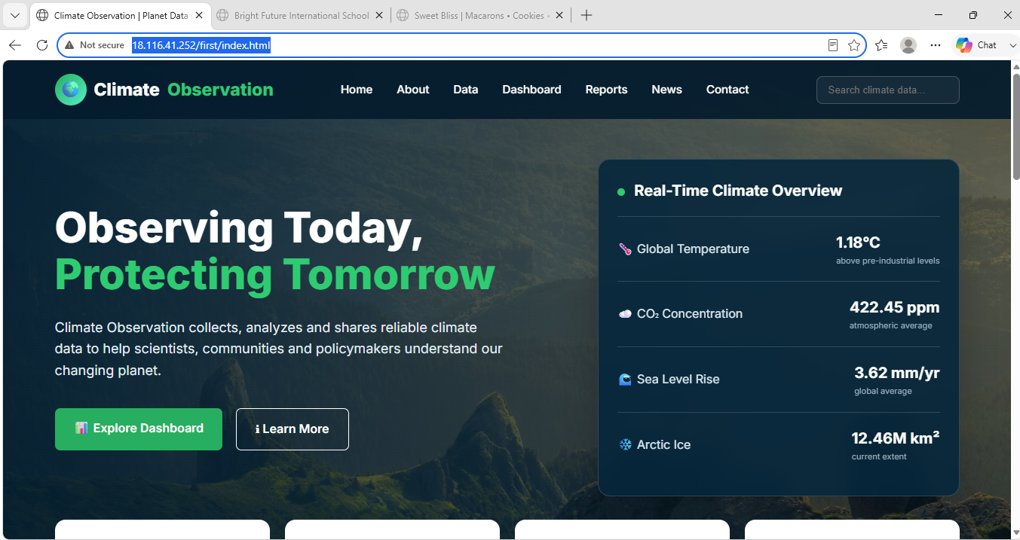
Publicip/second

Public ip/third
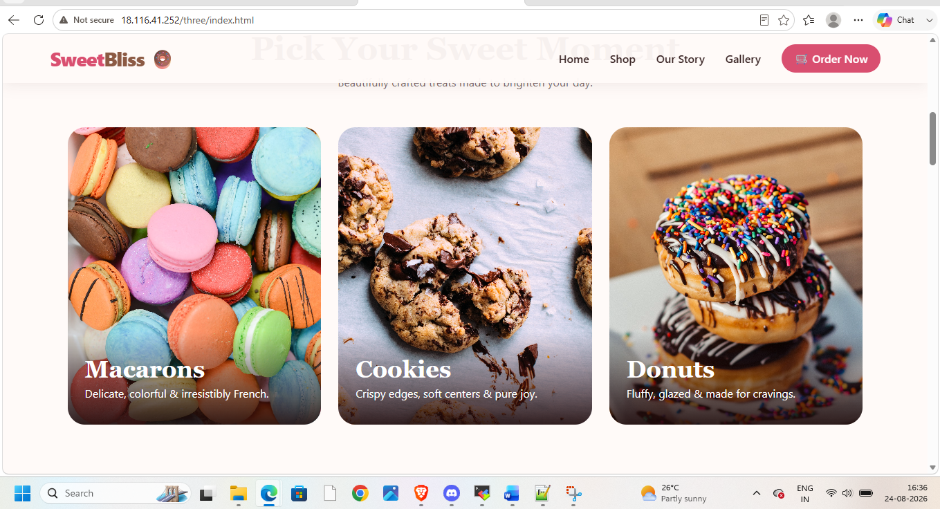
Now once all things checked

