Assignment-19: Create a Jenkins job to install httpd, start httpd and deploy index.html
Ans:
Launch new instance
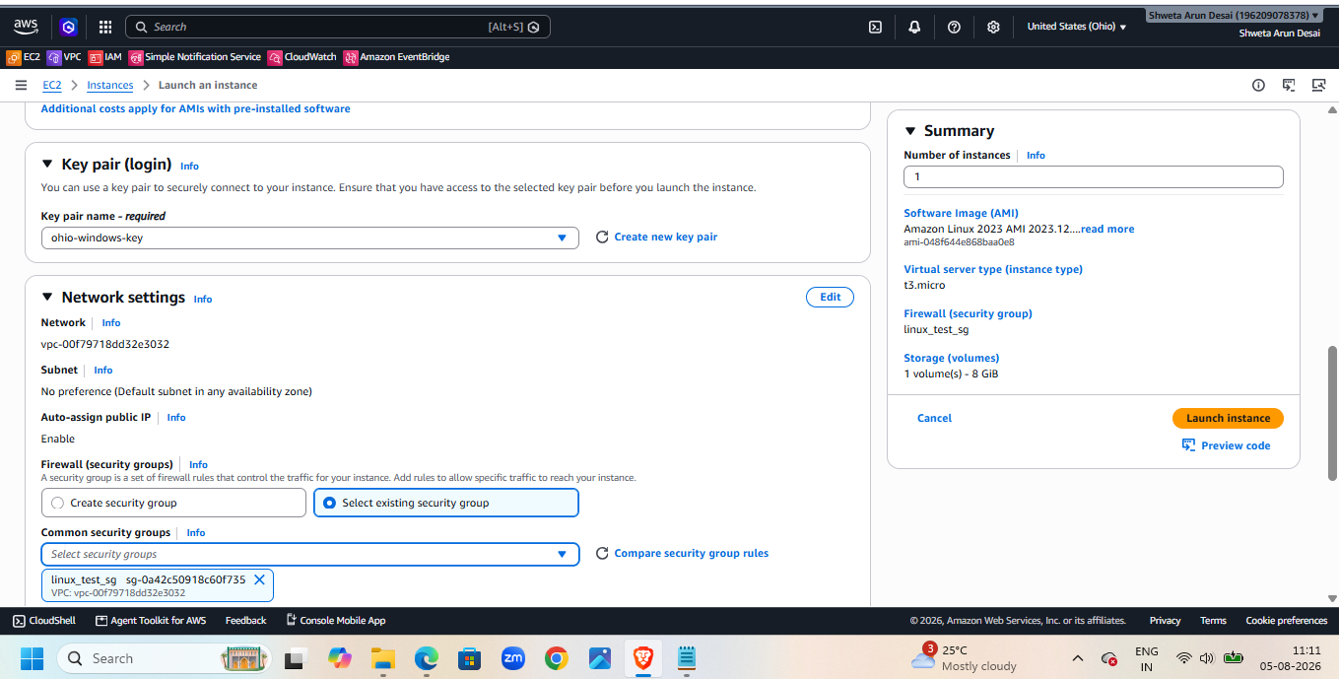
Make sure port 8080 enabled in security group
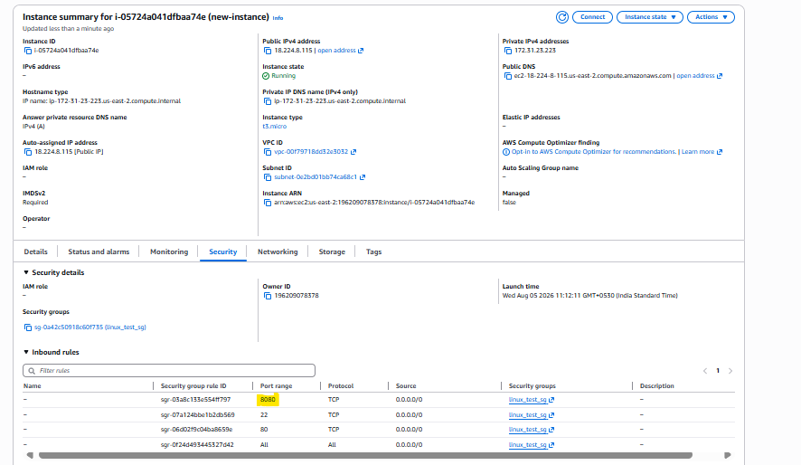
Connect to that instance
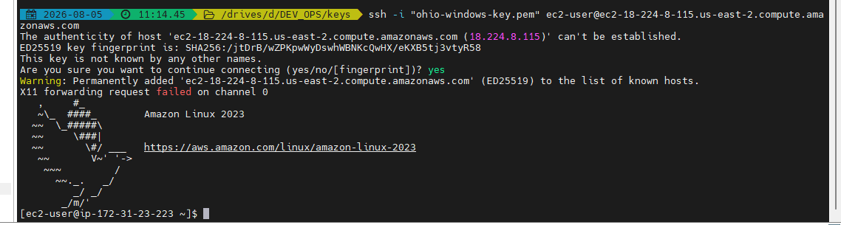
1 yum list java-21*
2 yum install java-21-amazon-corretto.x86_64 -y
3 java -v
4 java -version
5 cd /mnt/
6 mkdir servers
7 cd servers
8 wget https://dlcdn.apache.org/tomcat/tomcat-10/v10.1.57/bin/apache-tomcat-10.1.57.zip
9 unzip apache-tomcat-10.1.57.zip
10 rm -rf apache-tomcat-10.1.57.zip
11 cd apache-tomcat-10.1.57/webapps/
12 cd ../
13 chmod -R 755 apache-tomcat-10.1.57/
14 cd apache-tomcat-10.1.57/webapps/
15 wget https://get.jenkins.io/war-stable/latest/jenkins.war
16 cd ../
17 cd bin/
18 ./startup.sh
19 cat /root/.jenkins/secrets/initialAdminPassword
Once tomcat started login to Jenkins and start plugins download
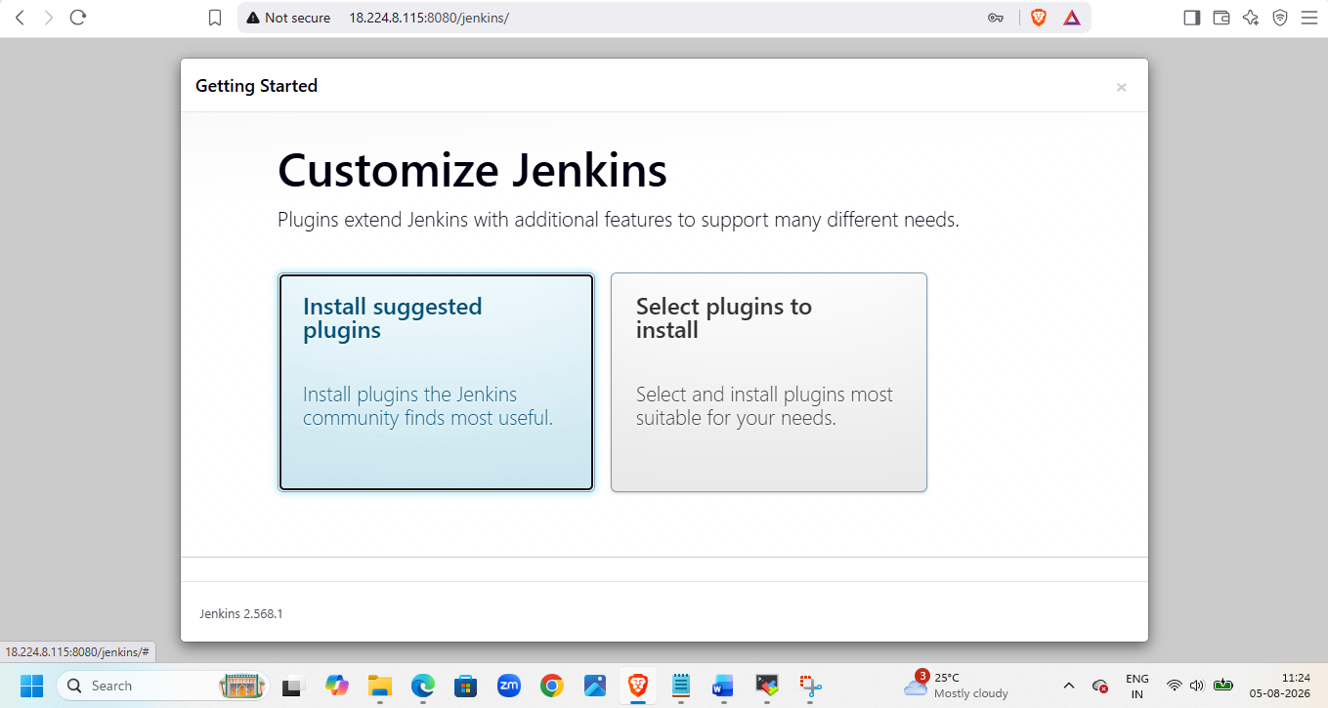
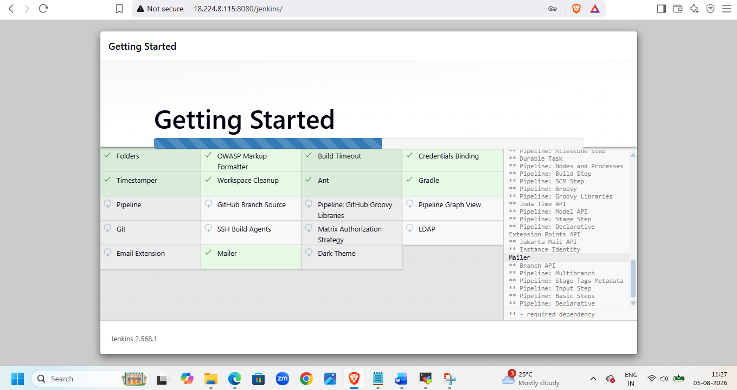
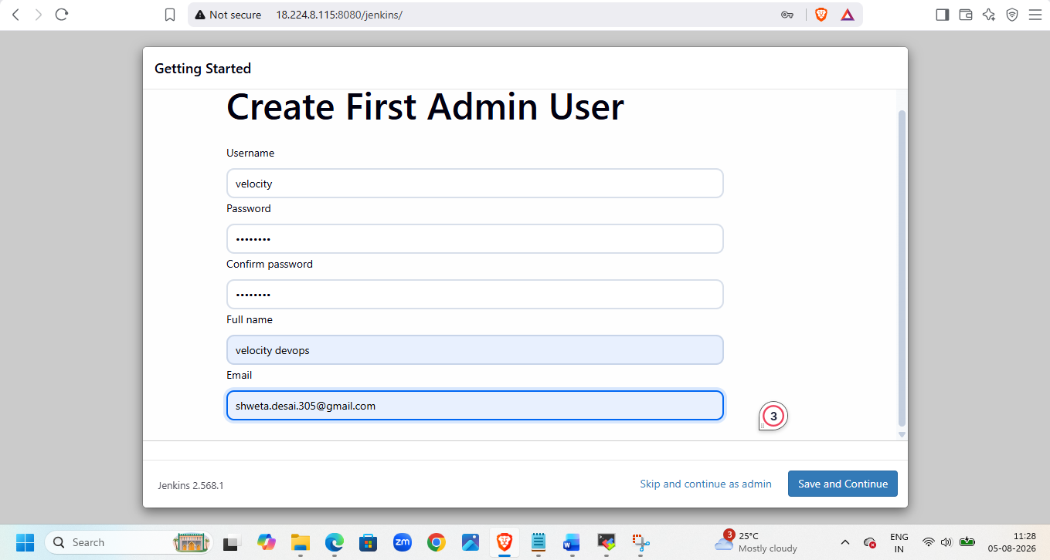
Check url
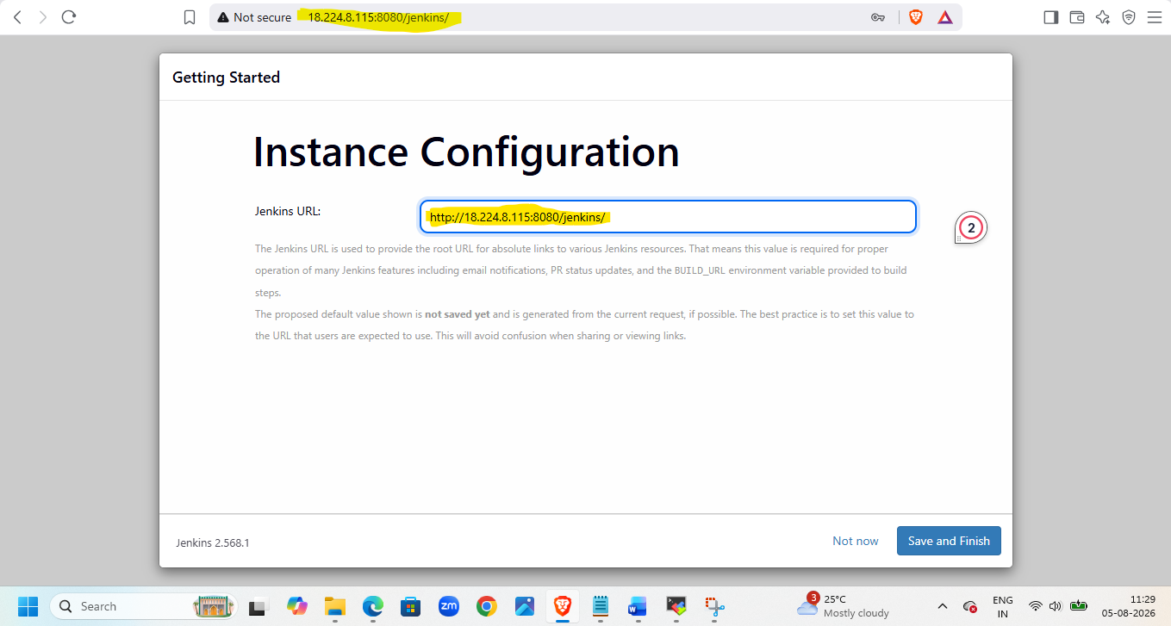
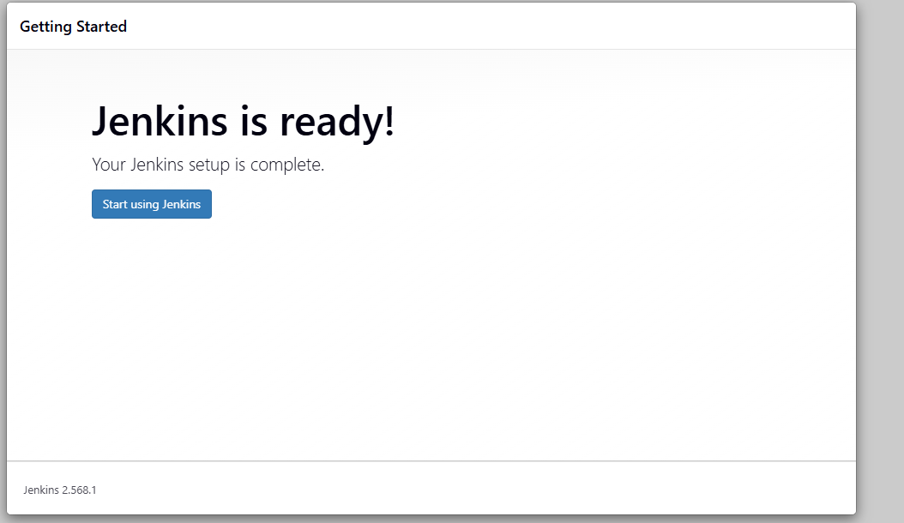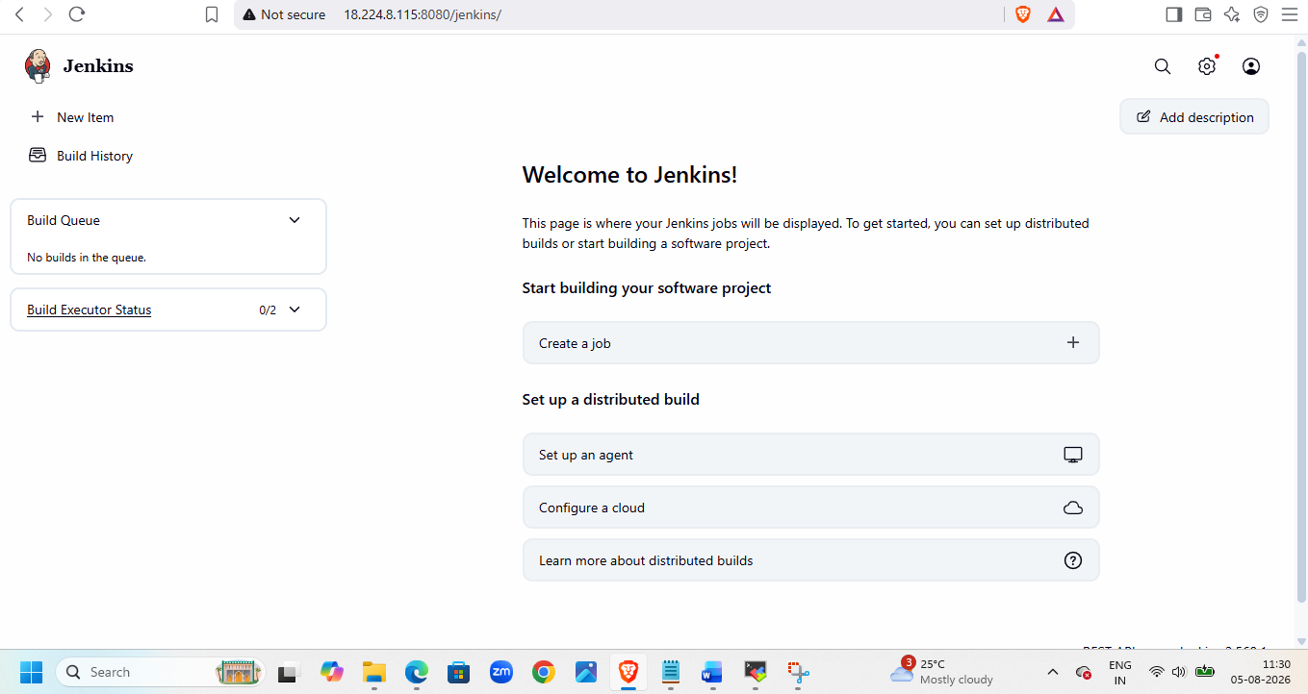
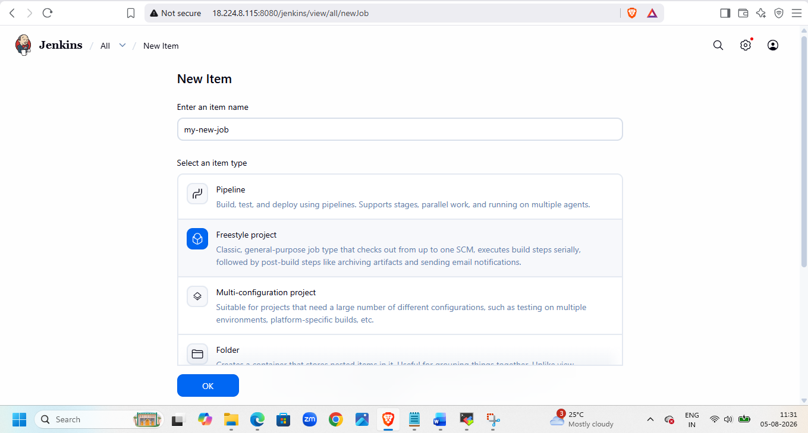
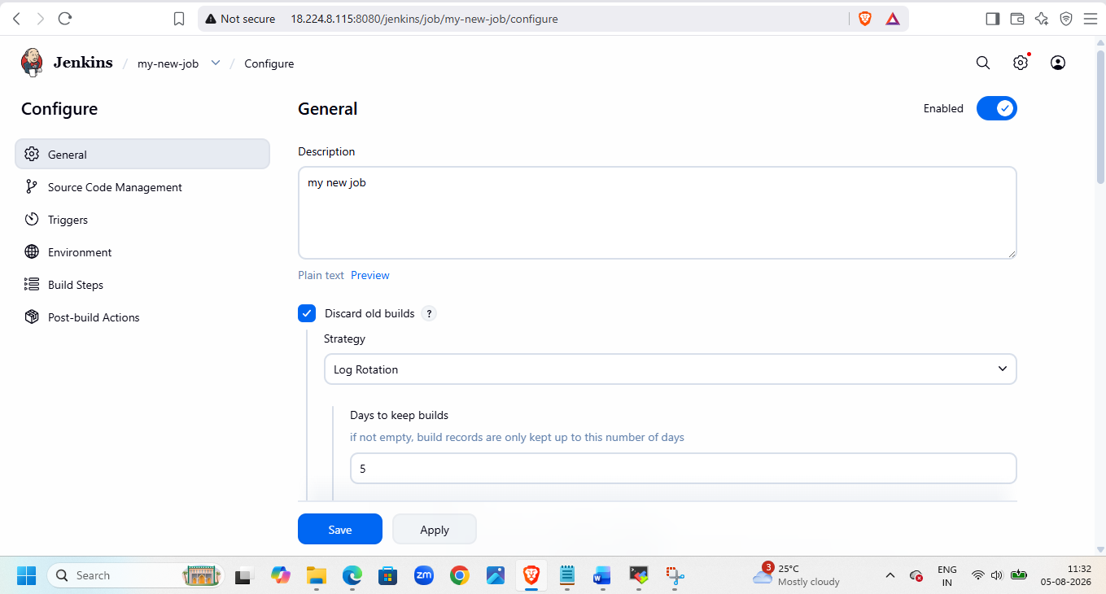
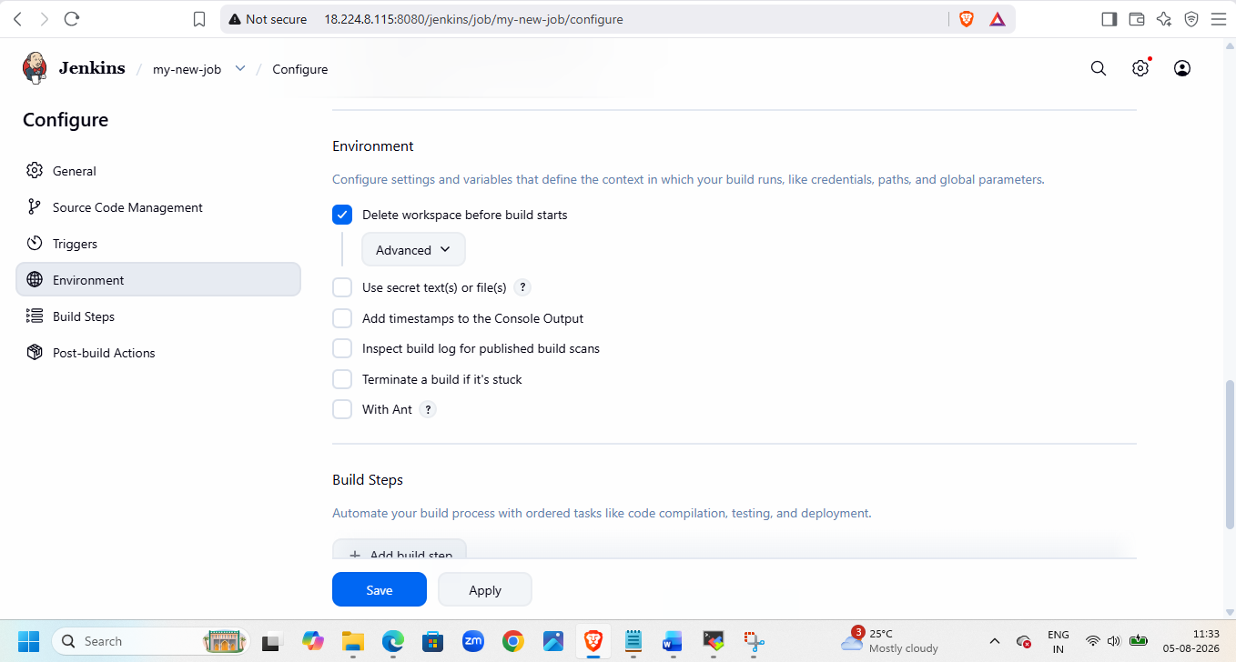
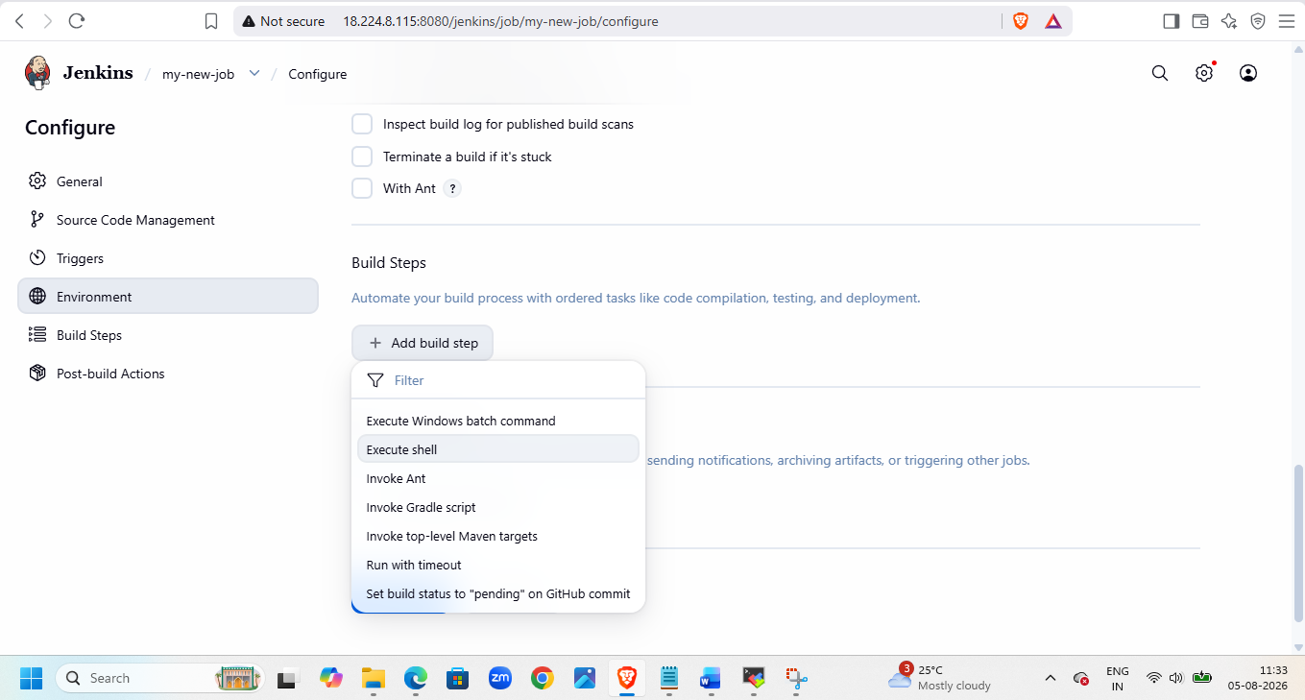
Add this code their
#!/bin/bash

# Update packages
sudo yum update -y

# Install Apache HTTP Server
sudo yum install -y httpd

# Enable and start Apache
sudo systemctl enable httpd
sudo systemctl start httpd

# Create index.html
echo "<html>
<head><title>Jenkins Deployment</title></head>
<body>
<h1>Deployment Successful!</h1>
<h2>Deployed using Jenkins</h2>
</body>
</html>" | sudo tee /var/www/html/index.html

# Restart Apache
sudo systemctl restart httpd

# Verify service status
sudo systemctl status httpd --no-pager

echo "Deployment Completed Successfully"

sudo chmod 644 /var/www/html/index.html

then apply and save

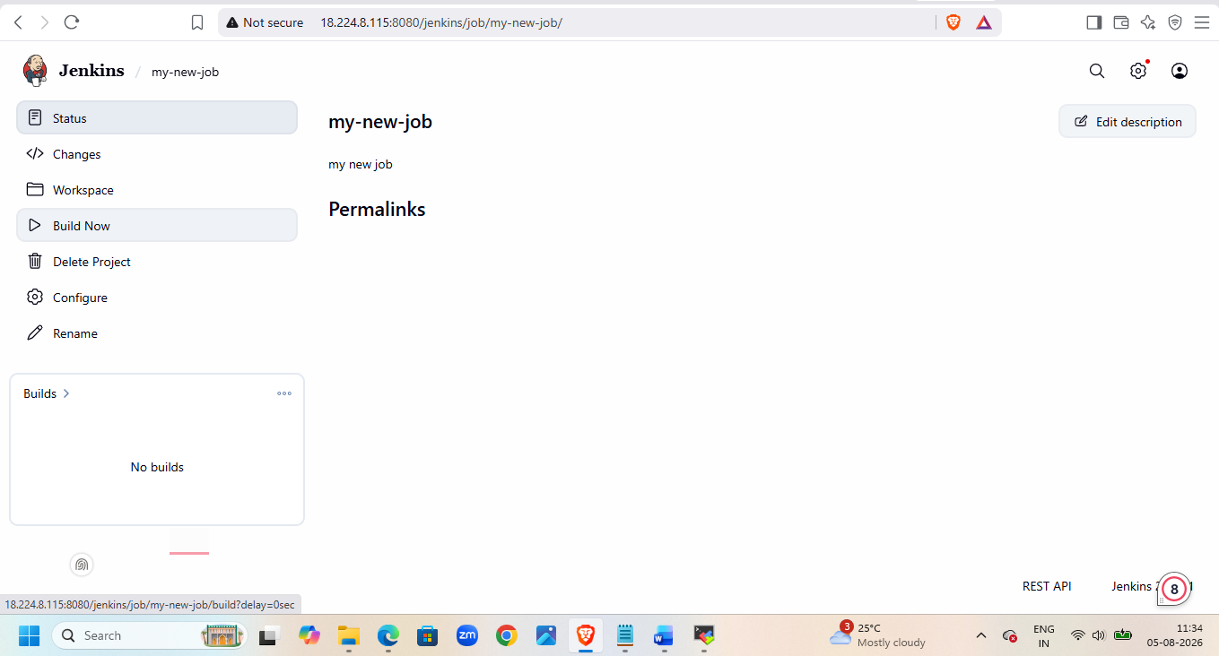
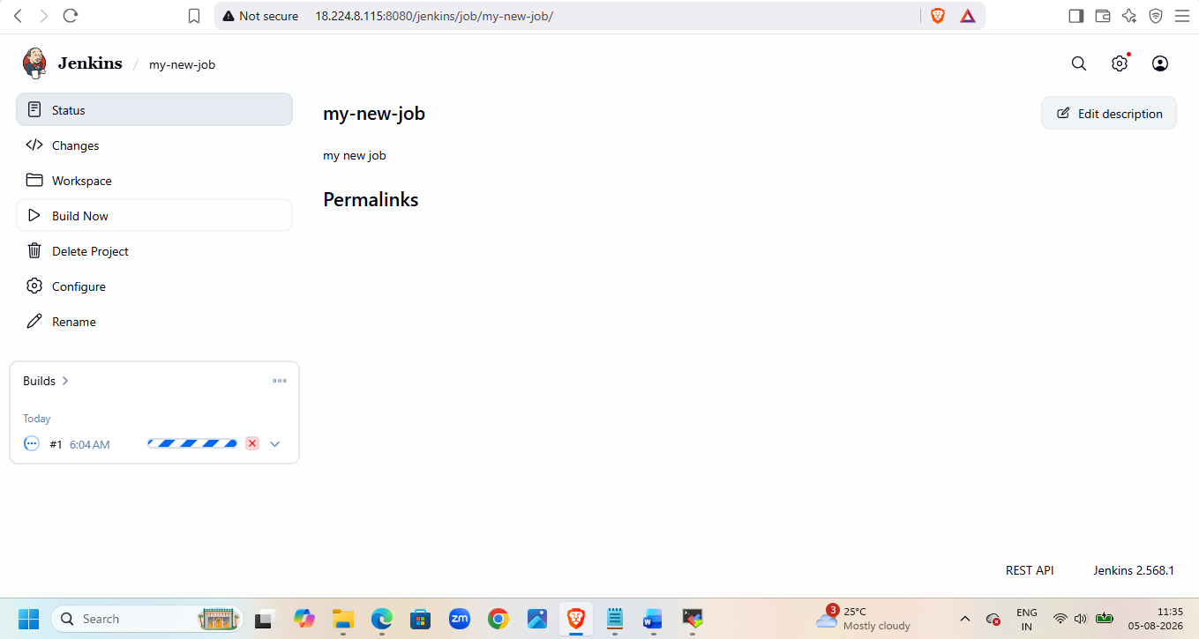
Check console output for execution status
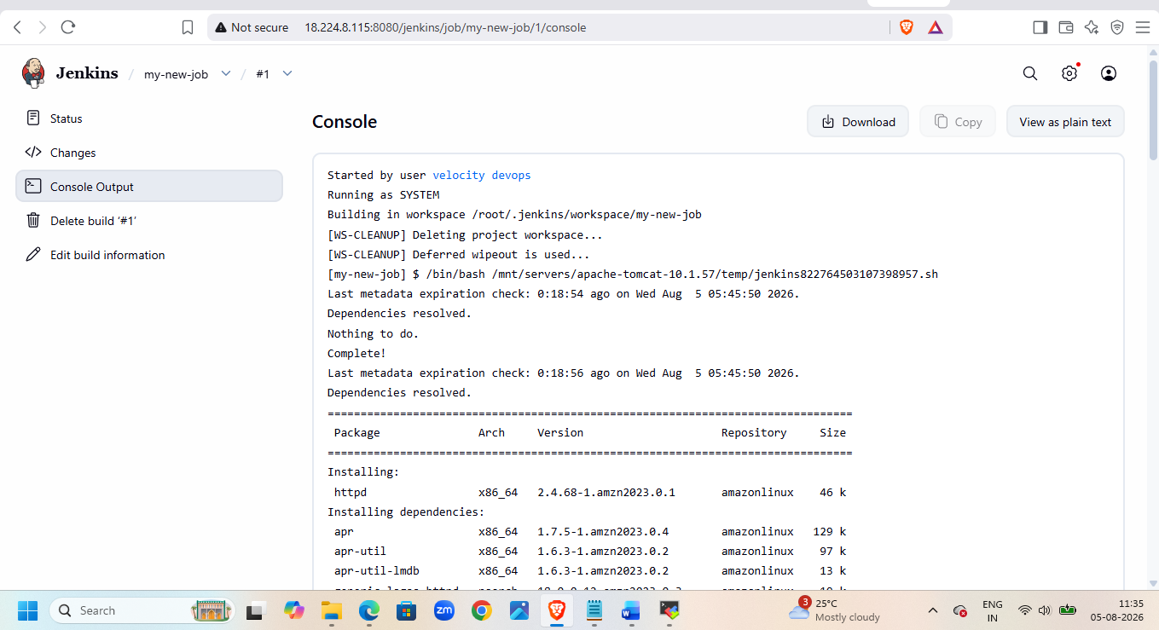
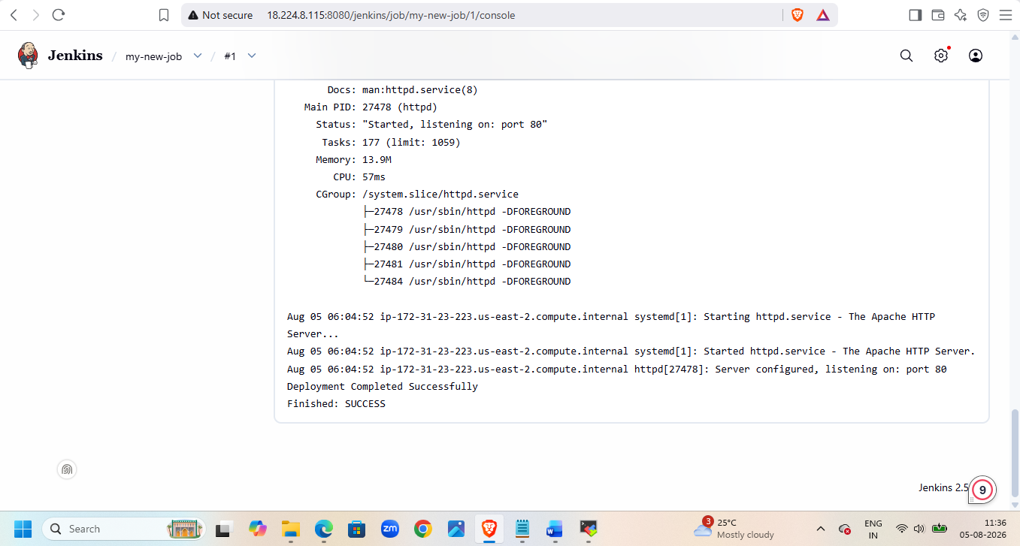
Check on browser
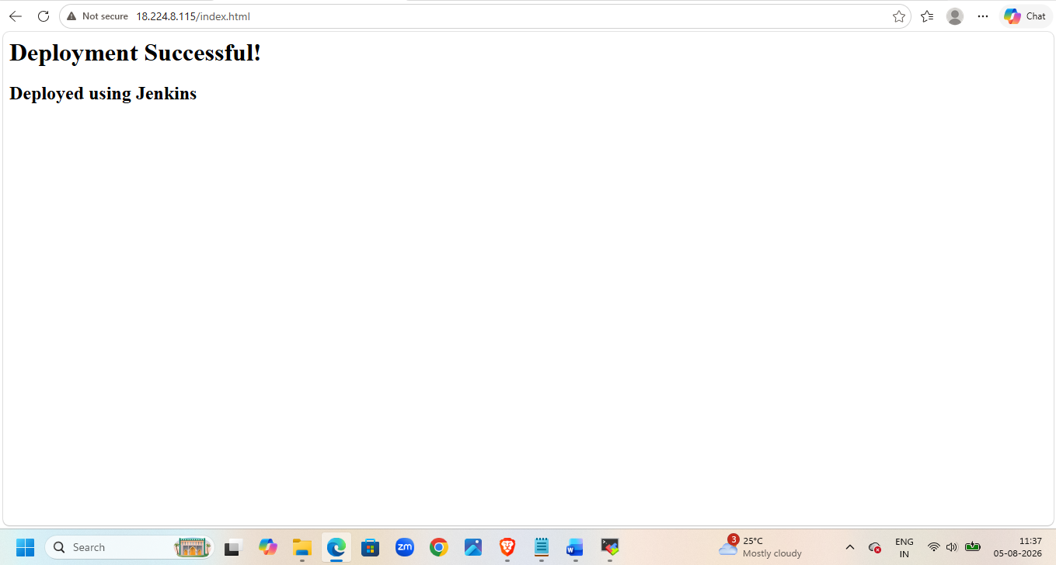

Check config.xml file in job

Cat /root/.jenkins/jobs/my-new-job/config.xml
Check httpd status and index file
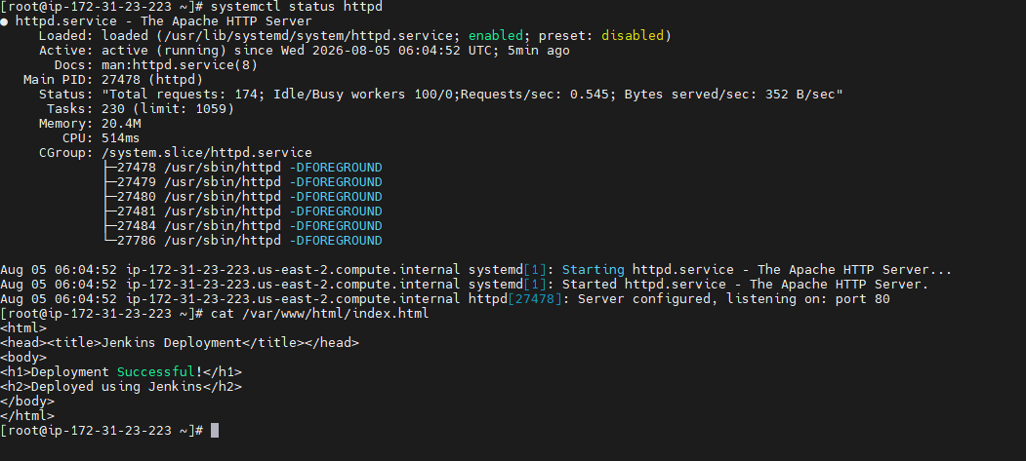
Then go to Jenkins and delete project

