Jenkins Assignment 5 -with pipeline
create a pipeline which will pull then changes of github repo of LoginWebApp war and deploy the App on the tomcat server after building and packing it.
Ans: We can use Jenkins tools, pipeline to integrate mvn
Launch instance and connect to it and install java21, mvn3.9, jenkins2.5, tomcat11
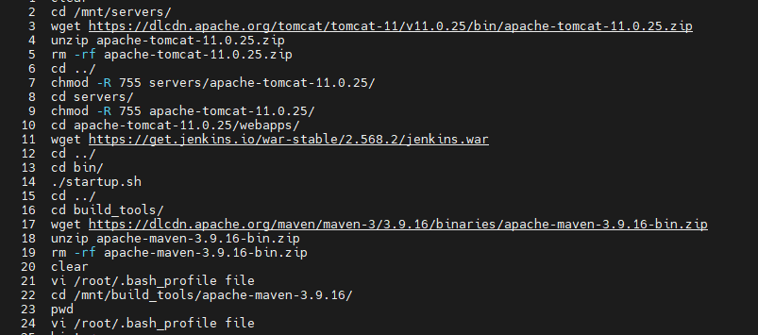

Add maven details in Jenkins tools

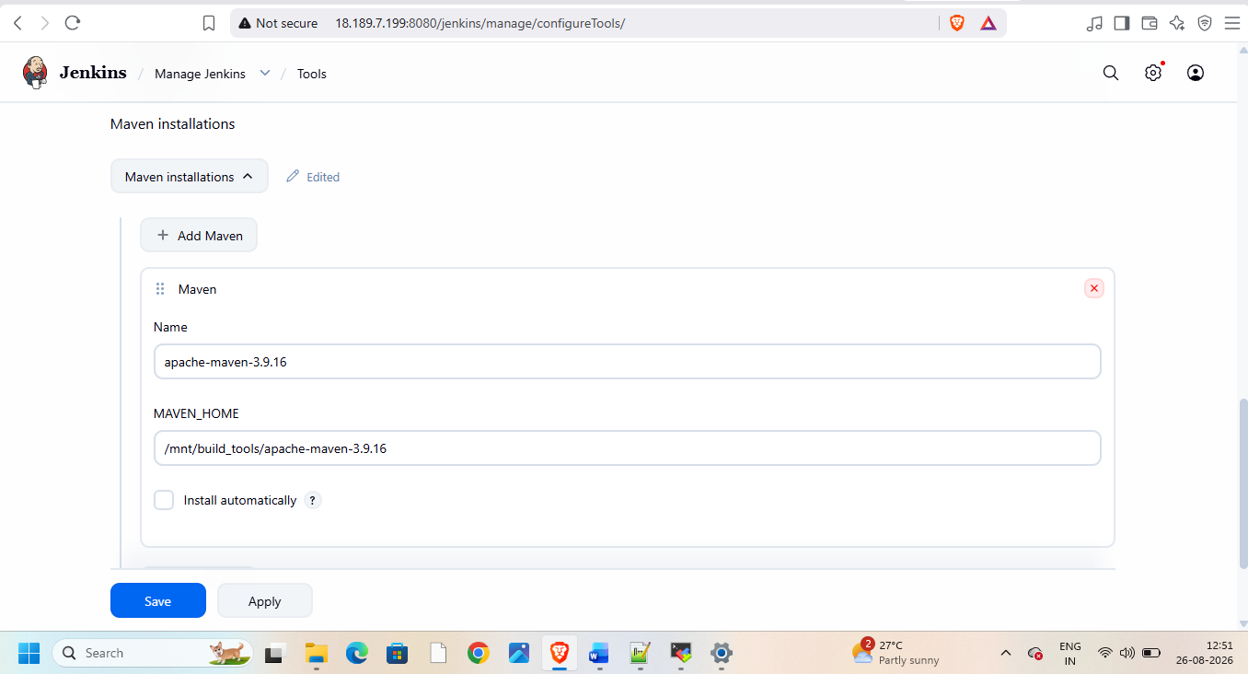
Create pipeline
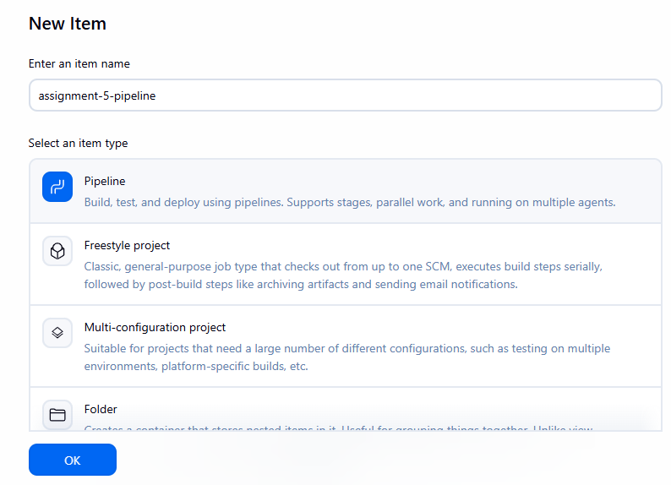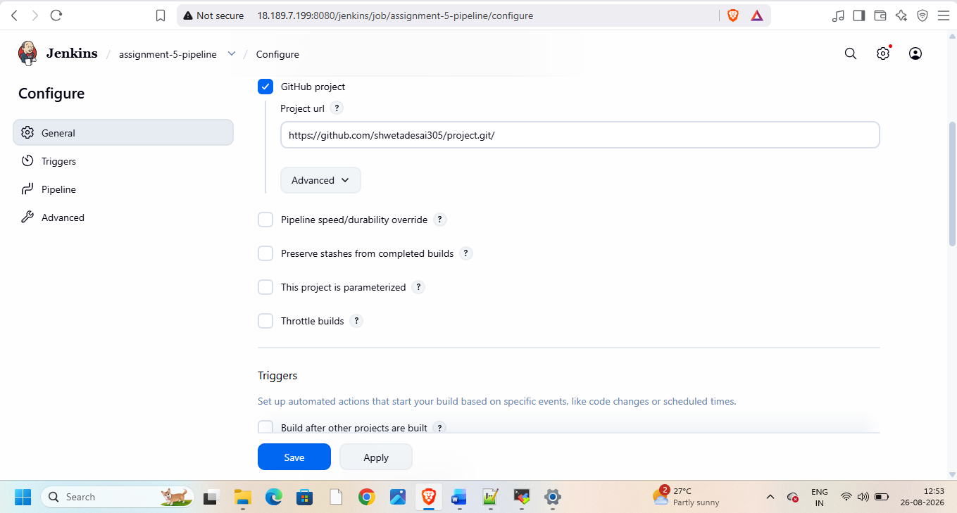
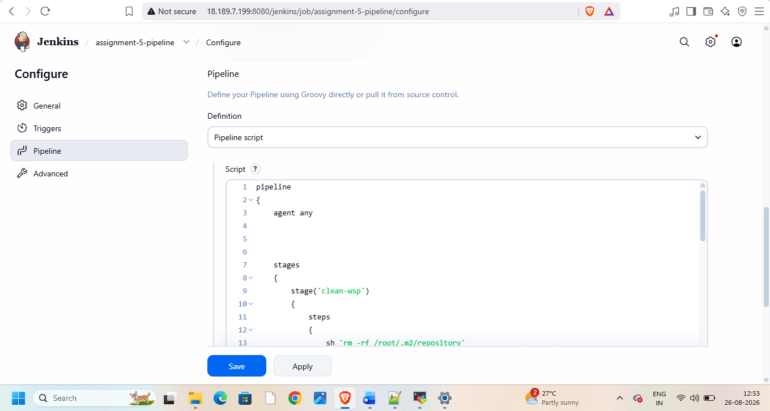
Add pipeline code in it
pipeline
{
agent any
stages
{
stage('clean-wsp')
{
steps
{
sh 'rm -rf /root/.m2/repository'
}
}

stage('git-clone')
{
steps
{
git branch: 'master' , url: 'https://github.com/shwetadesai305/project.git'
}
}

stage('mvn-pkg')
{
steps
{
sh '''
mvn clean package -DskipTests=true
'''
}
}
stage('copy-war')
{
steps
{
sh '''
rm -rf /mnt/servers/apache-tomcat-11.0.25/webapps/LoginWebApp*
cp -r target/LoginWebApp.war /mnt/servers/apache-tomcat-11.0.25/webapps
'''
}
}
}
}

Then build
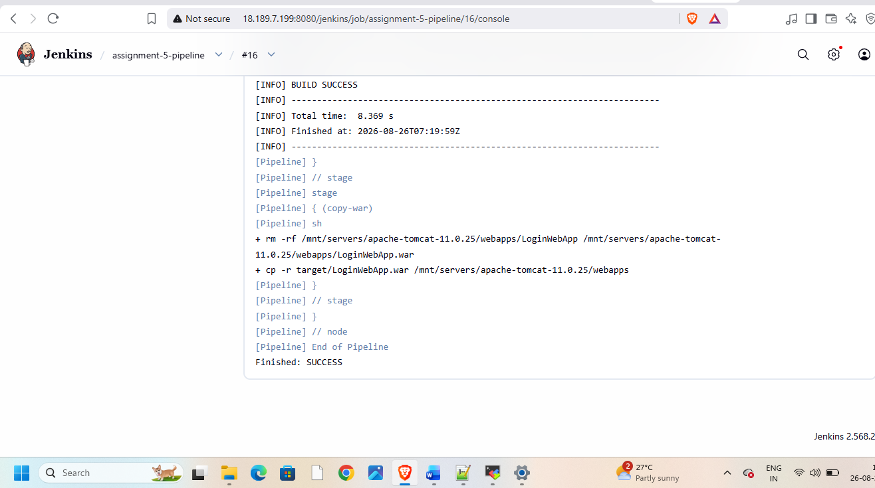
Now check on browser
