Jenkins Assignment 6 -with pipeline
create a pipeline which will pull then changes of github repo of LoginWebApp war and deploy the App on the tomcat server after building and packing it.
Ans: We can use Jenkins tools, pipeline to integrate mvn
Launch instance and connect to it and install java21, mvn3.9, jenkins2.5, tomcat11

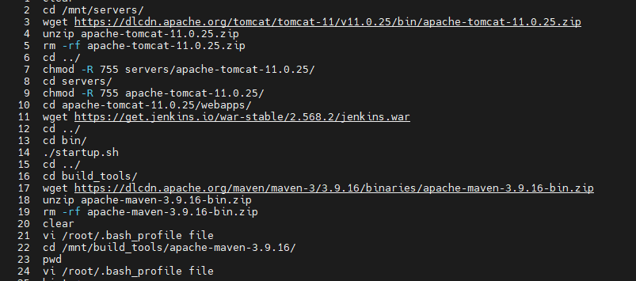

Add maven details in Jenkins tools

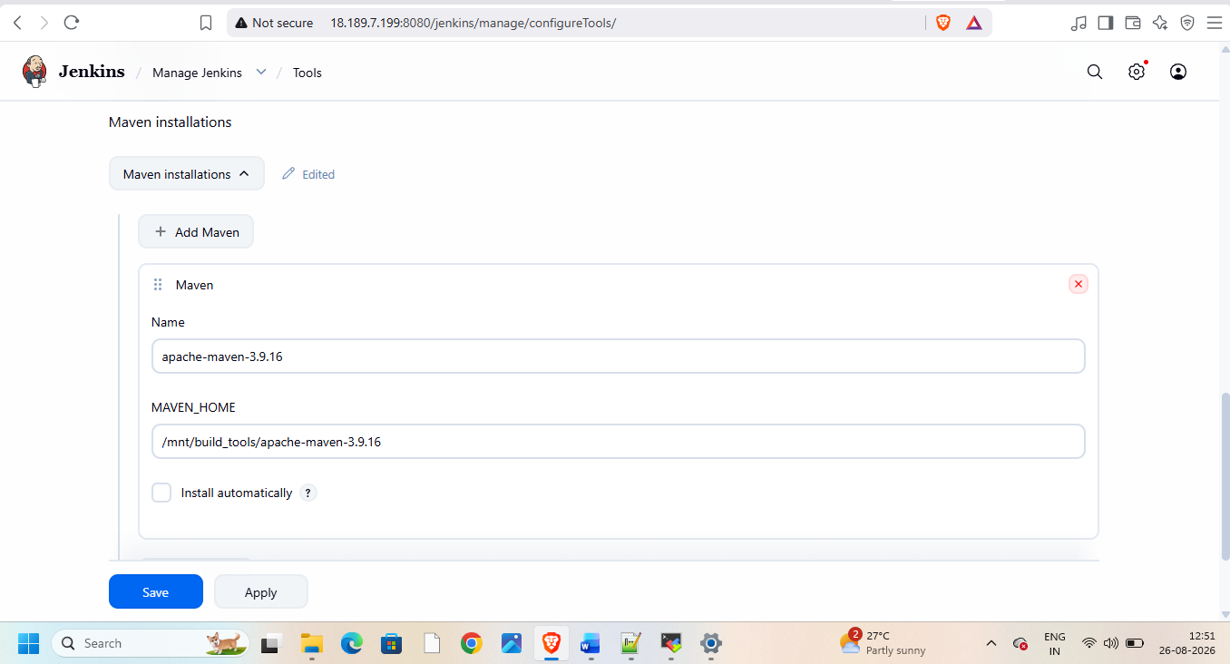
Create pipeline and add git url from git repo in it
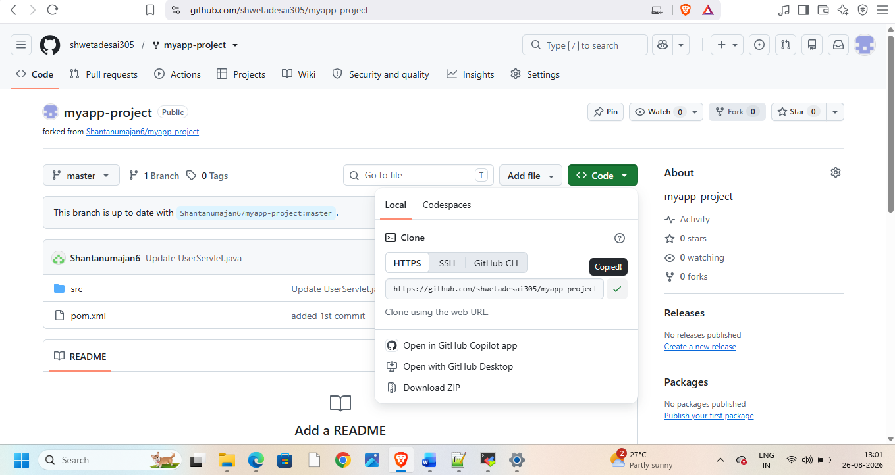
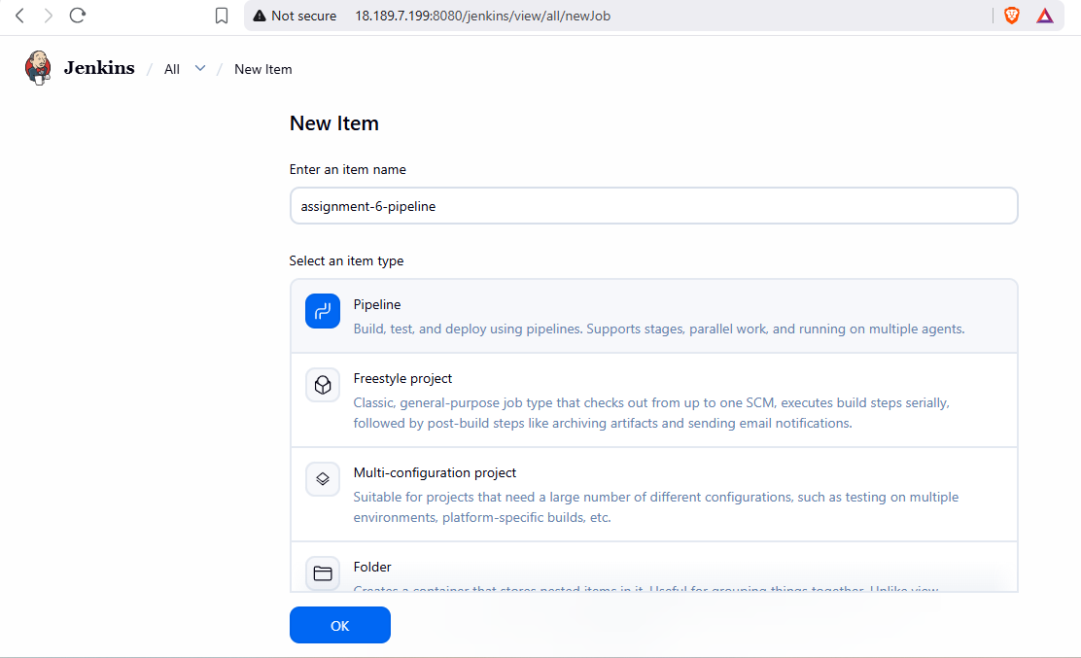
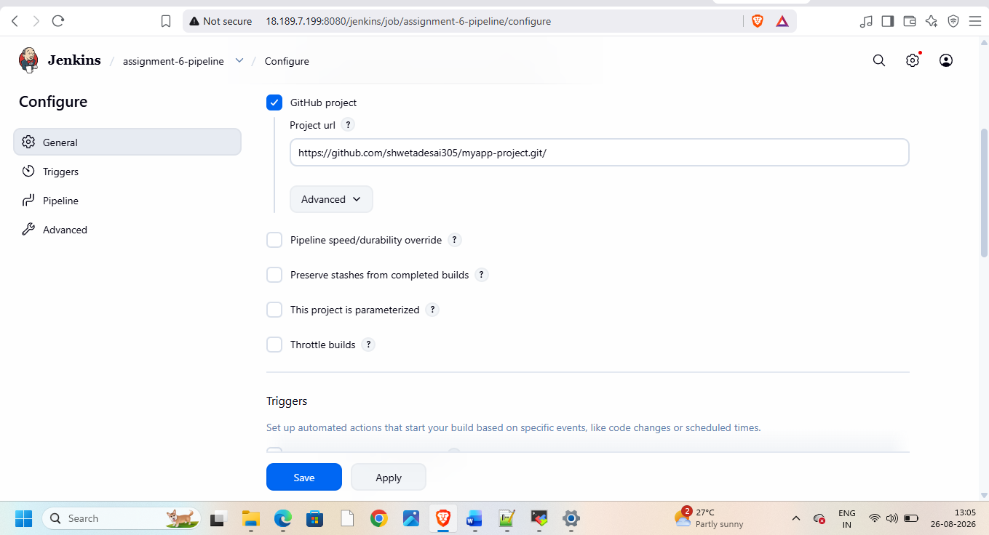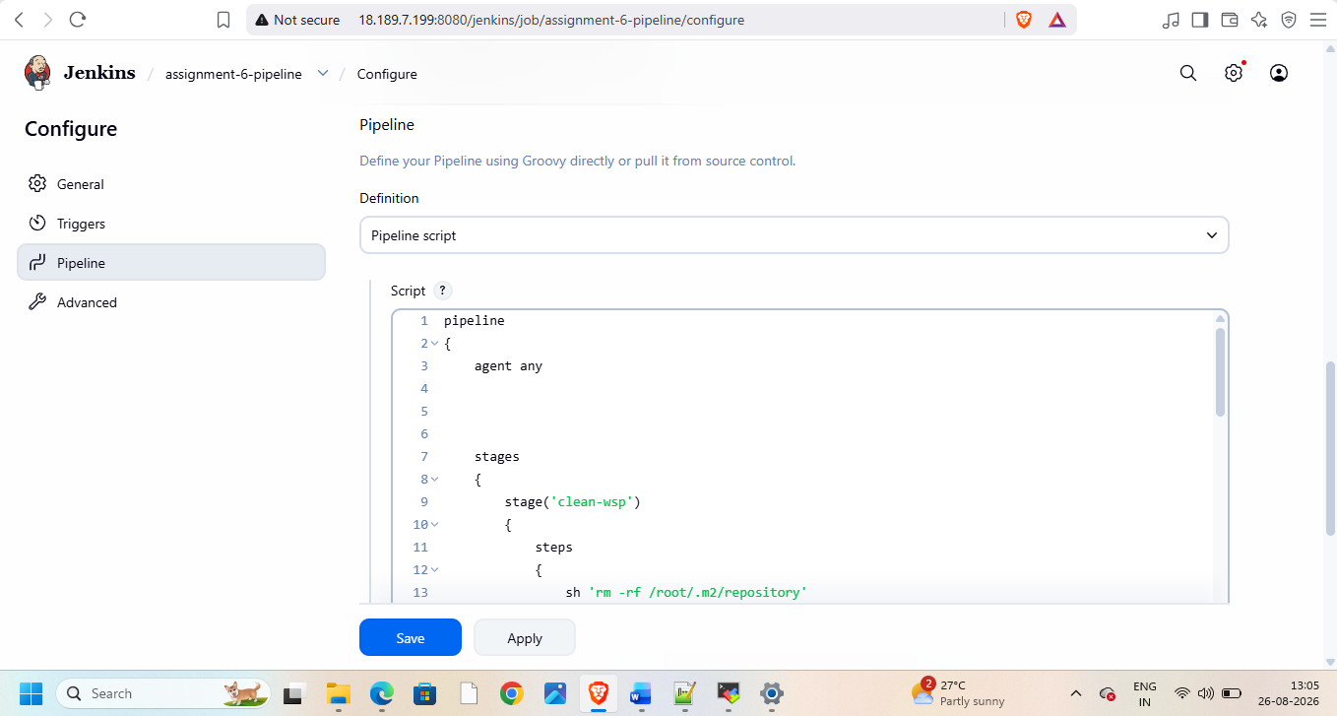
pipeline
{
agent any
stages
{
stage('clean-wsp')
{
steps
{
sh 'rm -rf /root/.m2/repository'
}
}

stage('git-clone')
{
steps
{
git branch: 'master' , url: 'https://github.com/shwetadesai305/myapp-project.git'
}
}

stage('mvn-pkg')
{
steps
{
sh '''
mvn clean package -DskipTests=true
'''
}
}

stage('copy-war')
{
steps
{
sh '''
rm -rf /mnt/servers/apache-tomcat-11.0.25/webapps/java17-mysql-webapp-1*
cp -r target/java17-mysql-webapp-1.0.war /mnt/servers/apache-tomcat-11.0.25/webapps
'''
}
}
}

}
Then build and check on browser
