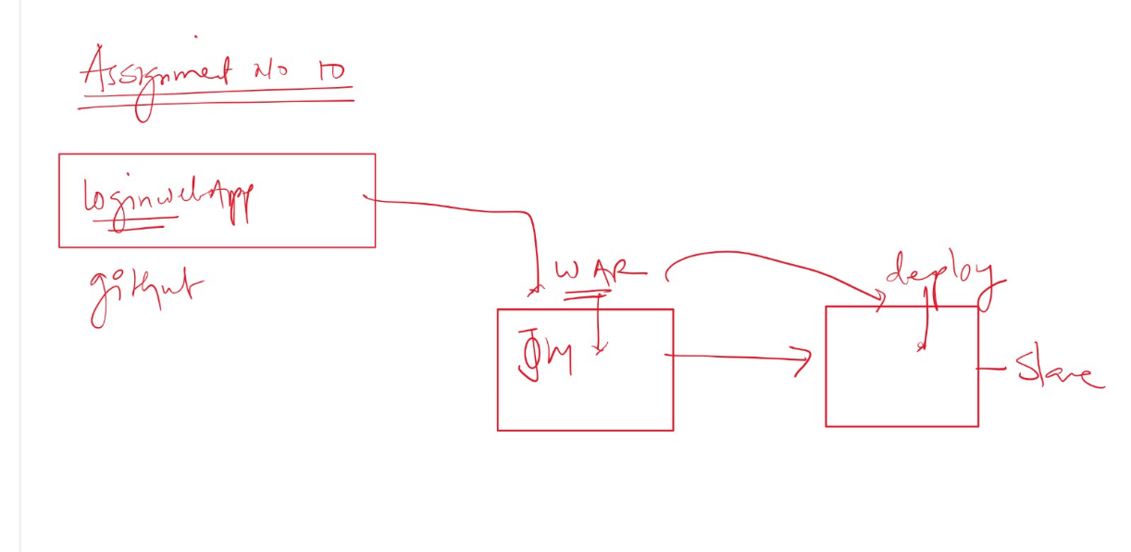
Que- create war file using git project and deploy it on slave
Ans- we can create 2 jobs
Job 1- create war file using git and upload that war file on s3
Job2- download war file from s3 and deploy it on slave
First launch 2 instance and connect to them
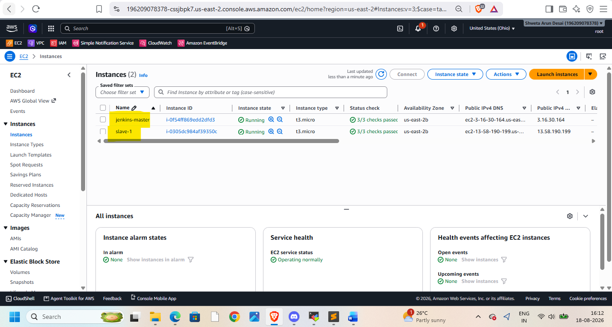
Install java,maven,git,Jenkins,tomcat on it
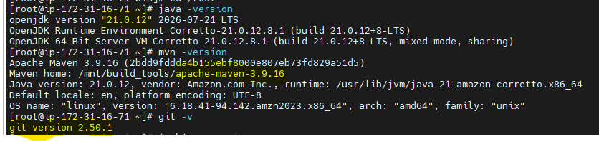
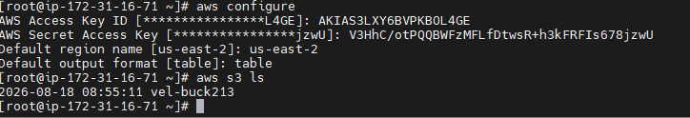
Create IAM role and attach to master instance
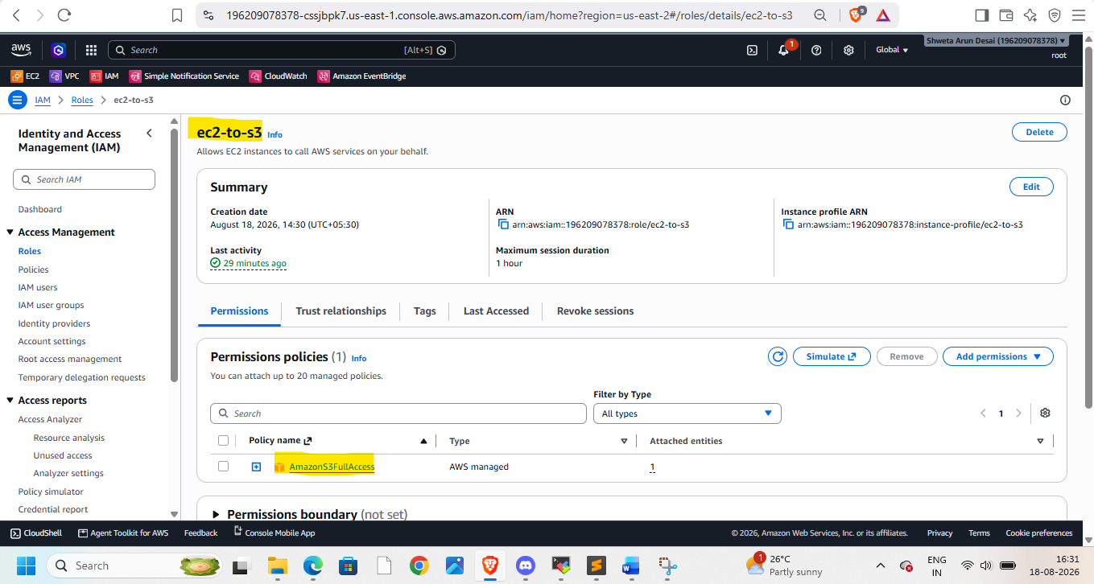
Connect to slave-1
Install java 21 ,git 2.5, tomcat10
create Jenkins-slave folder in /mnt -> workspace of slave
attach created IAM role to slave as well
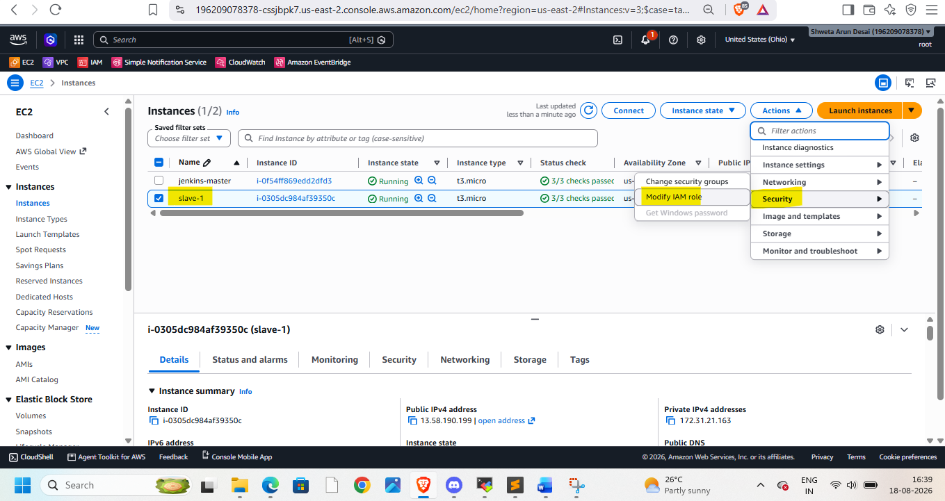
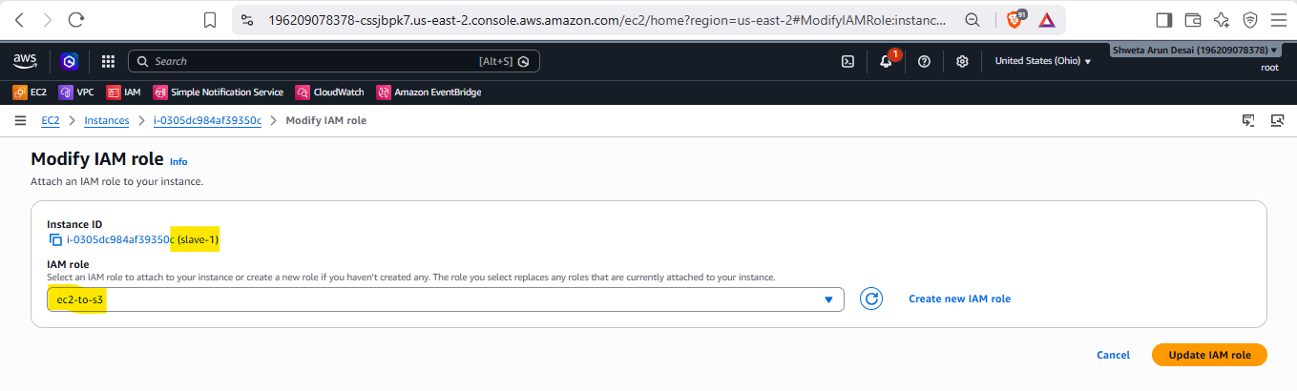Login to Jenkins
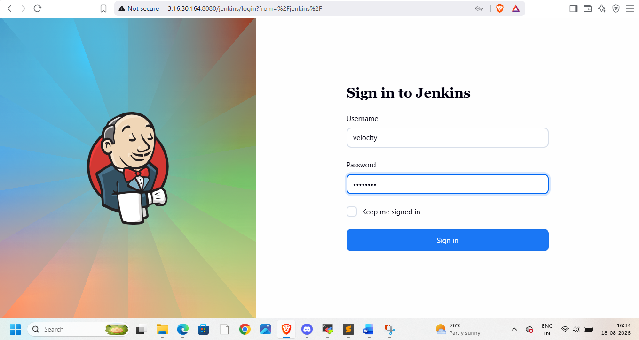
Goto manage Jenkins and node -> create node
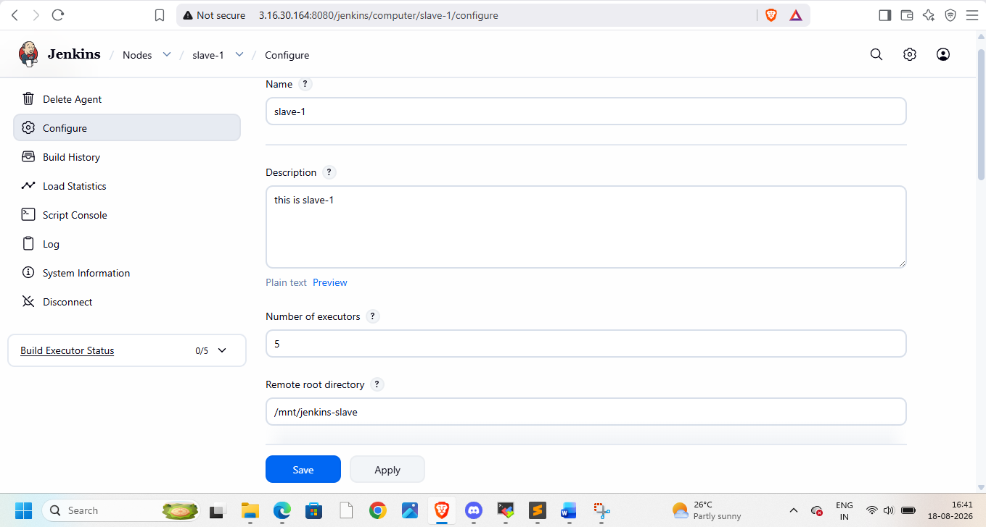 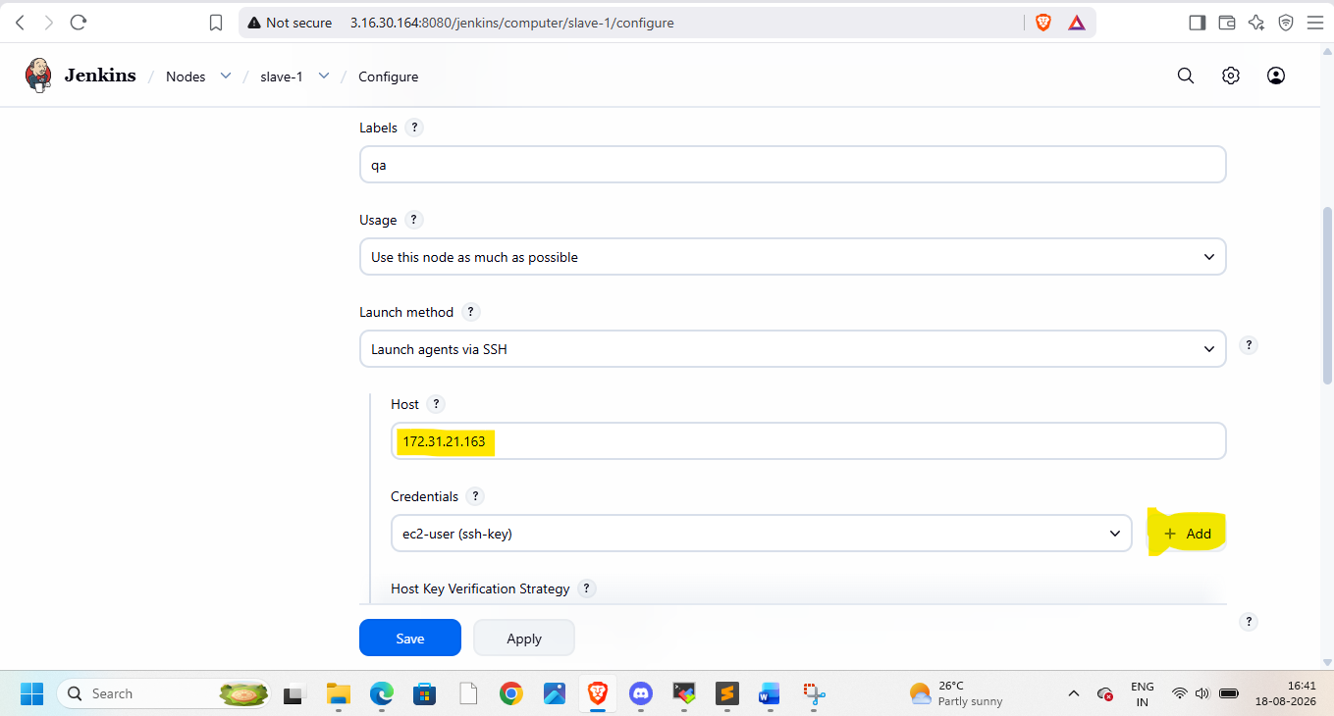add credentials
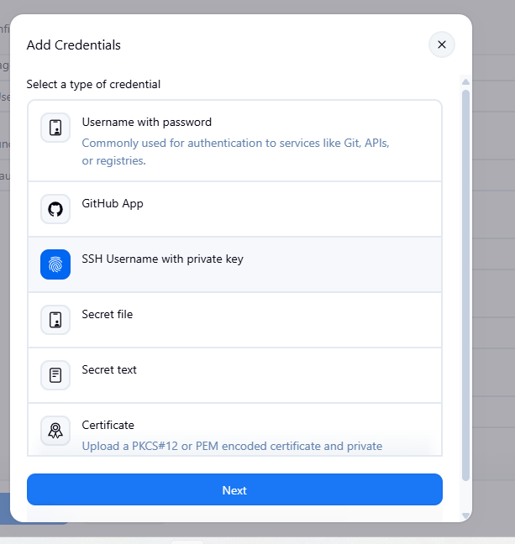
Provide pem file key with you
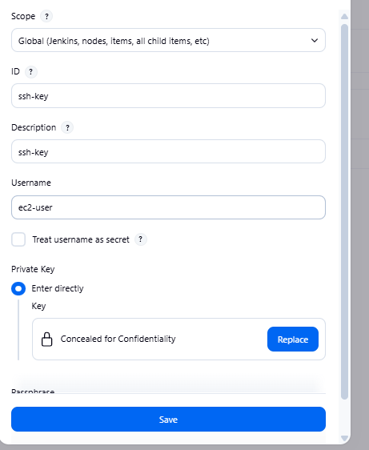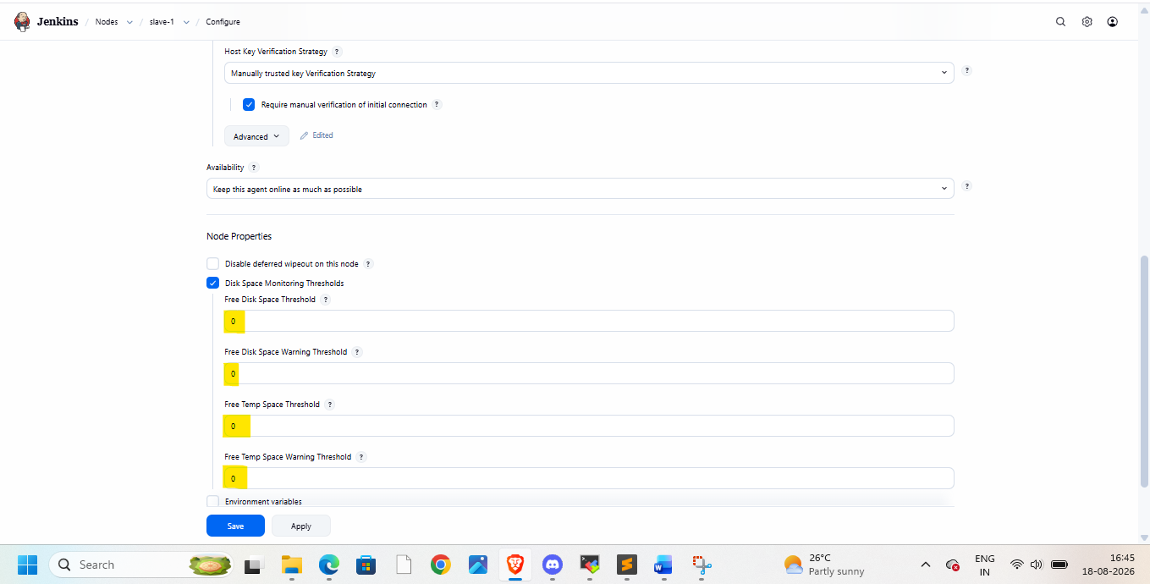
Then apply and save
As we need mvn here
Go to tools in manage jenkins and add maven details here
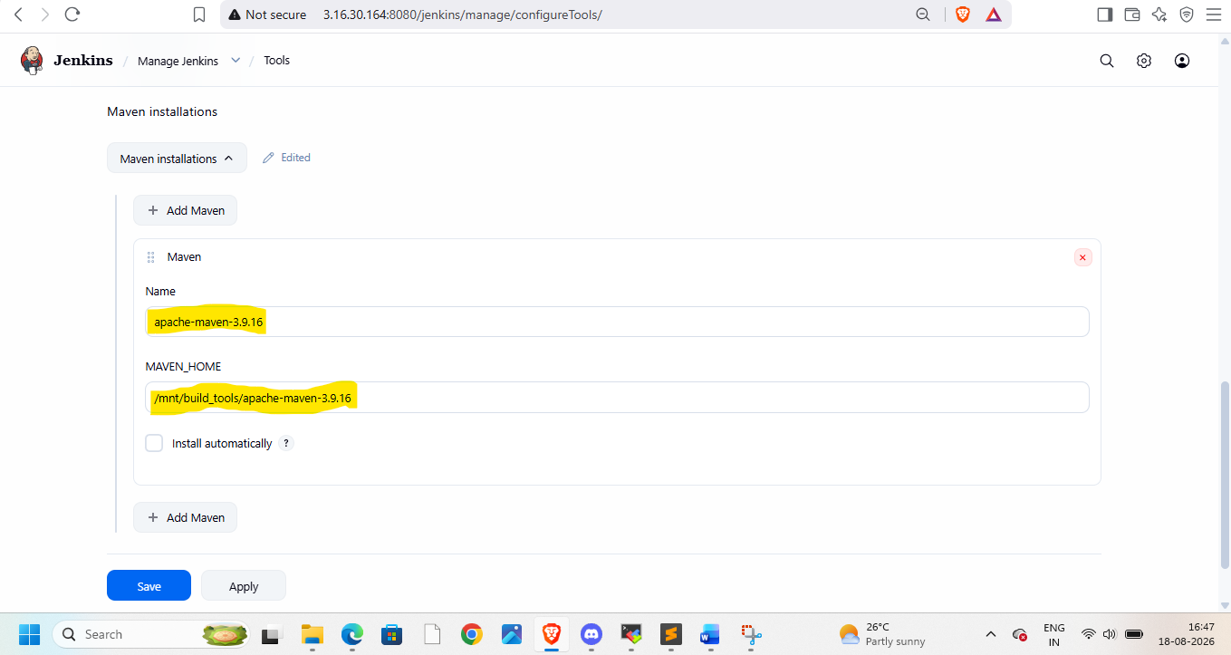
Now create job-1
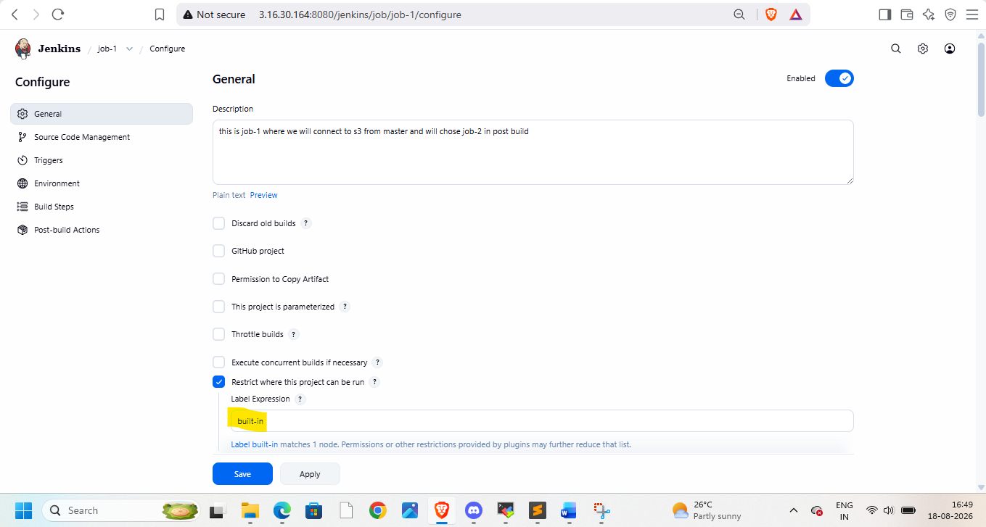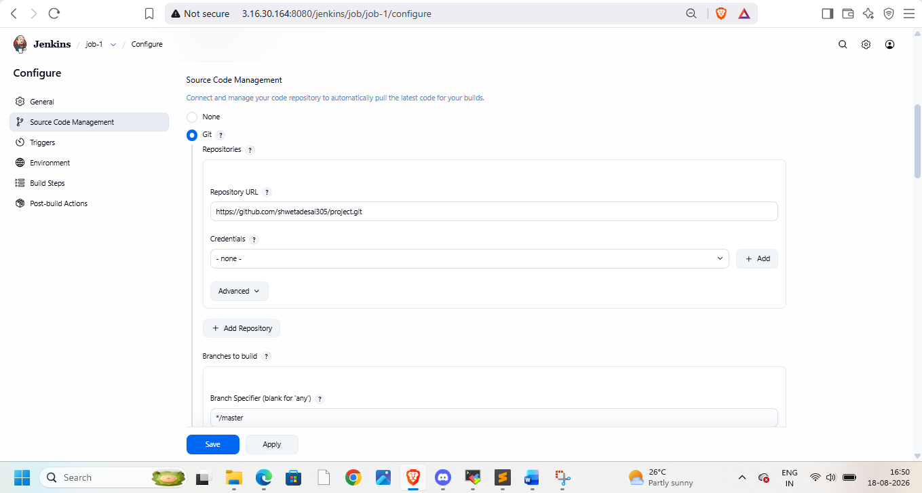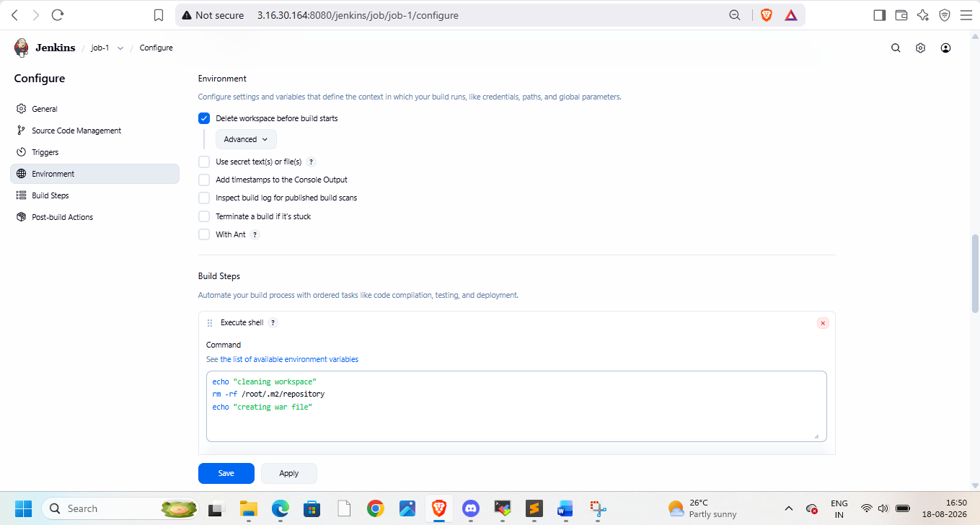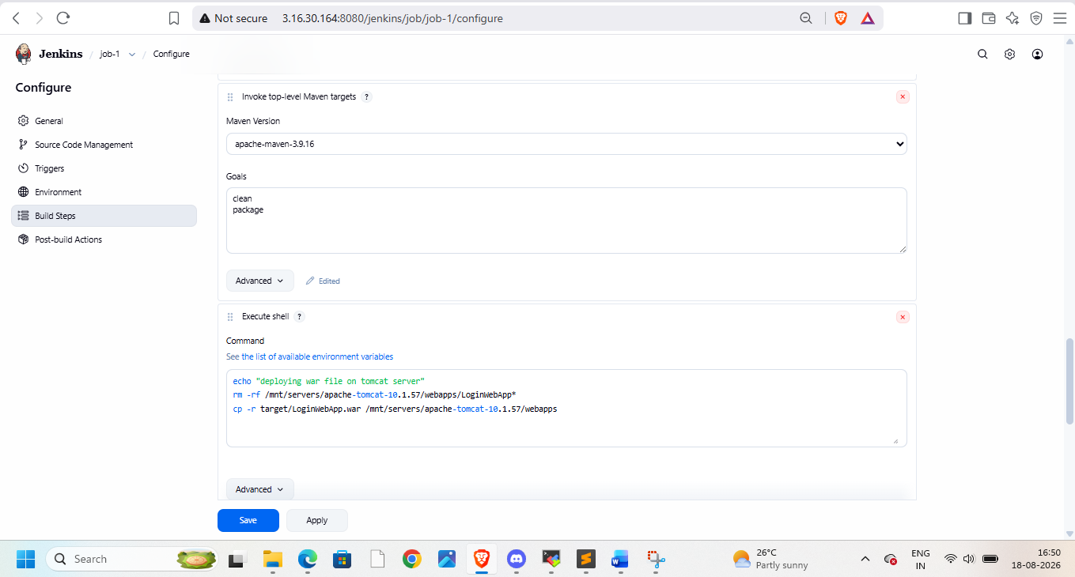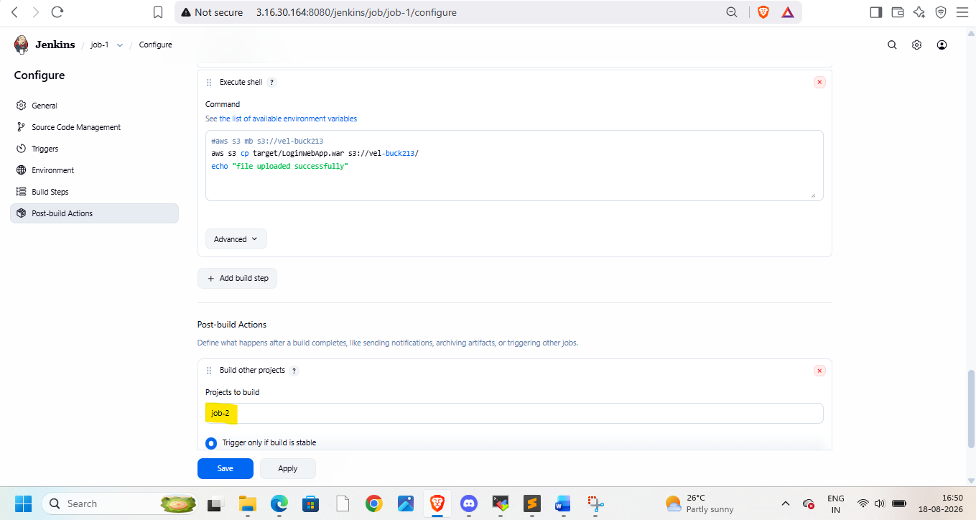
Add job-2 in post build
Create job-2 as below
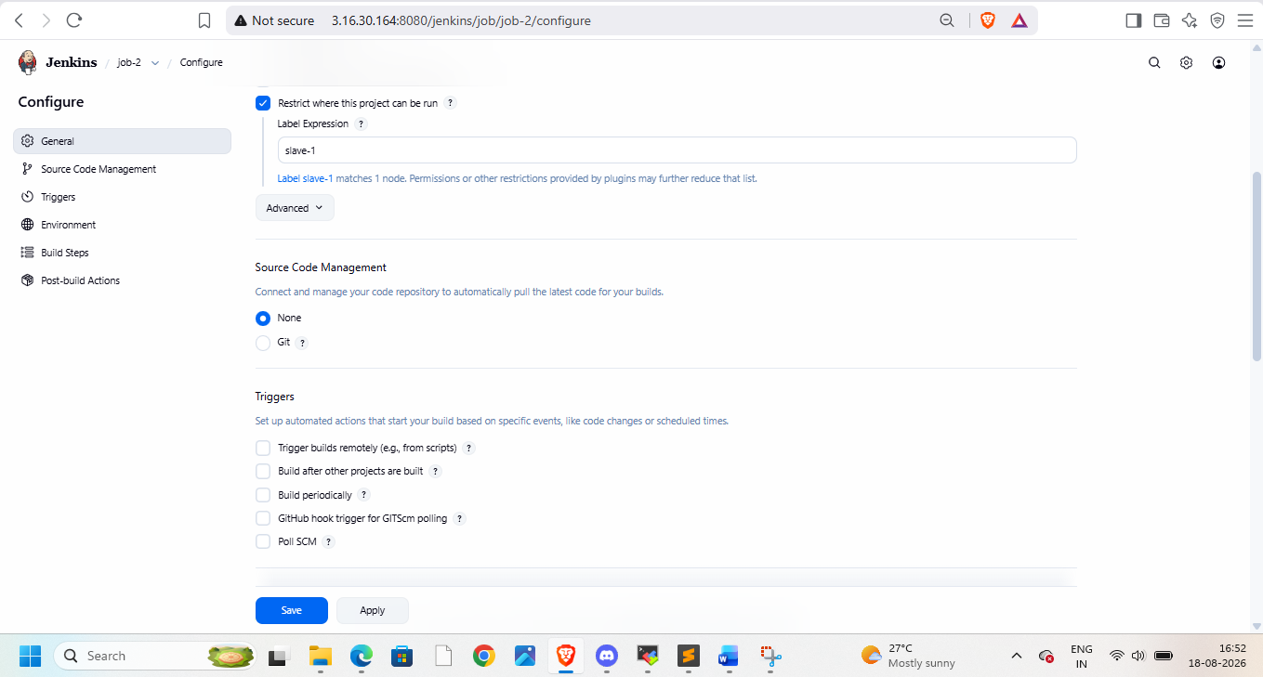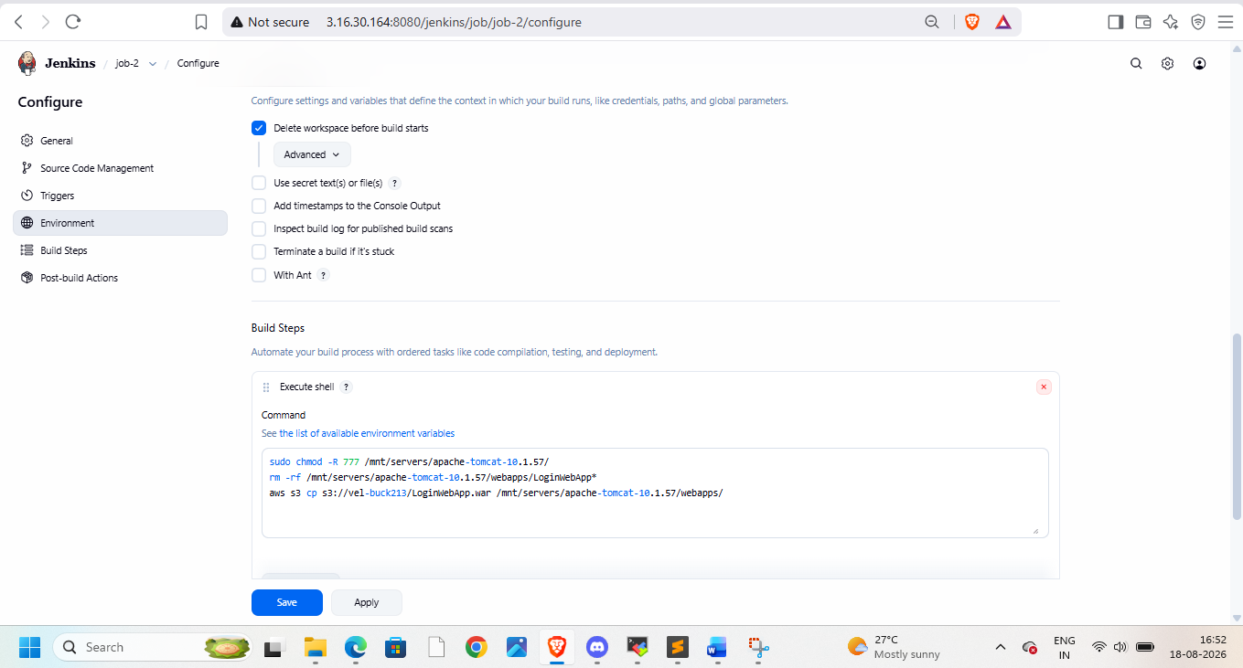
Here we download data from s3 and deploy it on slave
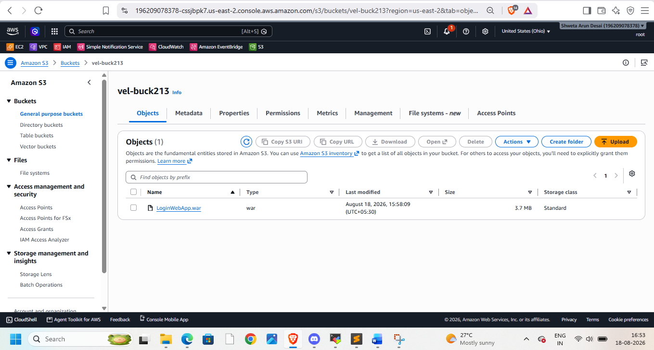
We can see war file in bucket, now check on browser
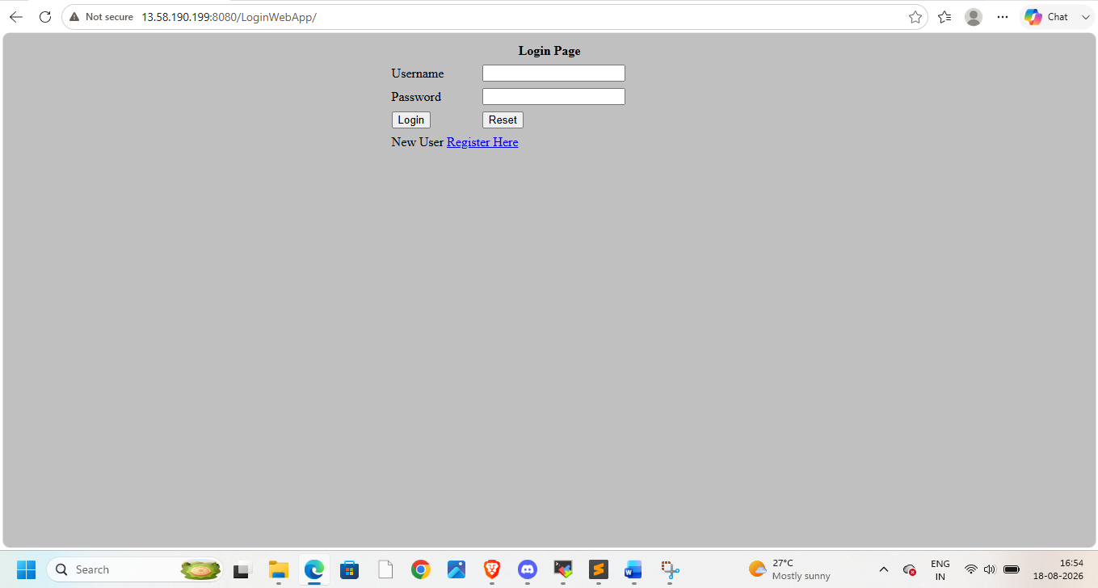
Once done terminate instances

