Jenkins Assignment 11
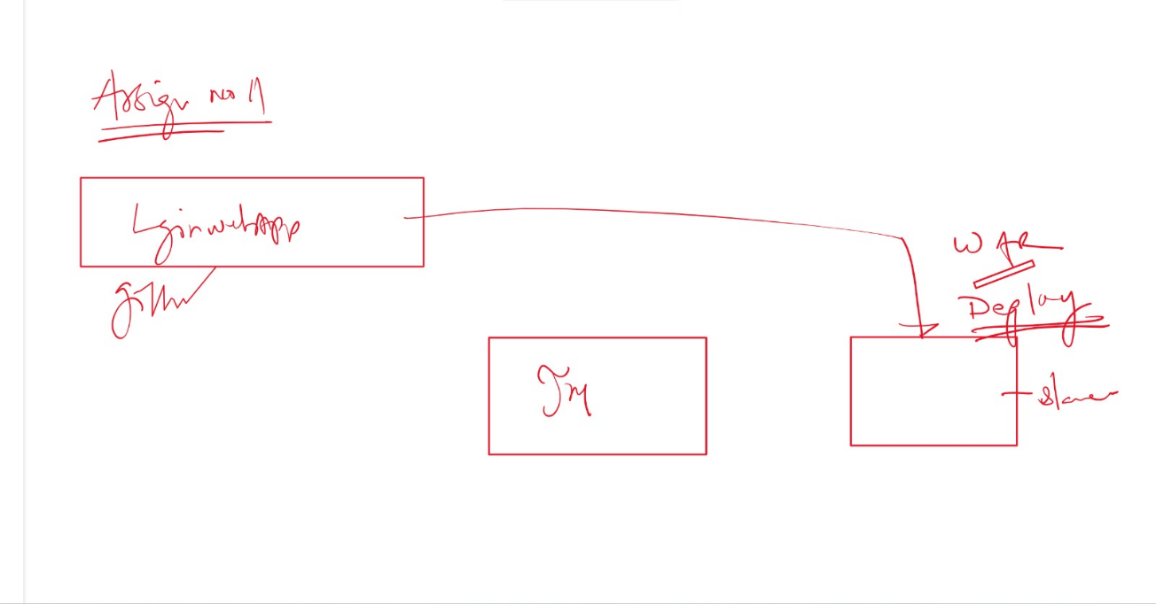
Create and deploy git project on slave from Jenkins master
Ans- create 2 instances connect and download java, maven, Jenkins, git, tomcat
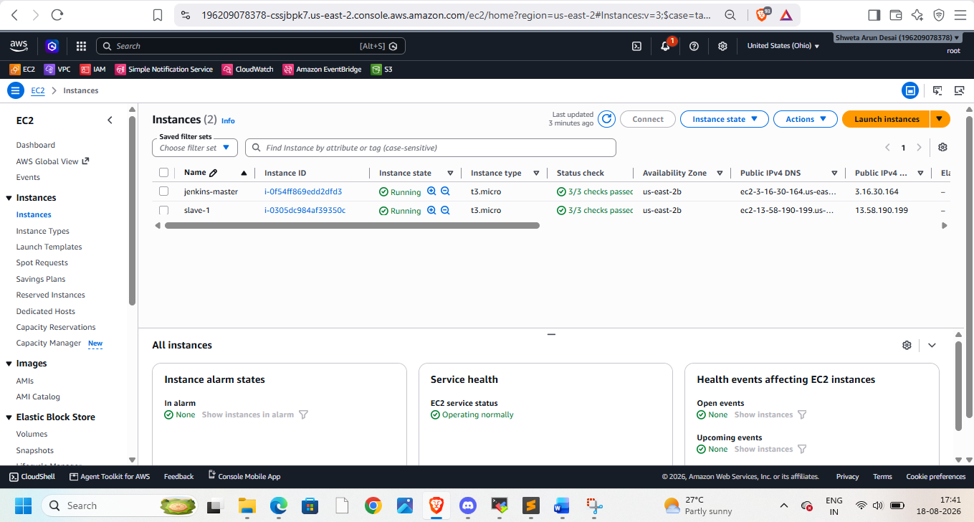
Do aws configure on slave
Start and login to Jenkins then goto manage Jenkins -> nodes -> create slave-1
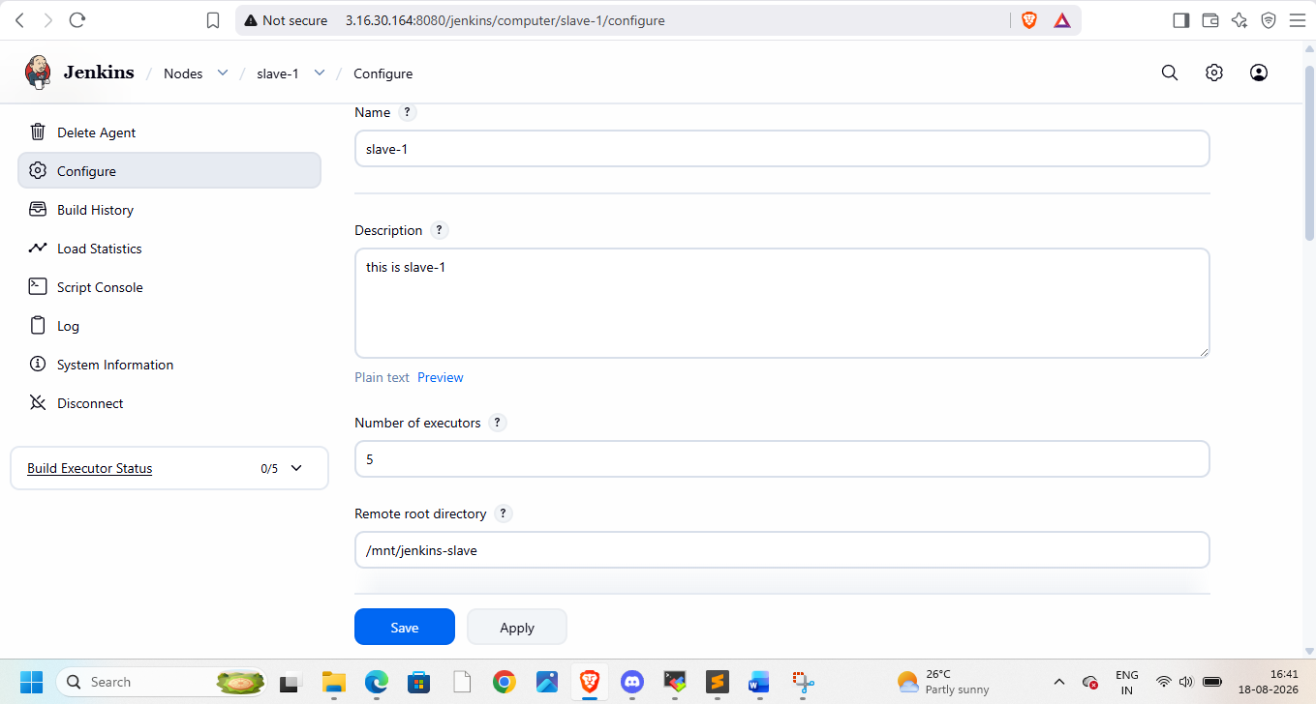
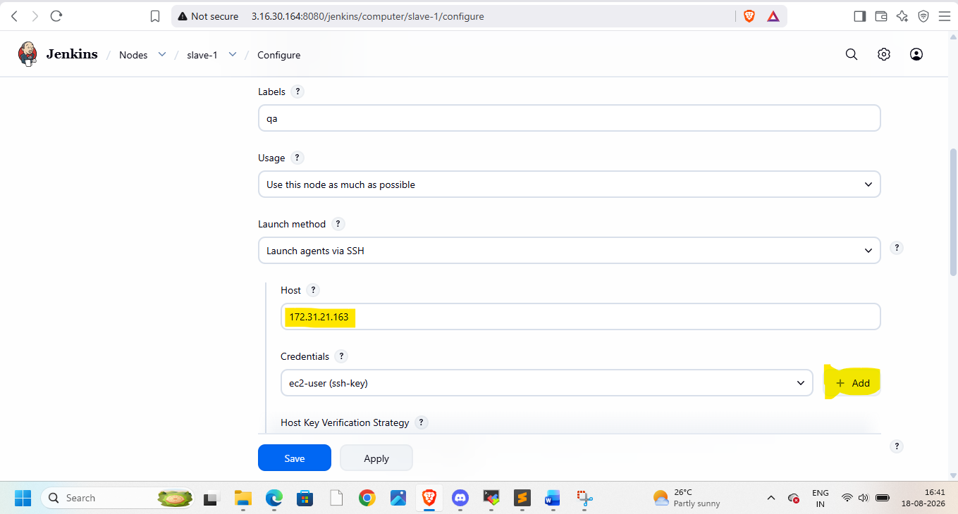add credentials, use private ip of slave-1
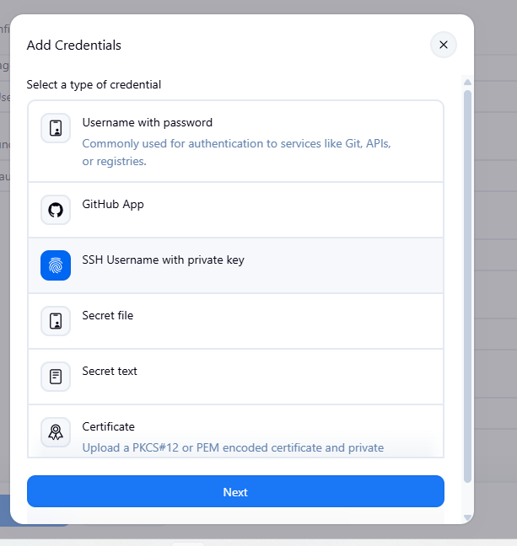
Provide pem file key with you
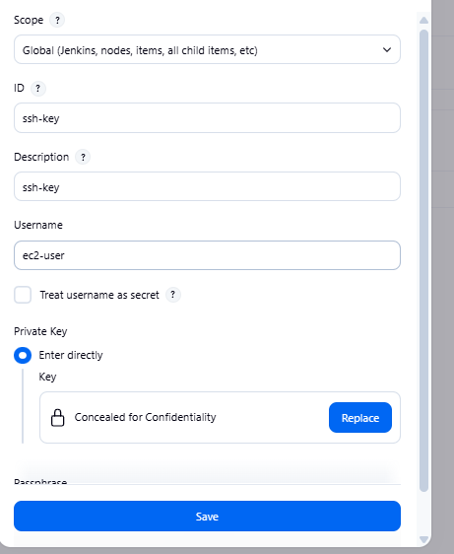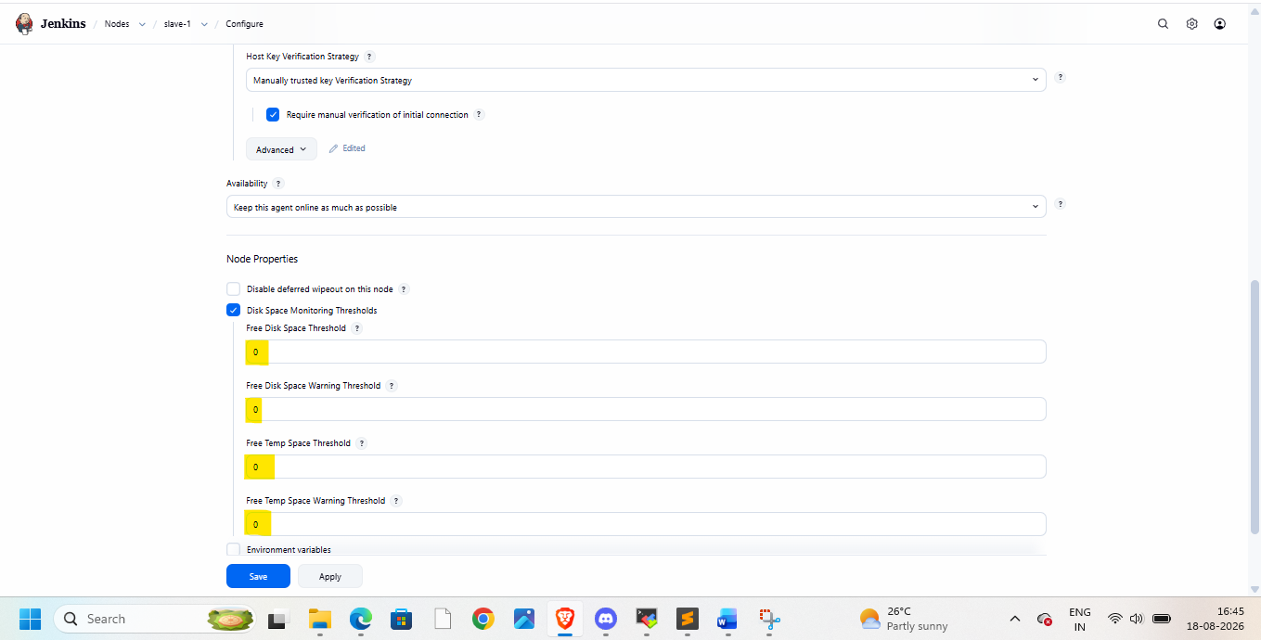
Then apply and save
As we need mvn here
Go to tools in manage jenkins and add maven details here
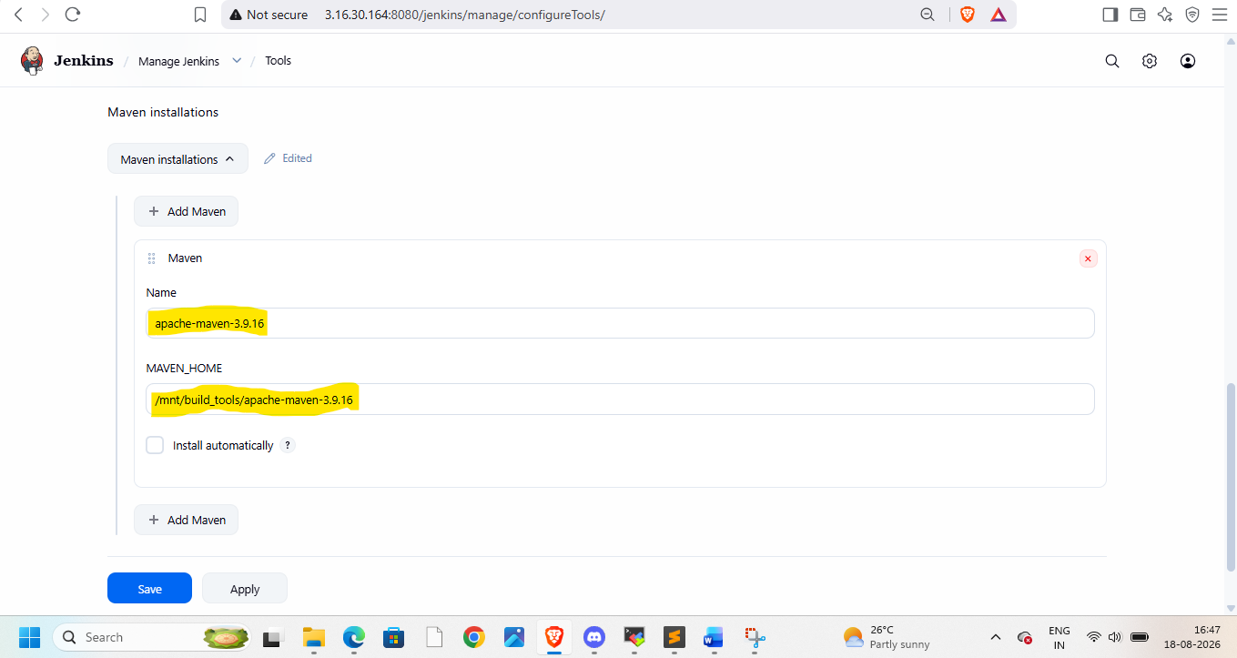
Create job
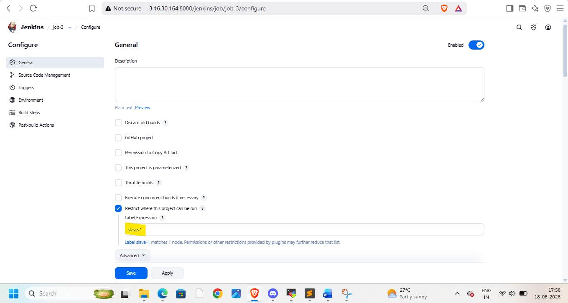
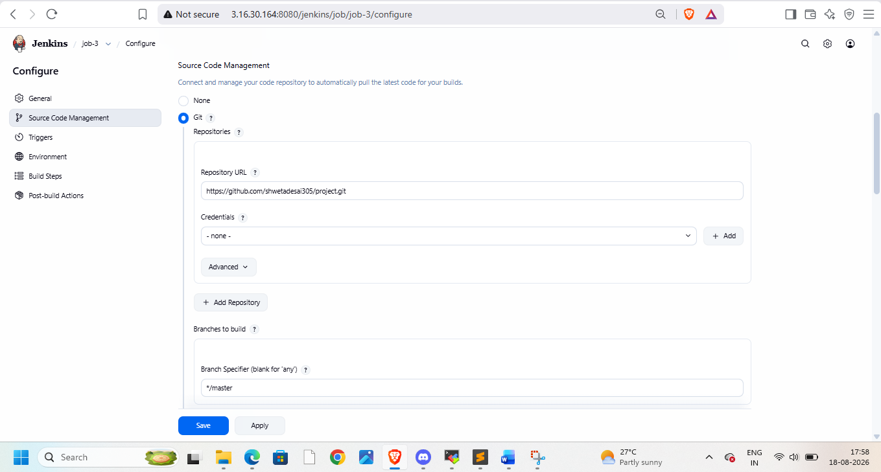
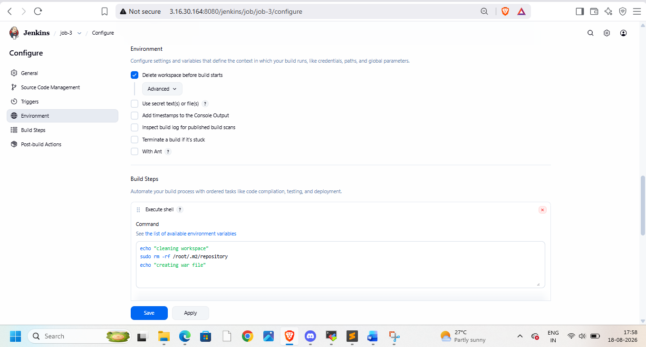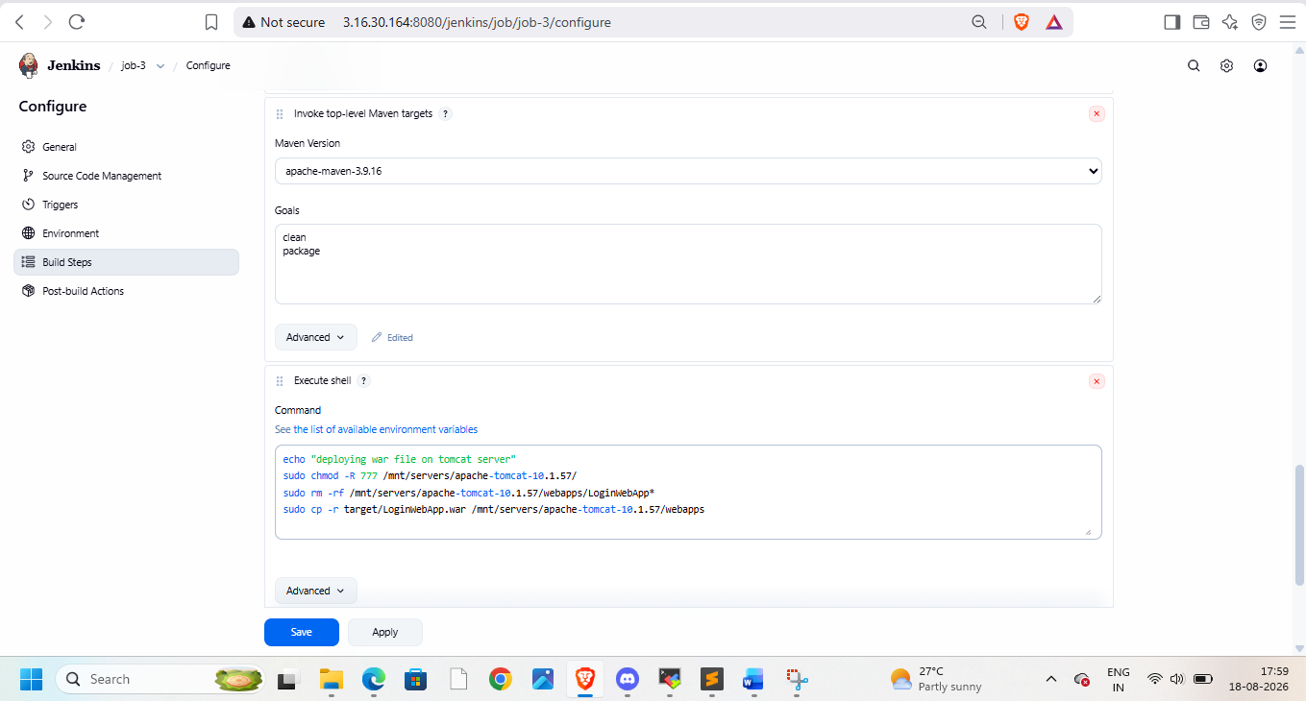
Use public ip of slave and application name – can get in git pom.xml file


