Assignment 24 – Jenkins-6 – create a job which will pull then changes of github repo of LoginWebApp war and deploy the App on the tomcat server after building and packing it.
Ans:
Launch instance and connect to it
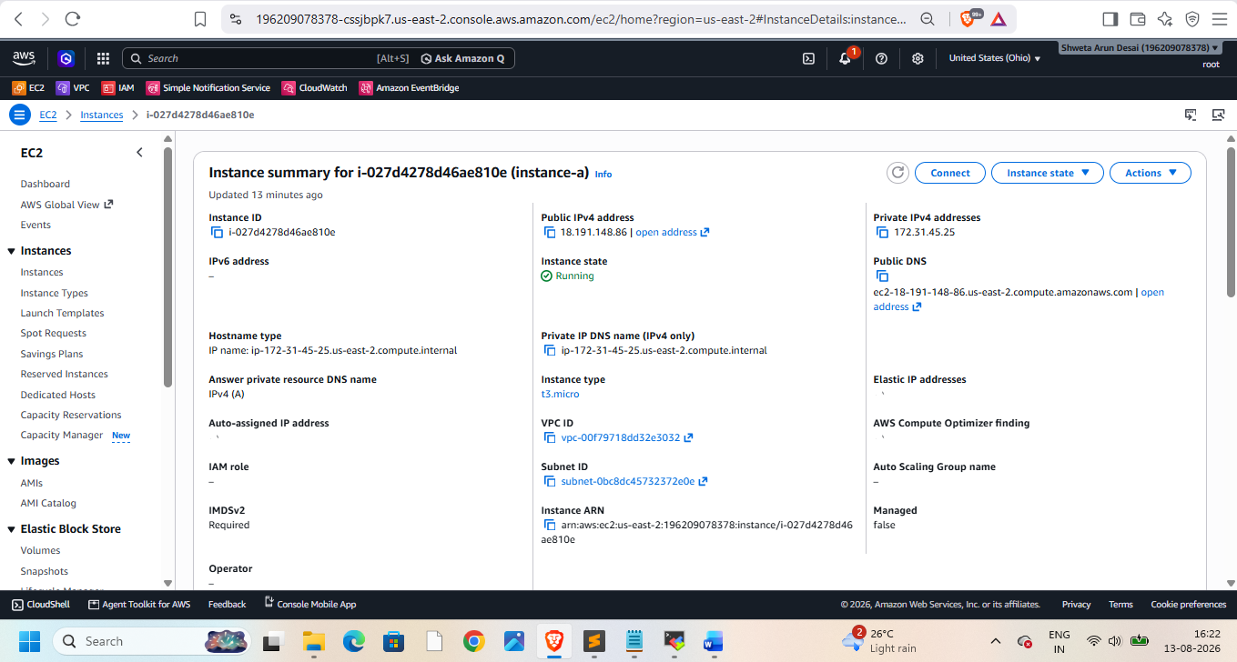
Then install java,git, tomcat, maven, Jenkins
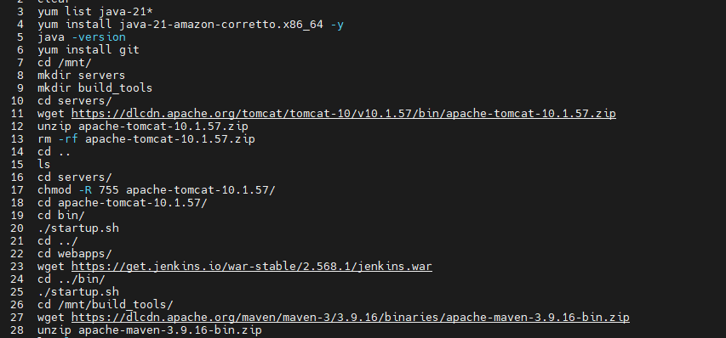
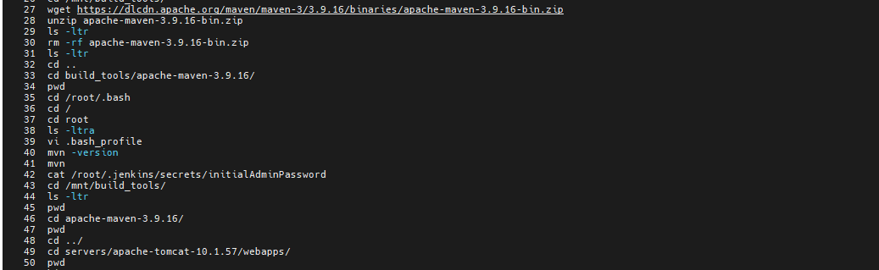
Start Jenkins install plugins. Then create Jenkins job to integrate with maven

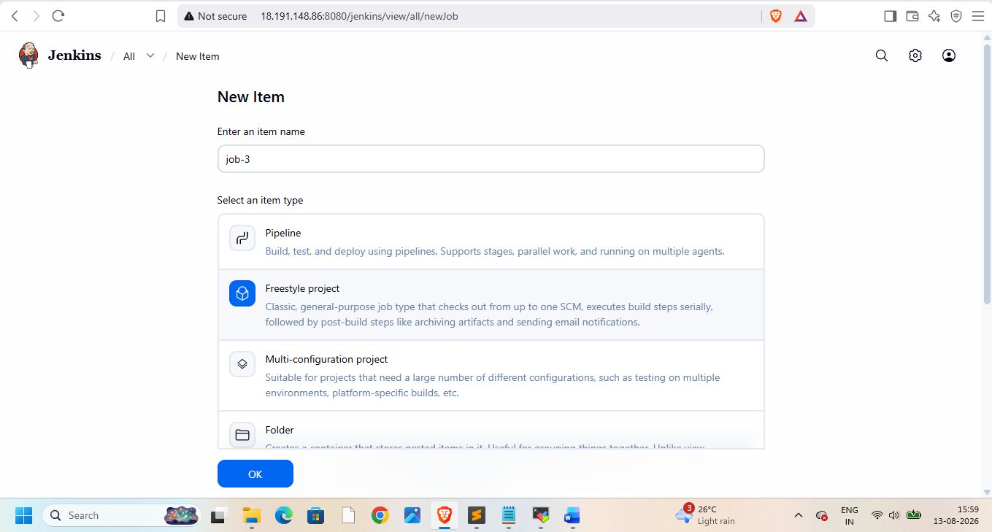

Go to manage Jenkins -> tools and add maven name and home their
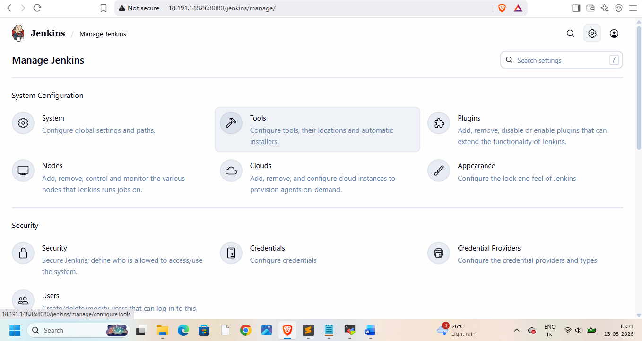
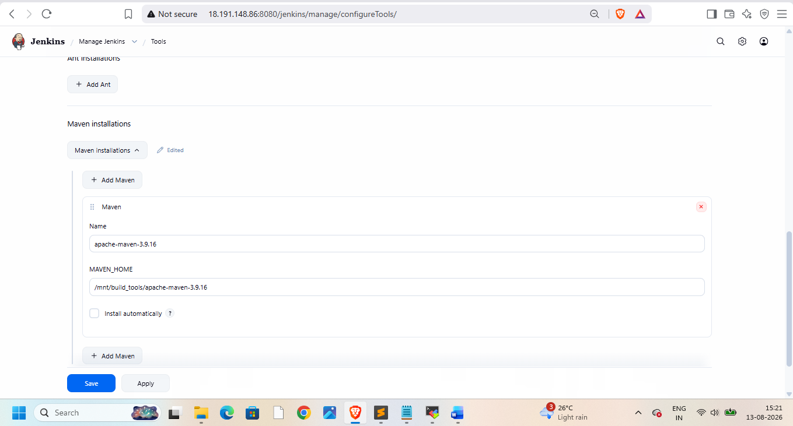
Goto git repo and take repo url
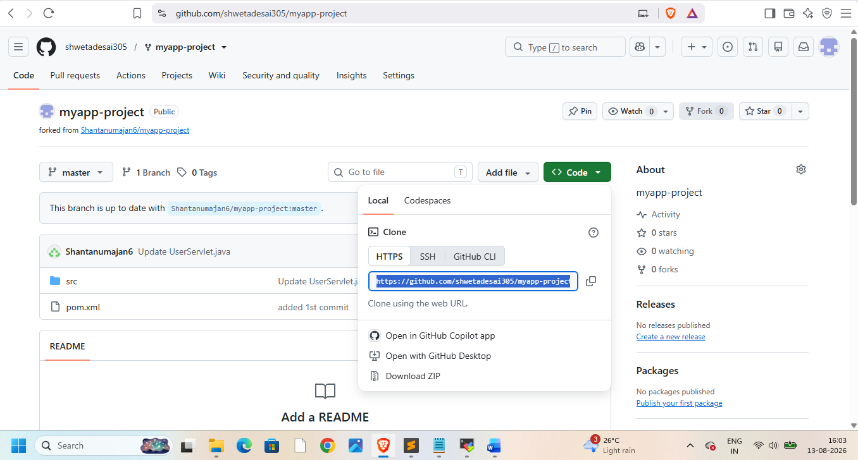put it into source code mgmt.
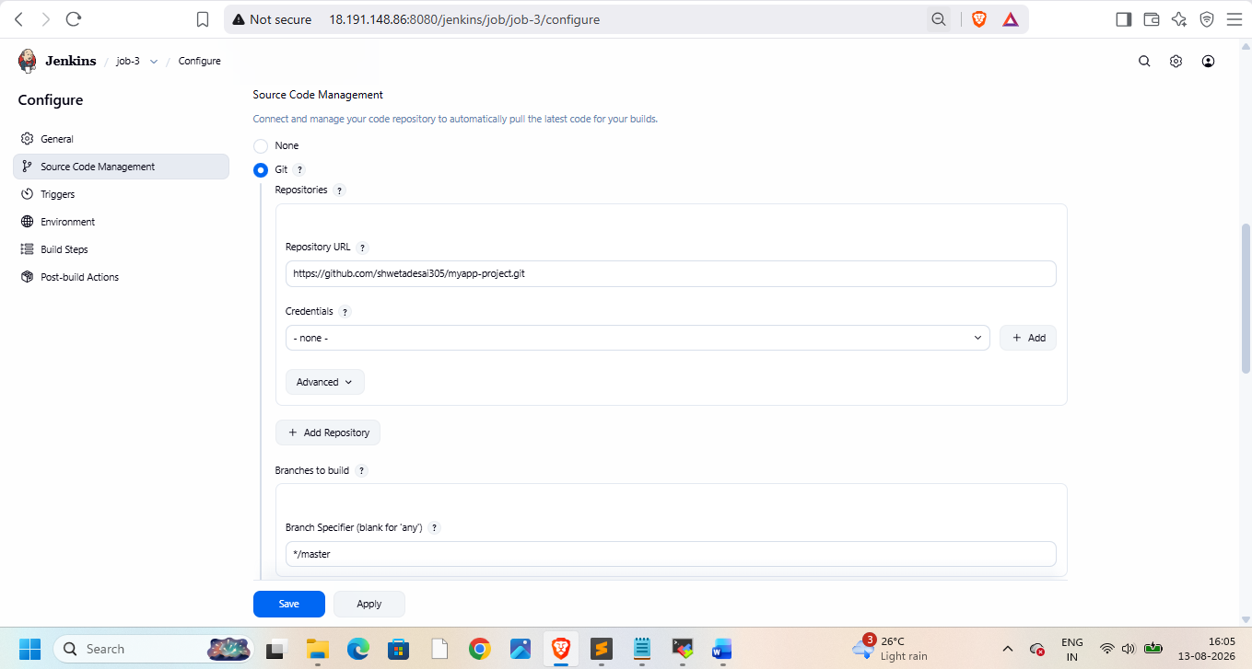
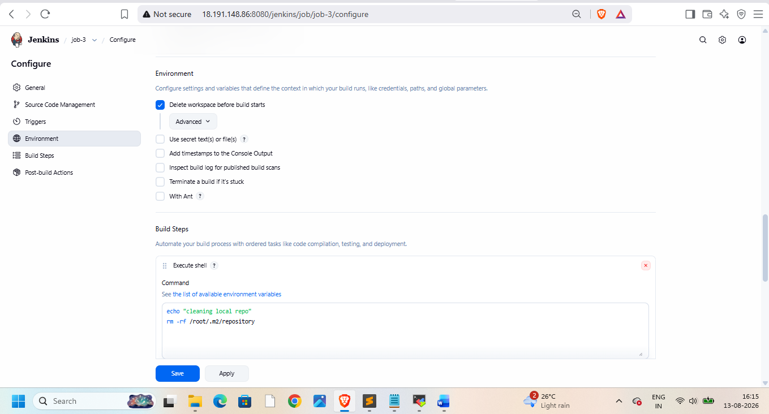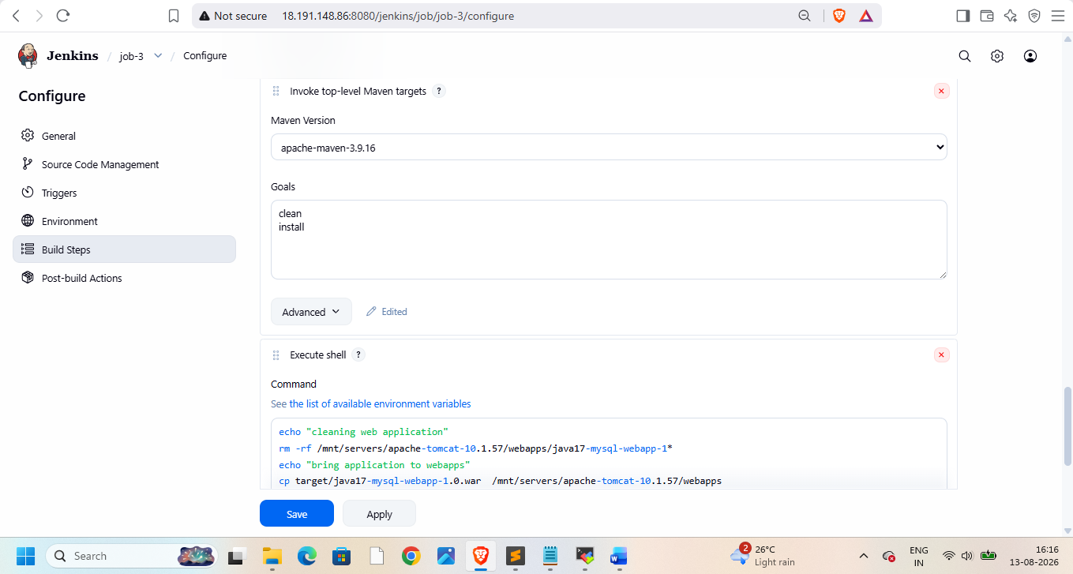
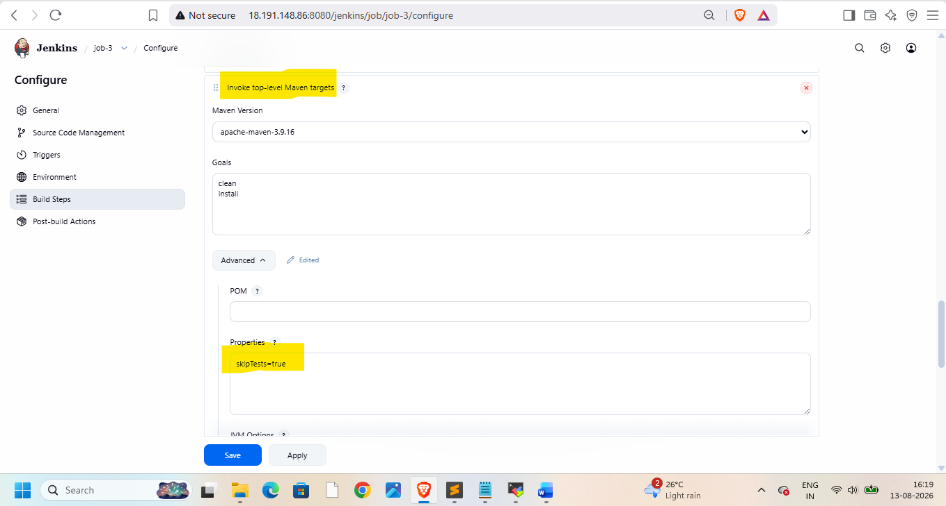
Now build this job
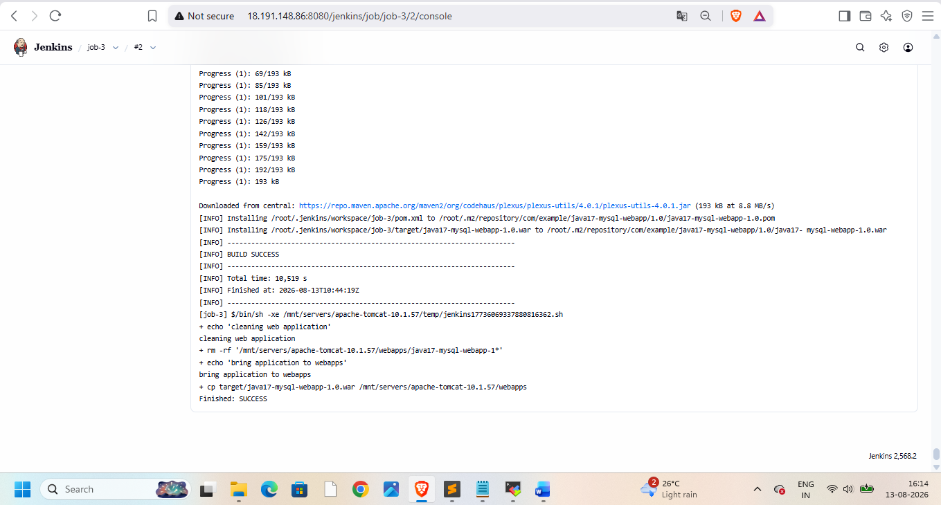
Now check web application
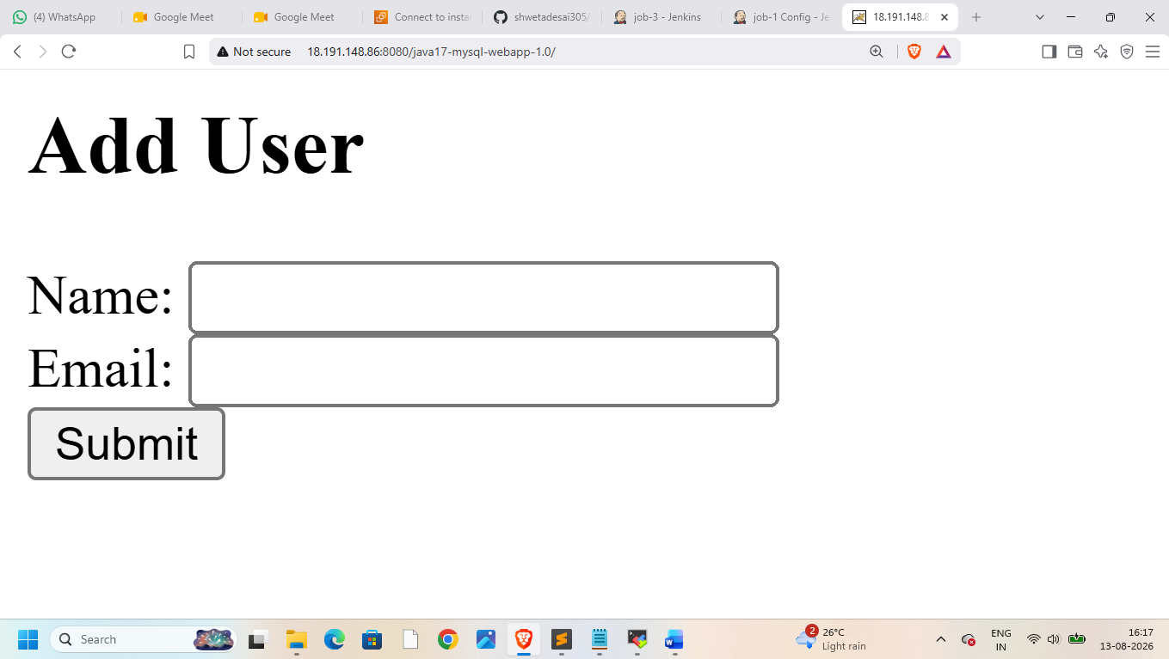
Now check on linux
