Assignment-25-jenkins-7: host web application from 1 machine and make it access with another instance
Ans: launch 2 instances and connect them
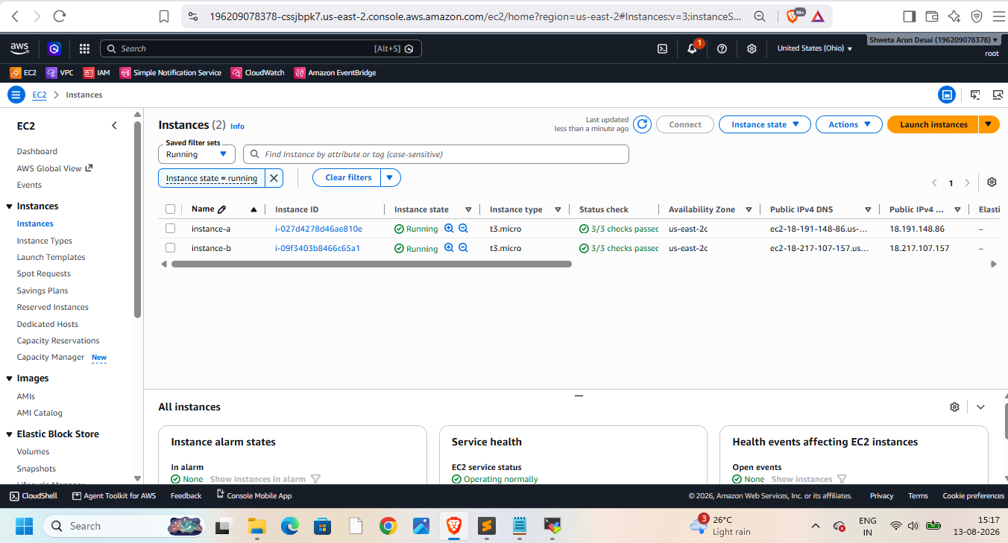
Install java,git,maven,tomcat in it
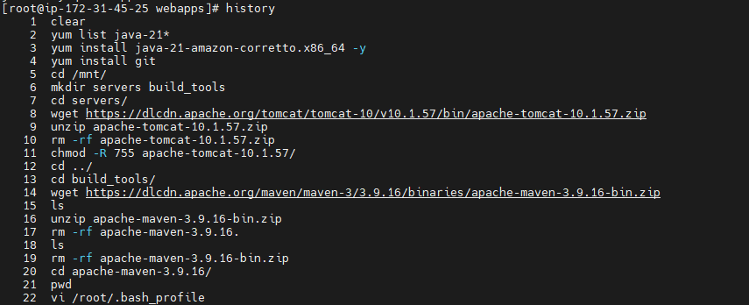
Connect to instance-2 and install java,tomcat,git,Jenkins and give permissions to apache file
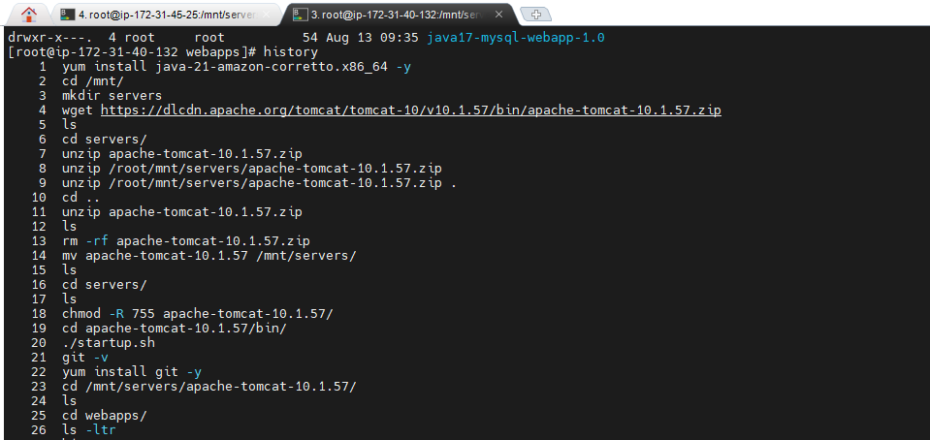
Then login to Jenkins from instance-1
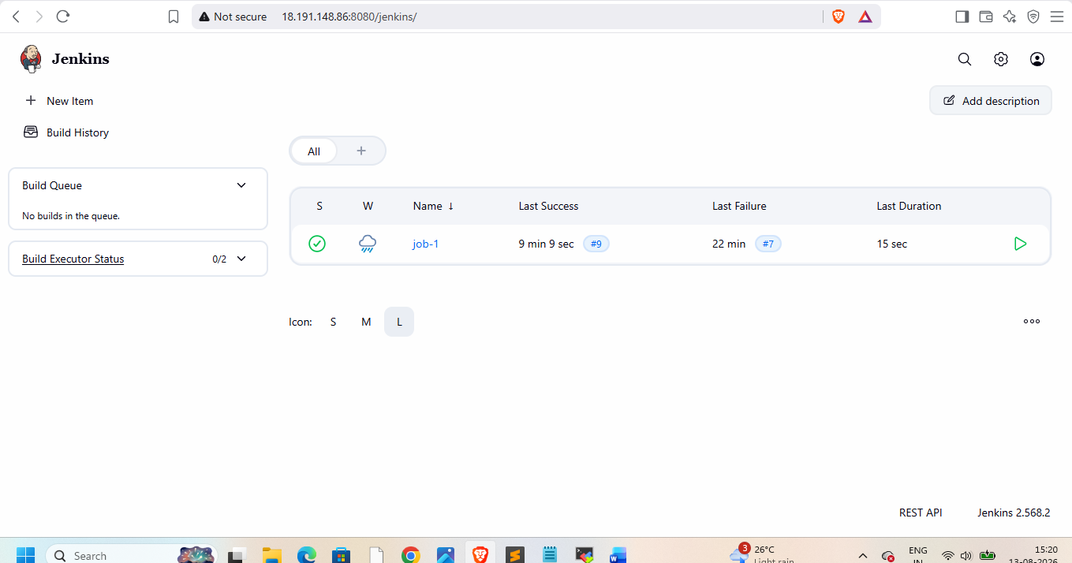
Goto manage Jenkins tools
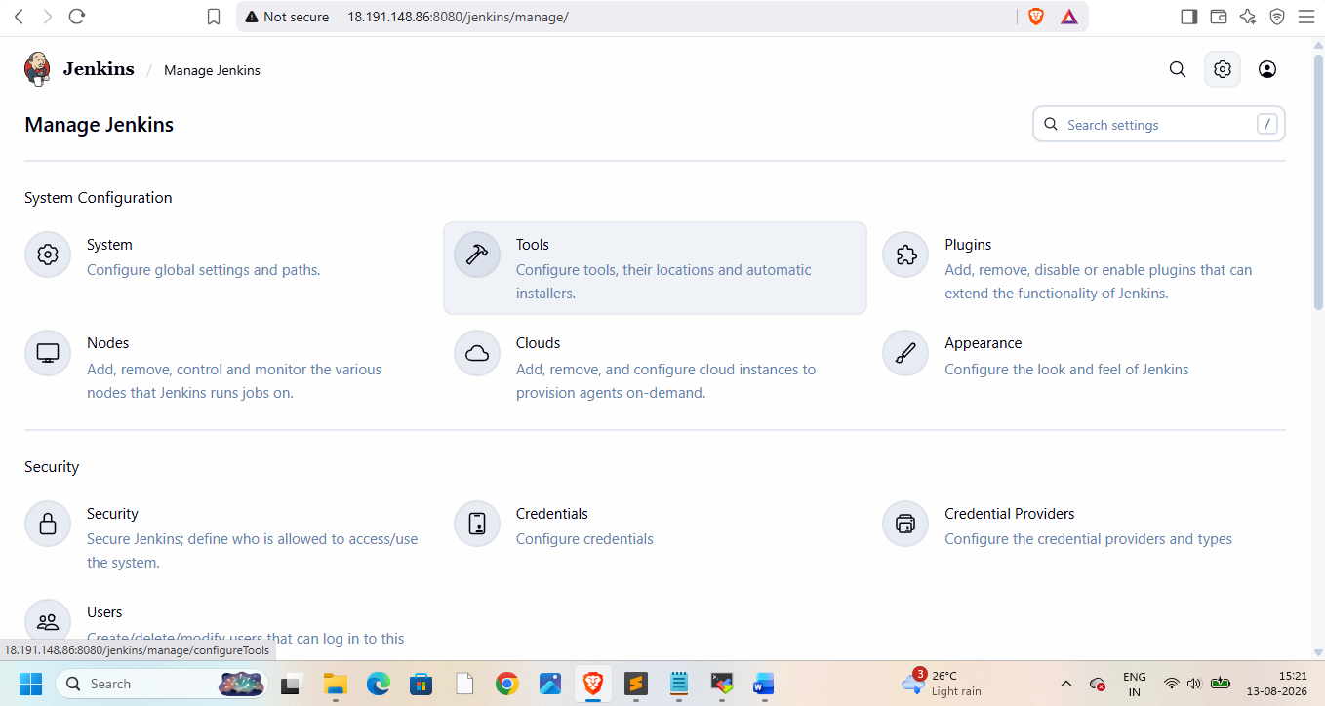add maven name and home in it so it will build application for us
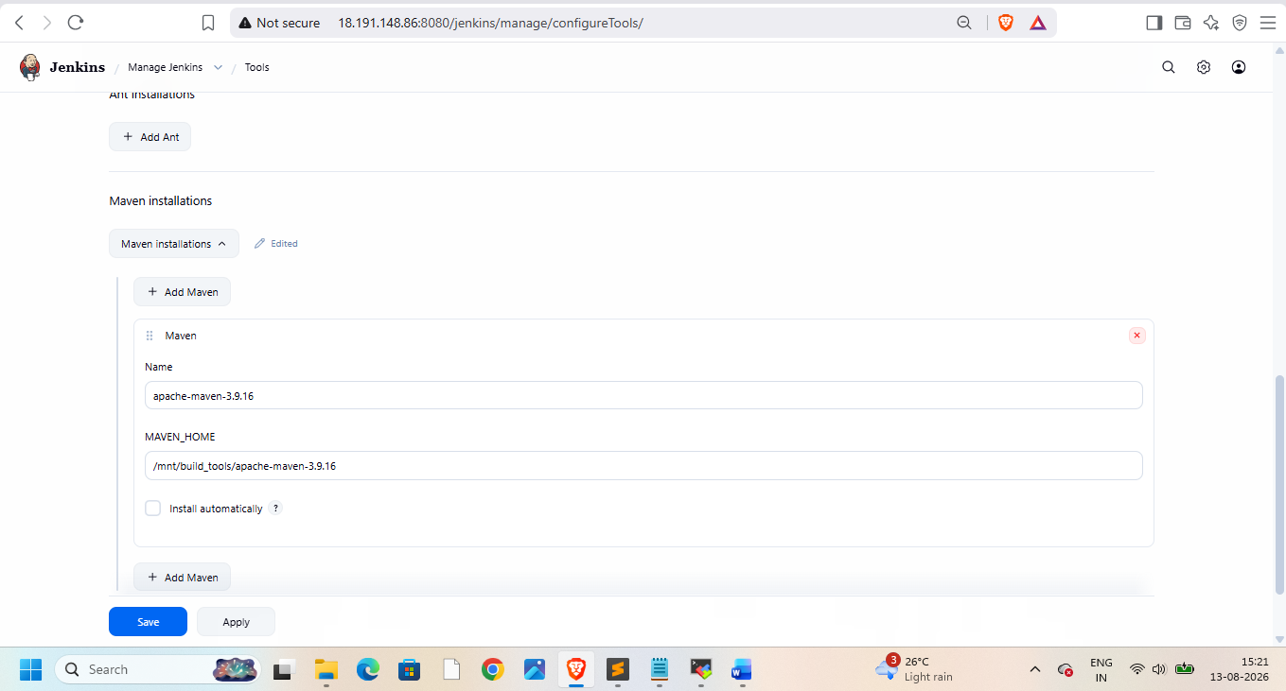
Now create job-1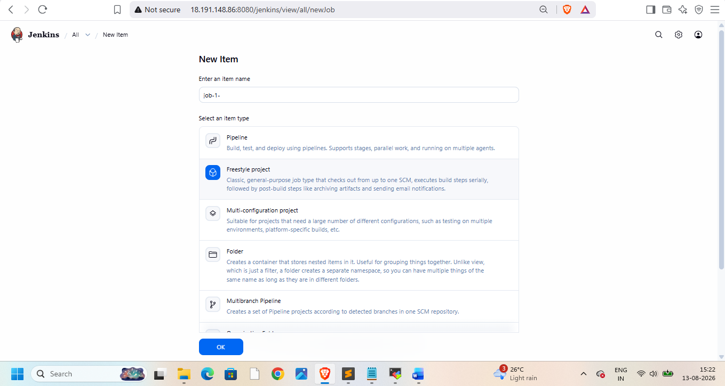
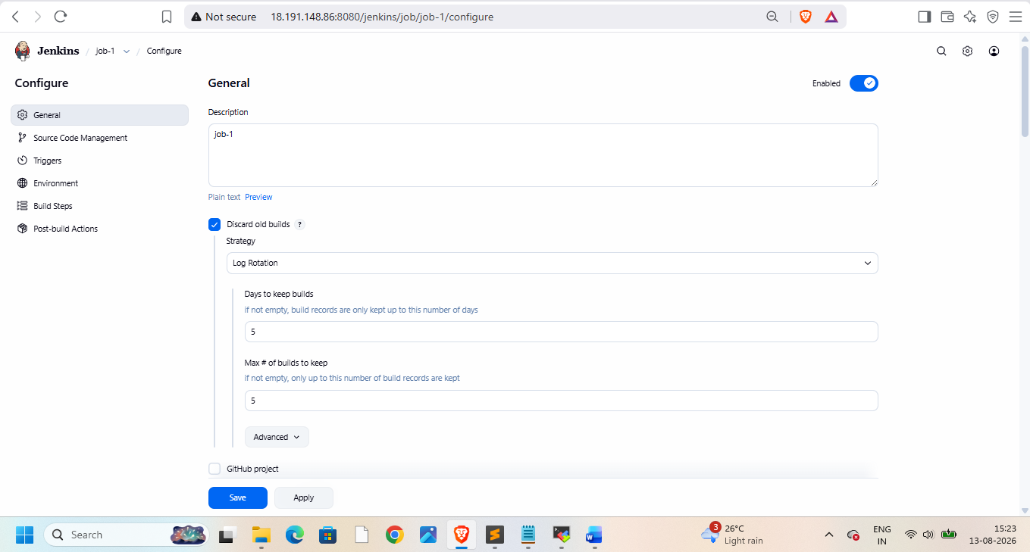

Now goto git hub and copy repo url
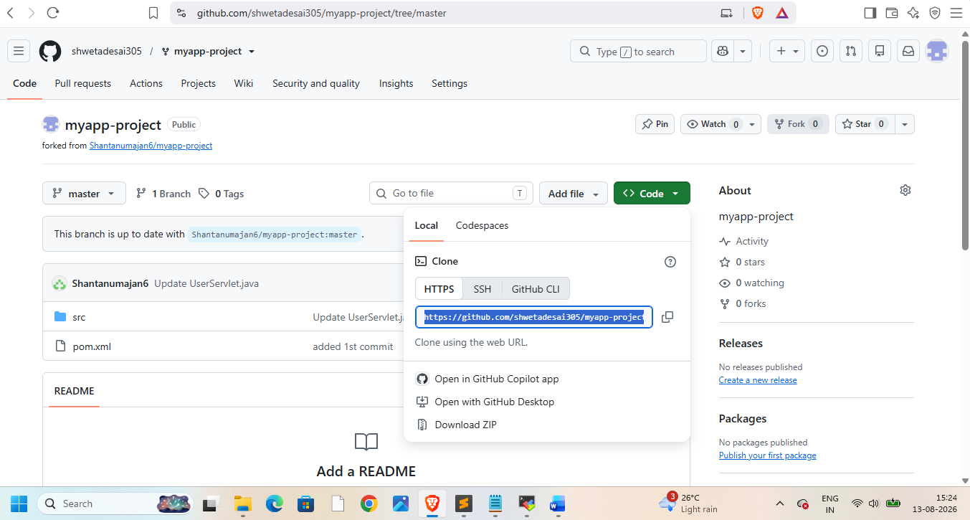put url in job configure
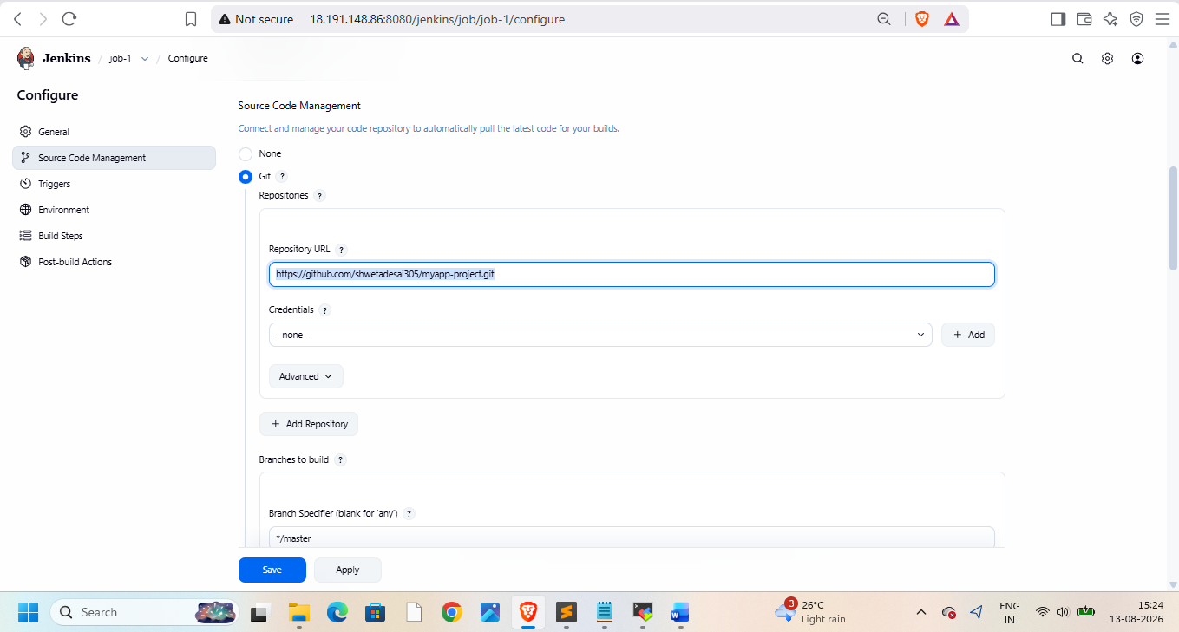
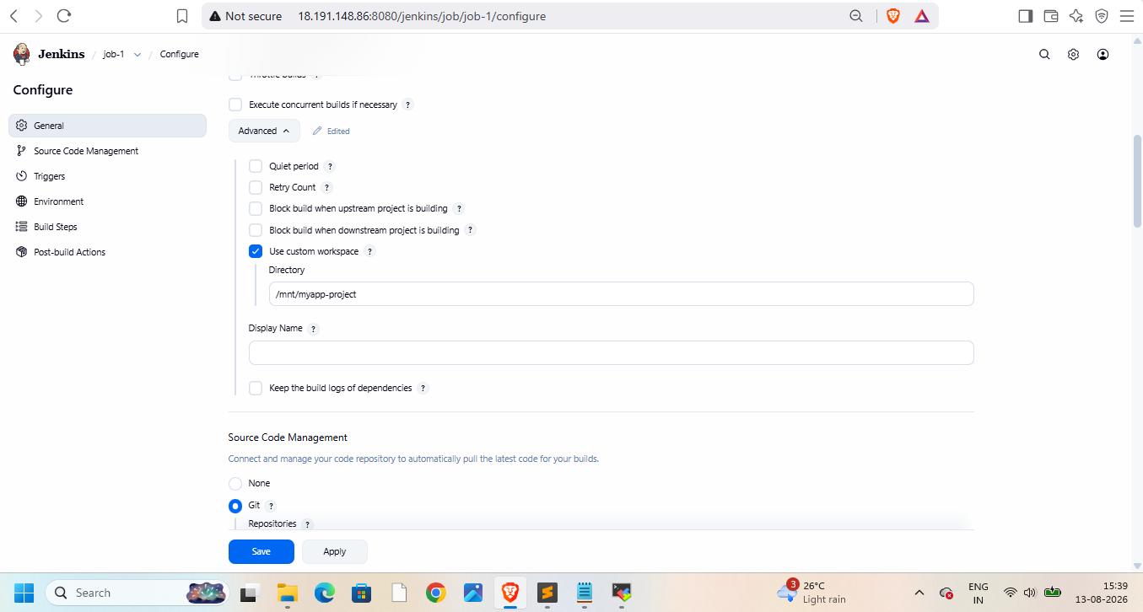
Now clean old workspace
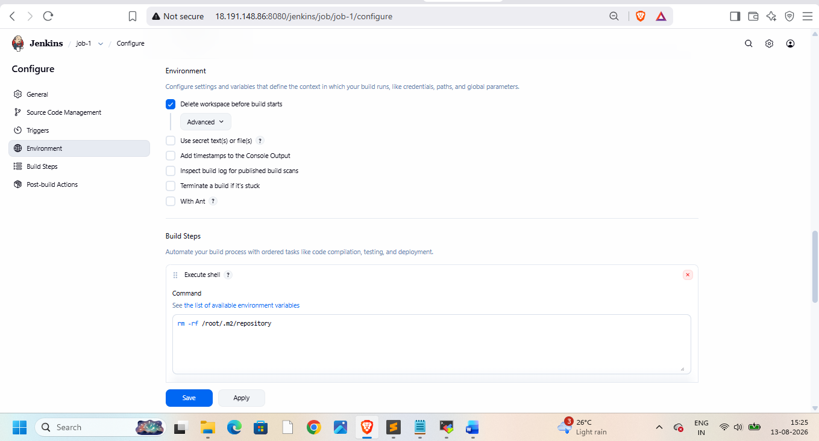
Then mvn clean install
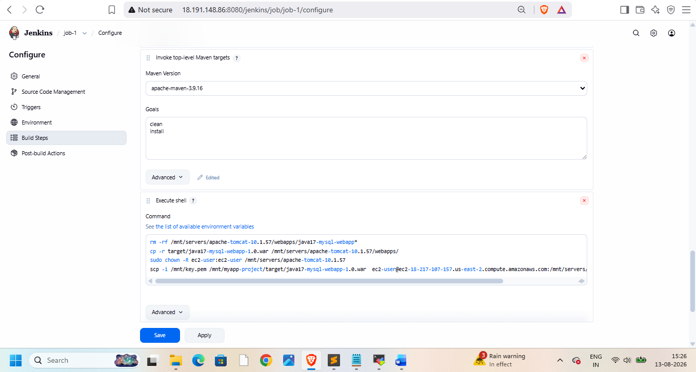
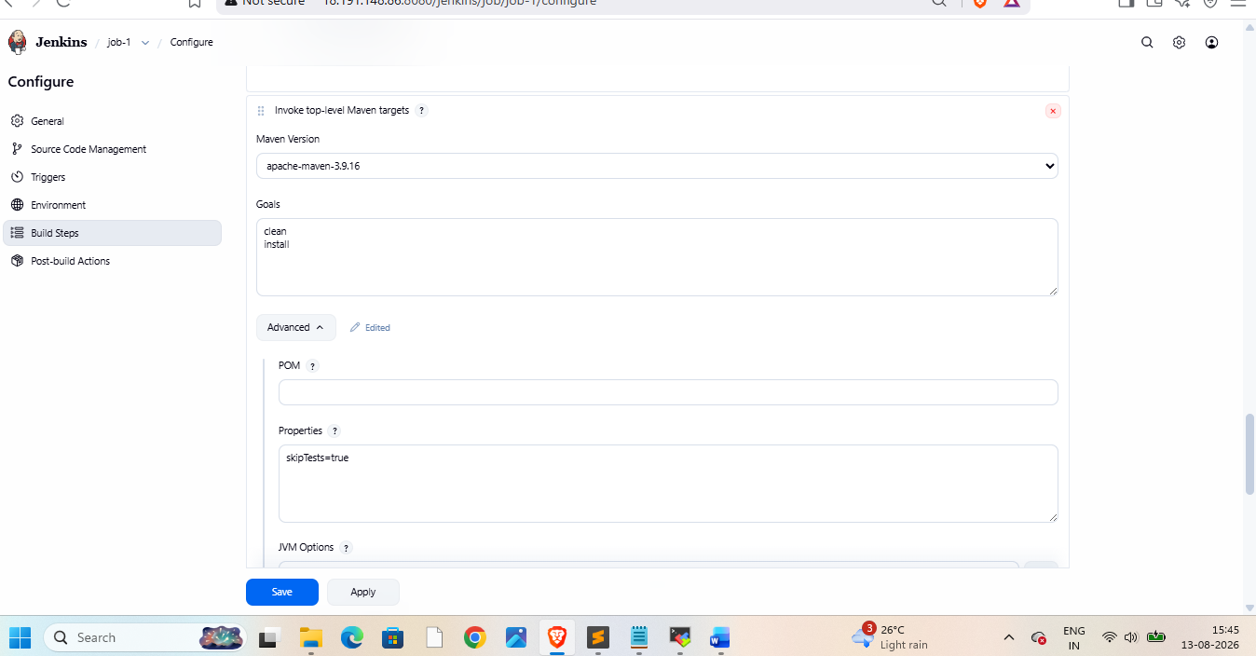

1. Remove the old application
rm -rf /mnt/servers/apache-tomcat-10.1.57/webapps/java17-mysql-webapp*
2. Copy the newly built WAR to Tomcat
cp -r target/java17-mysql-webapp-1.0.war /mnt/servers/apache-tomcat-10.1.57/webapps/
3. This changes the owner and group of the Tomcat directory and everything under it to:
sudo chown -R ec2-user:ec2-user /mnt/servers/apache-tomcat-10.1.57
4. scp copies the WAR to another machine
scp -i /mnt/key.pem /mnt/myapp-project/target/java17-mysql-webapp-1.0.war ec2-user@ec2-18-217-107-157.us-east-2.compute.amazonaws.com:/mnt/servers/apache-tomcat-10.1.57/webapps/
this cmd will copy file from source to destination
then bulid it
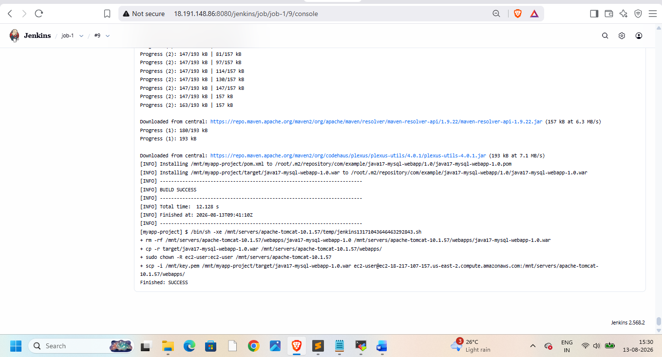

Now check with both matchines ip addresses
