**Curriculum Vitae**

**SAGOR CHOWDHURI**

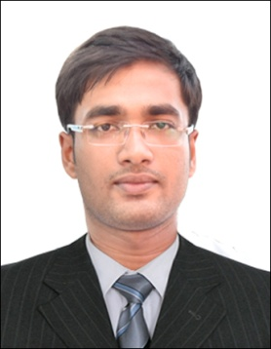

**Permanent Address:** Habra, North 24 Parganas, West Bengal-743271

**Email:** [sagorchowdhuri@gmail.com](mailto:sagorchowdhuri@gmail.com)

**Contact No.:** +91-9742649015

**Career Objective**

To work in a challenging environment using all my skills and efforts to explore different organizational goals and seek an opportunity for continuous learning and growth.

**Professional Experience**

* Company Name : Soinit Technology Solutions Pvt. Ltd.
* Designation : Jr. UI/ UX Designer.
* Period : June 2017 to November 2017
* Location : Kolkata.

**Educational Qualification**

|  |  |  |  |  |  |
| --- | --- | --- | --- | --- | --- |
| No. | Degree | School / University | Stream | DGPA/  Percentage | Year of passing |
| 1. | **B.Tech(MAKAUT)** | JIS College Of Engineering | **Computer Science And Engineering** | **8.27** | 2017 |
| 2. | **Higher Secondary** | Kazdia Higher Secondary School | **Science** | **4.20**  **(Out of 5.00)**  **or above 70%** | 2012 |
| 3. | **Secondary** | Pithabhogh D.G.C. Secondary School, | **Science** | **5.00**  **(Out of 5.00)**  **or above 80%** | 2010 |

**Technical Profile**

* Programming Language : C, Java.
* Web Technologies : HTML, CSS, SQL, JavaScript, J2Ee, AngularJS.
* Mobile Application : Android (B4A).
* Framework : Bootstrap(CSS).
* Application tool : Adobe Photoshop, Adobe Illustrator, Google Sketchup.

**Strengths**

* Excellent Interpersonal skills.
* Ability to work in a team.
* Hardworking.
* Self-confidence and great patience.
* Determinate and disciplined.
* Willing to learn and adapt to new skills**.**

**Personal Details**

**Name :** Sagor Chowdhuri

**Date of birth :** 11stMarch, 1994

**Gender :** Male

**Nationality :** Indian

**Father’s name :** Subol Chowdhuri

**Interest :** Playing Badminton, Watching Movies.

**Languages known :** English, Hindi and Bengali.

**Declaration:**

I hereby declare that the information furnished above is true to the best of my knowledge.

Date: 16.04.2018

Place: Bangalore.

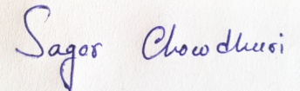

Signature: _______________________