Project Title: Design and Hardware Optimization of an IoT-Based Wearable Health Monitoring Node

1. Abstract & Project Scope
This report details the hardware development of a compact, dual-layer, wearable medical Internet of Things (IoT) node. The system is designed to acquire non-invasive photoplethysmography (PPG) data from a patient, process biometric fluctuations locally, output live telemetry to a modular visual interface, and maintain an ultra-low-power wireless data link for remote clinical monitoring.
The primary engineering focus of this design is the mitigation of parasitic electromagnetic interference (EMI) and the optimization of power networks to ensure medical-grade signal integrity within a highly constrained wearable form factor.
2. Detailed Schematic & Bill of Materials (BOM) Analysis
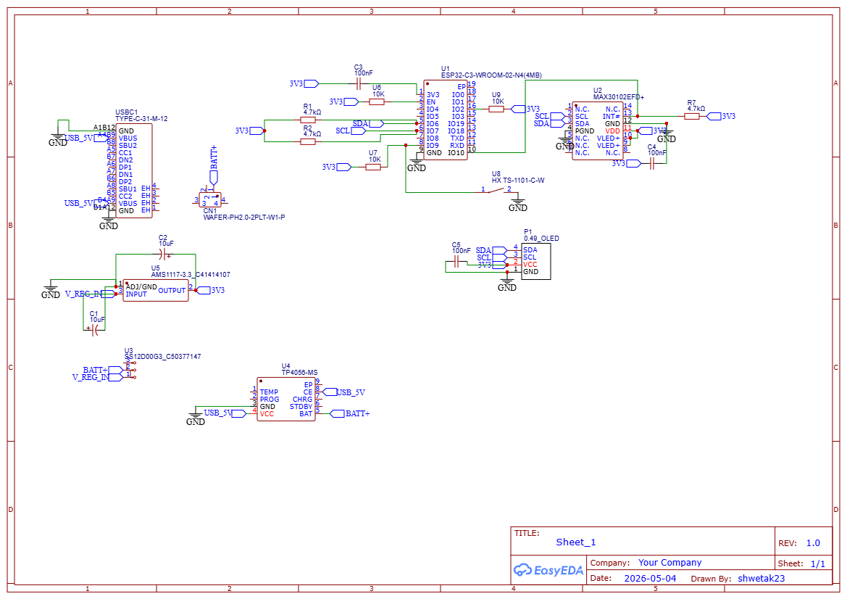

2.1 Power Routing & Battery Subsystem
- USBC1 (TYPE-C-31-M-12): Serves as the primary 5V DC power input boundary for stationary operation or battery recharging cycles.
- U4 (TP4056-MS): A dedicated constant-current/constant-voltage (CC/CV) linear lithium charging management IC that safely handles cycles for an external portable Li-Po battery connected to the BATT+ net.
- U3 (SS12D00G3): A sub-miniature SPDT mechanical slide switch that cuts or connects the physical supply line, serving as the master hardware lock.
- U5 (AMS1117-3.3): A high-current, low-dropout linear voltage regulator that converts raw input voltages down to a fixed 3.3 V rail with an 800mA maximum threshold to drive the system electronics.
2.2 Signal Conditioning & Transient Suppression Network
- C1 & C2 (10uF Polarized Electrolytic): Main reservoir capacitors placed at the entry/exit pins of the U5 regulator. They smooth out low-frequency voltage drops caused by current spikes during wireless transmissions.
- C3 & C4 (100 nf Ceramic Decoupling): Low-ESR bypass capacitors positioned near the power pins of the processor (U1) and sensor (U2). They shunt high-frequency digital noise to the ground plane, preventing data packet corruption.
2.3 Computational & Optical Ingestion Engine
- U1 (ESP32-C3-WROOM-02-N4): A 32-bit RISC-V microcontroller with 4MB of embedded Flash memory. It executes localized calculations and manages the RF wireless transceiver system.
- U2 (MAX30102EFD+): A highly integrated optical biosensor. It pulses red (660nm) and infrared (940 nm) LEDs through capillary beds to measure arterial blood volume fluctuations via its integrated photodiode and 18-bit internal ADC.
- R1 & R2 (4.7 kohm Resistors): Dedicated passive pull-ups tied between the I2C bus lines (SDA, SCL) and the 3.3 V rail, forcing crisp digital square-wave transitions.
- P1 (0.49" OLED Header): A robust 4-pin interface mapped directly to the I2C lines to output real-time vital telemetry to the patient.

3. Operational Mechanics & Signal Flow

Phase 1: Power Conditioning
Upon closing switch U3, current stabilizes across C1 into U5. The clean 3.3V output is scrubbed of high-frequency ripples by the C3 and C4 local decoupling network, providing a stable voltage baseline across all processing and sensor nodes.
Phase 2: Photoplethysmography (PPG) Processing
The U1 processor commands the U2 sensor via the I2C lines. The sensor alternates flashes of its Red and IR LEDs through the skin tissue. As oxygenated and deoxygenated haemoglobin absorb light differently, the reflected light captured by the photodiode yields raw digital waveform data stored in internal FIFO registers.
Phase 3: Dual-Channel Telemetry Routing
The U1 core extracts these packets and executes localized algorithms to calculate heart rate (BPM) via pulse-peak intervals and Blood Oxygen saturation (SpO2) using a Ratio-of-Ratios conversion method:


The resulting values are split simultaneously: routed through the I2C bus to the P1 display, and translated into high-frequency 2.4GHz signals routed through the built-in microstrip trace antenna to a local gateway and cloud server.

4. Physical PCB Layout & Signal Integrity Strategies

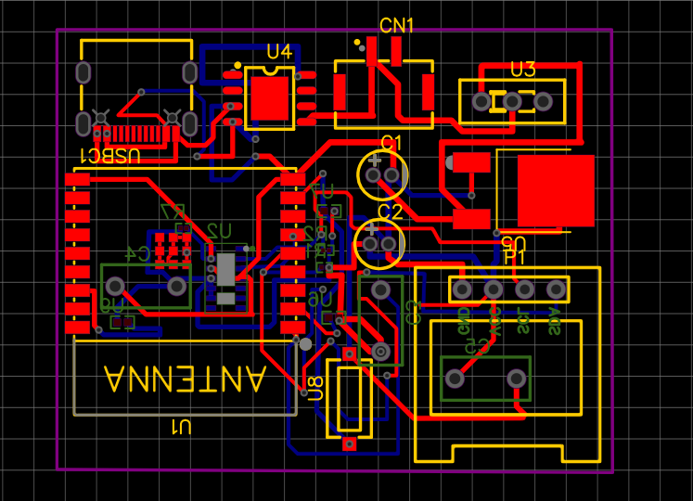
Fig(a) : Top layer of PCB
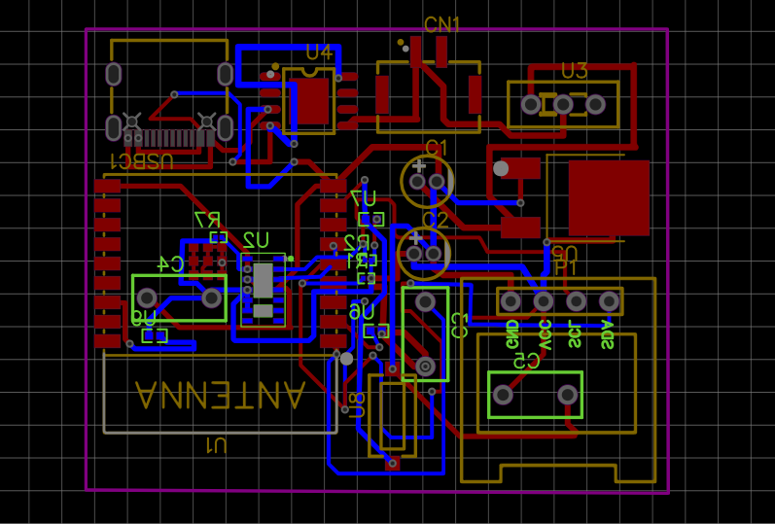
Fig (b): Bottom layer of PCB
Achieving a 0 Design Rule Check (DRC) error status required solving layout challenges using specialized trace geometries and layer stacking rules:
4.1 Layer Separation & Impedance Control
- Top Layer (Red Core): Reserved for primary surface-mount component footprints and heavy power tracks (V_REG_IN, 3V3). Power tracks were designed with increased width to minimize track resistance and current attenuation.
- Bottom Layer (Blue Core): Utilized as an operational underpass. When high-speed data traces (SDA, SCL) intersected power loops on the top layer, plated through-hole vias were added to safely route the traces on the bottom layer, eliminating cross-net short circuits.
4.2 Ground Plane Isolation & RF Shielding
Both layers were flooded with a solid polygon copper pour tied directly to the GND net. This dual-plane strategy satisfies three strict engineering constraints:
- Low-Impedance Return Paths: It creates an instantaneous ground path beneath signal traces, preventing voltage drift.
- Thermal Dissipation: The copper flood wraps around the heat sink tab of the U5 regulator, radiating excess heat away from the patient's skin.
- EMI Shielding: The ground plane acts as a physical shield around the sensitive SDA and SCL lines, absorbing radio waves from the adjacent antenna and preventing noise from corrupting the biometric sensor data.

5. Manufacturing Verification & Conclusion
The final layout design file was verified against strict standard fabrication rules (including clearances, track-to-pad constraints, and minimum via sizes). The design achieved a 0 DRC error status, confirming it is fully optimized, completely isolated from parasitic noise, and ready for physical manufacturing and deployment in telehealth sensing systems.

