TECHNICAL SPECIFICATION
Data Alchemist
Solution Architecture & Technical Specification — Agentic Data Quality & Trust Platform

Prepared for SCALEX Pursuit 2026 — Supporting Artefact | Editable working copy (Word)

Table of Contents
- 1. Executive Summary
- 2. System Architecture Diagram
- 3. Layer-by-Layer Component Description
- 4. Data Model — Entity-Relationship Overview
- 5. Technology Stack
- 6. Security & Compliance Posture

1. Executive Summary
Data Alchemist is an agentic data quality and trust platform built on a five-layer architecture: a browser-transpiled React SPA, a FastAPI application layer, an intelligence layer combining one LangGraph multi-step agent with three governed LLM-service modules, a connector abstraction layer supporting five database platforms, and a PostgreSQL metadata store spanning 36 versioned schema migrations.
The platform's central design decision is strict separation between AI-assisted authoring and deterministic execution: profiling, rule recommendation, and anomaly/failure explanation use an LLM (via a swappable LiteLLM gateway); rule execution and scoring are pure, deterministic SQL with no LLM involvement. Every AI output is either structurally validated before a human sees it, or requires explicit human approval before it changes system state.
Verified footprint at time of writing: 11 frontend screens · 12 API routers · 94 REST endpoints · 5 live database connectors · 4 backend agent/service modules · 36 PostgreSQL schema migrations · 30 database tables.

2. System Architecture Diagram
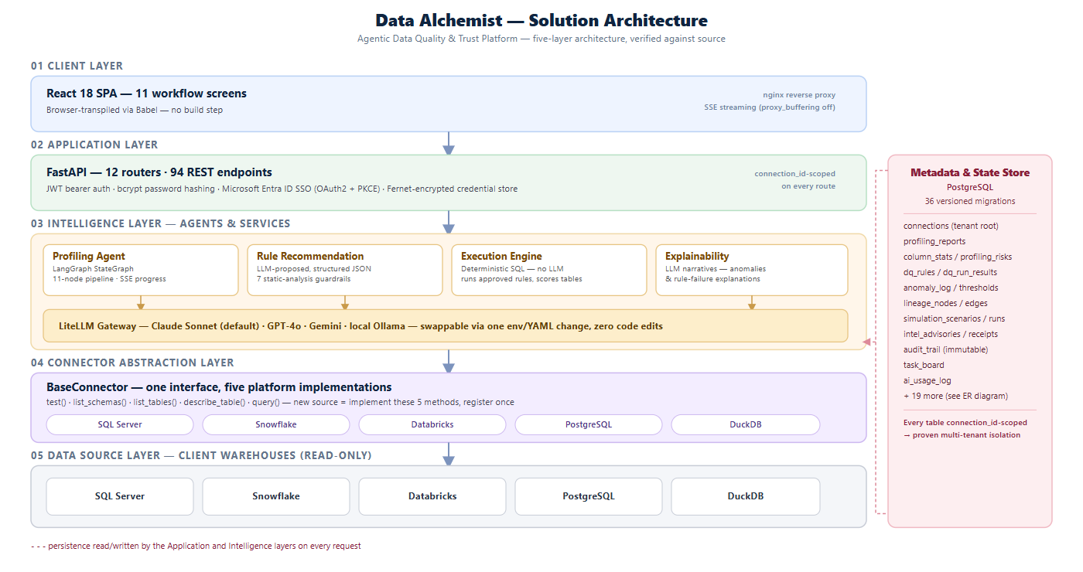

3. Layer-by-Layer Component Description

01 · Client Layer — React 18 SPA
11 workflow screens (Profiling, Rules, Execution, Anomalies, Dashboard, Lineage/Impact, Simulator, Intel, Metadata, Connections, Tasks), transpiled in-browser via Babel — there is no frontend build step. Served through an nginx reverse proxy configured with proxy_buffering off to support real-time Server-Sent Events for long-running agent operations.

02 · Application Layer — FastAPI
12 API routers exposing 94 REST endpoints. Authentication supports two paths simultaneously: local email/password (bcrypt-hashed, JWT bearer tokens) and Microsoft Entra ID SSO (OAuth2 Authorization Code + PKCE). Every table in the metadata store — with one deliberate exception (the shared simulation-scenario library) — carries a connection_id foreign key.

03 · Intelligence Layer — Agents & Services
- Profiling Agent — the only true LangGraph StateGraph in the codebase: an 11-node pipeline (fetch_schema → compute_null_stats → compute_distinct → check_referential_integrity → check_key_duplicates → compute_formats → compute_numerics → detect_duplicates → score_table → identify_risks → generate_summary).
- Rule Recommendation — LLM-proposed rules in structured JSON, validated by 7 deterministic static-analysis checks before reaching a human reviewer.
- Execution Engine — deliberately contains no LLM call; runs already-approved rules as parameterized SQL.
- Explainability — converts technical anomaly and rule-failure records into plain-English narratives via LLM, logged to the AI usage ledger.
LiteLLM Gateway: every LLM call routes through one abstraction layer. The active model (Claude Sonnet by default) is swapped for GPT-4o, Gemini, or a local Ollama model via a single environment variable — zero code changes at any call site.

04 · Connector Abstraction Layer
A single BaseConnector interface (test · list_schemas · list_tables · describe_table · query) with five concrete implementations: SQL Server, Snowflake, Databricks, PostgreSQL, DuckDB.

05 · Data Source Layer
Client warehouses are accessed read-only through the connector layer; credentials are Fernet-encrypted before they ever reach the metadata store.

4. Data Model — Entity-Relationship Overview
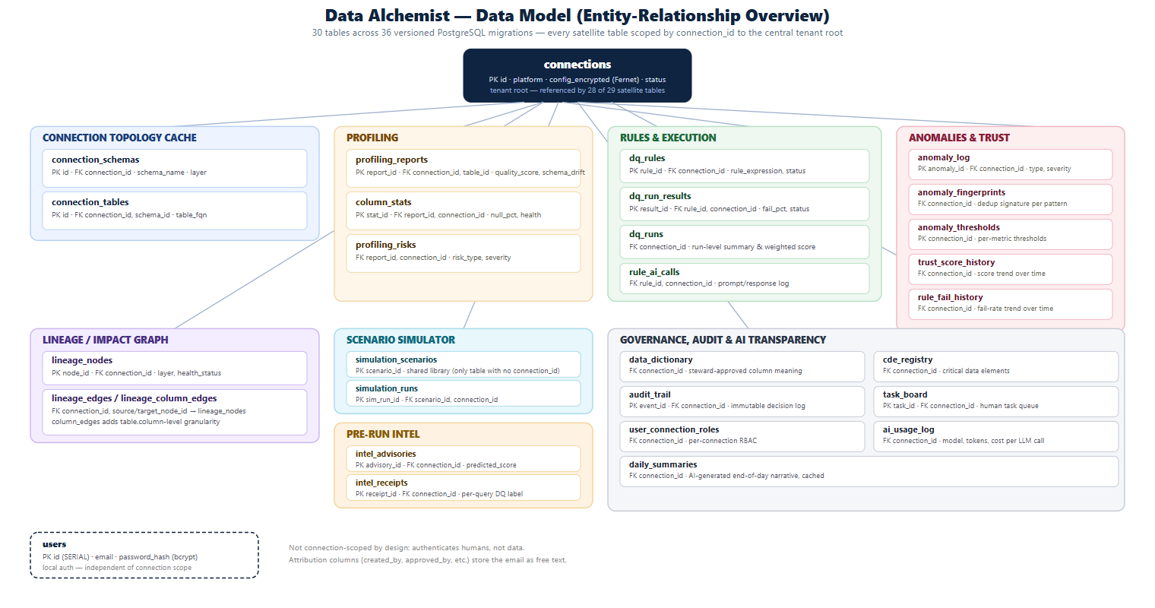
Full column-level detail for every table is available in the migration files (backend/db/schemas/*.sql, 36 files, numbered and auto-applied at startup).

5. Technology Stack
Layer | Technology | Notes
Frontend | React 18 + Babel (in-browser) | No bundler/build step
Reverse proxy | nginx | proxy_buffering off for SSE streaming
Backend framework | Python 3.11 · FastAPI | 12 routers, 94 endpoints, OpenAPI/Swagger auto-generated
Agent orchestration | LangGraph | StateGraph used for the Profiling Agent’s 11-node pipeline
LLM abstraction | LiteLLM | Anthropic, OpenAI, Azure OpenAI, Gemini, Ollama
Metadata database | PostgreSQL | 36 versioned migrations, auto-applied at startup
Auth | bcrypt + JWT · Microsoft Entra ID (OAuth2/PKCE) | Both paths supported simultaneously
Credential storage | Fernet symmetric encryption | Encrypted at rest, decrypted only in-process
Containerization | Docker Compose | postgres · backend · frontend services
Connectors | SQL Server, Snowflake, Databricks, PostgreSQL, DuckDB | Common BaseConnector interface

6. Security & Compliance Posture
- Credentials: Fernet-encrypted at rest; never returned by any API response or written to logs.
- Authentication: bcrypt password hashing, JWT bearer tokens, and Microsoft Entra ID SSO (OAuth2 + PKCE).
- Tenant isolation: 28 of 29 satellite tables carry a connection_id foreign key.
- Auditability: an immutable audit_trail table records every human decision with old/new value snapshots.
- AI governance: every LLM call is logged to ai_usage_log; LLM-proposed rules pass 7 static-analysis checks.
- Data minimization: connectors read schema metadata and bounded samples; no bulk-export path off the platform.

