electron app Packaging by using Command

npm install electron-packager

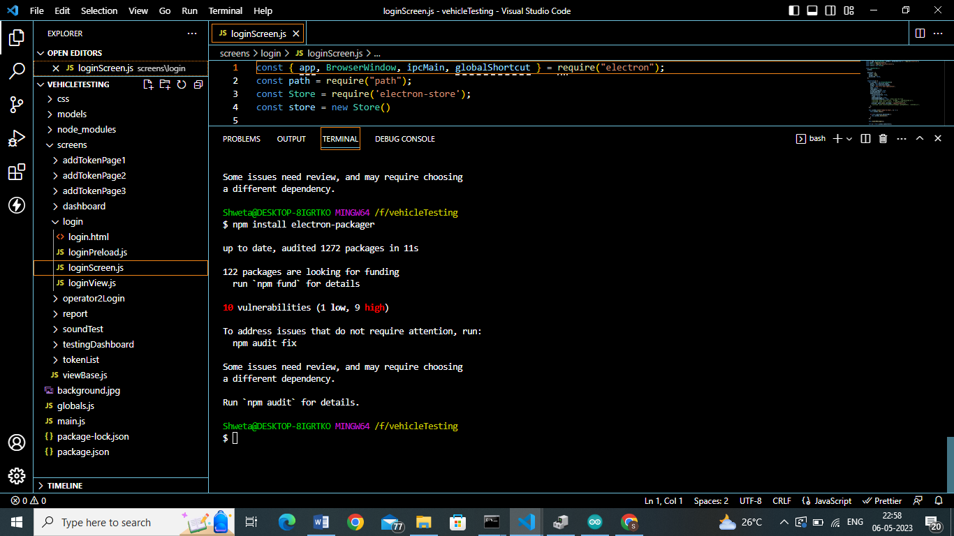

After this fix some issue using command

npm audit fix

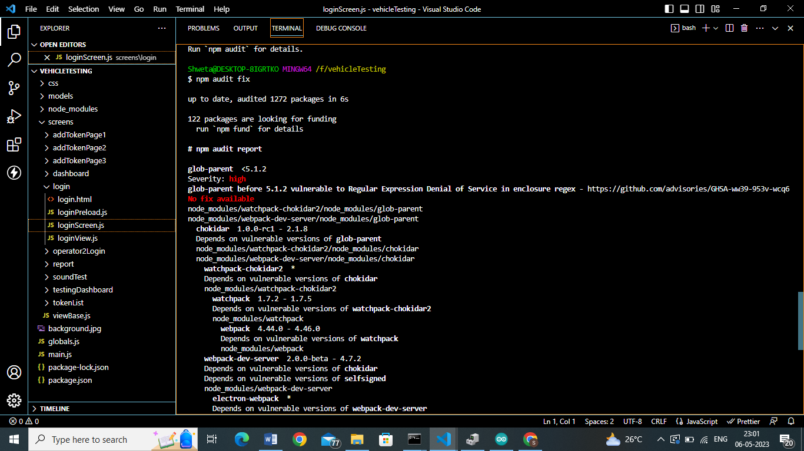

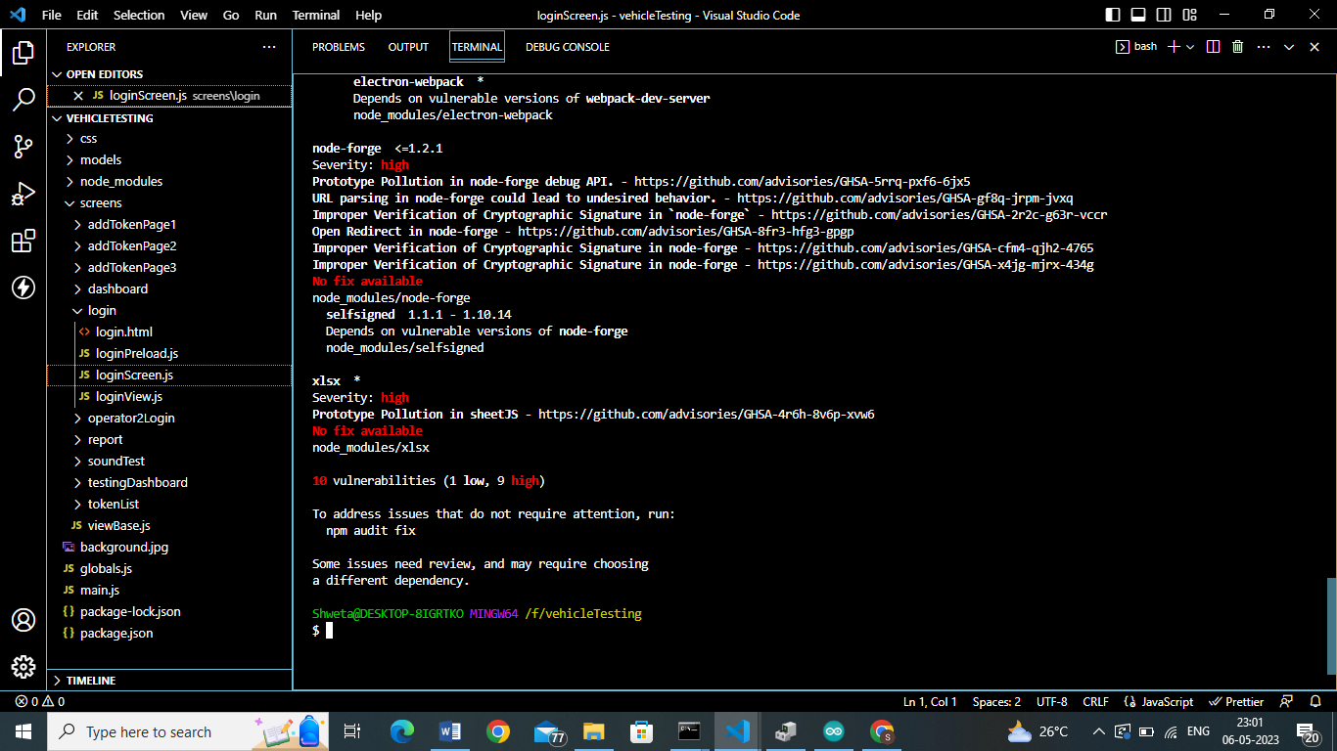

After Running Below Command

electron-packager F:\vehicleTesting vehicleTesting --platform=win32 --arch=x64

error:-

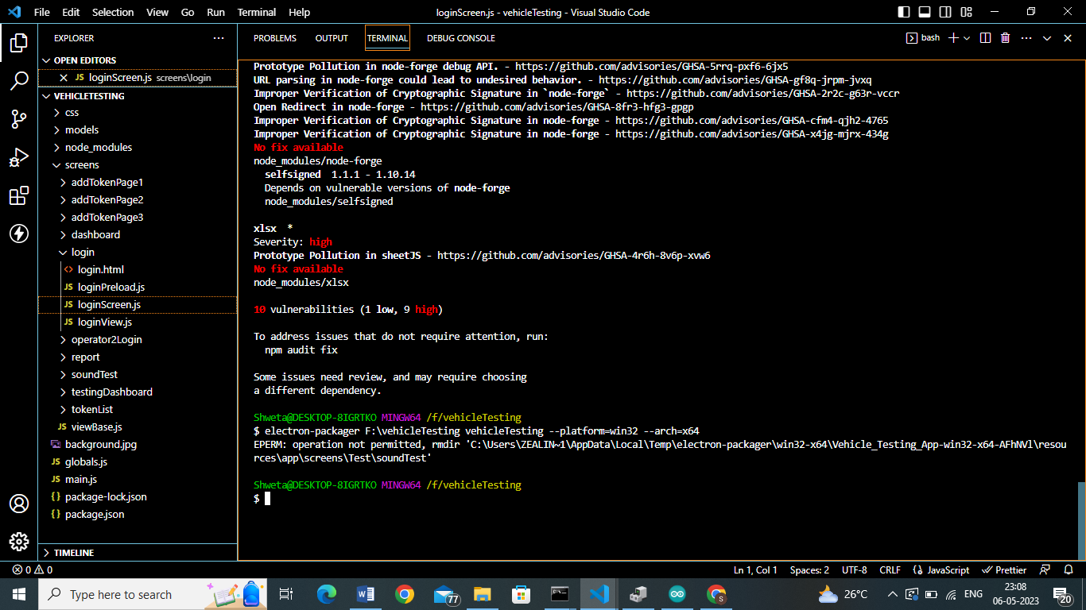

May be there is error in soundtest folder where we open the soundLevel Meter exe.

How to solve this error?