**PROJECT REPORT**

SUBMITED TO

**DEPARTMENT OF COMPUTER SCIENCE**



**VES COLLEGE OF ARTS, SCIENCE AND COMMERCE**

**SINDHI SOCIETY, CHEMBUR MUMBAI -400 071.**

**Android based Real-Time Smart Attendance System**

*For Partial Fulfilment for Degree of*

**Bachelor of Science (Computer Science)**

**Academic Year 2020-21**

HEAD OF DEPARTMENT COLLEGE GUIDE

**Mr. Kamlakar Bhopatkar Mr. Kamlakar Bhopatkar**

**Dr. Madhavi Vaidya**

SUBMITTED BY

**--------<<Shweta Sharad Katkar>>--------**

**INDEX**

|  |  |  |
| --- | --- | --- |
| **SR. NO.** | **TOPIC** | **PAGE NO.** |
| 1. | Organizational overview | 1 |
| 2. | Description of System | 1 |
| 3. | Limitations of present system | 2 |
| 4. | Proposed system | 3 |
|  | Advantages of proposed system | 5 |
| 5. | Technologies Used | 5 |
| 6. | Use case Diagram and Basic Scenarios & Use Case Description | 6 |
| 7. | Class Diagram | 8 |
| 8. | Activity Diagram | 9 |
| 9. | Database Diagram | 10 |
| 10. | Test Cases, Test Data and Test Results | 11 |

# **ACKNOWLEDGEMENT**

## I have great pleasure in presenting this project entitled **“Android based Real-Time Smart Attendance System”** and I grab this opportunity to convey my immense regards towards all the people who with their invaluable contributions made this project successful.

#### It gives me great pleasure in presenting this project report. Its justification will never complete if I don’t express my vote of thanks to our **V.E.S. College** and Principal **Dr. Anita Kanwar.**

I sincerely thank and express my profound gratitude to our Project Guide -**Dr. Madhavi Vaidya** and **Mr. Kamlakar Bhopatkar** for timely and prestigious guidance required for the project completion at each phase of the project development.

I also owe to my **friends** who have been a constant source of help to solve the problems that cropped up during the development of the project, positive criticism, suggestions, constant support, encouragement and guidance force towards the successful completion of the project.

# **Project Report**

## **Android-based Real-Time Smart Attendance System**

### **ORGANISATIONAL OVERVIEW:**

All organizations whether commercial or educational like schools, colleges, or private coaching classes need to maintain a proper record of the attendance of its employees or students for effective functioning, planning, and management of the organization. In developing countries, a minimum percentage of class attendance is required in most institutions. Any educational organization can use this app for attendance management.

### **DESCRIPTION OF PRESENT SYSTEM:**

The current attendance system in most of the educational institutions is paper-based, wherein the students are expected to sign an attendance sheet just next to their names and in most of the schools, attendance is usually taken using paper sheets and the old file system approach by calling students names. This system has several disadvantages

The existing system largely consists of a physical register where the supervisor manually inputs the attendance record of all students. Also, the report is analysed or generated manually or using MS-Excel.

Other technologies that have been developed to replace this manual system include Fingerprint, Retina scan, Voice recognition, Barcode readers, Radio Frequency Identification (RFID) system, etc.

### **LIMITATIONS OF THE PRESENT SYSTEM:**

Human effort is more in the present system. This system has Many disadvantages. Following are some limitations of the present system:

* **Time-consuming:** if a large group of students attends the lectures, checking and authenticating these students usually takes several minutes out of the lecture period and always reduces the topic coverage every other time.
* **Risk of error:** The students can mark attendance or scan the ID of their fellow classmates without being caught. Also, sometimes teachers may enter wrong inputs. Sometimes students lose or forget their Id at home so they miss their attendance since they didn’t scan their Id.
* **Slow retrieval of data**: The records are maintained in the handwritten registers and so takes a long time to find particular information
* **Manual control:** All calculations to generate reports are done manually so there is a greater chance of errors.
* **Difficulty in report generating:** We require more calculations to generate the report so it is generated at the end of the year or semester. And the student did not get a single chance to improve their attendance
* **Inconsistency of data**: Data might easily get misplaced. So, data won’t be preserved for future use.
* **Expensive technologies:** There are few advanced technologies that have replaced manual system work but these technologies are very expensive to implement. therefore, they had limited use.

Hence, a system that does not require a special infrastructure is developed using QR Code Scanning or Biometric Facial Detection and Recognition system – Smart Attendance Management.

### **PROPOSED SYSTEM:**

To overcome the drawbacks of the existing system, the proposed system has been evolved. This project aims to reduce the paperwork and save time to take attendance and generate accurate results from the student’s attendance.

The proposed system includes the following modules:

* Administrator/Teacher registration, student/parent registration.
* Attendance Management System
* QR code scanning
* Face detection and Recognition (Optional)
* Report generation.
* Notice Board for students

Working of the system is as follow:

1. The administrator has to register in a system providing information like Email Id, Organisation name, etc. Administrators can create classes and add subjects and teachers. Administrators can also add student’s data such as Name, Mobile no. Email id, Photo, etc. for each class.

Teachers can register under an administrator using the administrator’s name only if their data is added by the administrator. Students can also create account in system under respective admin using administrator’s name.

Administrators and Teachers can take attendance using two methods. Before taking attendance, teachers have to select the subject, lecture-type, and lecture time.

1. **QR Code Scanning:**

The system will generate an ID card with a QR code for each student. Students can also print their Id card. So that if mobile is not available or if students have some issues with their mobile, they can show their printed ID card while scanning for attendance. Teachers can take attendance by scanning QR codes of student’s Id cards.

1. **Face detection and Recognition**:

Attendance will be taken by capturing pictures of groups of students using mobile. Each face in the picture will be verified and information of the student will be displayed on the face if the face is verified and also attendance will be updated. For more accuracy students can update their profile by adding their 2-3 pictures.

1. Students can keep track of daily attendance. Reports will be generated on a weekly or monthly basis for students.
2. Teachers can send digital notices to all or selected students on the app and students can read that notice.

I am using Android Studio with Java programming language for developing this project with a backend as Firebase to store data centrally

### **ADVANTAGES OF PROPOSED SYSTEM:**

The system provides the best user interface. This app will reduce manual work and avoid redundant data. There are several advantages of the proposed system over the current system. They are as follows:

* User-friendly design
* It is a relatively fast approach to enter attendance
* Automatic updating
* Eliminate manual paperwork
* Eliminate attendance by proxy and data forging
* Highly reliable and trouble-free to use.
* Efficient and fast auto-generation of attendance report.
* Real-time data availability.
* Saves Time and cost.
* Easy access for students because they can view their attendance and make up for the shortage of attendance accordingly.

### **TECHNOLOGIES USED:**

#### **Android studio:**

Android Studio is Android's official IDE. It is purpose-built for Android to accelerate your development and help you build the highest-quality apps for every Android device.

#### **Firebase:**

Firebase is a mobile and web application development platform developed by Firebase and then acquired by Google.

Firebase provides developers with a plethora of tools and services to help them develop high-quality apps. Firebase gives you functionality like analytics, databases, messaging, and crash reporting. Firebase provides a real-time database and backend as a service. The service provides application developers an API that allows application data to be synchronized across clients and stored on Firebase's cloud.

### **BASIC SCENARIO**

* Register
* Log in
* Add new teacher
* Add a new class
* Add new subjects
* Set attendance criteria
* Add student’s data
* Take attendance
* Update attendance
* View attendance
* Backup attendance
* View profile
* Update profile
* Print ID card
* View attendance report
* Send Notice
* View Noticeboard
* Submit Feedback
* View Feedback

### **USE CASE DIAGRAM:**

### **CLASS DIAGRAM**

### **ACTIVITY DIAGRAM**

### **FIREBASE TREE DIAGRAM**

**AdMIN**

N

N

N

Name

Total Students

Total Subjects

Total Teachers

Class Info

FullName

EmailId

Mobile Number

BirthDate

Student Info

FullName

EmailId

Mobile Number

BirthDate

Teacher Info

1

1

1

Teachers

Classes

Students

FullName

EmailId

Mobile Number

BirthDate

**TEST CASES, TEST DATA AND RESULTS**

|  |  |  |  |  |  |  |  |  |
| --- | --- | --- | --- | --- | --- | --- | --- | --- |
| **Test**  **Case**  **ID** | **Module**  **/Sub**  **Module Name** | **Form Name** | **Test Condition** | **Steps/**  **procedure** | **Input**  **Test**  **data** | **Expected**  **output** | **Actual**  **Output** | **Pass/**  **Fail** |
| T01 | Login | Login | To check  login window with valid input | 1)Click on login button with blank Email & password |  | It should display message “Email and Password is required” | It displays message “Email and Password is required” | Pass |
| T02 | Login | Login |  | 2)Enter only Email with blank password  & click on login button | smartAttenfance@gmail.com | It should display message “Password is required” | It displays message  “Password is required” | Pass |
| T03 | Login | Login |  | 3)Enter only Password with blank Email id  & click on login button | Password : abcd | It should display message “Email Id is required” | It displays message  “Email Id is required” | Pass |
| T04 | Login | Login |  | 4)Enter correct User Name and wrong Password  & click on login | User  Name  Password : | It should display message “Invalid Email id or Password” | It displays message  “Invalid Email Id or Password” | Pass |

|  |  |  |  |  |  |  |  |  |
| --- | --- | --- | --- | --- | --- | --- | --- | --- |
| **Test**  **Case**  **ID** | **Module**  **/Sub**  **Module Name** | **Form Name** | **Test Condition** | **Steps/**  **procedure** | **Input**  **Test**  **data** | **Expected**  **output** | **Actual**  **Output** | **Pass/**  **Fail** |
| T05 | Login | Login |  | 5)Enter invalid Email Id and Password  & click on login button | [smartAttend](mailto:smartAttendance@gmail.com)  abcdabcd | It should display message  “Provide valid Email Id” | It displays message  “Provide valid Email Id” | Pass |
| T06 | Login/Student | Login |  | 5)Enter Email Id and Password and select wrong UserType  & click on login button | [smartAttend](mailto:smartAttendance@gmail.com)@gmail.com  abcdabcd | It should display message  “Please select valid user type” | It displays message  “Please select valid user type” | Pass |
| T07 | Login | Login |  | 5)Enter correct Email Id and Password  & click on login button | [smartAttendance@gmail.com](mailto:smartAttendance@gmail.com)  abcdabcd | It should display message  “Logged In successfully” | It displays message  “Logged In successfully” | Pass |
| T08 | Sign Up | Sign Up | To Check Sign up window | Click on Sign Up button with blank Fields |  | It should display all Fields are required ony by one. | It displays all fields are required on by one. | pass |
| T09 | Sign Up | Sign Up |  | Enter wrong/ Invalid Email Id | Xyz.com | It should display Enter valid Email Id | It displays Enter valid Email Id. | pass |
| T10 | Sign Up | Sign Up |  | Enter wrong/ Invalid Mobile Number | 12345 | It should display Enter valid Mobile Number | It displays Enter valid Mobile Number. | pass |
| T11 | Sign Up | Sign Up |  | Enter password less than 6 characters. | abcd | It should display password should be greater than 6 characters. | It displays Password should be greater than 6 characters. | pass |
| T12 | Sign Up | Sign Up |  | Enter different values in password and confirm password | Abcdabcd  abcdefgh | It should display Password doesn’t match | It displays Password doesn’t match. | pass |
| T13 | Sign Up | Sign Up |  | Enter Admin Id which doesn’t exists | Admin | It should display Admin name doesn’t exists | It displays Admin name doesn’t exists. | pass |
| T14 | Sign Up/Student | Sign Up |  | Enter Student Name which is not added by admin. | Stud name | It should display Student name doesn’t exist. Please contact your admin. | It displays Admin Student name doesn’t exist. Please contact your admin. | pass |
| T15 | Forget Password | ForgetPassword | Check ForgetPassword window | Enter black email id |  | It should display email id is required | It displays email id is required | Pass |
| T16 | Forget Password | ForgetPassword |  | Enter Invalid email id | Xyx.com | It should display enter valid email id | It displays enter valid email id | Pass |
| T17 | Forget Password | ForgetPassword |  | Enter email id which doesn’t exists | xy@gm.cm | It should display failed to send reset link | It displays failed to send reset link | pass |

### **SCREENSHOTS**

1. Splash Screen

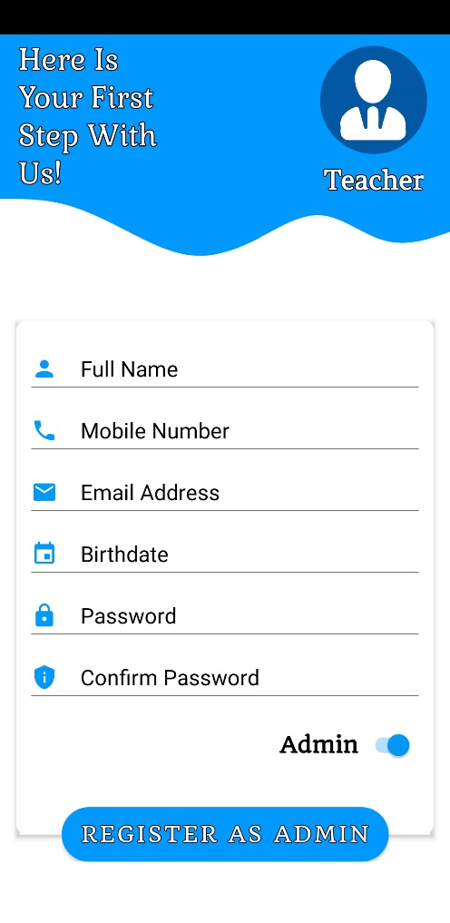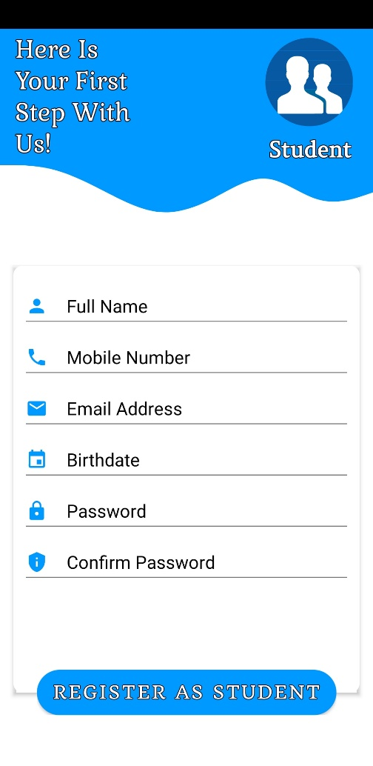2. Sign Up Module

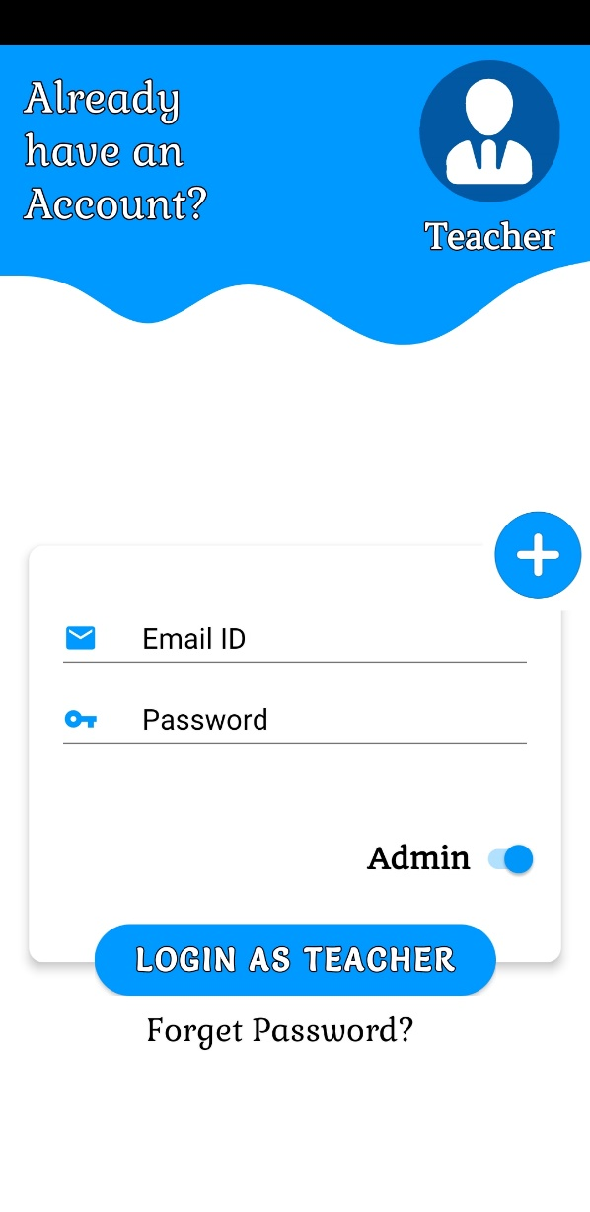3. Login Module

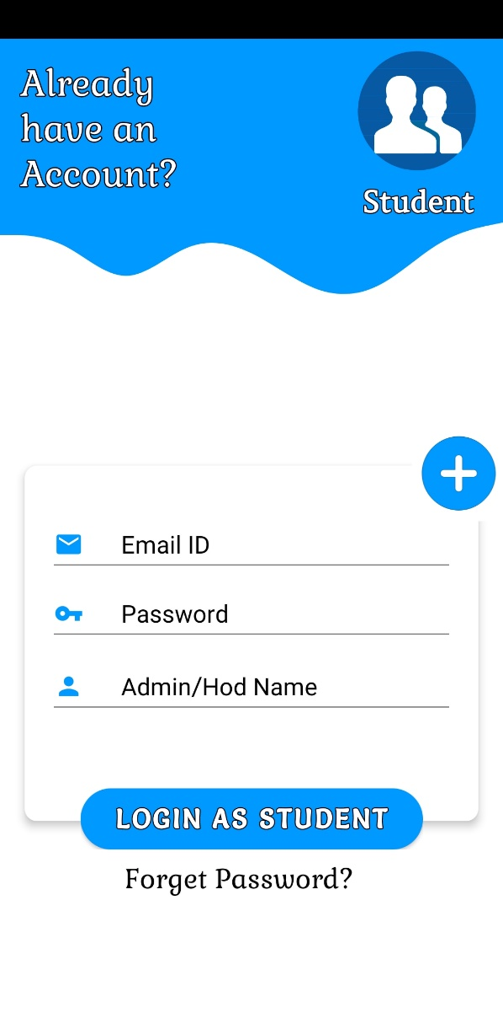

3. Forget Password :

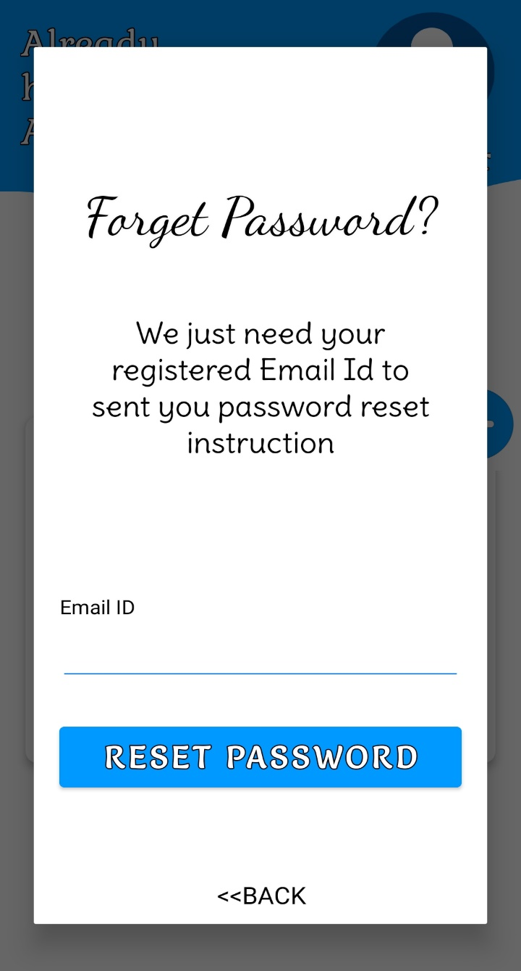

5. Admin Module:

