Deploy Your flask backend and express frontend in amazon single ec2 instance.

EC2 Instance Running
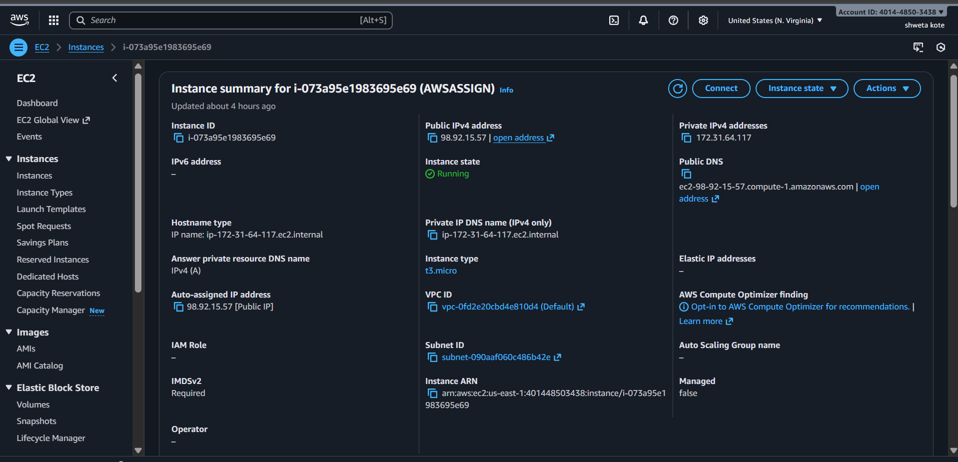

2. EC2 Security Group (Inbound Rules)
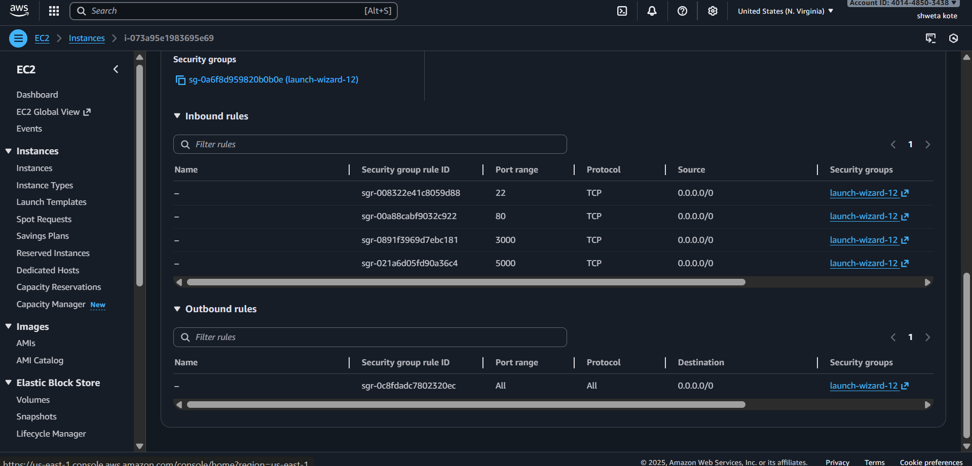

3. EC2 CONNECTION
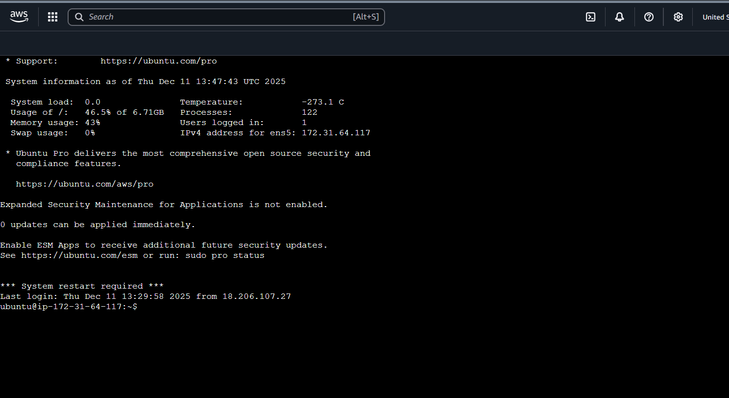

4. Package Installation Screenshot

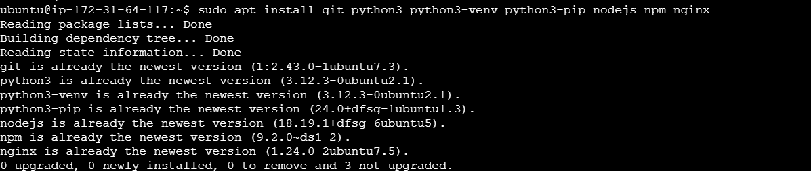5. Cloned Repositories in /opt

6. Flask Backend Running (systemctl status flask)
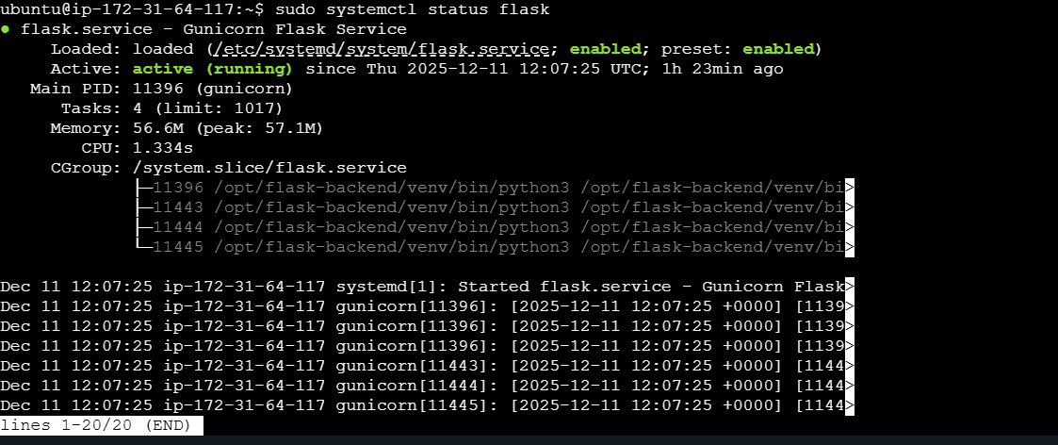

7. Express Frontend Running (pm2 status)
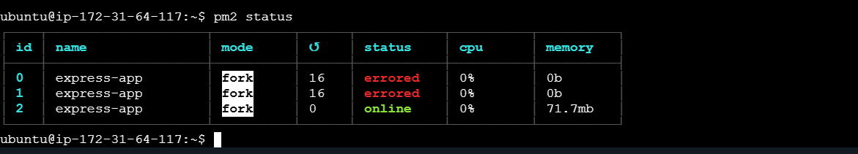

8. Nginx Configuration File (/etc/nginx/sites-available/fullstack)
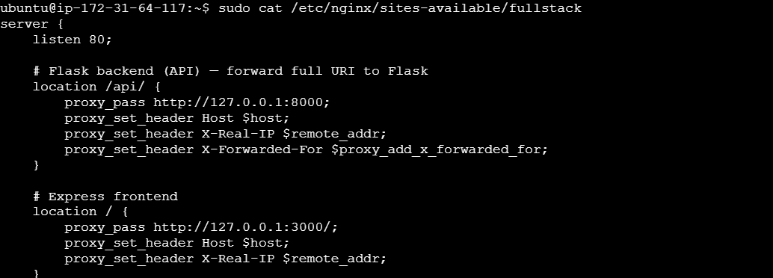

9. API Local Test (curl 127.0.0.1/api/health)

10. Frontend Local Test (curl 127.0.0.1/)
