**Ally bedside assistant:-**

**To create SNS topic** go to the dxc amazon account and then services, type sns then create topics and then give topic name then copy the arn and to subscribe it go to subscription then select the topic and then give arn then protocols as sms and then give your mobile number with country code.

Errors:-

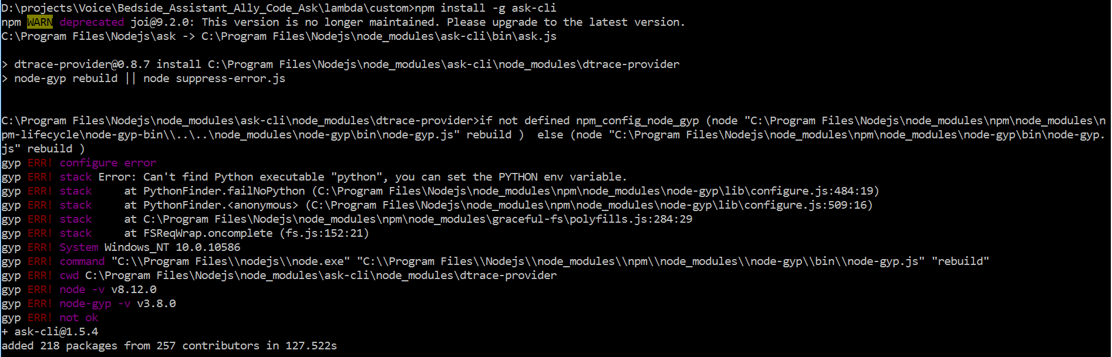

Admin rights error:-

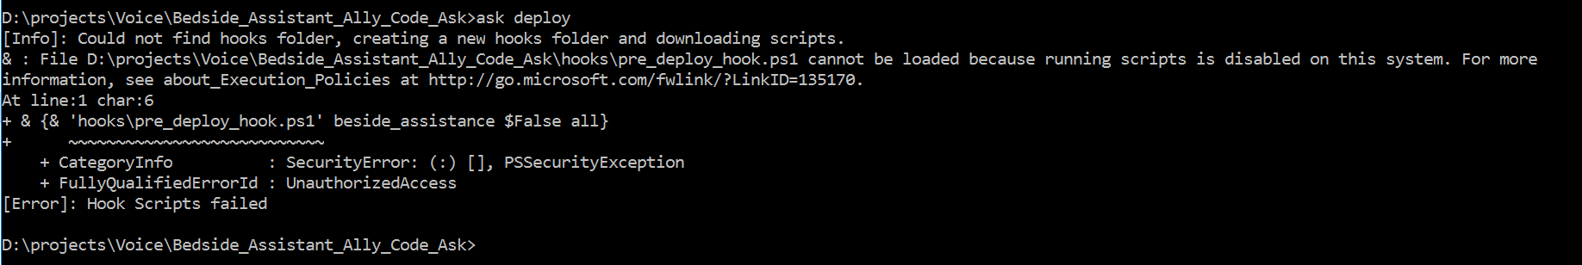

Lambda function is serverless function. Code that we run in amazon is called lambda funtion. We have to upload the code by zipping it and then upload.

An *intent* represents an action that fulfills a user's spoken request.

Intents can optionally have arguments called *slots*.

The *sample utterances* are set of likely spoken phrases mapped to the intents. Invocation name is name to invoke or trigger the lambda function.

While uploading file in lambda function take a proper care while uploadinf. Upload the zip combination of index, node modulus and package.json. zip it by using send to zipped folder.

To create lambda function, click on

Create lambda function,

Select middle template,

Give name for lambda function,

Then role should be exec lambda role

If you are changing lambda function for same skill, then go to developer amazon account then go to your skill then build then give endpoints ie uri link is your lambda function arn that is in your right of the lambda function screen.

Create lambda function from dxctechlabs and to test build of bot can be done from developer amazon account.

Try this line in line 15 for index.js file that deals with region of the amazon

AWS.config.update({region:'us-west-2'});

Install npm, chai and mocha virtual device sdk, virtual alexa

To create virtual device sdk and create token

To install bespoken in project add : npm install bespoken-tools -g

To install virtual device in project

**npm install virtual-device-sdk –save**

**Token for virtual device:- alexa-9a2982bf-259e-4365-8881-4ee1ac696dd1**

**alexa-cbf937a8-4f63-495d-b563-e2dda0fd6c85**

**What are Virtual Devices?**  
A full-featured automation voice-app platform – one that ensures your skill or action is always working.

**Who Needs Virtual Devices?**  
If you want complete assurance your voice app is working, you need a Virtual Device.

**How to Get a Virtual Device**  
You will get a Virtual Device with your Bespoken account. [**Log in**](https://apps.bespoken.io/dashboard/login) or [**create a new account**](https://apps.bespoken.io/dashboard/login), get a token, install the Virtual Device SDK. For help setting up your device, chat with us in the lower right-hand corner.

**What else do Virtual Devices do?**

* Provides an intuitive, natural way to unit test Alexa skills programmatically – as if you were speaking to the device
* Gives you a simpler interface for startup and teardown of tests

**In order to test your Alexa skills and Google Actions, you need to create a Virtual Device. What is a Virtual Device? It is like a physical Amazon Echo, but one that can be interacted with programmatically.**

**We’ll create a trial Virtual Device for you, the only thing we need you to do is to grant us to access to your Amazon Alexa or Google Assistant account. Once completed, you will have a token, which uniquely identifies the Virtual Device, that you can use in your tests.**

**There a couple steps for the setup - but don’t worry - you will only have to do it once. And if you run into any issues, just**[**ping us here**](https://gitter.im/bespoken/bst)**. We’ll get it sorted out quickly!**

[**#**](https://read.bespoken.io/end-to-end/setup/#creating-a-virtual-device)**Creating A Virtual Device**

[**#**](https://read.bespoken.io/end-to-end/setup/#virtual-devices-for-alexa)**Virtual Devices for Alexa**

1. **The way to get a token is through**[**Bespoken Dashboard**](https://apps.bespoken.io/dashboard)**. Sign up for free or login; you will see a screen like this: 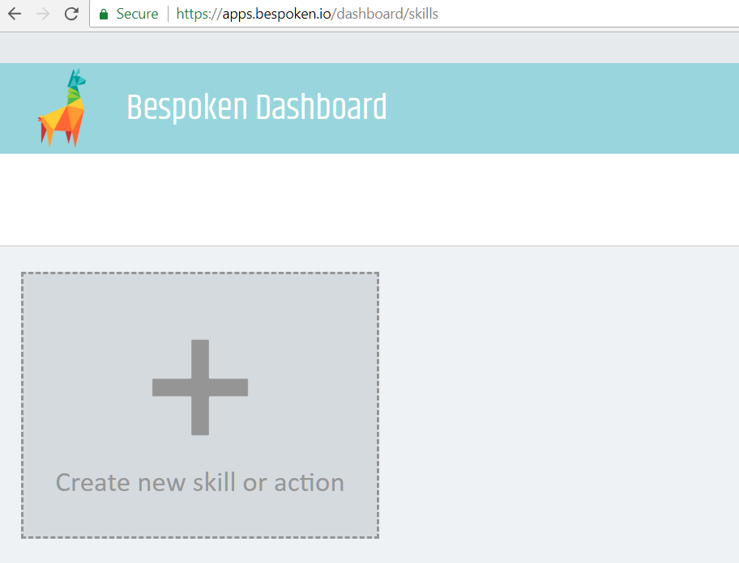**
2. **Add a source for your skill, to do it just click on the big + icon below the llama, you will be asked to input the name for this source, for example, *“my awesome skill”*. Then click on the text saying “Validate your new skill »“. You will see a window like this:**

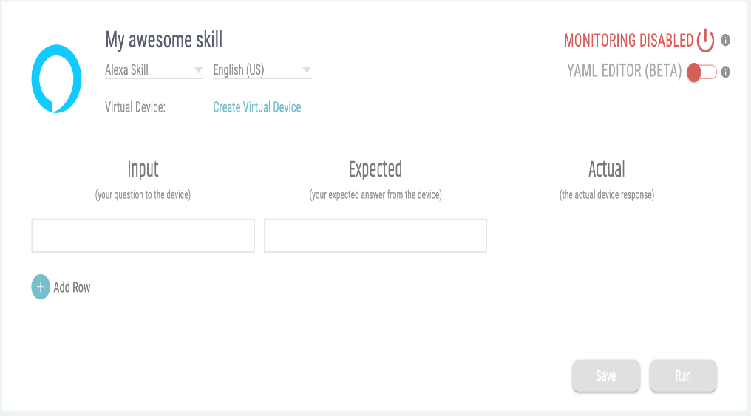

**Give open medicalhelp in the input and give your expected output in expected ie hi I am ally your…. And then save and run**

1. **Click on the “Create Virtual Device” link, you will see an Amazon window where you have to log in:**

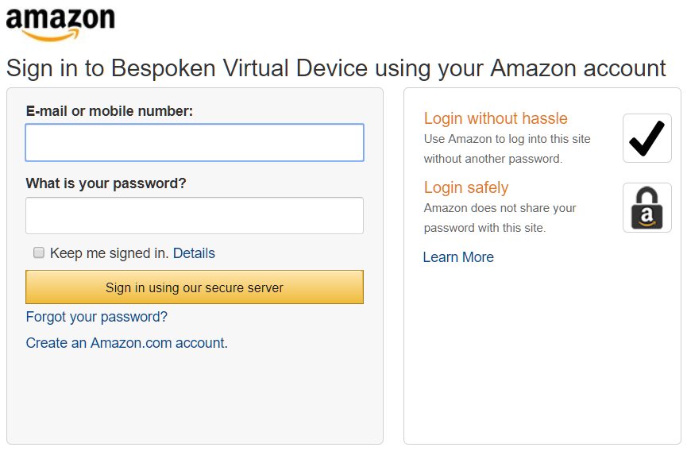

1. **After providing your credentials you will return to Bespoken dashboard and the “Virtual Device Token” will be retrieved automatically: 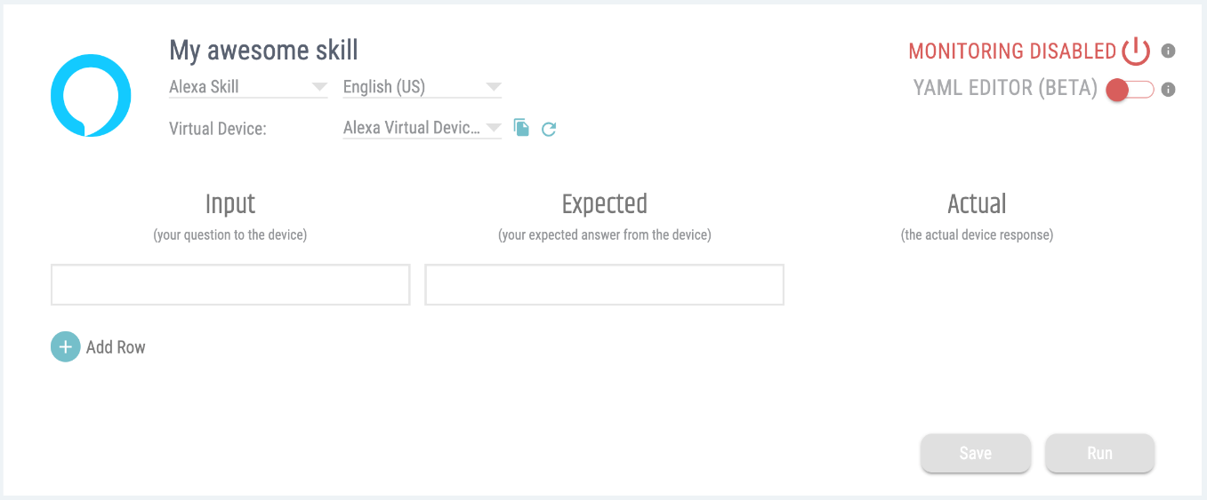**
2. **Click on the copy icon next to the name of your virtual device to copy it to the clipboard and you are set.**

**Name in package.json = bedside_assistant_ally_code_ask**