WEEK 3 TASK REPORT
Advanced Data Analysis and Visualization in Logistics
Internship Task | Hypothetical Logistics Dataset | Python EDA and Visualization

1. Objective
The objective of this task is to explore a hypothetical logistics dataset using Python, calculate descriptive statistics, study relationships between operational variables, create visualizations, and convert the results into practical recommendations. The analysis focuses on delivery time, shipment distance and weight, transportation mode, transportation cost, and on-time delivery.

2. Dataset Simulation and Structure
The simulated dataset contains 15 shipments and 8 columns. Each row represents one shipment. The data is intentionally small so that the analysis is easy to understand; real operational decisions should use a larger, validated dataset.
Variable | Meaning | Data type
Shipment_ID | Unique shipment identifier | Text
Region | Destination/operating region | Category
Transport_Mode | Road, Rail, or Air | Category
Distance_km | Shipment distance in kilometres | Numeric
Shipment_Weight_kg | Shipment weight in kilograms | Numeric
Delivery_Time_days | Total delivery duration in days | Numeric
Transport_Cost_INR | Transportation cost in Indian rupees | Numeric
On_Time | Whether the shipment arrived on time | Category

3. Methodology and Data Preparation
- Create the hypothetical dataset in a pandas DataFrame.
- Inspect the first rows, data types, dimensions, and missing values.
- Check duplicate shipment identifiers and confirm that numerical columns contain valid values.
- Calculate descriptive statistics such as mean, median, minimum, maximum, and standard deviation.
- Group shipments by transportation mode to compare average delivery time, cost, and on-time rate.
- Create a histogram, bar chart, scatter plot, and correlation heatmap.
- Interpret each chart and develop recommendations while acknowledging the small simulated sample.

4. Exploratory Data Analysis (EDA)
Number of shipments: 15
Missing values in the simulated dataset: 0. Duplicate shipment IDs: 0.
Overall on-time delivery rate: 73.3%.
Average delivery time: 1.98 days. Median delivery time: 2.00 days.
Average transportation cost: ₹4,666.67. Median transportation cost: ₹3,900.00.

4.1 Descriptive Statistics
Metric | Mean | Median | Std. Dev. | Minimum | Maximum
Distance (km) | 421.33 | 320.00 | 302.25 | 120.00 | 1100.00
Weight (kg) | 370.67 | 330.00 | 198.66 | 90.00 | 700.00
Delivery time (days) | 1.98 | 2.00 | 0.74 | 1.00 | 3.10
Cost (INR) | 4666.67 | 3900.00 | 3203.50 | 1800.00 | 12500.00
Interpretation: The mean and median help describe typical performance. A noticeable difference between the mean and median can indicate that a few unusually high or low observations affect the average. The minimum and maximum show the observed range, while standard deviation indicates how much values vary.

4.2 Delivery Time Distribution
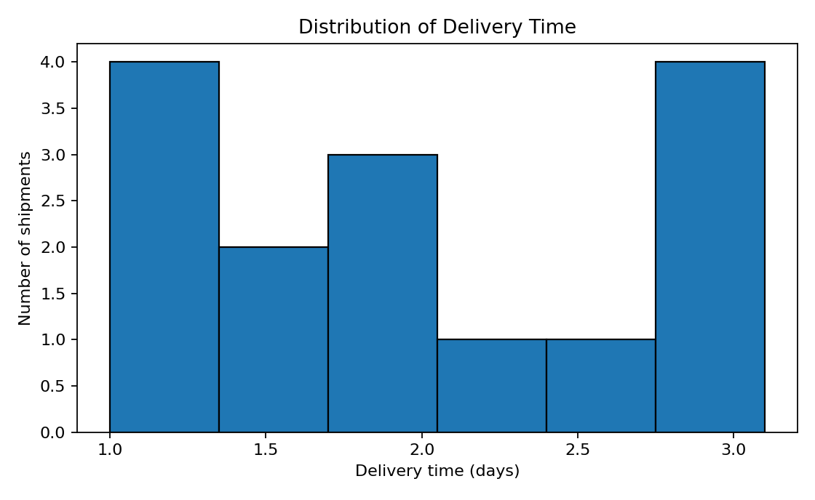
Why this chart: A histogram groups delivery durations into intervals and makes it easier to see where most shipments fall and whether unusually long deliveries exist. Interpretation: Most simulated deliveries are clustered around roughly one to three days. The slower observations deserve review to identify possible delays, transfer waits, or route issues.

4.3 Average Cost by Transportation Mode
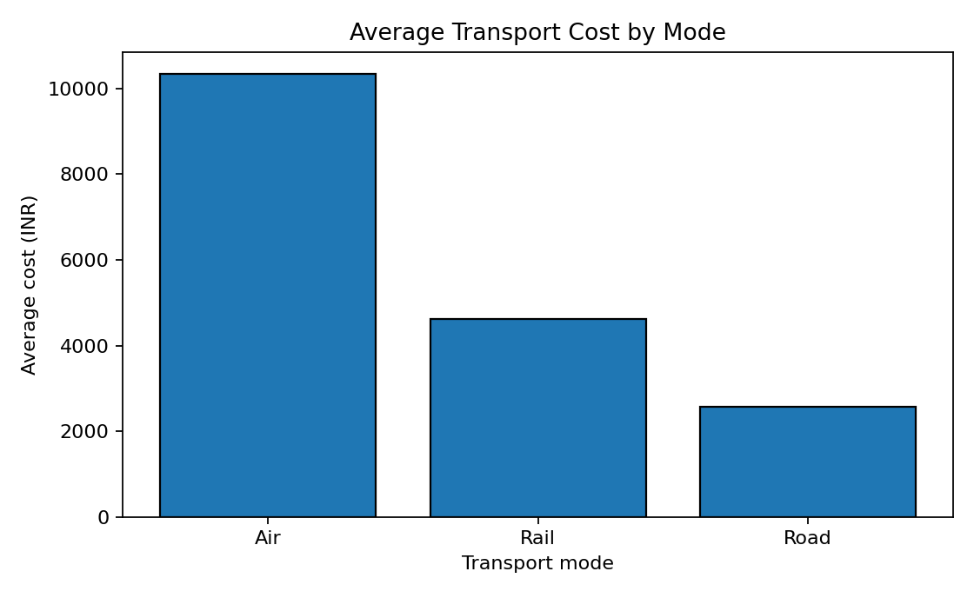
Why this chart: A bar chart is suitable for comparing average costs across discrete categories such as Road, Rail, and Air. Interpretation: Air shipments have the highest average cost in this sample, while road shipments generally cost less per shipment. However, shipment distance, weight, urgency, and service level differ, so this chart alone cannot prove that one mode is always more economical.

4.4 Distance and Transportation Cost
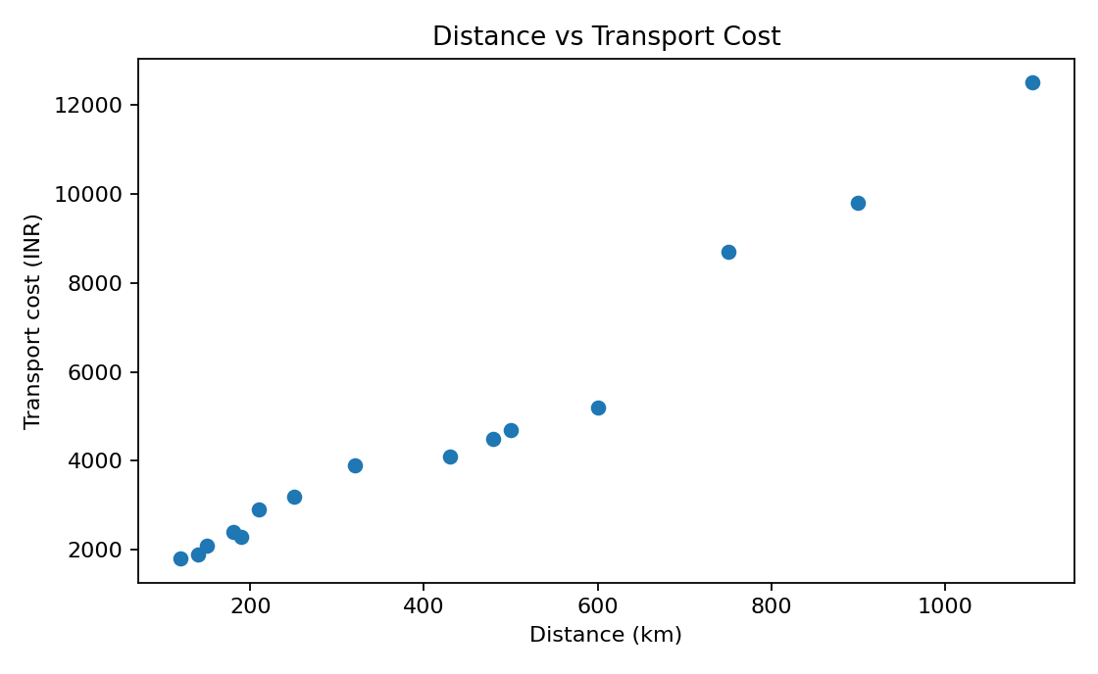
Why this chart: A scatter plot shows the relationship between two numeric variables and helps reveal trends or unusual points. Interpretation: The simulated data generally suggests that longer-distance shipments can have higher costs. Some variation is expected because transportation mode and shipment weight also influence cost.

4.5 Correlation Between Numerical Metrics
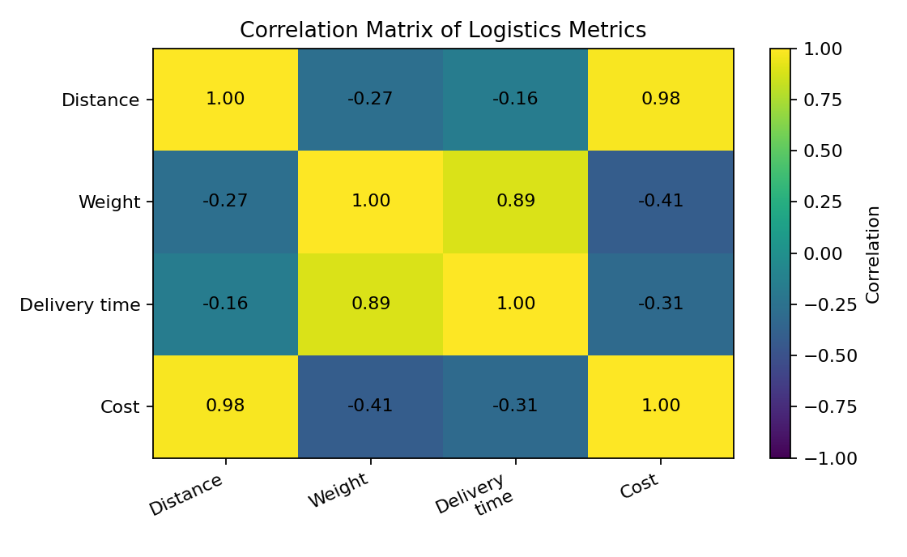
Why this chart: A correlation heatmap summarizes pairwise linear relationships. Values closer to +1 indicate a positive linear association, values closer to -1 indicate a negative association, and values near 0 indicate a weak linear association. Interpretation: Distance and cost show a positive relationship in this simulated dataset. Correlation does not establish causation and may be affected by mode, weight, and the small sample size.

5. Comparison by Transportation Mode
Mode | Shipments | Avg. delivery (days) | Avg. cost (₹) | On-time rate
Air | 3 | 1.10 | 10,333.33 | 100.0%
Rail | 4 | 2.95 | 4,625.00 | 0.0%
Road | 8 | 1.82 | 2,562.50 | 100.0%
This comparison provides a quick operational view of service and cost by mode. The results should be interpreted alongside distance, weight, delivery commitment, and shipment urgency. A fair comparison would control for these factors rather than selecting a mode based only on average cost.

6. Key Findings and Potential Bottlenecks
- The overall on-time delivery rate in the sample is 73.3%; late shipments should be examined individually to find common route, region, or mode patterns.
- The average delivery time is 1.98 days, but the distribution shows that shipments do not all take the same amount of time.
- Transportation cost varies by mode. Air may be suitable for urgent shipments, while road or rail may be more suitable for cost-sensitive shipments when the required delivery window allows it.
- Distance and weight are useful explanatory variables for transportation cost, but they should be analysed together with mode and service level.
- Because the dataset is small and hypothetical, the findings are illustrative and cannot support definitive business conclusions.

7. Recommendations
- Monitor on-time delivery rate and average delivery time weekly, broken down by region, carrier, and transport mode.
- Investigate late shipments to identify recurring causes such as dispatch delays, route congestion, transfer time, or inaccurate estimated delivery times.
- Compare transport modes using cost per kilometre, cost per kilogram, and on-time performance—not just total cost per shipment.
- Use validated historical data with more rows and include planned delivery date, actual delivery date, fuel surcharge, carrier, and delay reason.
- Set data-quality checks for missing values, duplicates, invalid distances, negative costs, and inconsistent delivery-status labels.
- Re-run the analysis regularly and compare performance before and after process changes.

8. Python Code Used
# Advanced Data Analysis and Visualization in Logistics
import pandas as pd
import matplotlib.pyplot as plt

# 1. Create a small hypothetical logistics dataset.
# These values are simulated for this assignment, not real company records.
data = {
"Shipment_ID": ["S001","S002","S003","S004","S005","S006","S007","S008",
"S009","S010","S011","S012","S013","S014","S015"],
"Region": ["West","West","South","North","West","East","South","North",
"East","West","South","East","North","West","South"],
"Transport_Mode": ["Road","Road","Air","Road","Rail","Road","Road","Air",
"Rail","Road","Rail","Air","Road","Rail","Road"],
"Distance_km": [120,250,900,180,430,320,150,1100,500,210,600,750,140,480,190],
"Shipment_Weight_kg": [220,480,120,350,700,260,310,90,620,400,560,150,290,680,330],
"Delivery_Time_days": [1.2,2.1,1.0,2.0,2.8,2.5,1.4,1.2,3.1,2.0,3.0,1.1,1.8,2.9,1.6],
"Transport_Cost_INR": [1800,3200,9800,2400,4100,3900,2100,12500,4700,2900,5200,8700,1900,4500,2300],
"On_Time": ["Yes","Yes","Yes","Yes","No","Yes","Yes","Yes","No","Yes","No","Yes","Yes","No","Yes"]
}
df = pd.DataFrame(data)

# 2. Inspect and validate data before analysis.
print("Dataset shape:", df.shape)
print(df.head())
print(df.info())
print("\nMissing values by column:\n", df.isna().sum())
print("Duplicate shipment IDs:", df["Shipment_ID"].duplicated().sum())

# 3. Basic preprocessing: standardize text labels and convert numeric columns.
df["Transport_Mode"] = df["Transport_Mode"].str.strip().str.title()
df["On_Time"] = df["On_Time"].str.strip().str.title()
numeric_cols = ["Distance_km", "Shipment_Weight_kg",
"Delivery_Time_days", "Transport_Cost_INR"]
df[numeric_cols] = df[numeric_cols].apply(pd.to_numeric, errors="coerce")

# Check for missing/invalid numeric values before calculating metrics.
print("\nMissing values after conversion:\n", df.isna().sum())
print("\nDescriptive statistics:\n", df[numeric_cols].describe())
print("On-time delivery rate (%):", round((df["On_Time"] == "Yes").mean() * 100, 1))

# 4. Histogram: show the distribution of delivery times.
plt.figure(figsize=(7, 4))
plt.hist(df["Delivery_Time_days"].dropna(), bins=6, edgecolor="black")
plt.title("Distribution of Delivery Time")
plt.xlabel("Delivery time (days)")
plt.ylabel("Number of shipments")
plt.tight_layout()
plt.show()

# 5. Bar chart: compare average transportation cost by mode.
avg_cost = df.groupby("Transport_Mode")["Transport_Cost_INR"].mean()
avg_cost.plot(kind="bar", edgecolor="black", title="Average Transport Cost by Mode")
plt.xlabel("Transport mode")
plt.ylabel("Average cost (INR)")
plt.tight_layout()
plt.show()

# 6. Scatter plot: inspect the relationship between distance and cost.
plt.figure(figsize=(7, 4))
plt.scatter(df["Distance_km"], df["Transport_Cost_INR"])
plt.title("Distance vs Transport Cost")
plt.xlabel("Distance (km)")
plt.ylabel("Transport cost (INR)")
plt.tight_layout()
plt.show()

# 7. Correlation matrix: summarize relationships among numeric metrics.
corr = df[numeric_cols].corr()
print("\nCorrelation matrix:\n", corr)
plt.figure(figsize=(7, 4))
plt.imshow(corr, vmin=-1, vmax=1, aspect="auto")
plt.xticks(range(len(numeric_cols)), numeric_cols, rotation=30, ha="right")
plt.yticks(range(len(numeric_cols)), numeric_cols)
plt.colorbar(label="Correlation")
plt.title("Correlation Matrix of Logistics Metrics")
for i in range(len(numeric_cols)):
for j in range(len(numeric_cols)):
plt.text(j, i, f"{corr.iloc[i, j]:.2f}", ha="center", va="center")
plt.tight_layout()
plt.show()

# 8. Compare delivery time and on-time rate by transport mode.
mode_summary = df.groupby("Transport_Mode").agg(
Shipments=("Shipment_ID", "count"),
Average_Delivery_Days=("Delivery_Time_days", "mean"),
Average_Cost_INR=("Transport_Cost_INR", "mean"),
On_Time_Rate=("On_Time", lambda values: (values == "Yes").mean() * 100)
)
print("\nPerformance by transport mode:\n", mode_summary.round(2))
Data preprocessing and decision-making reflection: Preprocessing improves the reliability of logistics decisions. Checking missing values, duplicate shipment IDs, numeric data types, and inconsistent labels helps prevent incorrect KPI calculations. For example, a delivery status entered as ' yes ' instead of 'Yes' could be counted incorrectly unless labels are standardized. Converting invalid numeric values safely also makes data-quality problems visible before averages and charts are produced. If the underlying data is incomplete or inconsistent, managers could misjudge on-time performance, underestimate costs, or target the wrong bottleneck. In this simulated dataset, the checks are included for demonstration; the values are hypothetical and the sample is too small for definitive business decisions.

Reflection on Data Preprocessing
Cleaning and validating data before analysis supports better decisions because the resulting charts and KPIs are more trustworthy. Standardized categories make mode comparisons fairer, while missing-value and duplicate checks reduce the risk of misleading results. The organization should resolve data-quality issues before changing routes, carriers, or transport modes based on analytical findings.

9. How Visualizations Support Logistics Decisions
Visualizations convert tables of numbers into patterns that are easier to interpret. A histogram shows delivery-time spread and possible delays; a bar chart compares typical cost across modes; a scatter plot helps examine distance-cost relationships; and a correlation heatmap summarizes associations between numeric metrics. Together, these visuals help managers decide where to investigate, what to monitor, and which operational changes should be tested. They support—not replace—context, data validation, and business judgment.

10. Conclusion
This task demonstrates a basic logistics EDA workflow using pandas and Matplotlib. Descriptive statistics summarize shipment performance, while visualizations reveal distribution, cost differences, and relationships between variables. The most useful next step is to repeat this analysis on a larger real-world dataset, validate the results, and track KPIs over time to support reliable data-driven decisions.

Appendix: Simulated Dataset Preview
Shipment_ID | Region | Transport_Mode | Distance_km | Shipment_Weight_kg | Delivery_Time_days | Transport_Cost_INR | On_Time
S001 | West | Road | 120 | 220 | 1.2 | 1800 | Yes
S002 | West | Road | 250 | 480 | 2.1 | 3200 | Yes
S003 | South | Air | 900 | 120 | 1.0 | 9800 | Yes
S004 | North | Road | 180 | 350 | 2.0 | 2400 | Yes
S005 | West | Rail | 430 | 700 | 2.8 | 4100 | No
S006 | East | Road | 320 | 260 | 2.5 | 3900 | Yes
S007 | South | Road | 150 | 310 | 1.4 | 2100 | Yes
S008 | North | Air | 1100 | 90 | 1.2 | 12500 | Yes
S009 | East | Rail | 500 | 620 | 3.1 | 4700 | No
S010 | West | Road | 210 | 400 | 2.0 | 2900 | Yes

