Mini Project

**WeatherApp**

**Team members:**

# Shwetal – 195034

# Anshit - 195029

## WeatherApp

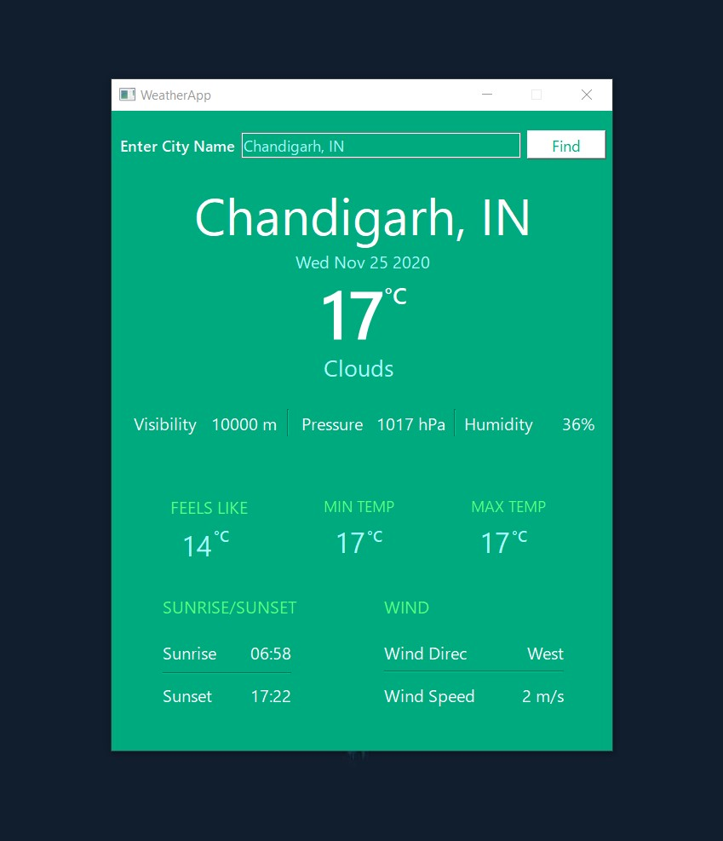

Made using OpenWeatherMap API. Enter your location to get the following weather details -

* Temperature
  + Feels Like
  + MaxTemp
  + MinTemp
* Humidity
* Visibility
* Pressure
* Sunrise
* Sunset
* WindDir/WindSpeed

Language

* C++ (Object Oriented)

Tool

* Qt Creator