High level design document - Flex one UI

We are designing a Flex One UI using React JS utilising different components and REDUX middleware to demonstrate RBAC capabilities inside the application. Components are modelled as REACT modules including higher order components where data is flowing through REDUX (avoiding PROP based data transfer)

Assumption - A backend application would ideally be the data source for the application which would make available the RBAC information to the client through REST api’s. In absence of such a server we have mocked the information inside the REDUX store assuming any REST call.

Component Diagram

We have defined below components for the application
- Configuration component which us responsible for showing config data to the user. This component is wired to Route “/component”. For simplicity I am just showing a string when the component is accessed. This component is accessible only to ADMIN user.
- Dashboard component is responsible to show info to the user and is wired to Route “/dashboard”. All types of user can access this component
- User Identity component is used to select a role and dispatch the role to REDUX store for awareness.
- Common component is used to render the NavBar and footer (footer has been mocked as empty)
- REDUX middleware defines two slices config slice and user slice storing config and user entities. When integrated with the backend application these slices will handle REST calls.
- A utility component holding Roles and permission constants

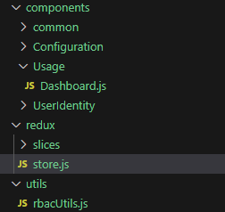

UML Diagram demonstrating control flow

Below diagram illustrates the user interaction and control flow when user access the React App and chooses different roles
